Summary:
1 variation. Sin, cos and tan ratios. Arc length.

Question:
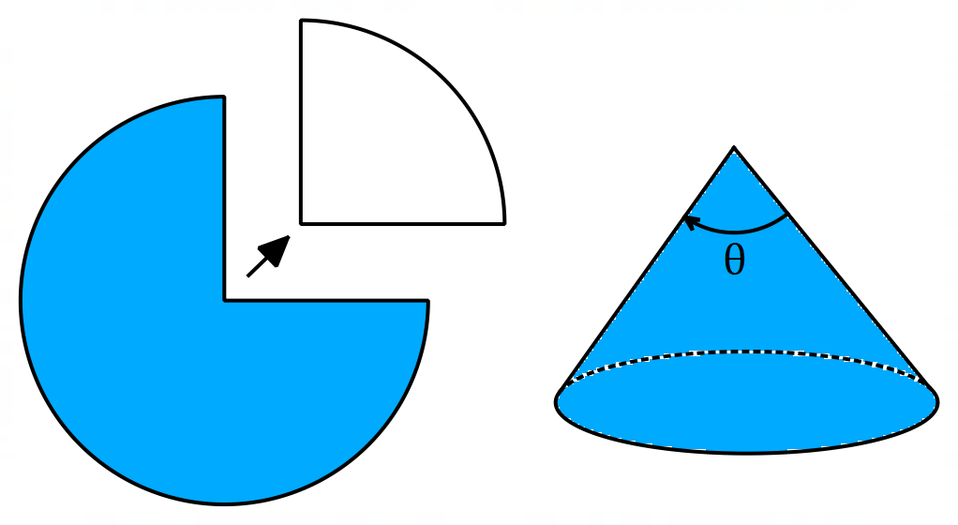
A cone is produced by removing a quarter of a circle and joining the two edges. When you look at the code from the side, what angle is formed by the two sloping sides?

Solution:
Assume that the radius of the original circle = 1
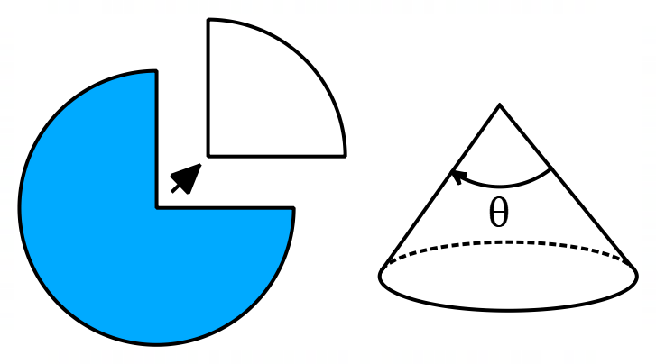

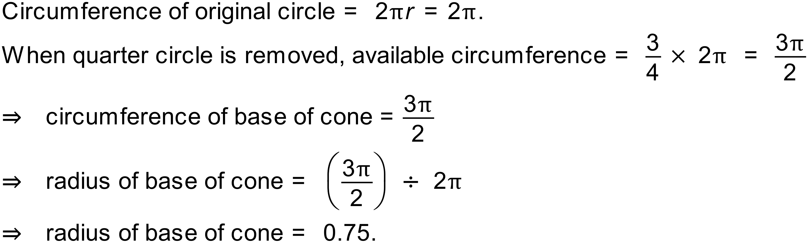
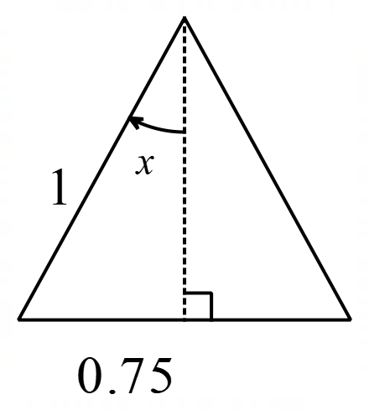
On this cross section of the cone you can see the radius of the base and the radius of the original circle which becomes the slope height of the cone.
