Summary:
1 variation. Sin, cos and tan ratios. Area of triangle.

Question:
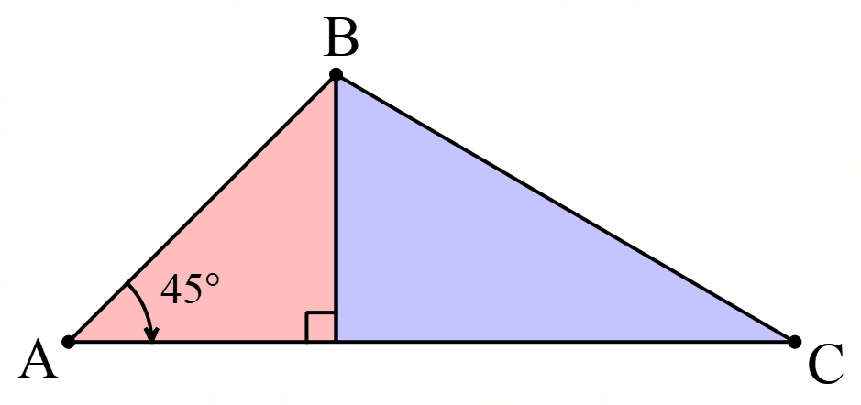
This triangle has been divided so that the area of the blue (right) side is 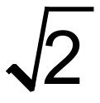 times the area of the red (left) side. What are the angles of triangle ABC?

Solution:
This triangle has been divided so that the area of the blue (right) side is times the area of the red (left) side. What are the angles of triangle ABC?

Assume sides to be one as shown.
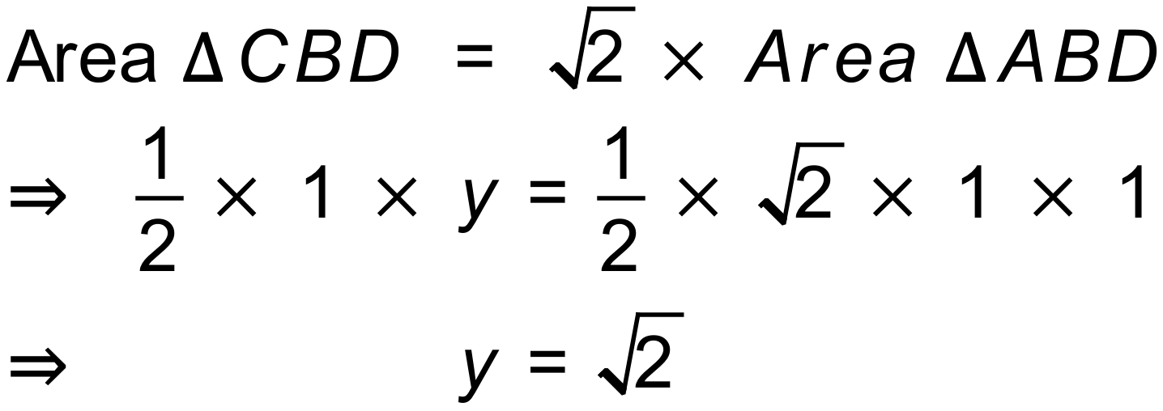
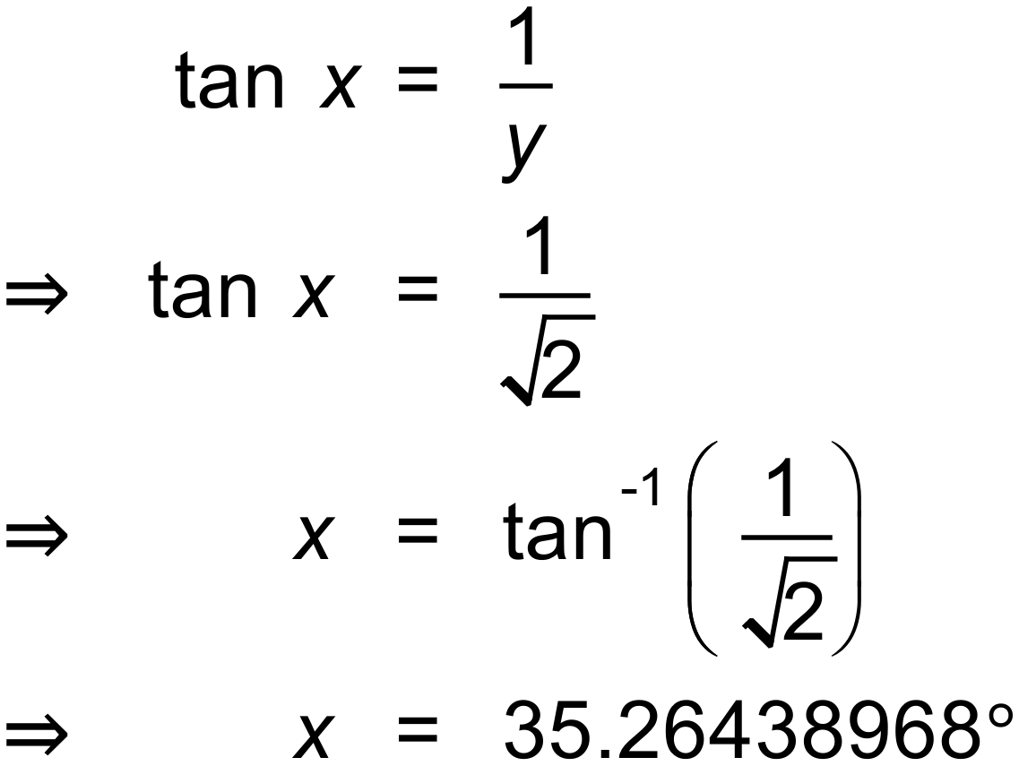

Angles are 45°, 35.3° and 99.7°

