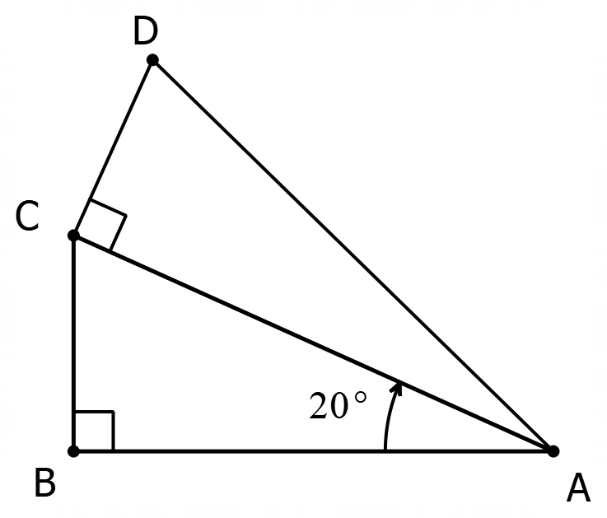
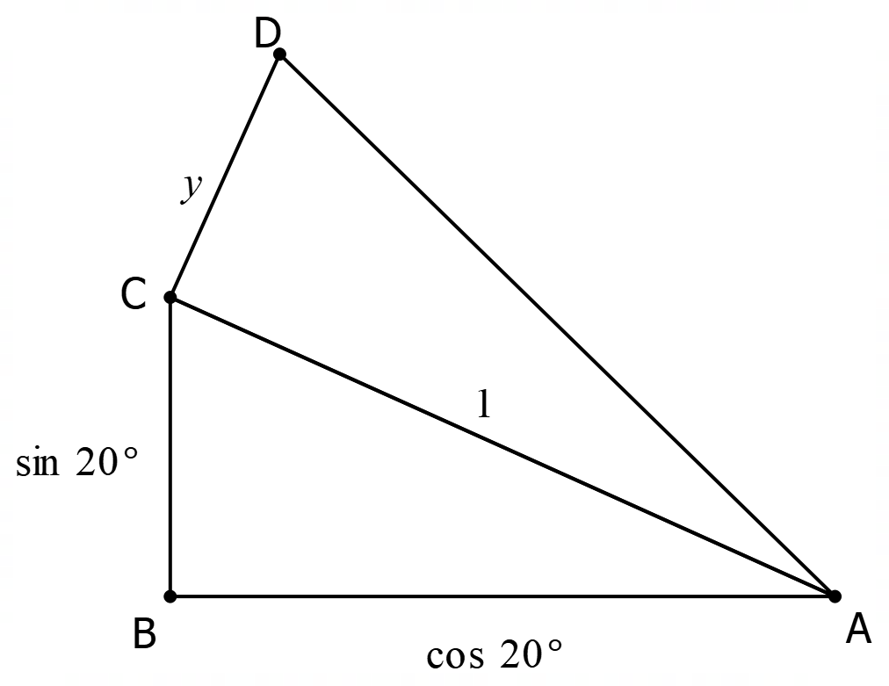
Summary:
8 variations. Sin, cos and tan ratios. Pythagoras. Area of triangle.

Question:
a) The two triangles below have the same area. How large is angle CAD?

b) This time, the two triangles have the same PERIMETER. Again, how large is angle CAD?

Solution:
a)
The best way to start this question is make one of the sides a standard length. In this case the best way is to make AC = 1. The other sides then determined relative to this.
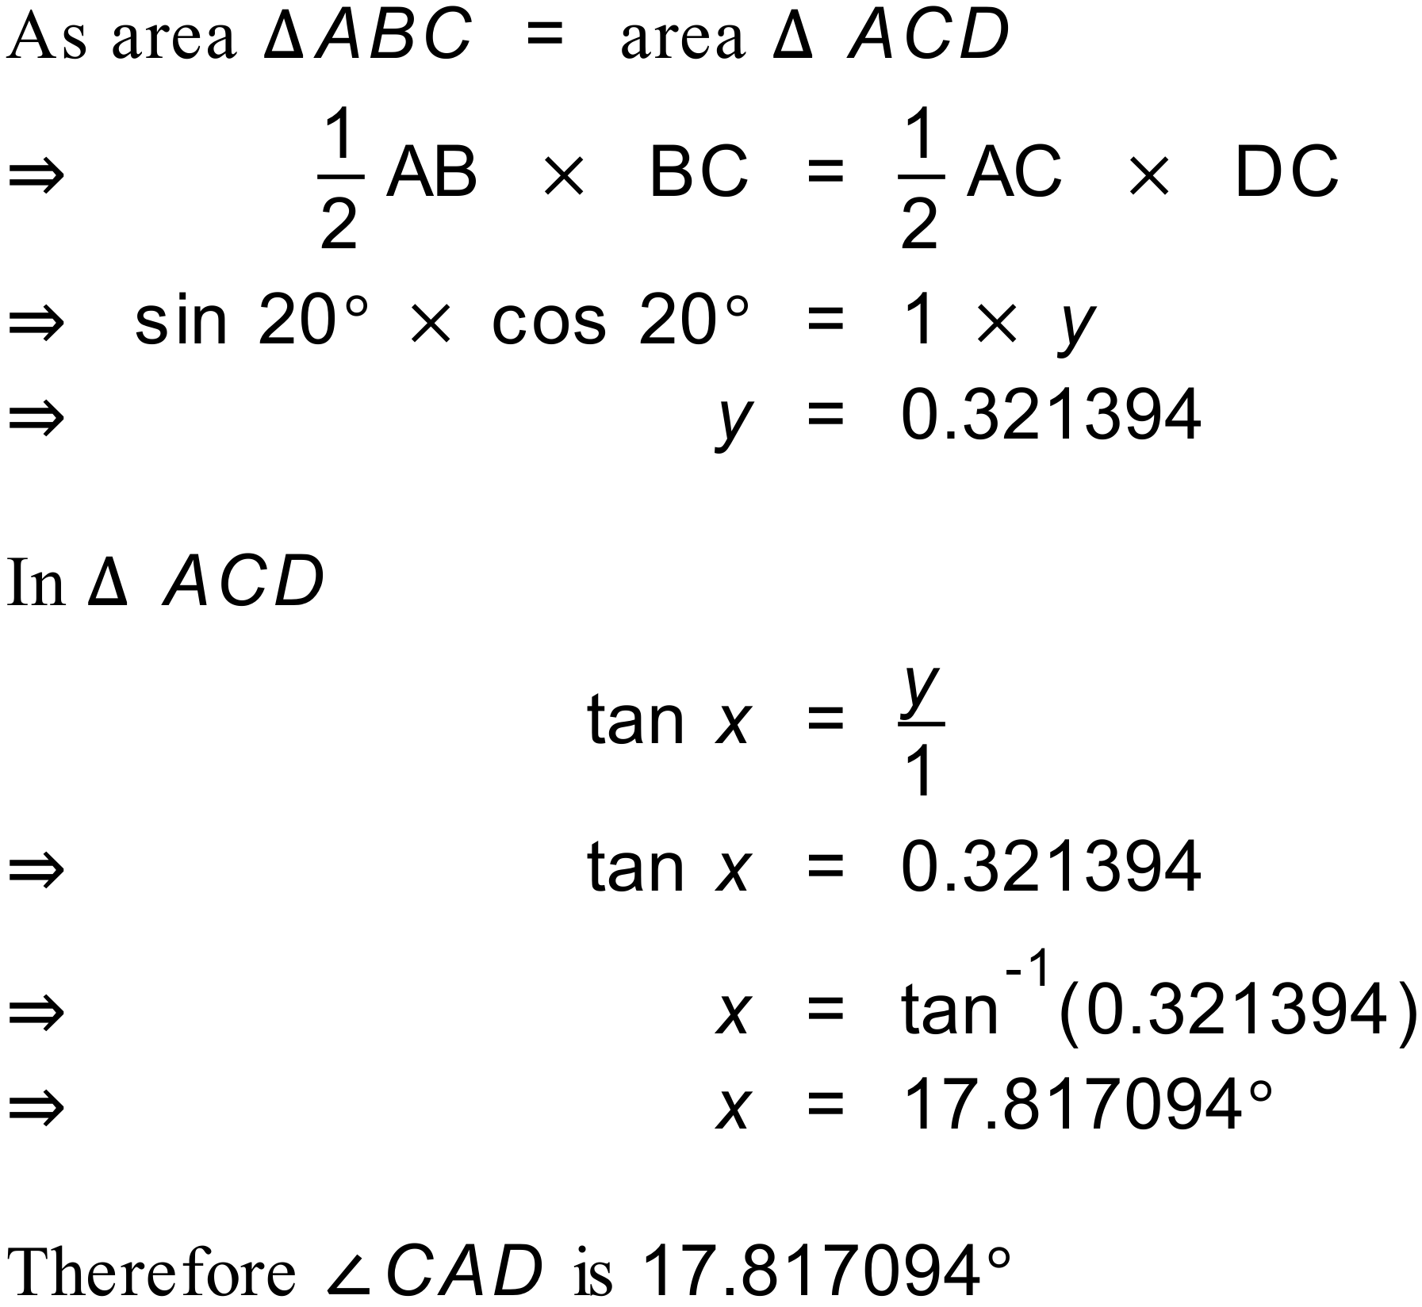

b)
In this question we use the same technique of setting the length of one side. In this case we need an extra side, z.
Using Pythagoras.
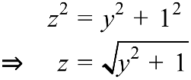
Because the perimeters of the triangles are the same
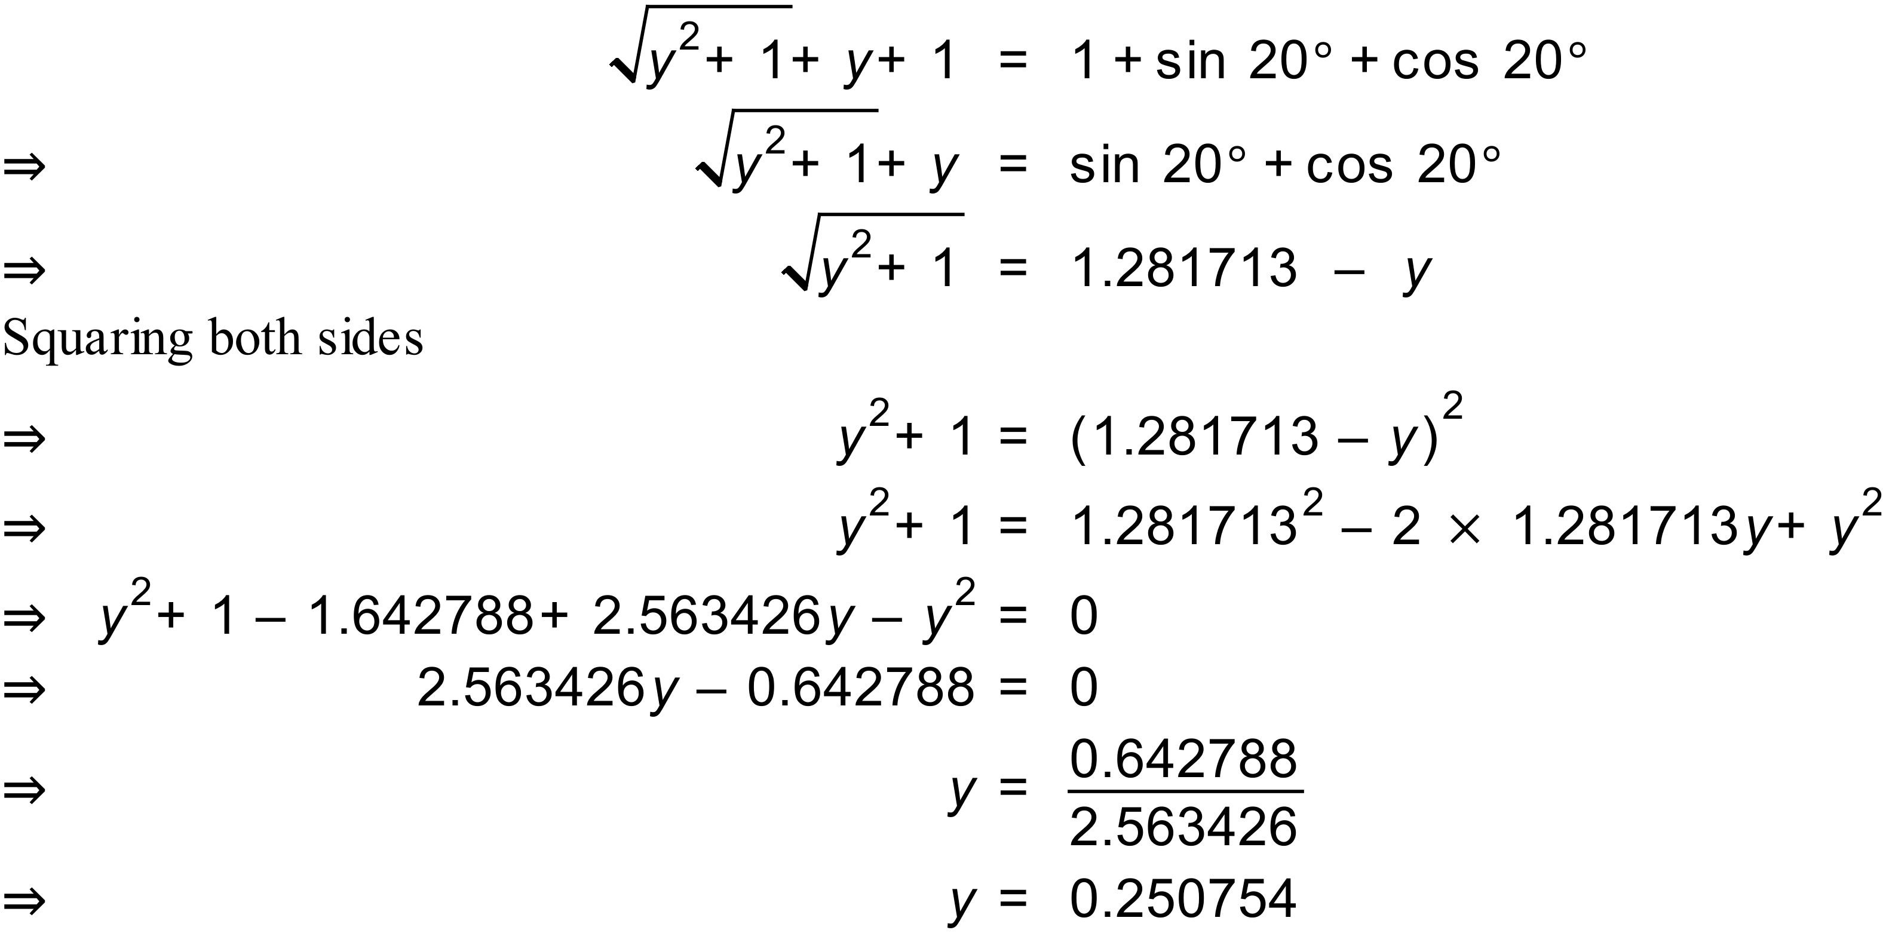
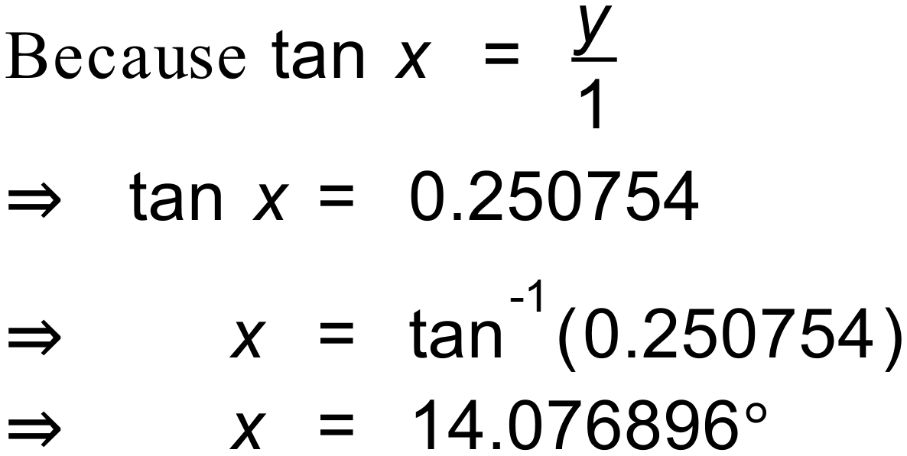
Therefore angle CAD is approximately 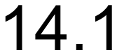 degrees.

