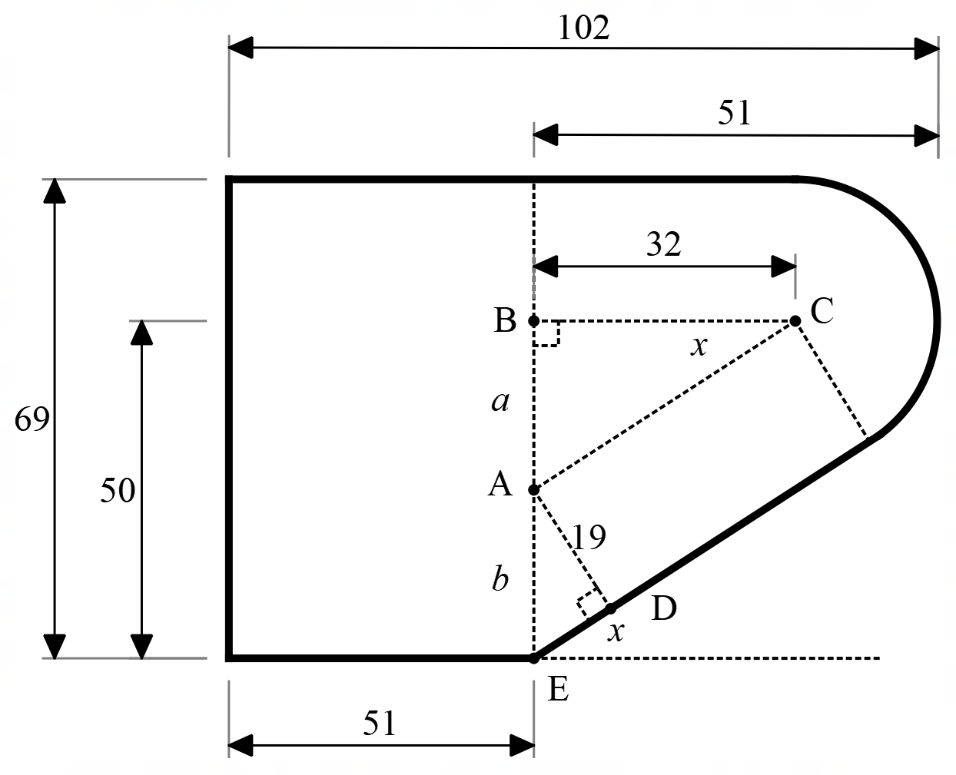
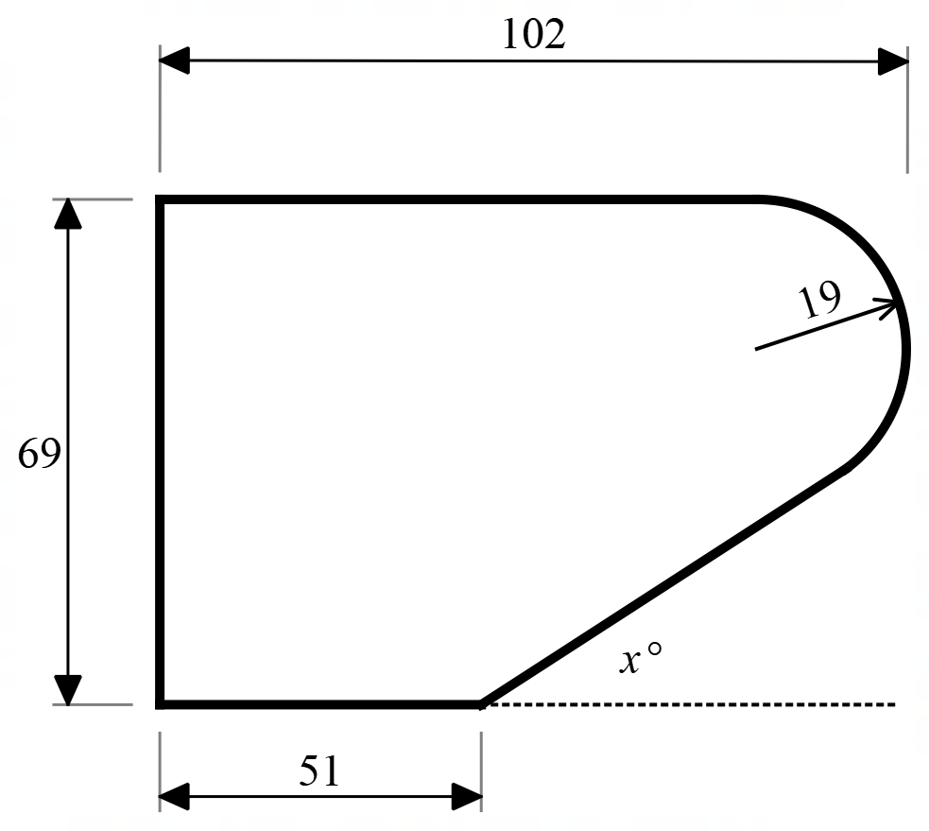
Summary:
3750 variations. Sin, cos and tan ratios. Pythagoras. Similar triangles. Quadratic formula.

Question:
A kitchen supply company is designing a new edge-moulding for benchtops that has this design.
All distances are in millimetres. You can assume that the straight edges are tangential to the rounded corner. Find the size of angle x.

Solution:
The solution to this question requires you to add a lot of extra lines to the diagram. From the diagram, with a little geometry, you can show that triangle ADE is similar to triangle CBA. You use this to solve the question.
