Summary:
10000+ variations. Simple surds.

Question: >10000 Variations
- Estimate the value of 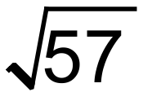. Show how you arrived at your answer.

- Simplify each of the following to an expression that contains radicals (surds) of prime numbers.
(i) 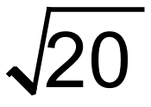 (ii) 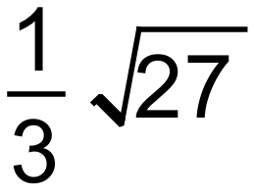
(iii) 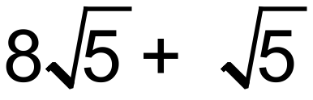 (iv) 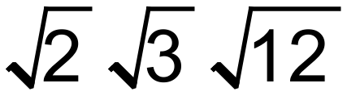

Solution:
- Answer to 2dp is 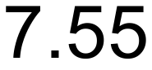. Acceptable responses between 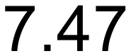 and 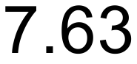
- i) 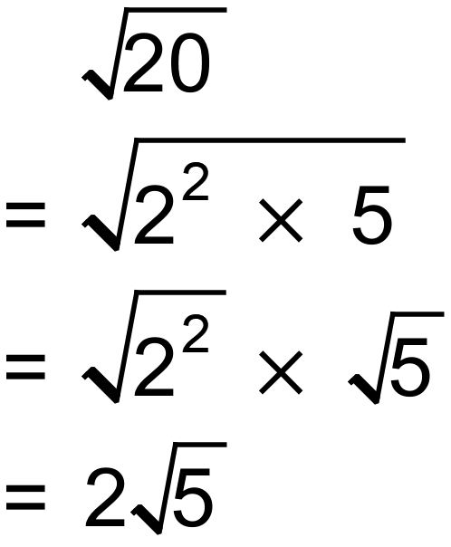 ii) 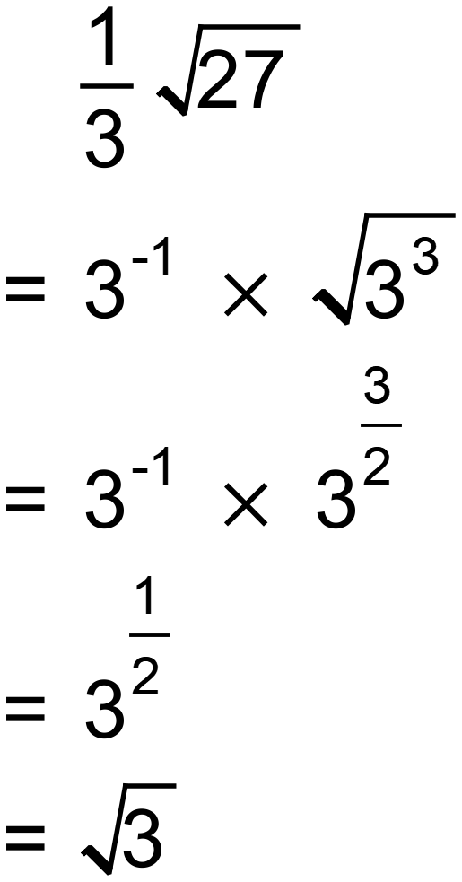

iii) 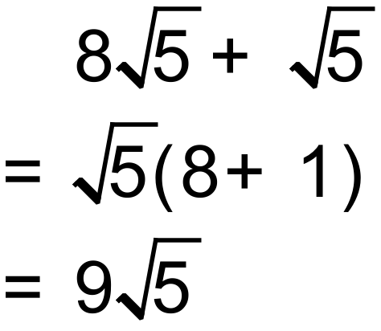 iv) 