Summary:
>100000 variations. Back to back stem and leaf plots, IQR and median.

Question:
The maximum temperatures (in degrees Celsius) for Coastville and Plainstown were recorded over 30 days in January and displayed in this back-to-back stem and leaf diagram.
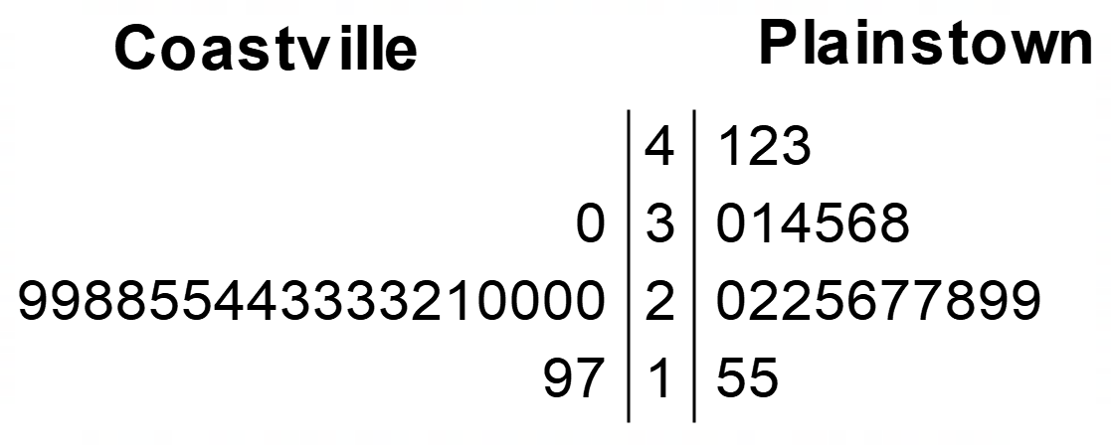
- What was the median temperature in Coastville?

- What was the median temperature in Plainstown?

- Using the interquartile ranges of the two towns, comment on which town had the most variable temperature.

Solution:

- 