Summary:
100000+ variations. Solving linear equations.

Question: 100000 Variations
Solve the following equations
a) 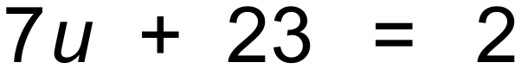
b) 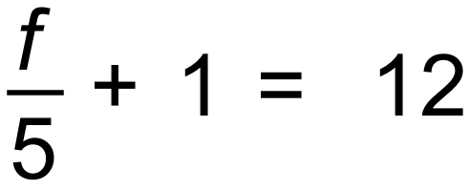
c) 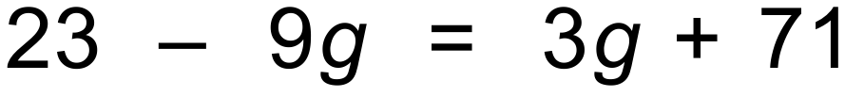
d)

Solution:
a) 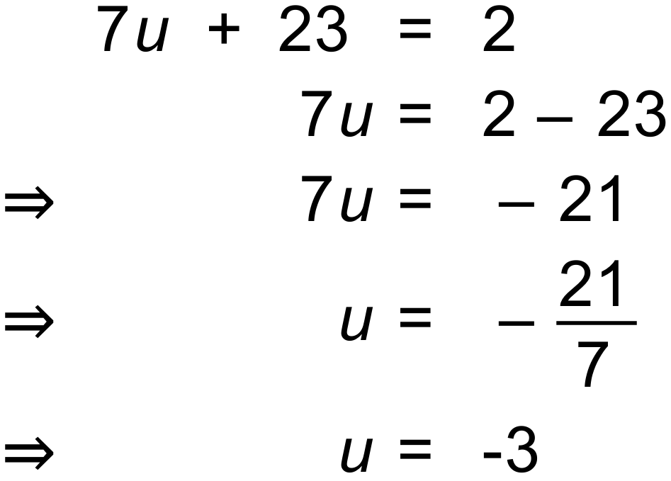

b) 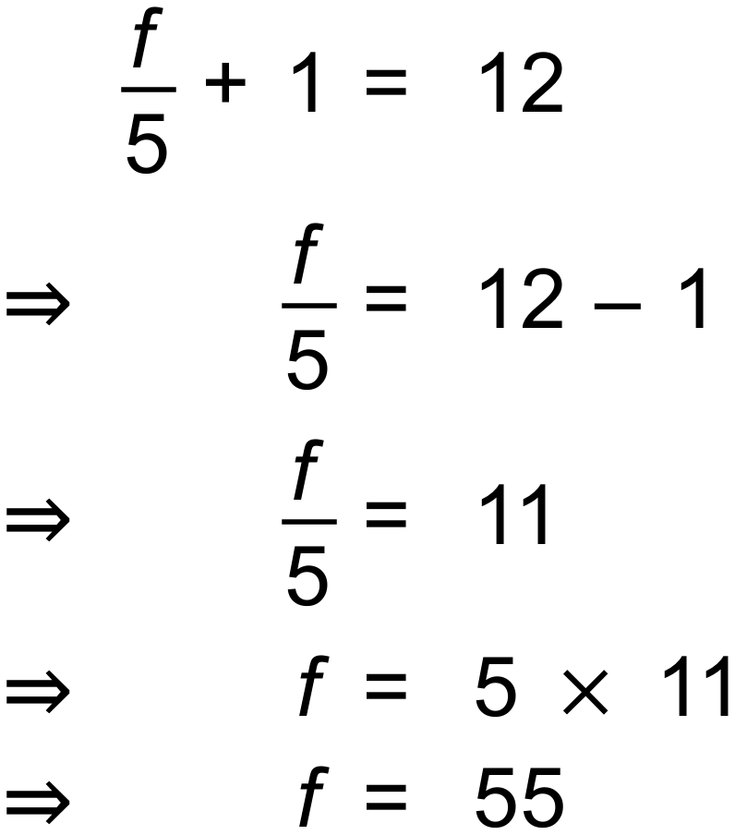

c) 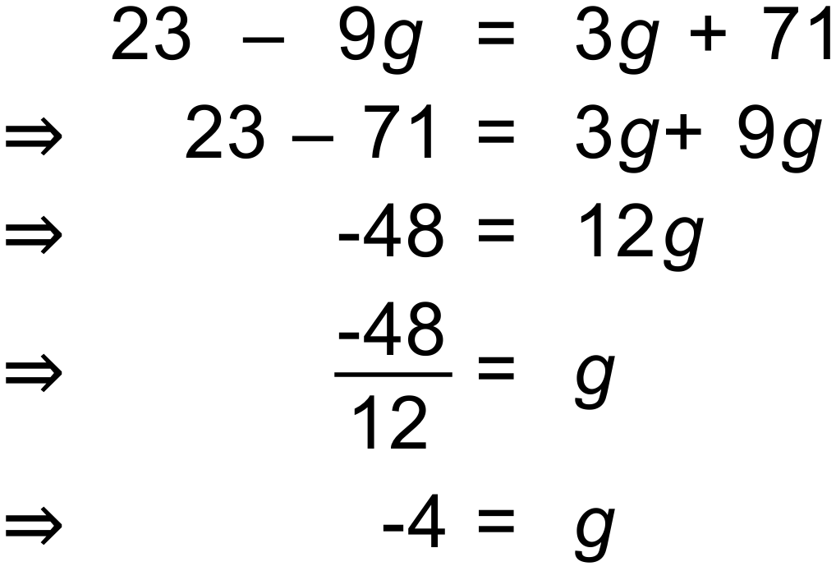

d) 