Summary:
100000+ variations. Solving equations.

Question:
Solve for the value of w in each equation below.

a) b) 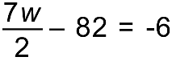

c) 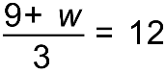 d) 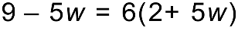

[2,3,2,3 = 10 Marks]

Solution:
a) 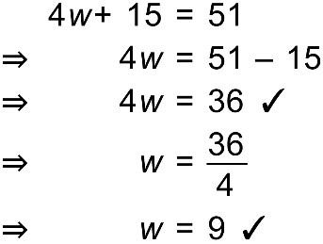 b) 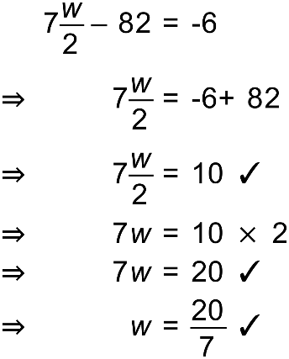

c) 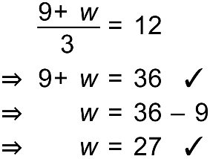 d) 