Summary:
1000 variations. Similar triangles. Pythagoras.

Question: 1000 Variations
a) Δ LQP ~ Δ LMN. Find LM and MN.
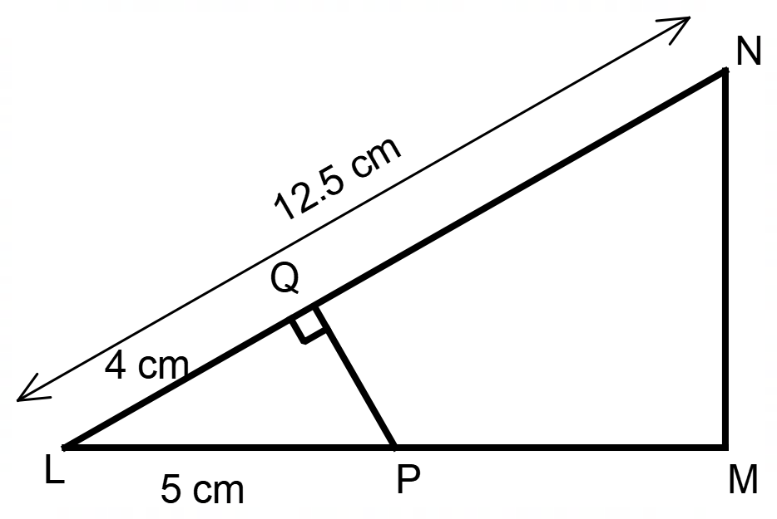

[4]
b) A mobile tower metres high has two parallel wires that join from the mast to the ground. The first, from the top if the mast, is m long and is fastened on the ground metres from the foot of the mast. The second is fastened on the ground m from the foot of the mast. Find the length of the second wire and how far up the mast it is fastened.

Solution:
a) 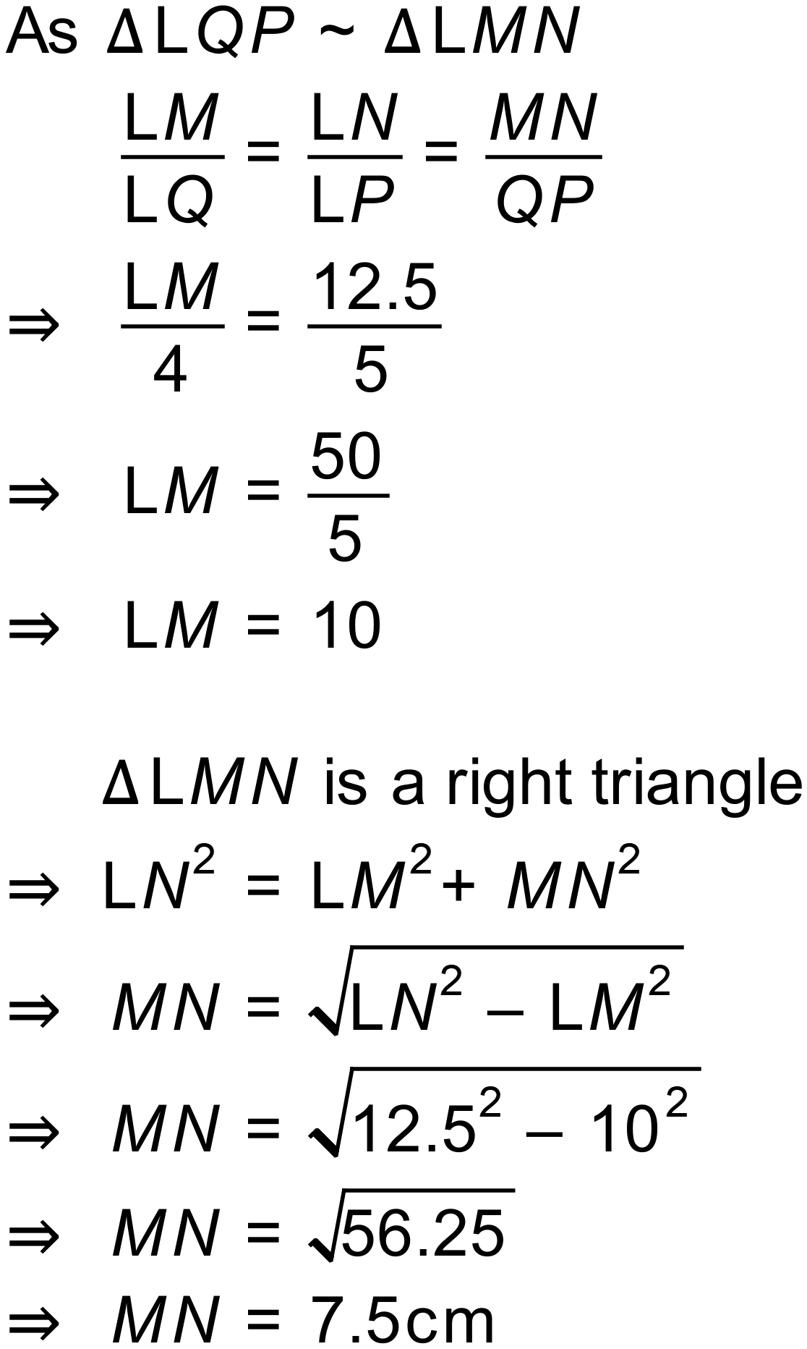

b)
