Summary:
25000 variations. First order linear recurrence relation.

Question:
The number of numbats in an area near Perth has been dropping by 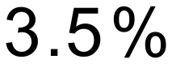 per year. Researchers have determined that the current population of numbats is 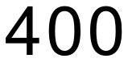. The researchers start trialling a program where 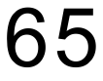 numbats are introduced into the area each year.
The population of numbats can be modelled using a first-order linear recurrence relation.
where T_{n} is the number of numbats in the area at the beginning of the n^{th} year.
- Explain the coefficient 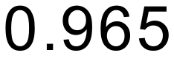 in the context of the situation.

- State the value of a in the equation.

- Graph the number of numbats numbers in the area for every 3 year period (commencing at n = 0) up to the 30th year on the axes below.

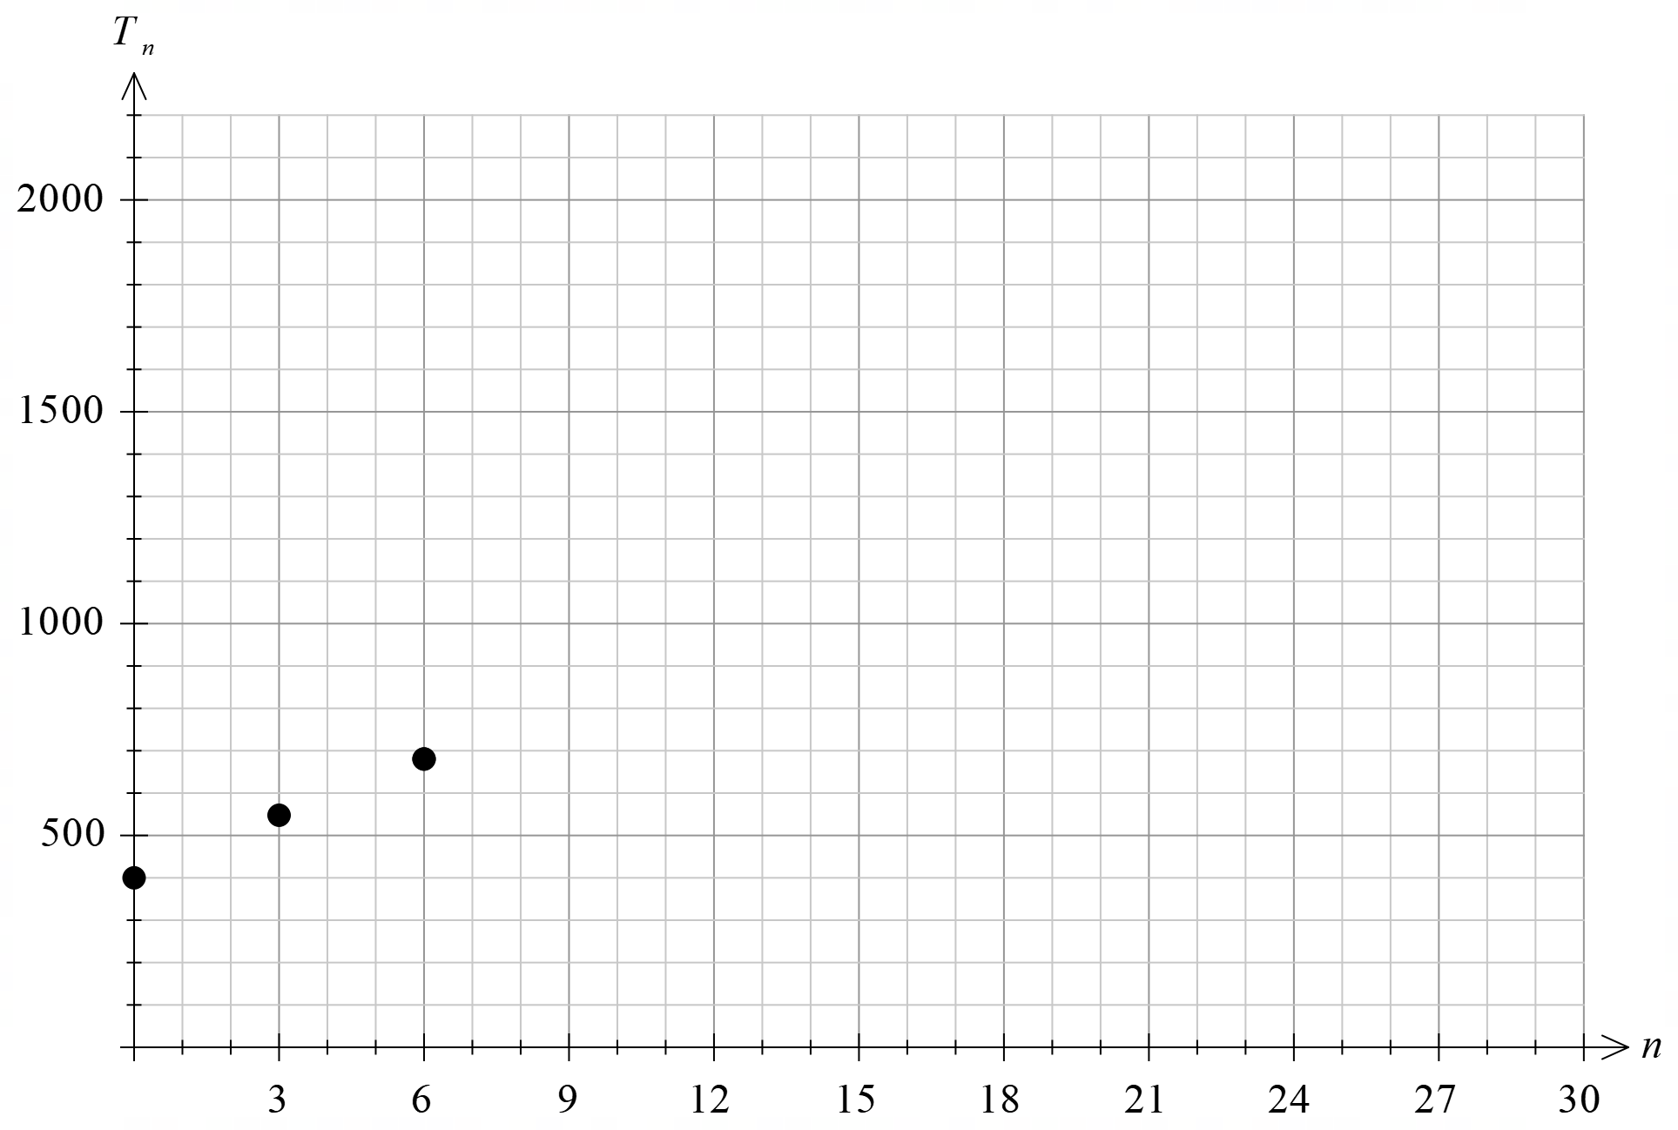

- Using your graph, comment on how the population of numbats is changing over time.

- To the nearest whole number, what is the long-term effect of the repopulation program.

Solution:
- is the ratio of numbats remaining in the area each year. This is equivalent to a percentage of 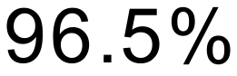

- a = . This is the number of numbats added to the population each year.

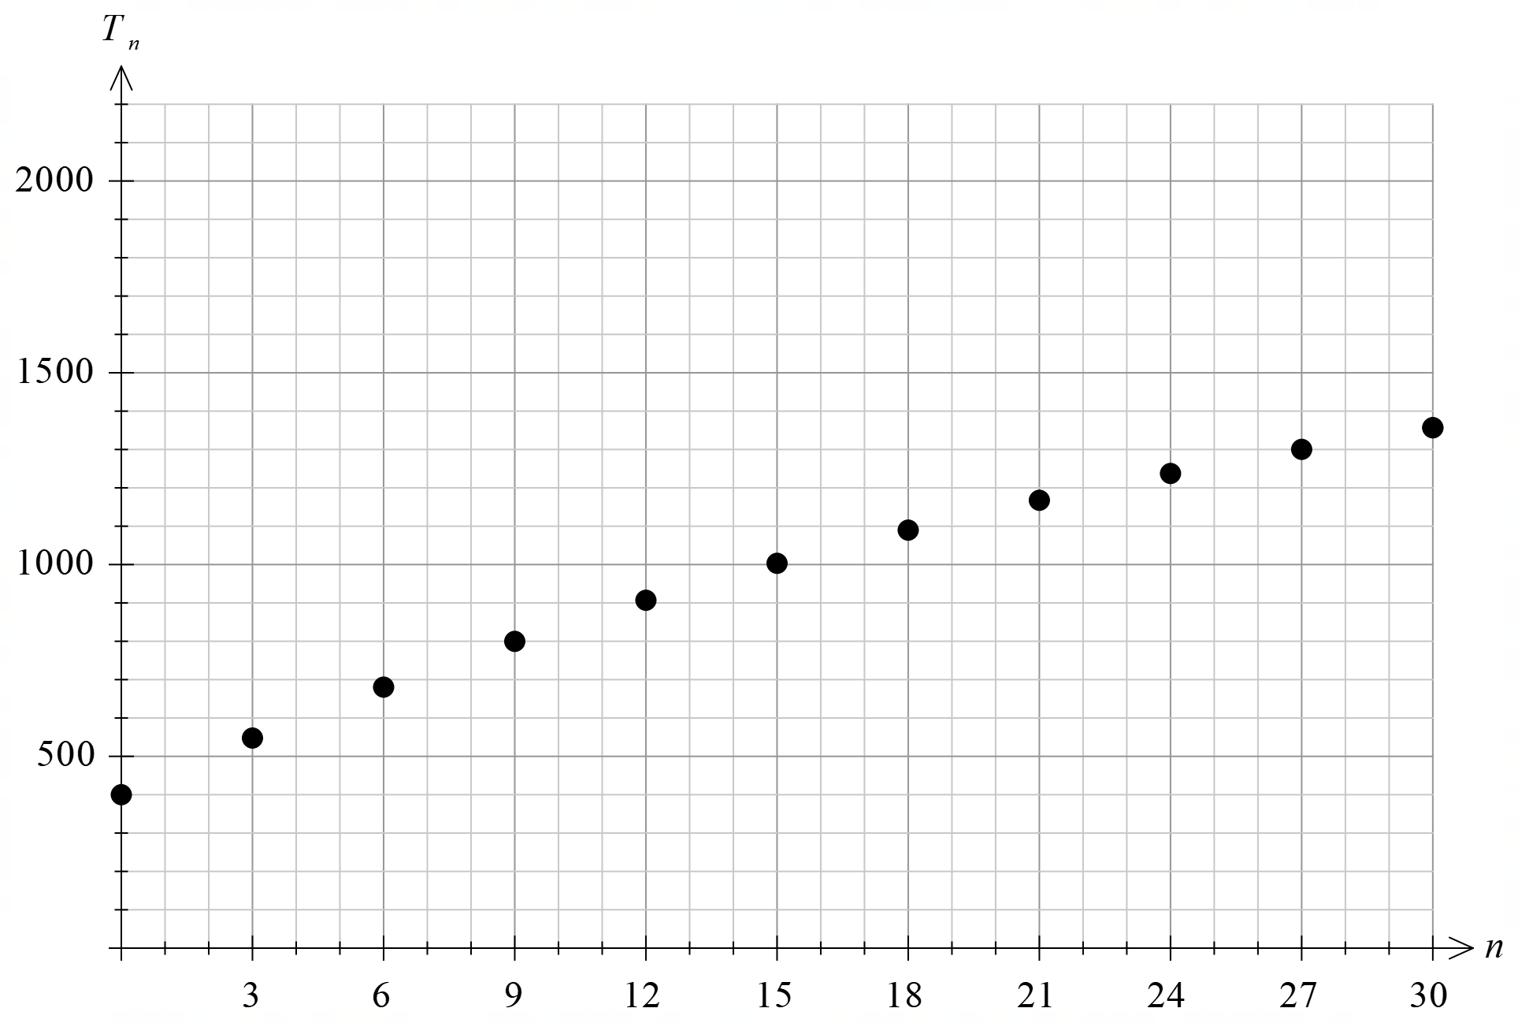

- The population of numbats is 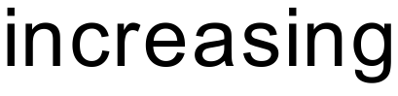. The population is levelling out over time.

- 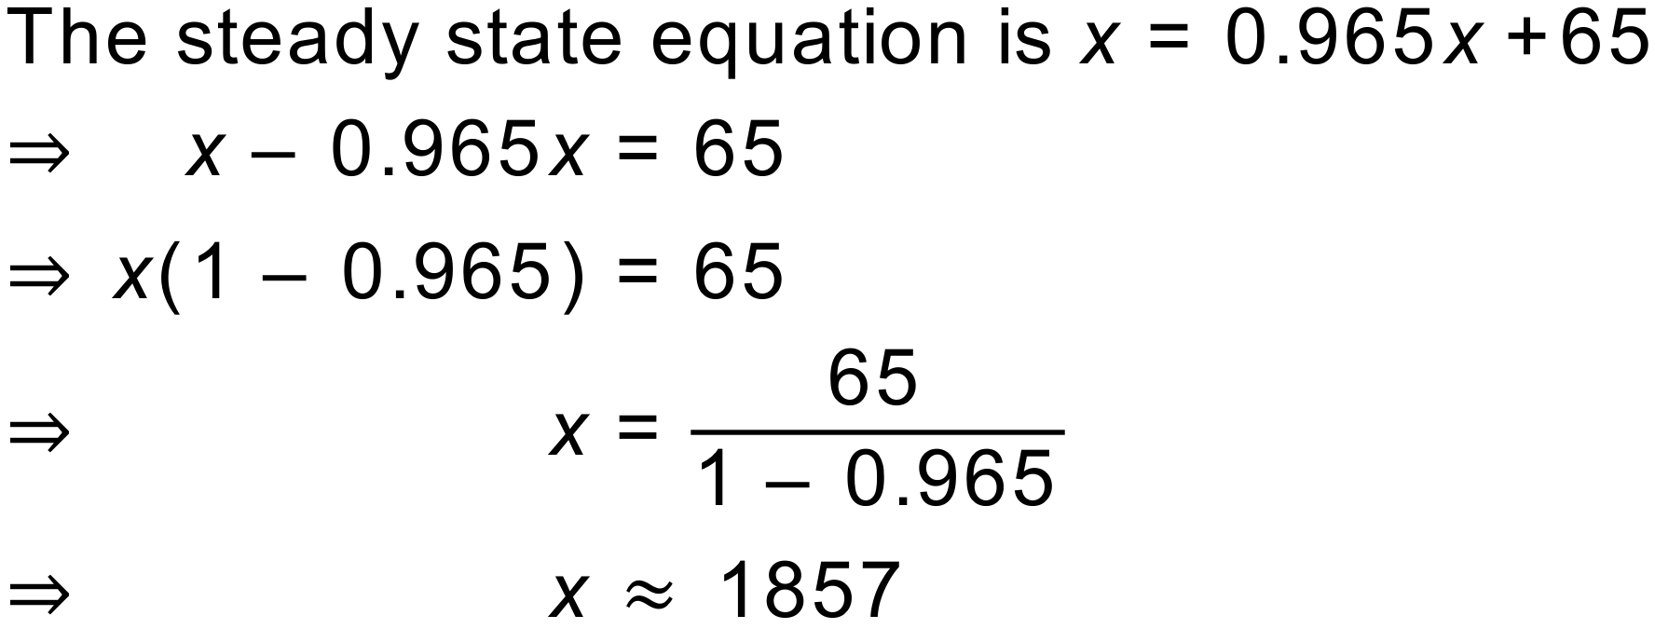

The population of numbats will settle to approximately 

