Summary:
3300 variations. Scientific notation.

Question: 3300 Variations
- The mean radius of the earth is approximately 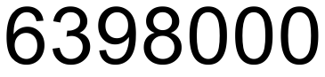m. Express this measurement using scientific notation.
- The mean radius of the moon is 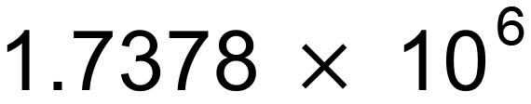metres. Write metres as a number without scientific notation.
- The diameter of a single human hair is approximately 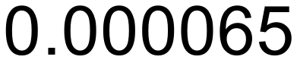m. Express in scientific notation.
- A nanometre is 10⁻⁹ metres. Express this in decimal form.

Solution:
- 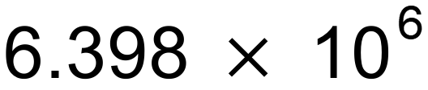m.
- 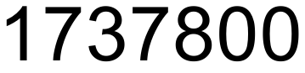 m.
- 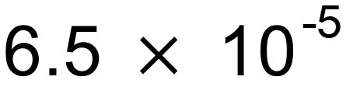m.
- 0.000000001 m.

