Summary:
100000+ variations. Rates.

Question:
a) Blake can run 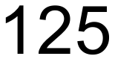 m in 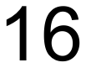 seconds. Express this rate in
(i) metres per second.
(ii) kilometres per hour.

b) An active ingredient is included in a children’s medicine at a concentration of . The dosage for a baby (3-6 months) is and the dosage for a child (9-12 years of age) is .
- How much of the active ingredient would a baby receive?
- How much of the active ingredient would a child receive?
- A physician has calculated that a toddler would need to receive 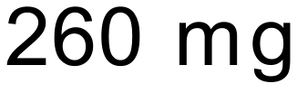 of the active ingredient to be effective. What dosage (to the nearest mL) would the physician need to prescribe for the toddler?

c) A car travels at 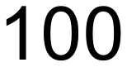 km/h for 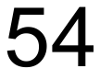 km and then changes its speed to 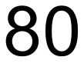 km/h for the next kilometres. What is the average speed for the whole journey?

Solution:
a) i) 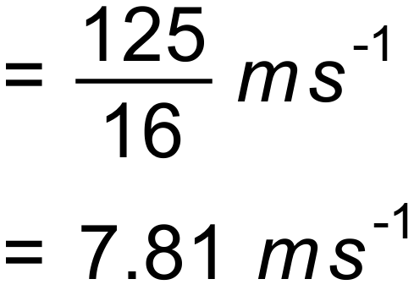

ii) 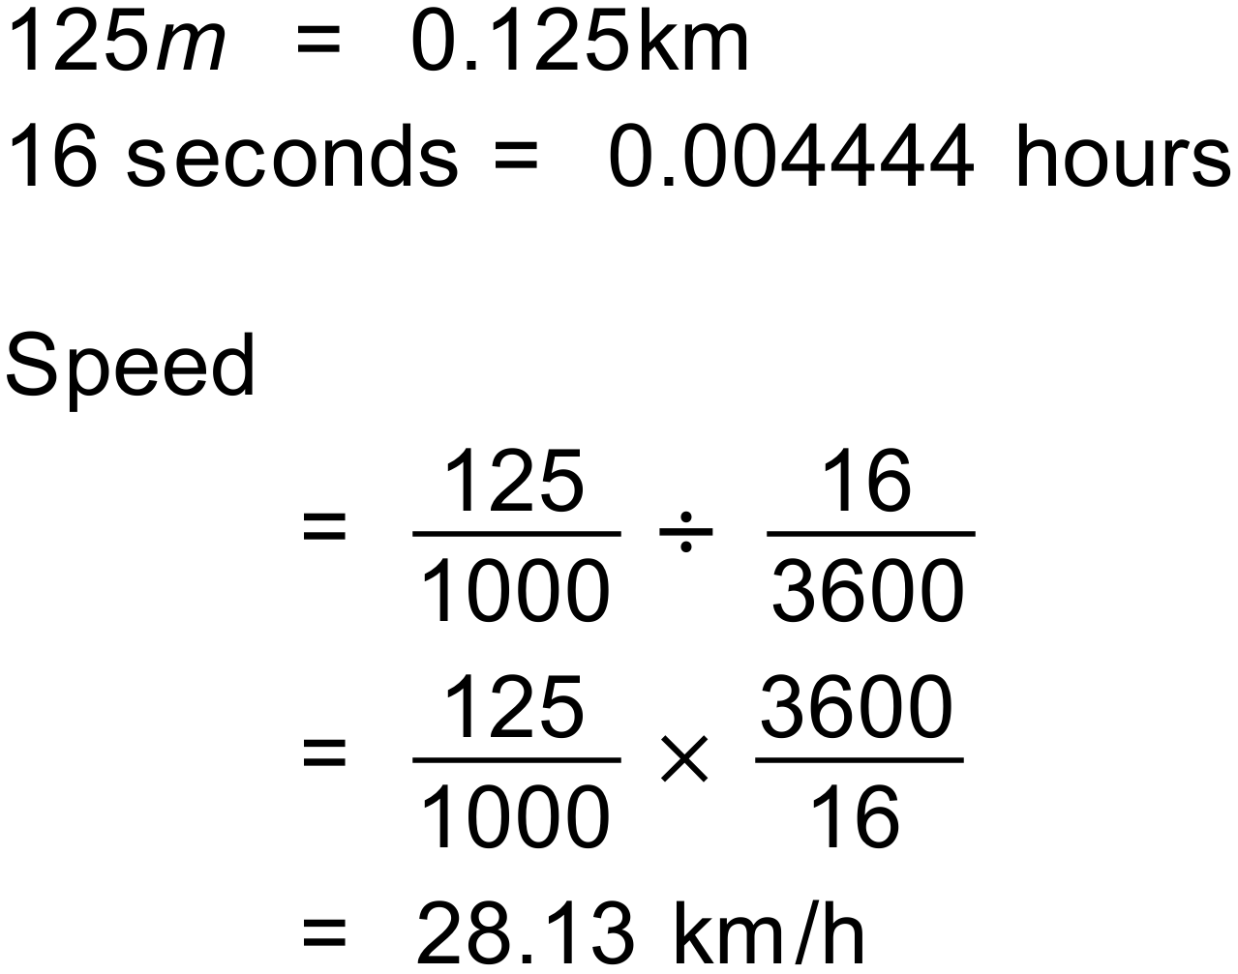

b) i) 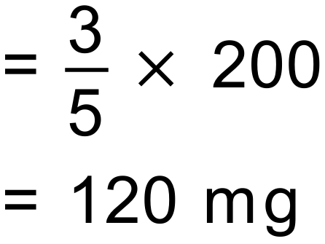
ii) 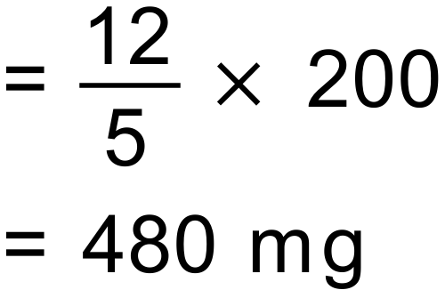
iii) 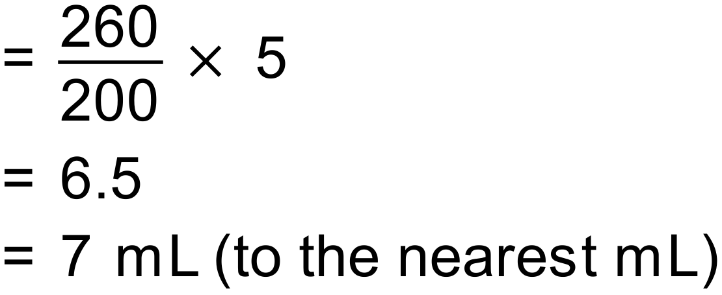

c) 