Summary:
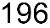 variations. Quotient Rule. Using first and second derivatives to describe the shape of a graph.

Question:
For the function 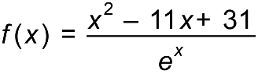,
- Show that the first derivative is 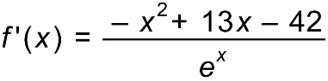.

- Use your results from part a) to show that the function has a stationary point at 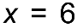

- A sketch graph of the function has shown that it has two stationary points. Use your previous answers to find the x value of the other stationary point.

It can be shown that the second derivative of the function is 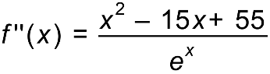.
- Use the second derivative to describe the type of stationary points at and the second stationary point from part c).

Solution:
- 

 