Summary:
16 variations. Quotient Rule.

Question:
For the function 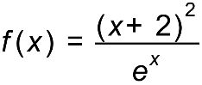, show that the first derivative is 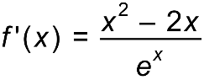.

Solution:
