Summary:
. Probability. False positives, false negatives. .

Question:
A fast, new saliva test has been developed that can detect whether a person has COVID 19. The test, however, is not perfect: only 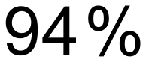 of people with COVID 19 are detected by the test and 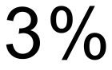 of people without COVID 19 will be falsely detected. It is believed that of the target group has COVID 19.
- What is the probability that a person tested at random will receive a positive test?
- What proportion of the people who receive a positive test are actually infected with COVID 19?
The most dangerous results are false negatives, where someone who has COVID 19 is not detected by the test.
- If 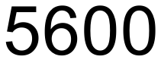 people from the target group are tested, how many people infected with COVID 19 should we expect to be missed.

Solution:
- 

 