Summary:
. Probability. Tree diagram, without replacement.

Question:
A box contains 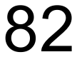 socks. There are green socks and blue socks in the box. Two socks are drawn at random, without replacement.
- Complete this tree diagram.

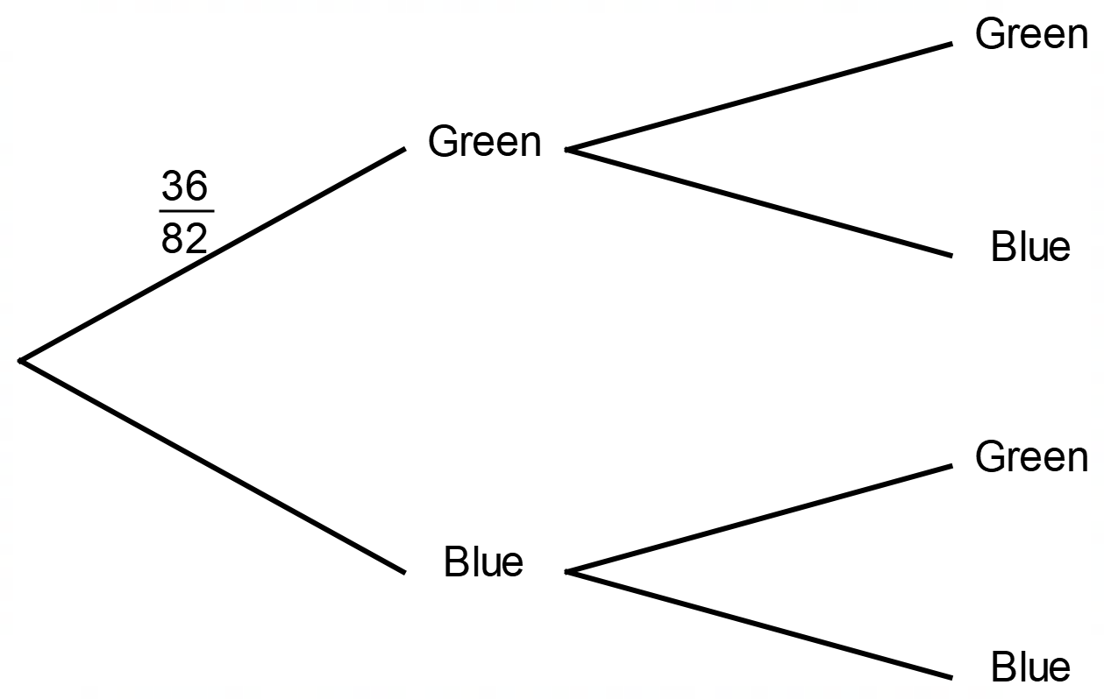

- Use your completed tree diagram to calculate the probability that the two socks drawn from the box will be the same colour.

Solution:


 