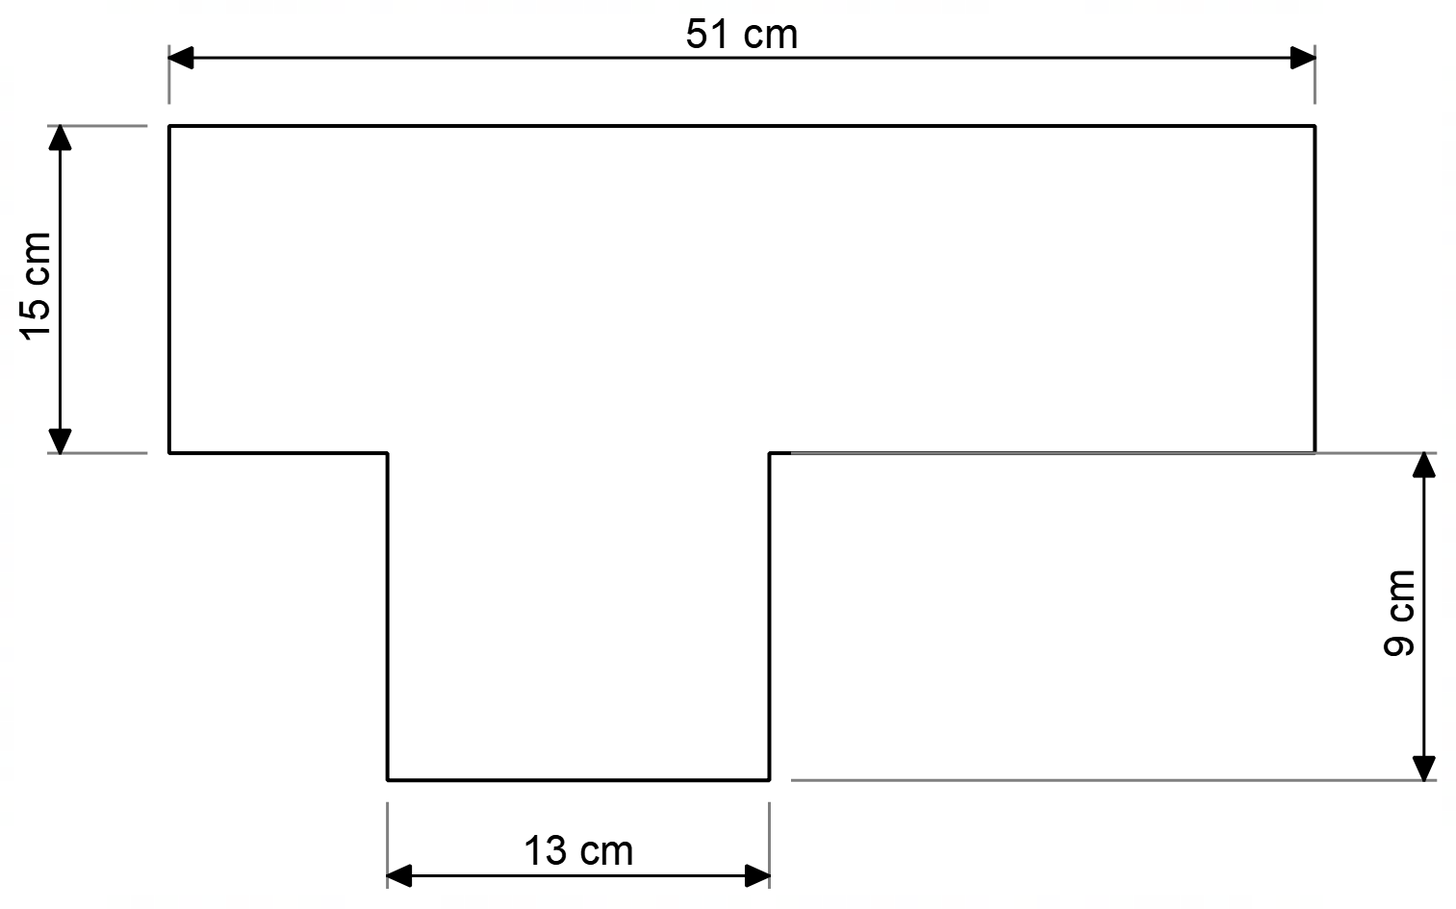
Summary:
14000 variations. Multichoice. Perimeter

Question:
What is the perimeter of this shape?

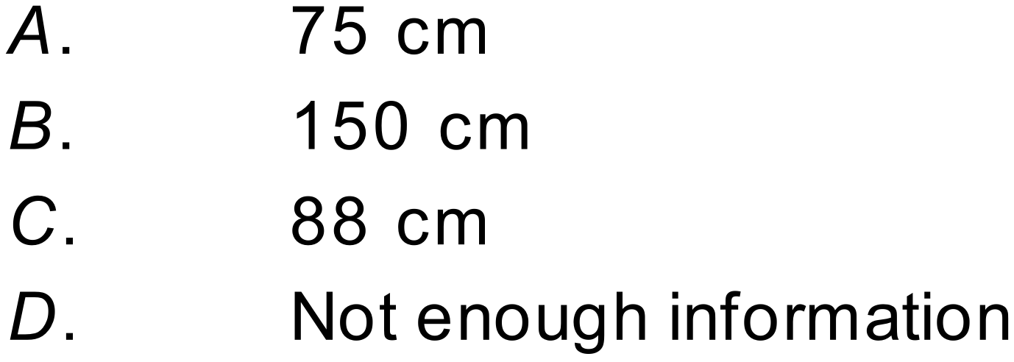

Solution:
