Summary:
1 variations. Minimum spanning tree from table.
Question:
A company decides to network its computers. The computer terminals; A, B, C, D, E, F, G, H, I and J are located on one floor and need to be connected to each other.

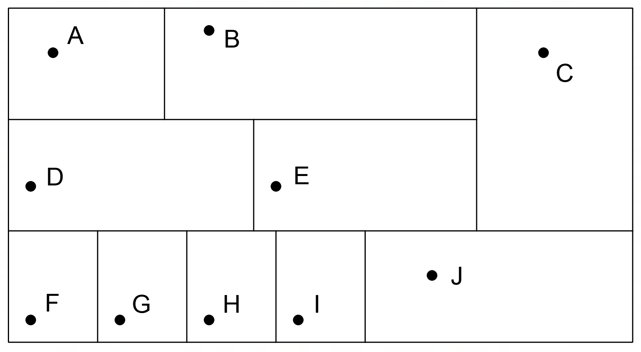

The following table gives the distances (in metres) of feasible connections between the terminals.

 | A | B | C | D | E | F | G | H | I | J
A | - | 7 | 11 | 5 | 8 | 6 | - | - | - | 22
B | 7 | - | 7 | 9 | 5 | - | 12 | 13 | - | -
C | 11 | 7 | - | 25 | 18 | - | - | - | - | 9
D | 5 | 9 | 25 | - | 12 | 9 | 6 | 12 | 15 | 14
E | 8 | 5 | 18 | 12 | - | - | 9 | 8 | 8 | 12
F | 6 | - | - | 9 | - | - | 10 | - | - | -
G | - | 12 | - | 6 | 9 | 10 | - | 9 | 9 | -
H | - | 13 | - | 12 | 8 | - | 9 | - | 4 | 12
I | - | - | - | 15 | 8 | - | 9 | 4 | - | 10
J | 22 | - | 9 | 14 | 12 | - | - | 12 | 10 | -

Cable used in the connections costs $15.50 per metre.

- On the diagram, show the links that must be used to link the terminals together in the least costly way.
- What is the minimum cost to link the computers?
- When installing the new network, the installers discovered that the 9m link between C and J could not be used. What effect will this have on the minimum cost to link the computers?

[6,2,2 = 7 Marks]

Solution:

 | A | B | C | D | E | F | G | H | I | J
A | - | 7 | 11 | 5 | 8 | 6 | - | - | - | 22
B | 7 | - | 7 | 9 | 5 | - | 12 | 13 | - | -
C | 11 | 7 | - | 25 | 18 | - | - | - | - | 9
D | 5 | 9 | 25 | - | 12 | 9 | 6 | 12 | 15 | 14
E | 8 | 5 | 18 | 12 | - | - | 9 | 8 | 8 | 12
F | 6 | - | - | 9 | - | - | 10 | - | - | -
G | - | 12 | - | 6 | 9 | 10 | - | 9 | 9 | -
H | - | 13 | - | 12 | 8 | - | 9 | - | 4 | 12
I | - | - | - | 15 | 8 | - | 9 | 4 | - | 10
J | 22 | - | 9 | 14 | 12 | - | - | 12 | 10 | -

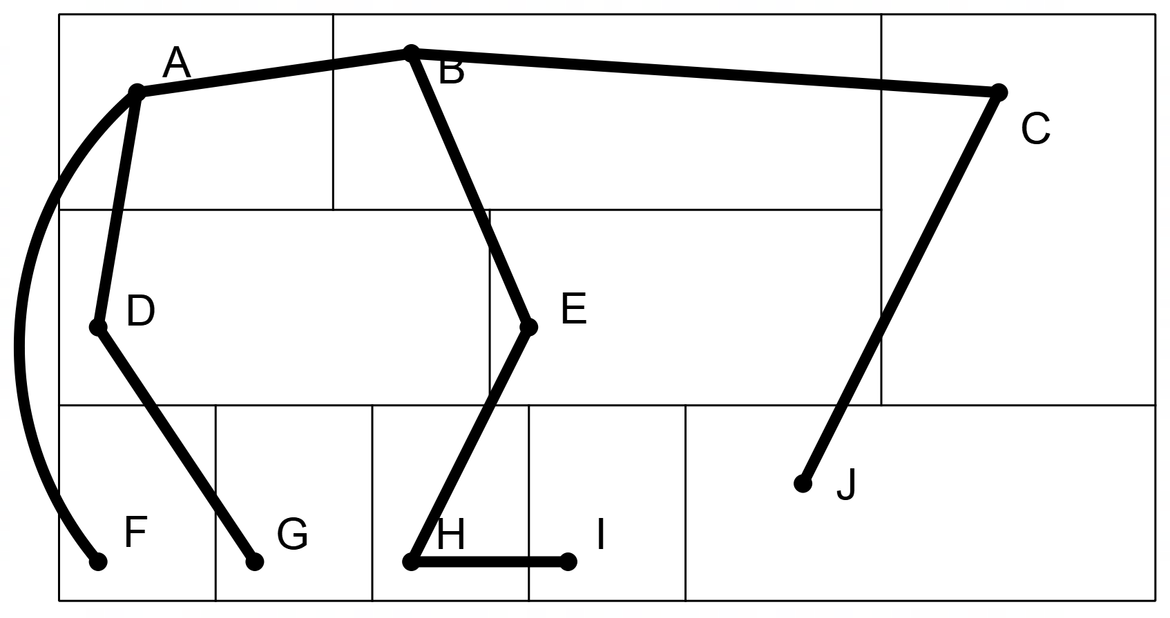

- As the 9m link between C and J cannot be used, the installers must use the next shortest link to J which is from I. The link is 1m longer so adds $15.50 to the cost of the installation.

