Summary:
1 variation. Minimum spanning tree.

Question:
Which of these options is the minimum spanning tree?

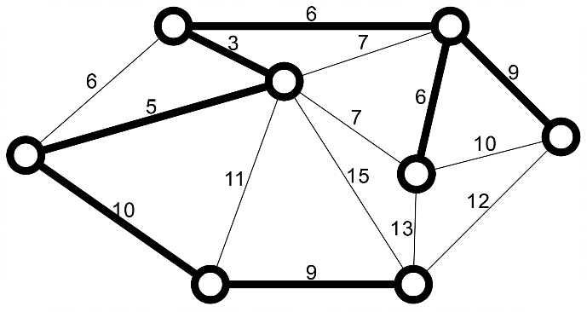
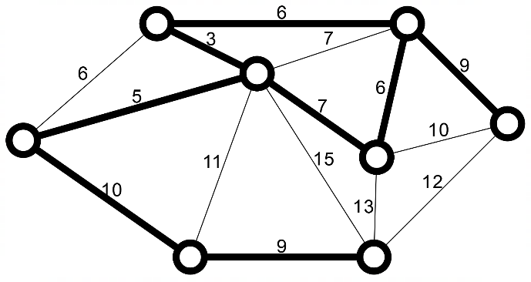
a) b)

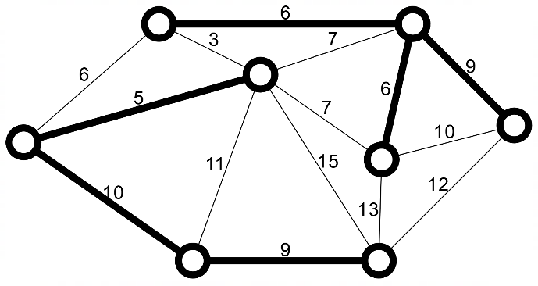
c) d)
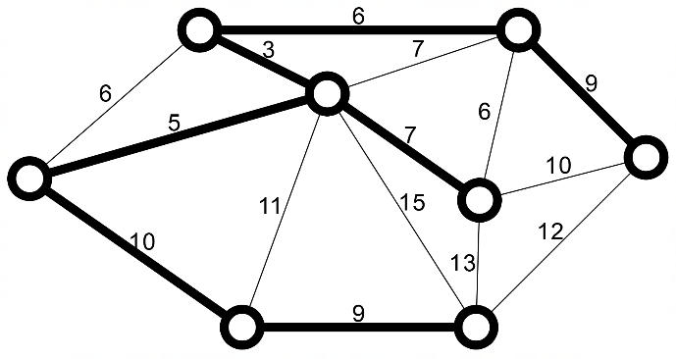

[1 Mark]

Solution:
B.

