Summary:
1 variation. Minimum Spanning Tree.

Question: 1 Variation
This network shows the cost of laying water pipes (in millions of dollars) between twelve country towns. The water supply authority wants to link the towns into a pipe network at the lowest possible cost.

- Find the minimum spanning tree of the pipe network. Show your answer on the network below.
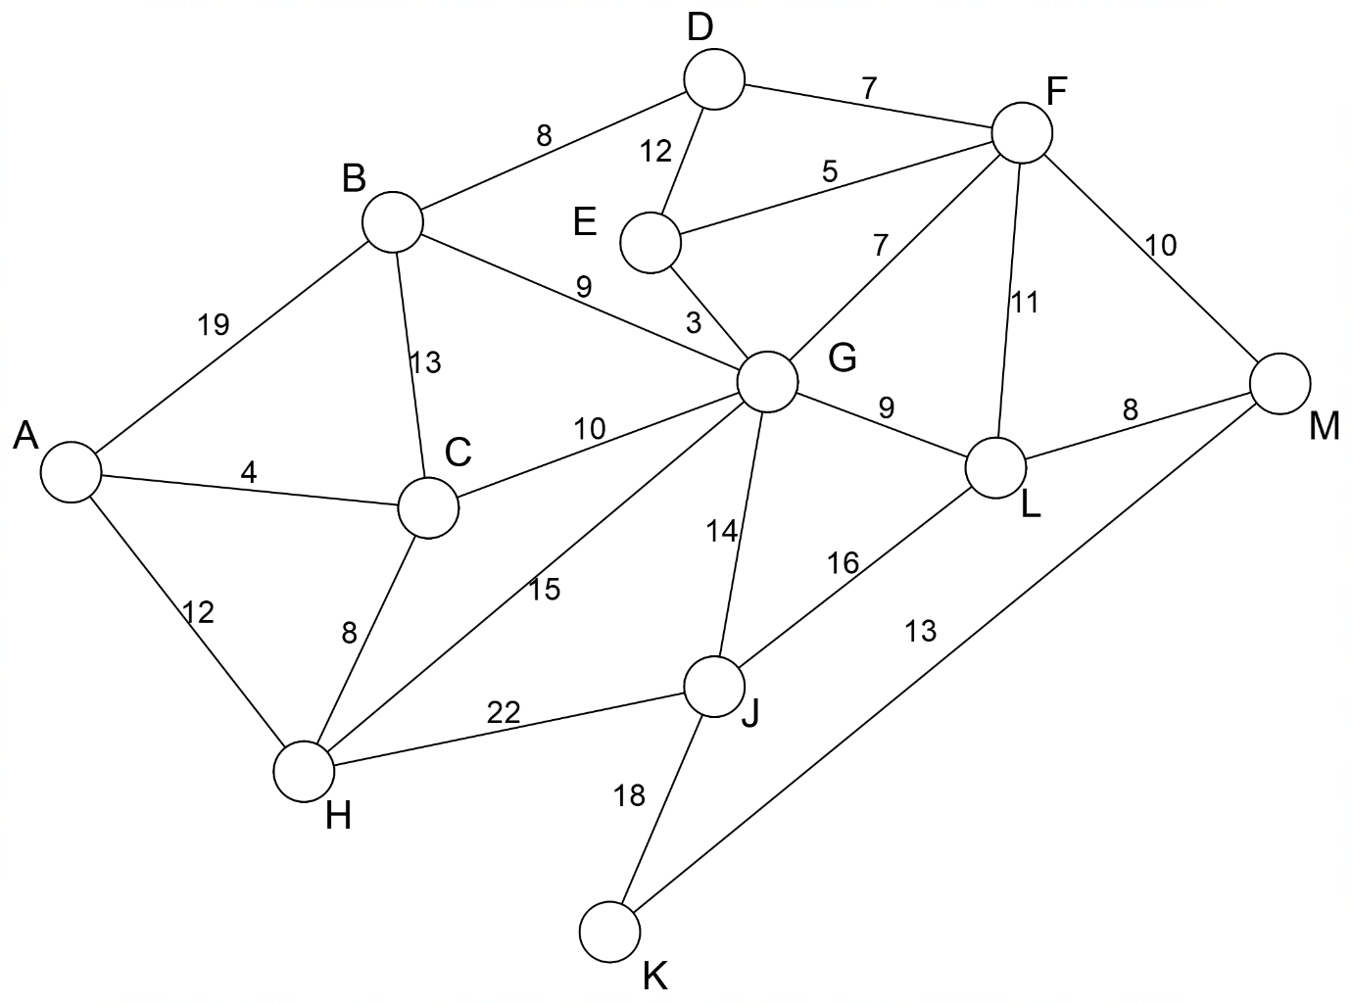
- What is the minimum cost of building the network? (Don’t forget that the prices are in millions of dollars).
- The water authority calculates that it does not have sufficient funds to link all of the towns into the network and has to remove one town from the network. Which town should they remove from the network and how much would this save?

[4,1,2 = 7 Marks]

Solution:
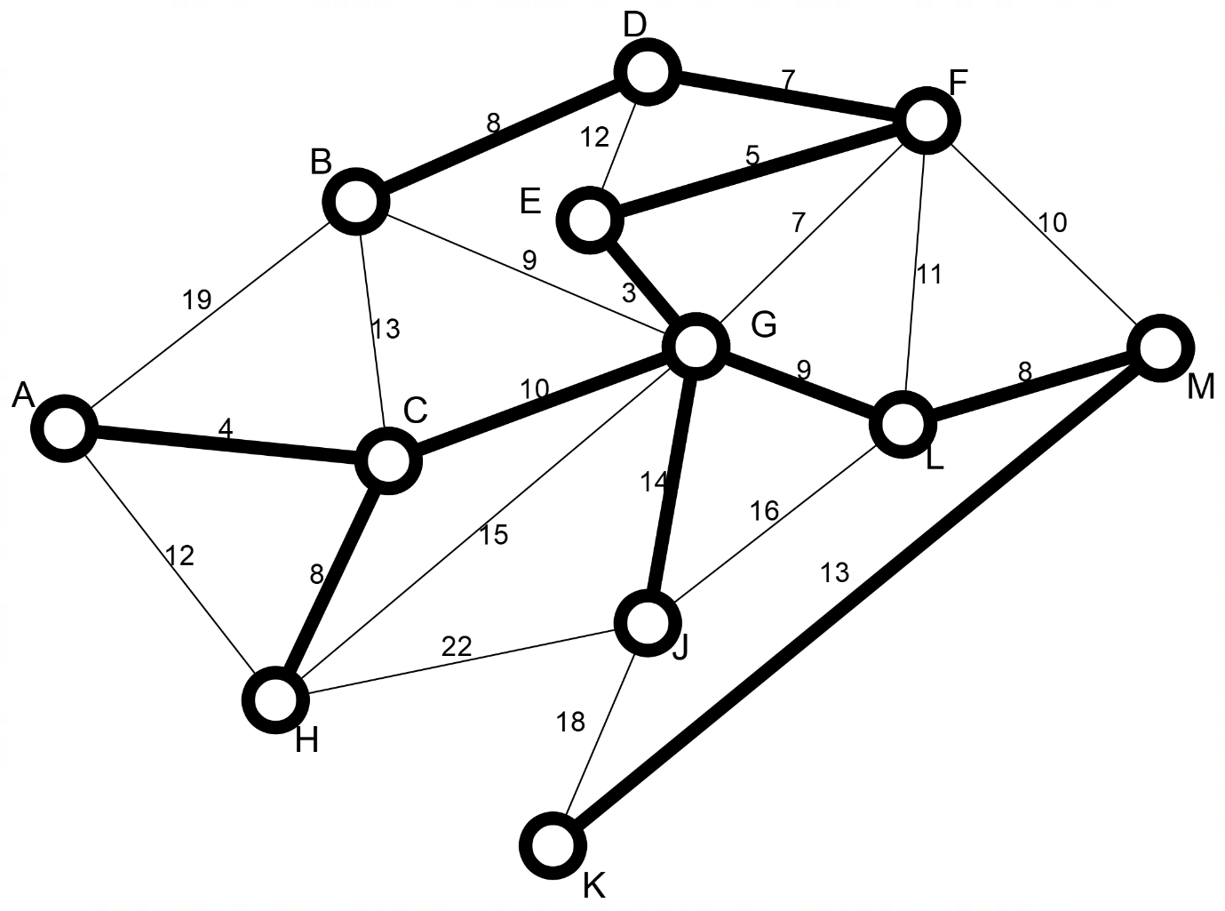

a)
Deduct one mark for every incorrect arc marked.

b) The minimum cost is 89 million dollars
c) They should remove town J from the network for a saving of 14 million dollars.

