Summary:
36000 variations. Perimeter. Arc length. Area. Surface area.

Question: 36000 Variations
a) Calculate the perimeter and area of the following shape.
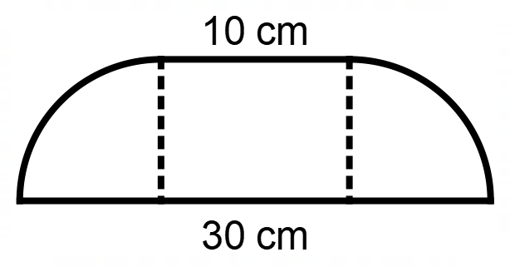

b) Find the surface area of the following solid.

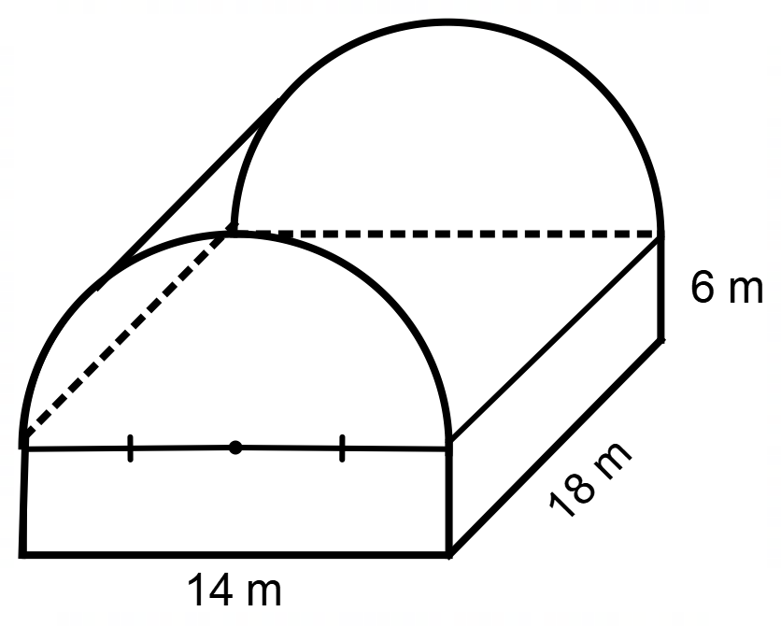

Solution:
a)
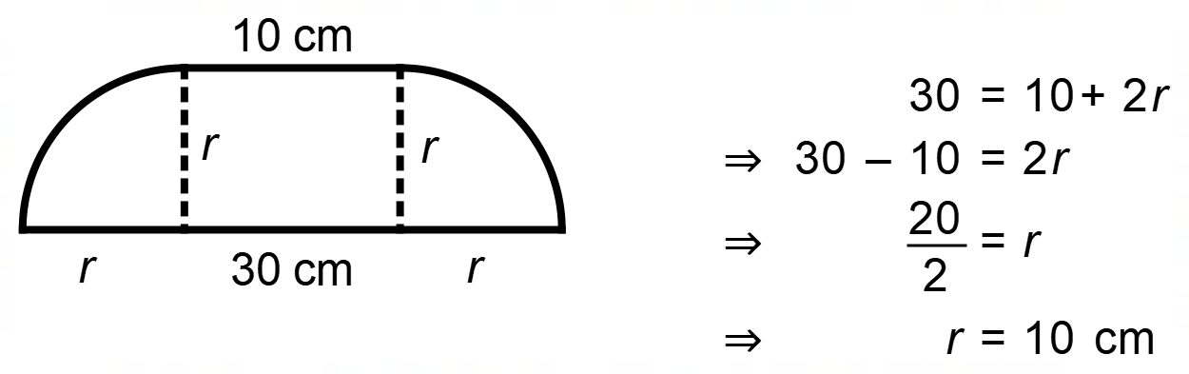
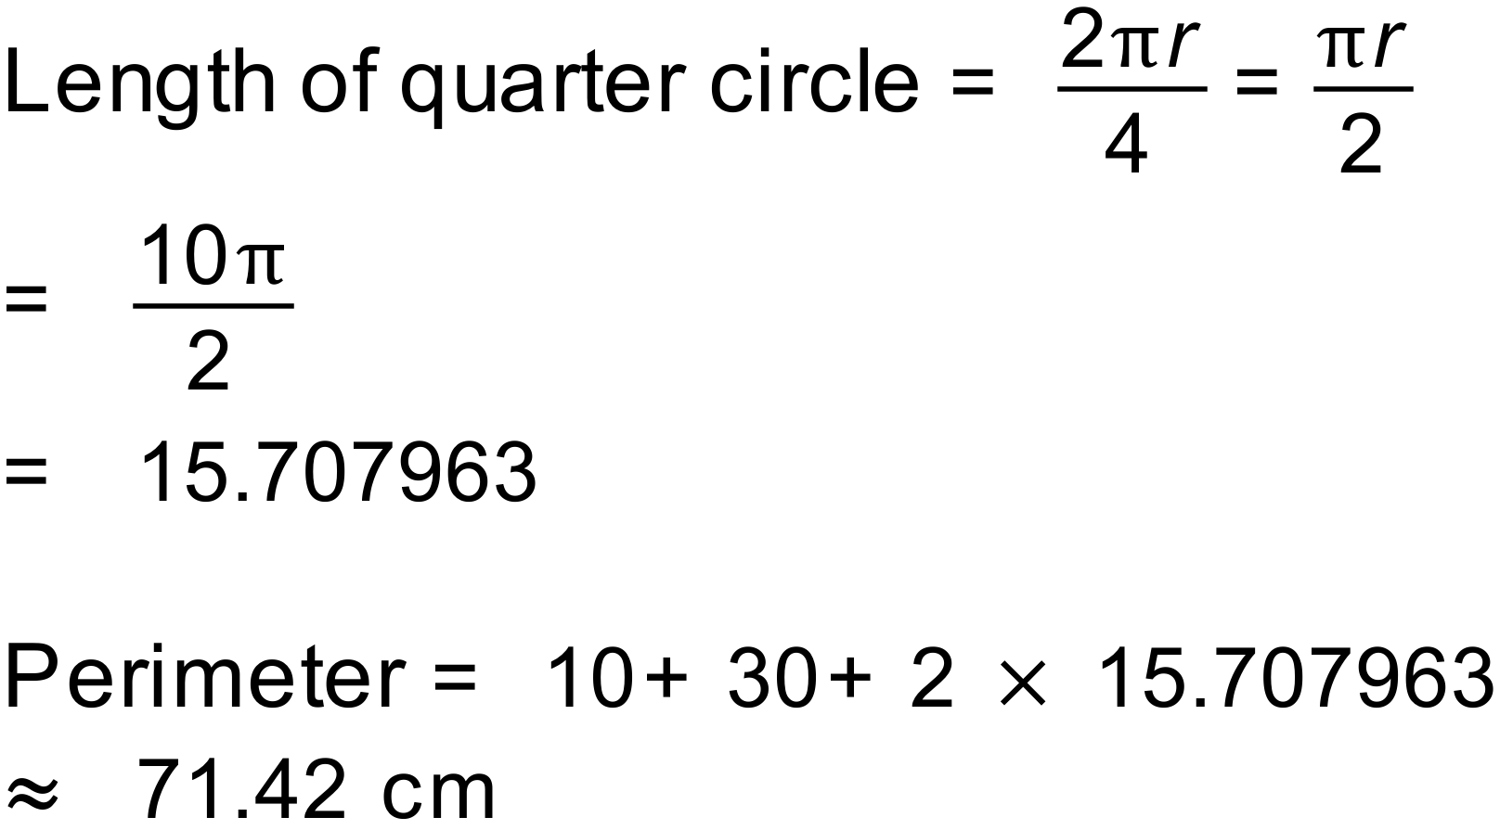

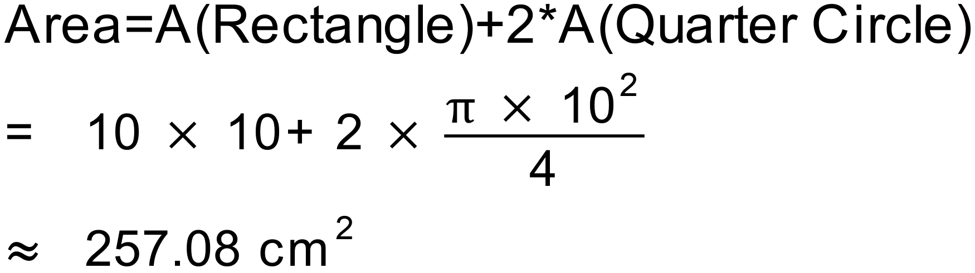

b)
