Summary:
108 variations. Log laws. Transformational graphing

Question:
- Simplify the following expression

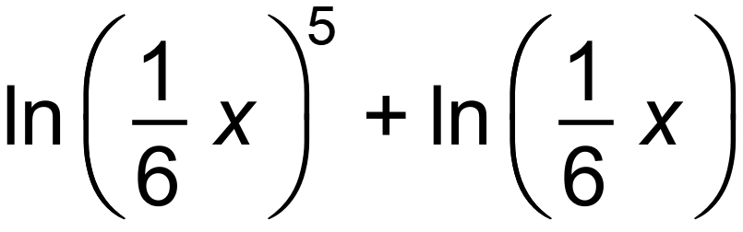
Write your answer in the form a ln bx where a and b are real numbers.
- The graph of the function 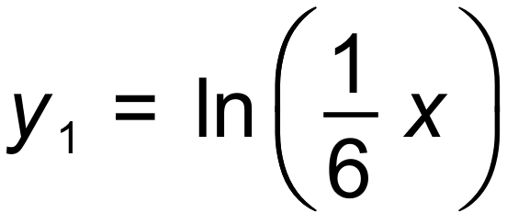 is shown below.
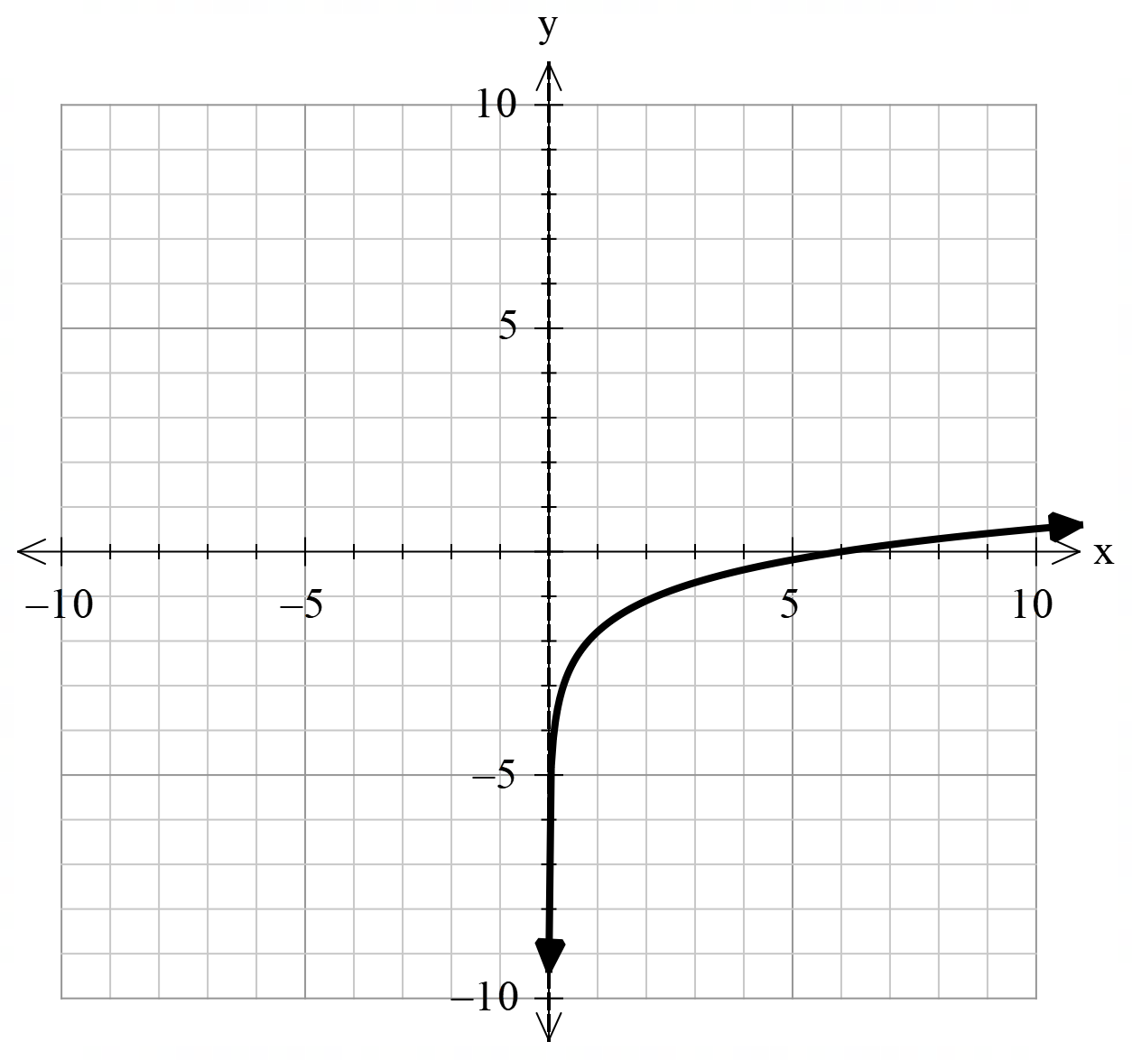

On the axes above, sketch the graph of the function 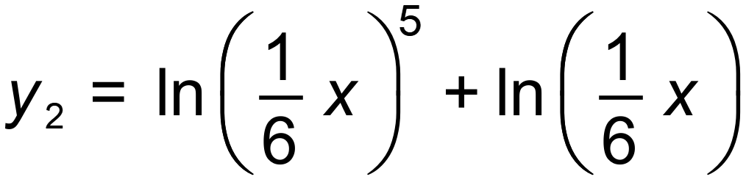

- Describe the relationship between the graphs of the functions and

Solution:
- 