Summary:
60 variations. Linear Patterns.

Question:
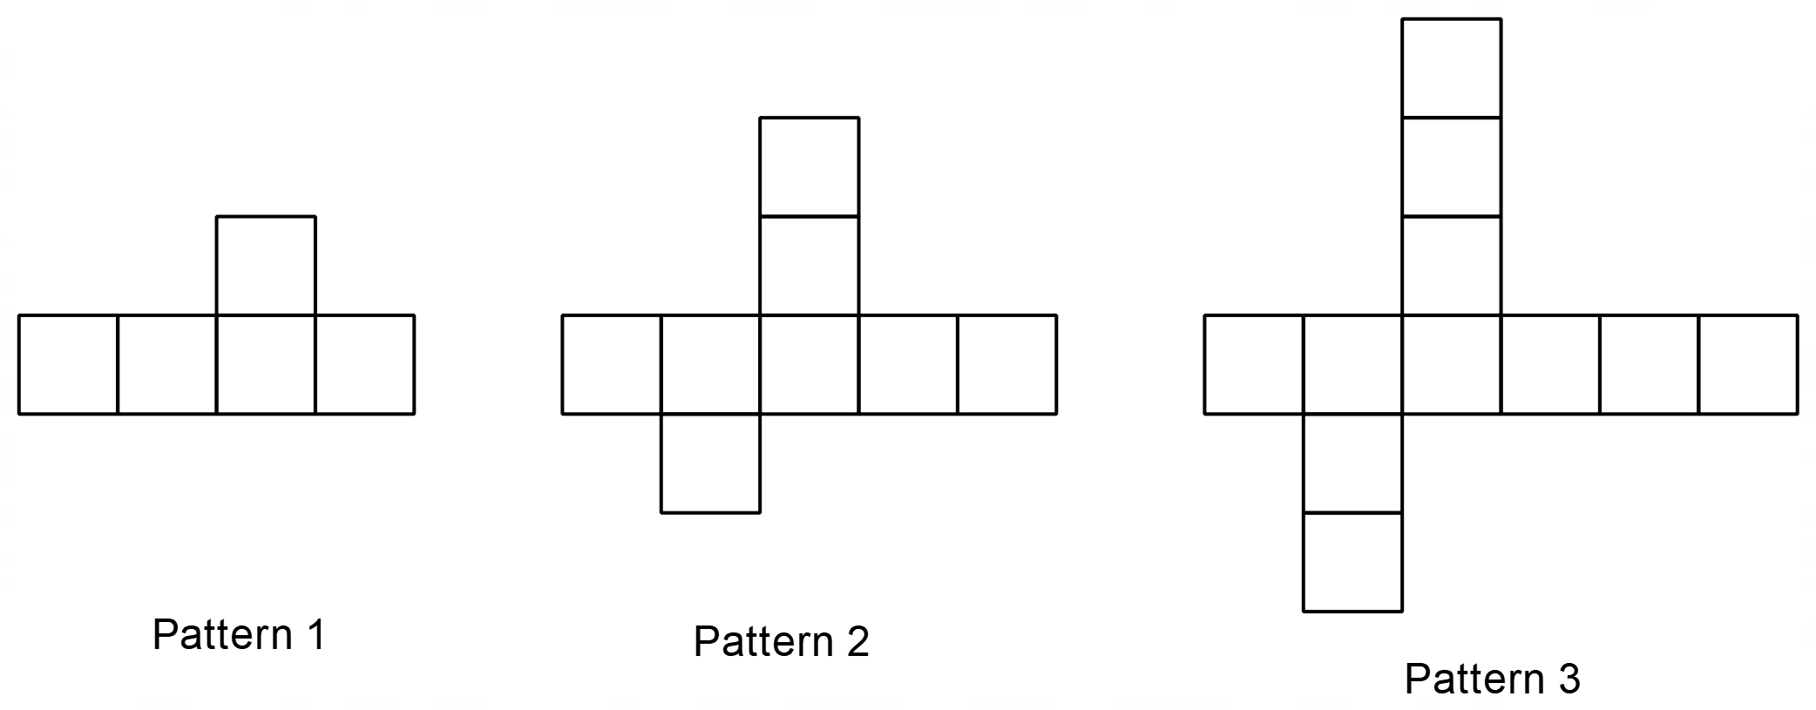a) Complete the table of values
Pattern Number (n) | 1 | 2 | 3 | 4 | 5
Total Number of Squares (s) | 5 | 8

b) Explain why the relationship between (n) and (s) is linear.

c) Write an algebraic rule for finding the total number of squares (s) from any given pattern number (n).

d) Use your rule to find the total number of squares (s) for pattern number .

e) Use your rule to find the pattern number (n) if squares are used.
[2,1,2,2,2 = 9 Marks]

Solution:
a)
Pattern Number (n) | 1 | 2 | 3 | 4 | 5
Total Number of Squares (s) | 5 | 8 | 11 | 14 | 17
b) The first difference is constant.
c) 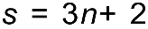
d) 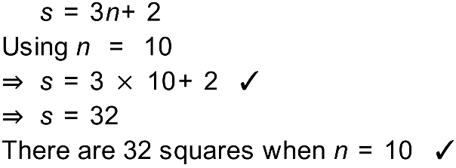
e) 