Summary:
3000 variations. Linear functions.

Question: 3000 Variations
The initial temperature of a kiln (oven for baking pottery) is 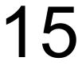°C. Every hour for 8 hours it increases by 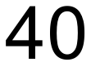°C.
a) Construct a table of values that shows the temperature over the 8 hours.

b) Plot an appropriate graph for your table of values.
c) Write a rule that connects time in hours (h) to the temperature of the kiln (T).

d) What is the temperature when time is hours and mins? Use your rule.

e) Use your equation in (c) to calculate the time, to the nearest minute, taken for the temperature to reach 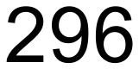°C.

Solution:
a)
h | 0 | 1 | 2 | 3 | 4 | 5 | 6 | 7 | 8
T |  | 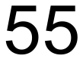 | 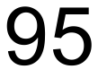 | 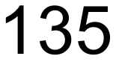 | 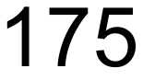 | 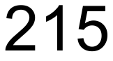 | 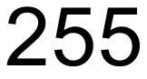 | 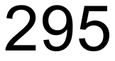 | 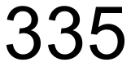

b)
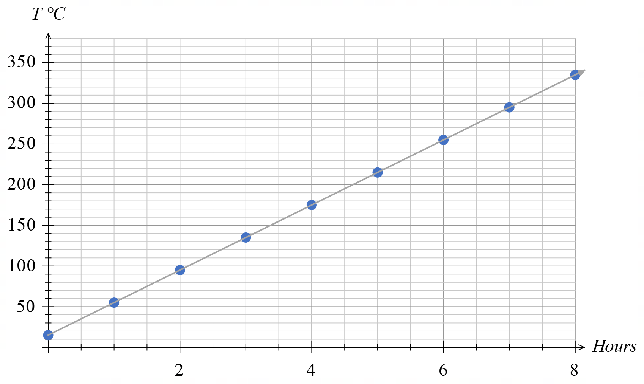
c)

d) 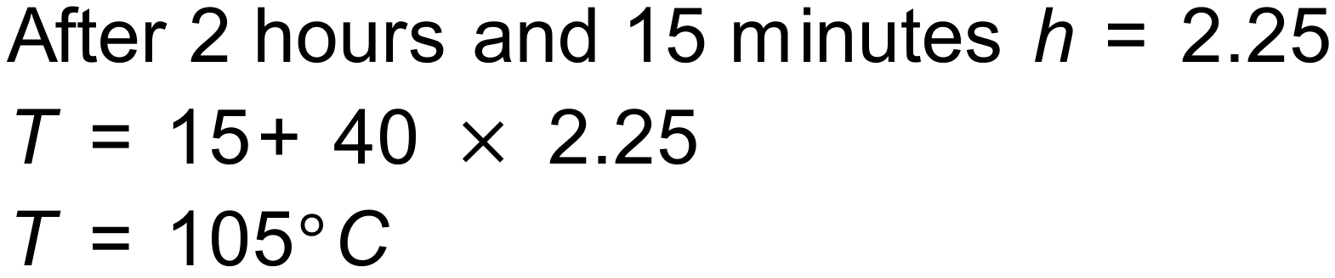

e) 