Summary:
100000+ variations. Graphing quadratics. Turning point. Line of symmetry. Transformations of quadratics.

Question: >100 000 Variations
- Complete the following table by matching each graph (A, B, C, D, E, F) with an equation below. Some graphs may not be matched.
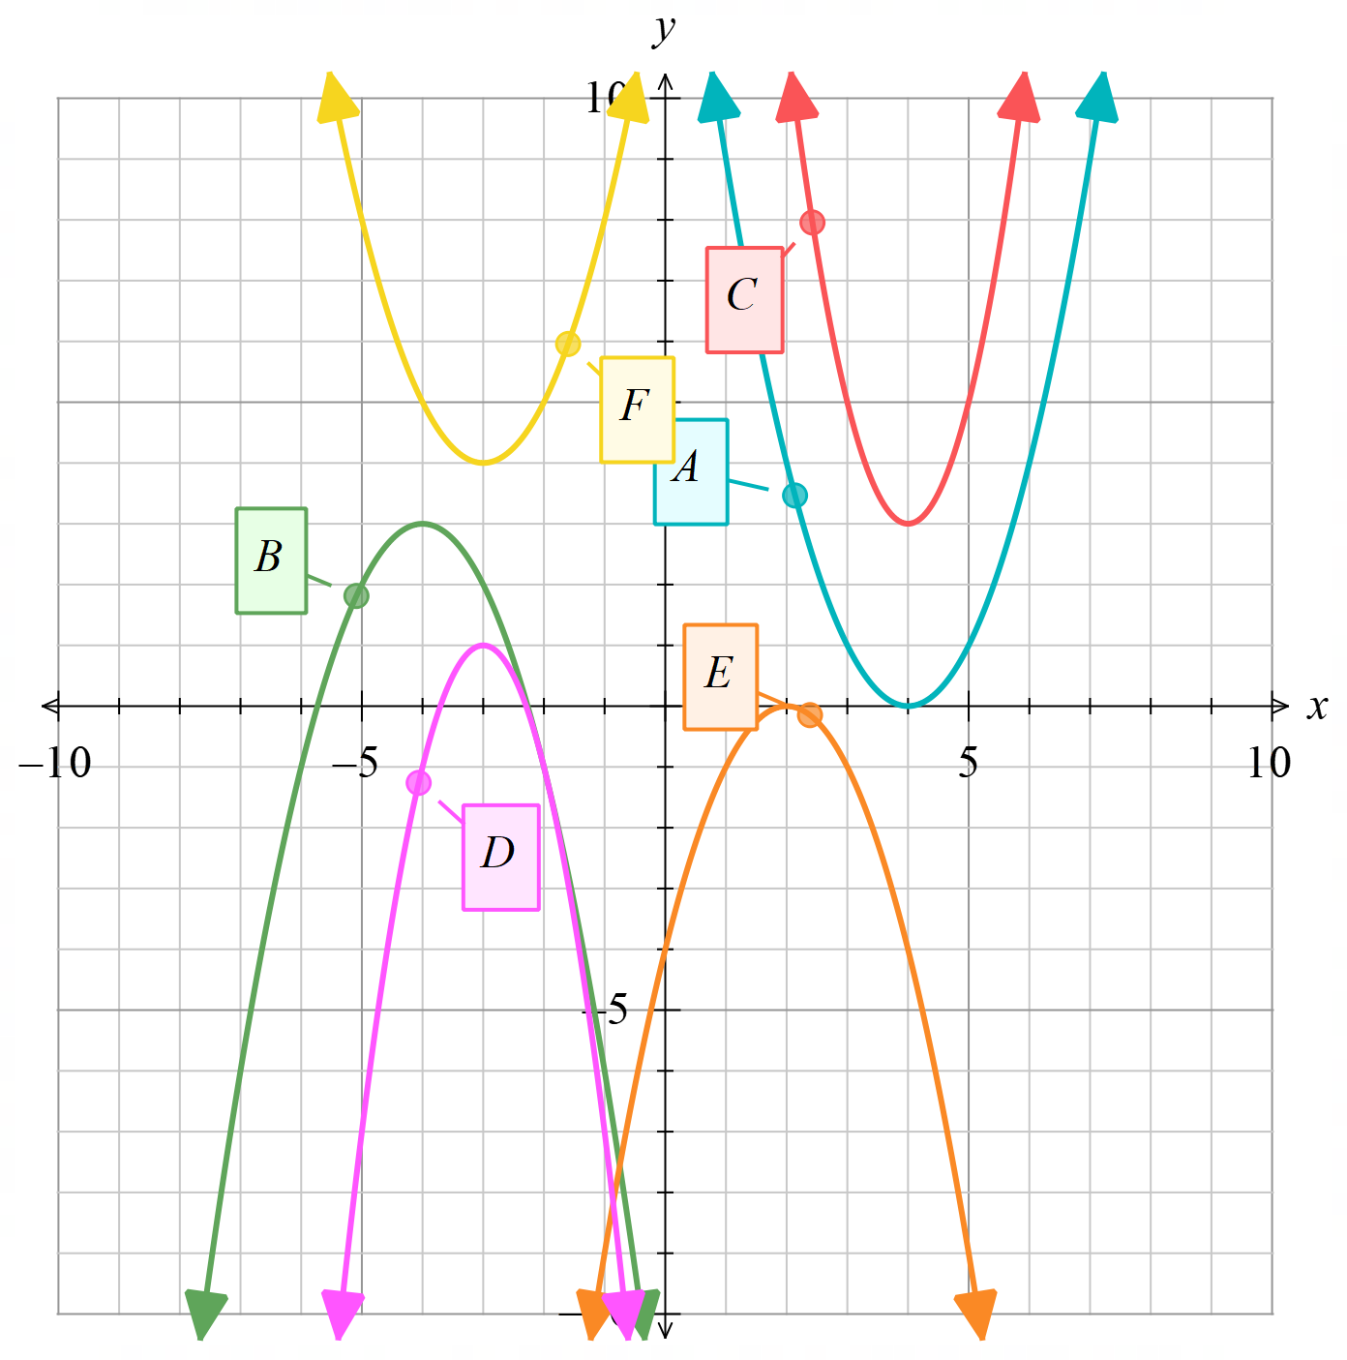

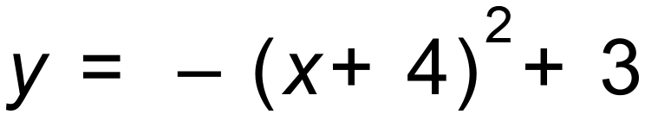 |  | 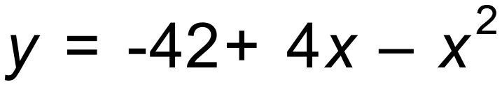 | 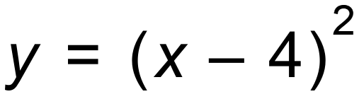

b) The graph of y = x² is translated 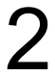 units to the right and units down. What is the equation of the new parabola?

[2]

c) (i) The graph of 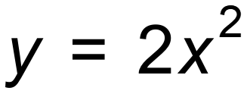is reflected about the x- axis, then translated units left and units up. What is the equation of the new parabola?

[4]
(ii) What is the turning point, y intercept and equation of line of symmetry of the new curve?

Solution:
a)
B | D | E | A

b)

c) 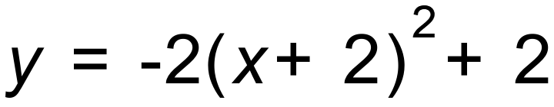

d) 