Summary:
768 variations. Linear functions, gradient, x and y intercepts.

Question:
Consider the equation of the line 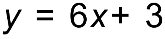

Clearly show your method of finding the coordinates of the:

a) x intercept b) y intercept

Consider the equation of the line 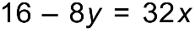

c) Re-arrange this equation into the form 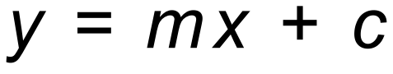 and state the gradient.

[3,2,3 = 8 Marks]

Solution:
a) The x intercept is when y = 0.
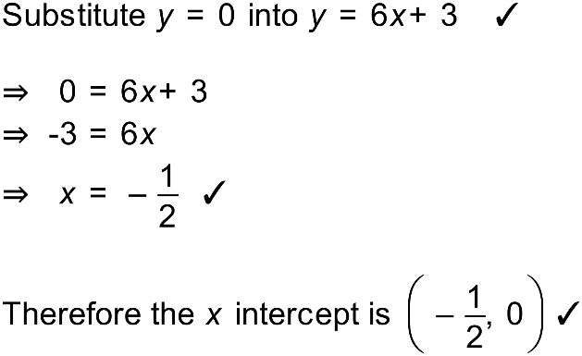

b) The y intercept is when x = 0.
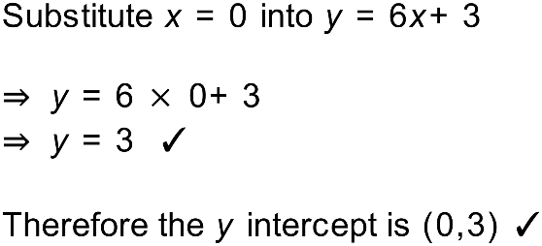

c) 