Summary:
4608 variations. Linear Functions - gradients.

Question:
Match each of the graphs shown (A, B and C) with its equation from the list in the table.
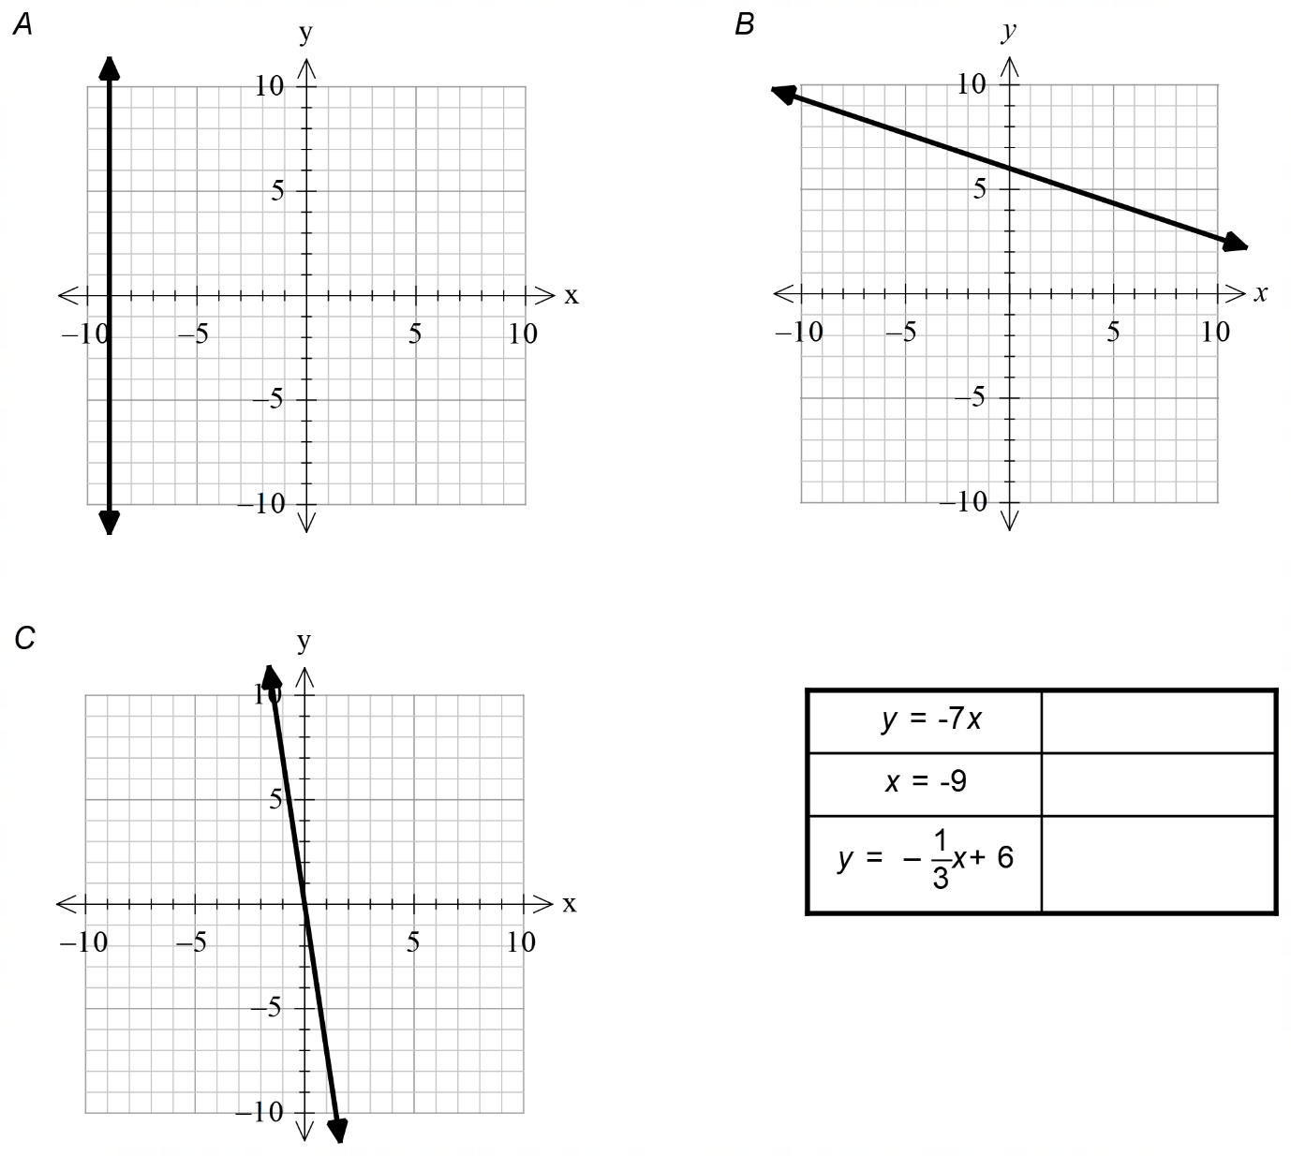
[2 Marks]

Solution:
