Summary:
100000+ variations. Angle sum of quadrilateral. Central angle theorem. Coressponding angles.

Question:
Use algebra to find the value of each variable. Give reasons and show your working.

a)
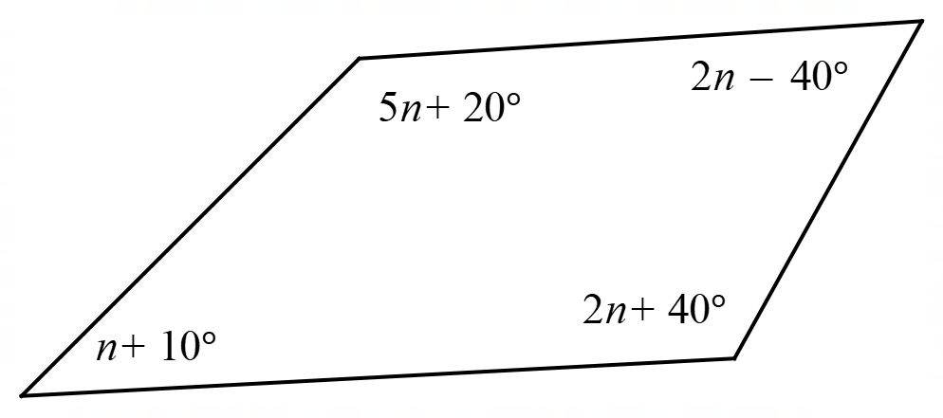

b)
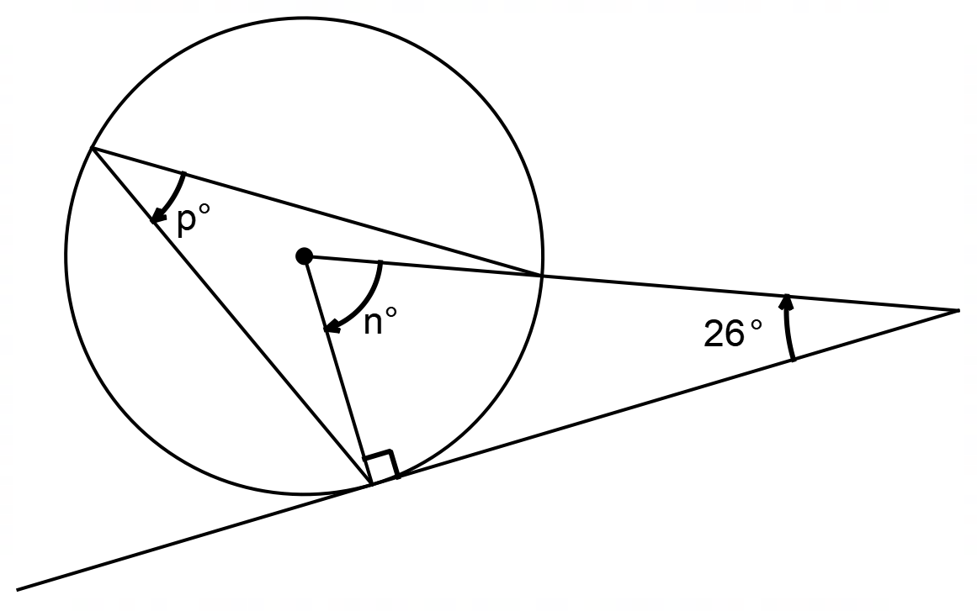
c)
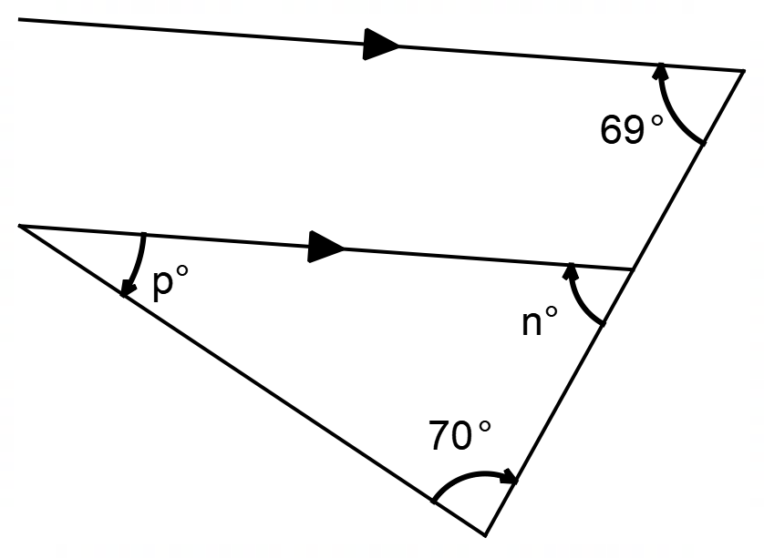

Solution:
- 

 