Summary:
100000+ variations. Formula manipulation.

Question: >100000 Variations
a) Complete each statement.
(i) If _____________
(ii) If ______________
(iii) Over the same distance, doubling the speed causes time to ________.
(iv) If the time of travel is constant then tripling the speed will _______ the distance.
b) Ryan travelled a distance of 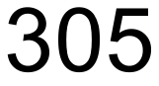 km at 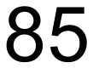 km/h. If he had taken the same amount of time, how far would he have travelled at km/h?
c) A gear having 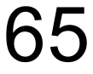 teeth drives another which has 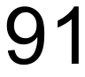 teeth. If the first gear makes 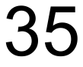 revolutions, how many revolutions does the second gear make?

Solution:
a) Complete each statement.
(i) If
(ii) If
(iii) Over the same distance, doubling the speed causes time to halve.
(iv) If the time of travel is constant then tripling the speed will triple the distance.

b) 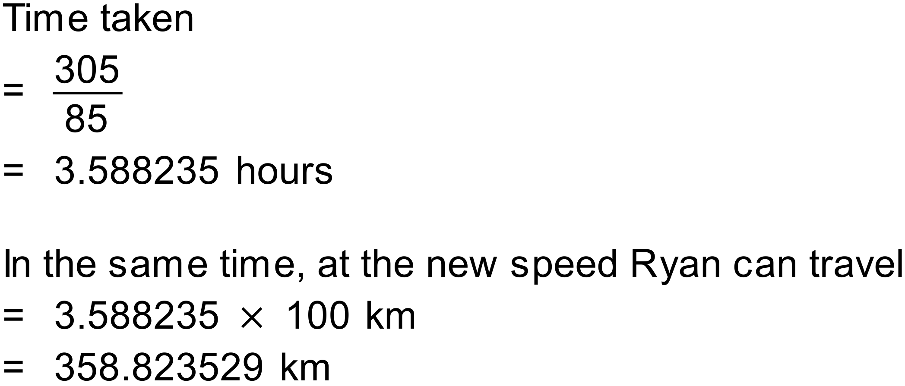

c) 