Summary:
320 variations. Using formulae.

Question:
Consider the formula 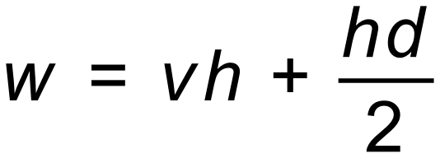
Solve for d given

[4 Marks]

Solution:
