Summary:
1000+ variations. Formula manipulations.

Question: >1000 Variations
a) If 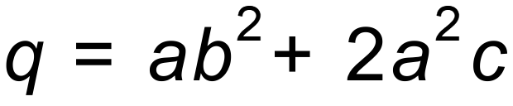 find q if , and .
b) If find u if , and .
c) Make b the subject of this formula.
d) Make r the subject of this formula. 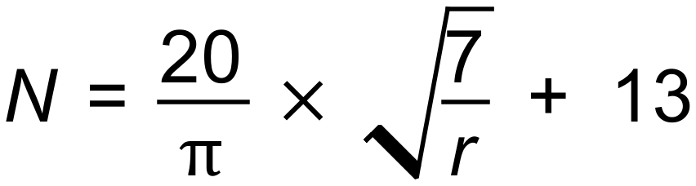

Solution:
a) 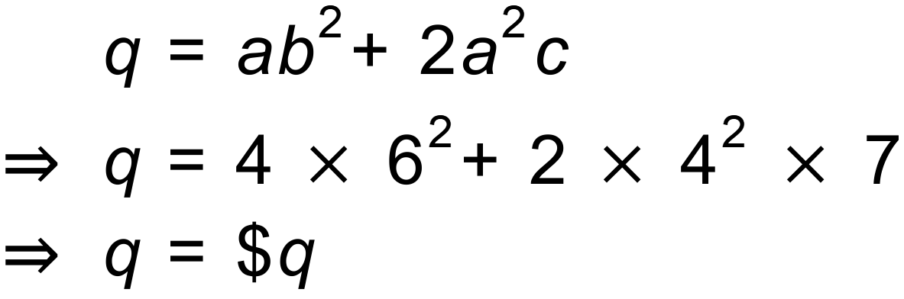

b) 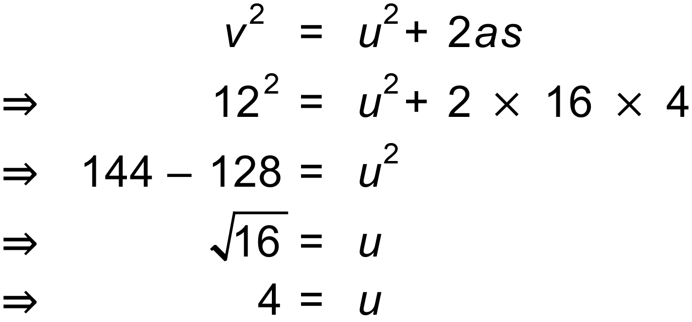

c) 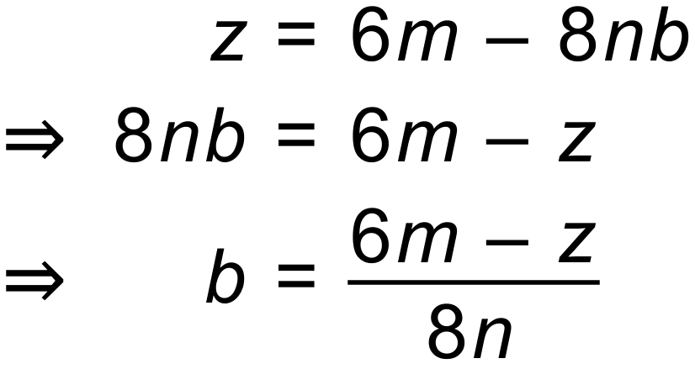

d) 