Summary:
100000+ variations. Factorising quadratics.

Question:
a) Solve by factorising:
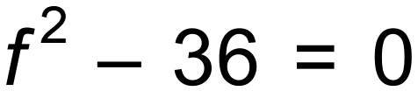
b) Solve by factorising
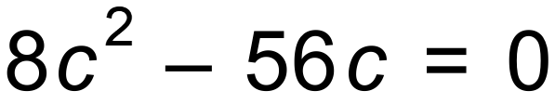
c) The length of a rectangular lot is metres more than its width. Let the width be w. Draw a diagram and label the length and width in terms of w.

Find the length and width of the rectangular lot if the area is 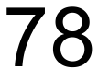m².

d) Solve by equating to 0 and factorising.

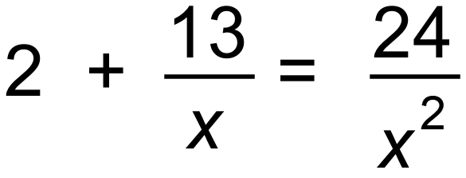

Solution:
a) 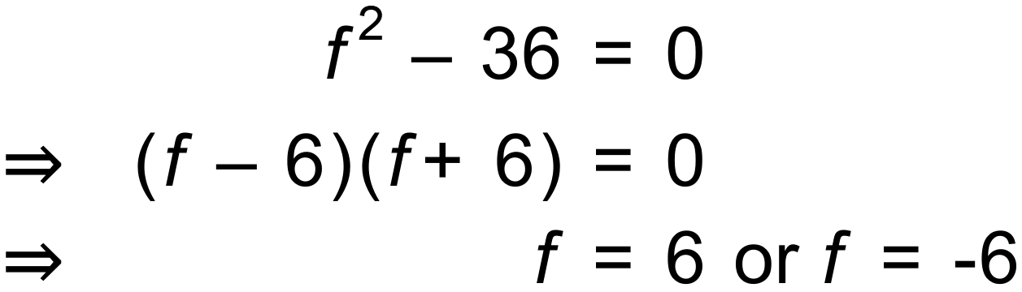

b) 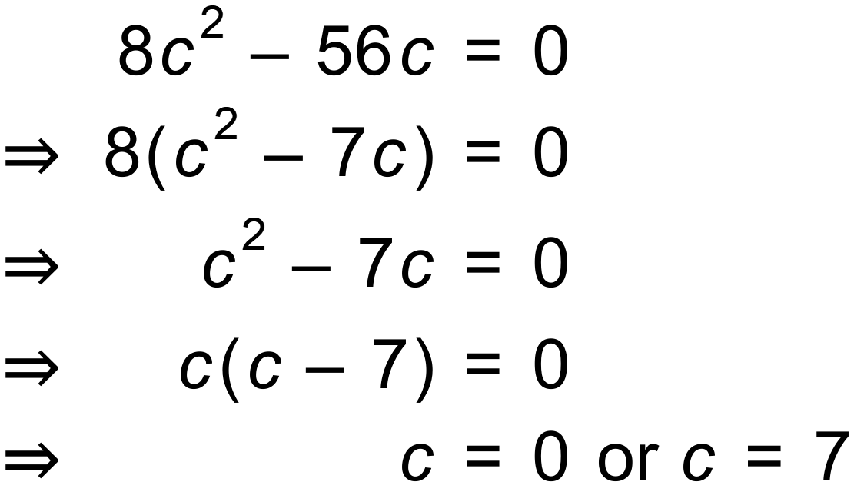

c)
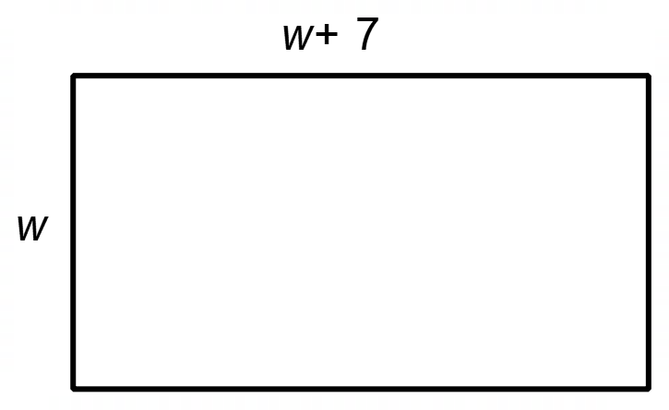
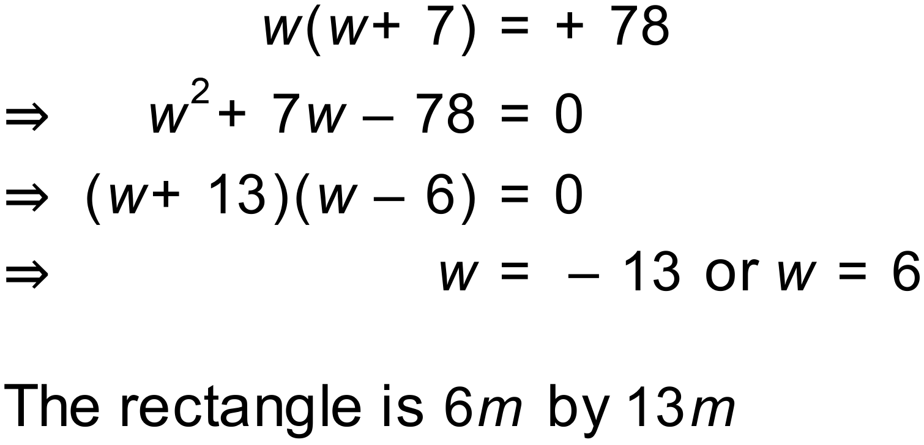

d) 