Summary:
+100000 variations. Expanding Brackets.

Question:
Expand the following brackets. Simplify where possible.
a) 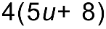 b) 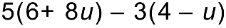

[5 Marks]

Solution:
a) 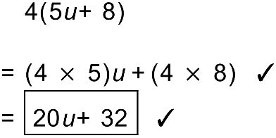 b) 