Summary:
>100 000 variations. Cumulative frequency of grouped data. Median and IQR

Question:
The test results of 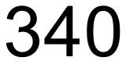 students were recorded. The table below shows the student’s grouped marks.
- Complete the table by calculating the cumulative frequencies.

Score (s) | 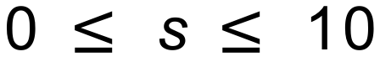 | 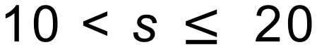 | 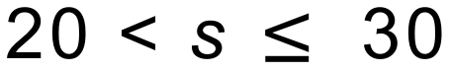 | 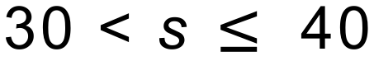 | 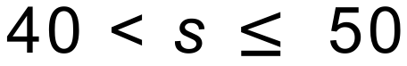 | 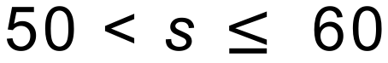
Frequency | 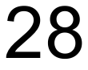 | 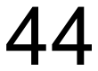 | 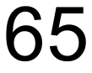 | 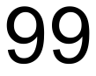 | 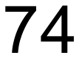 | 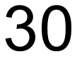
Cumulative Frequency

- On the following axes, draw a smooth cumulative frequency curve to illustrate this information.
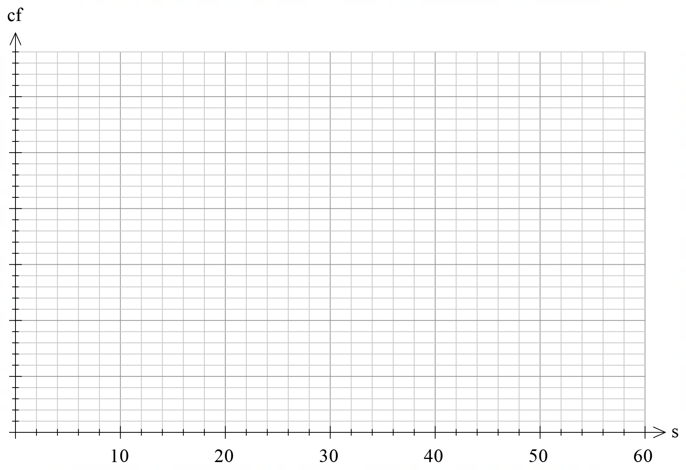
- Use your graph to find the lower and upper quartile scores.

- Find the interquartile range of the scores.

- Given that 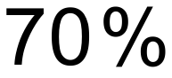 of the students passed the test, use your graph to estimate the pass mark.

Solution:

Score (s)
Frequency
Cumulative Frequency |  | 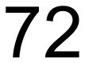 | 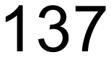 | 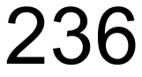 | 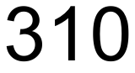

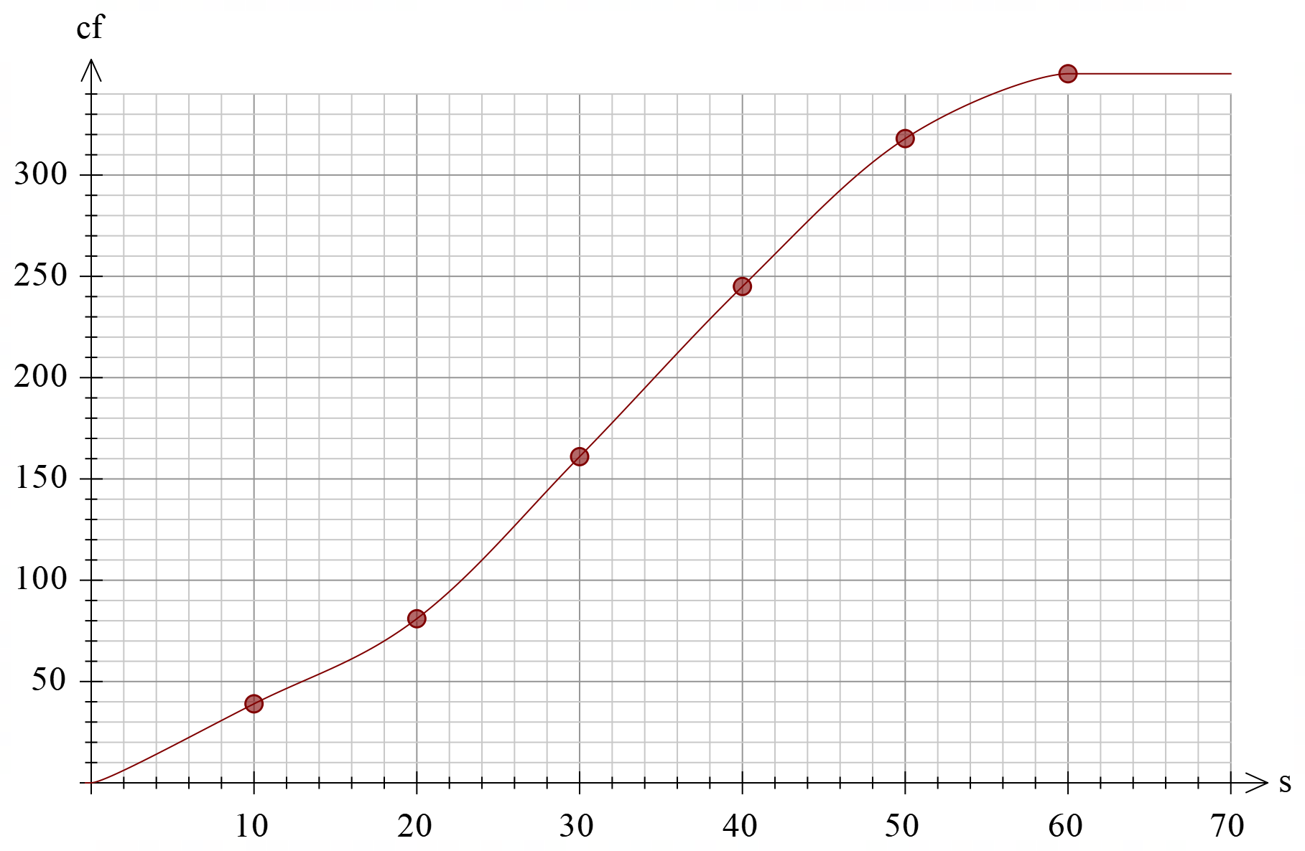

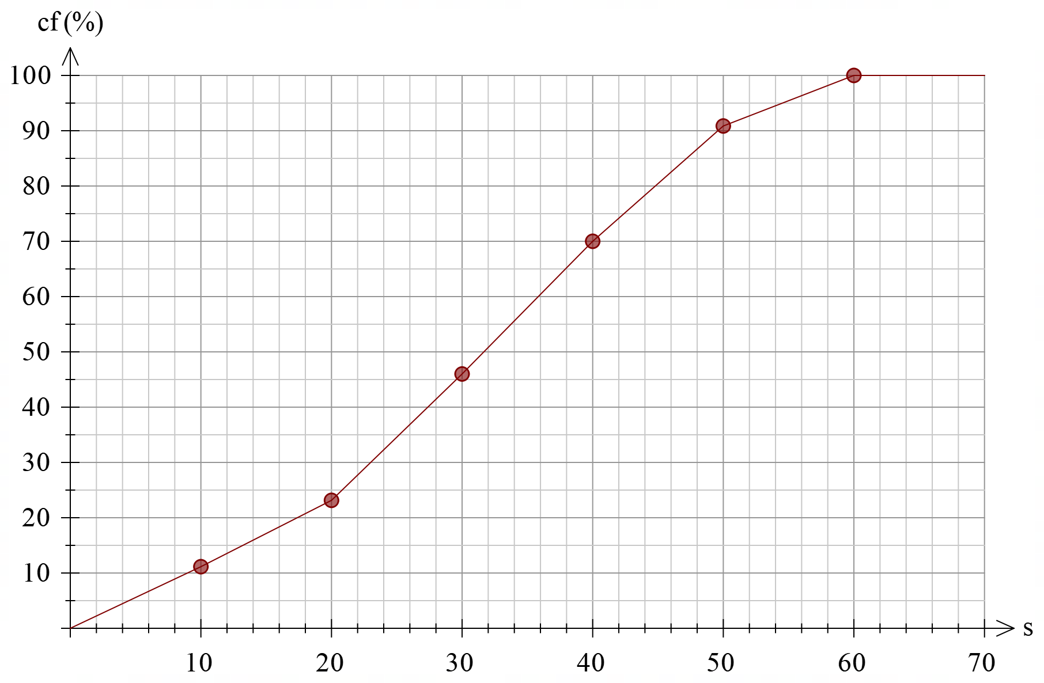
From graph, upper quartile is approximately 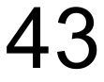 and lower quartile is approximately 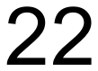. (Note that this graph uses no smoothing. If the student has smoothed the graph, you need to adjust these values to suit the student’s work)

- The interquartile range is approximately 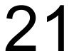

- The pass mark is approximately

