Summary:
108 variations. Coordinate geometry – Line from two points.

Question:
Point C is found at 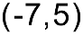and Point B is located at 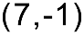.

a) Plot these points on the Cartesian plane provided. Clearly label them on the grid.

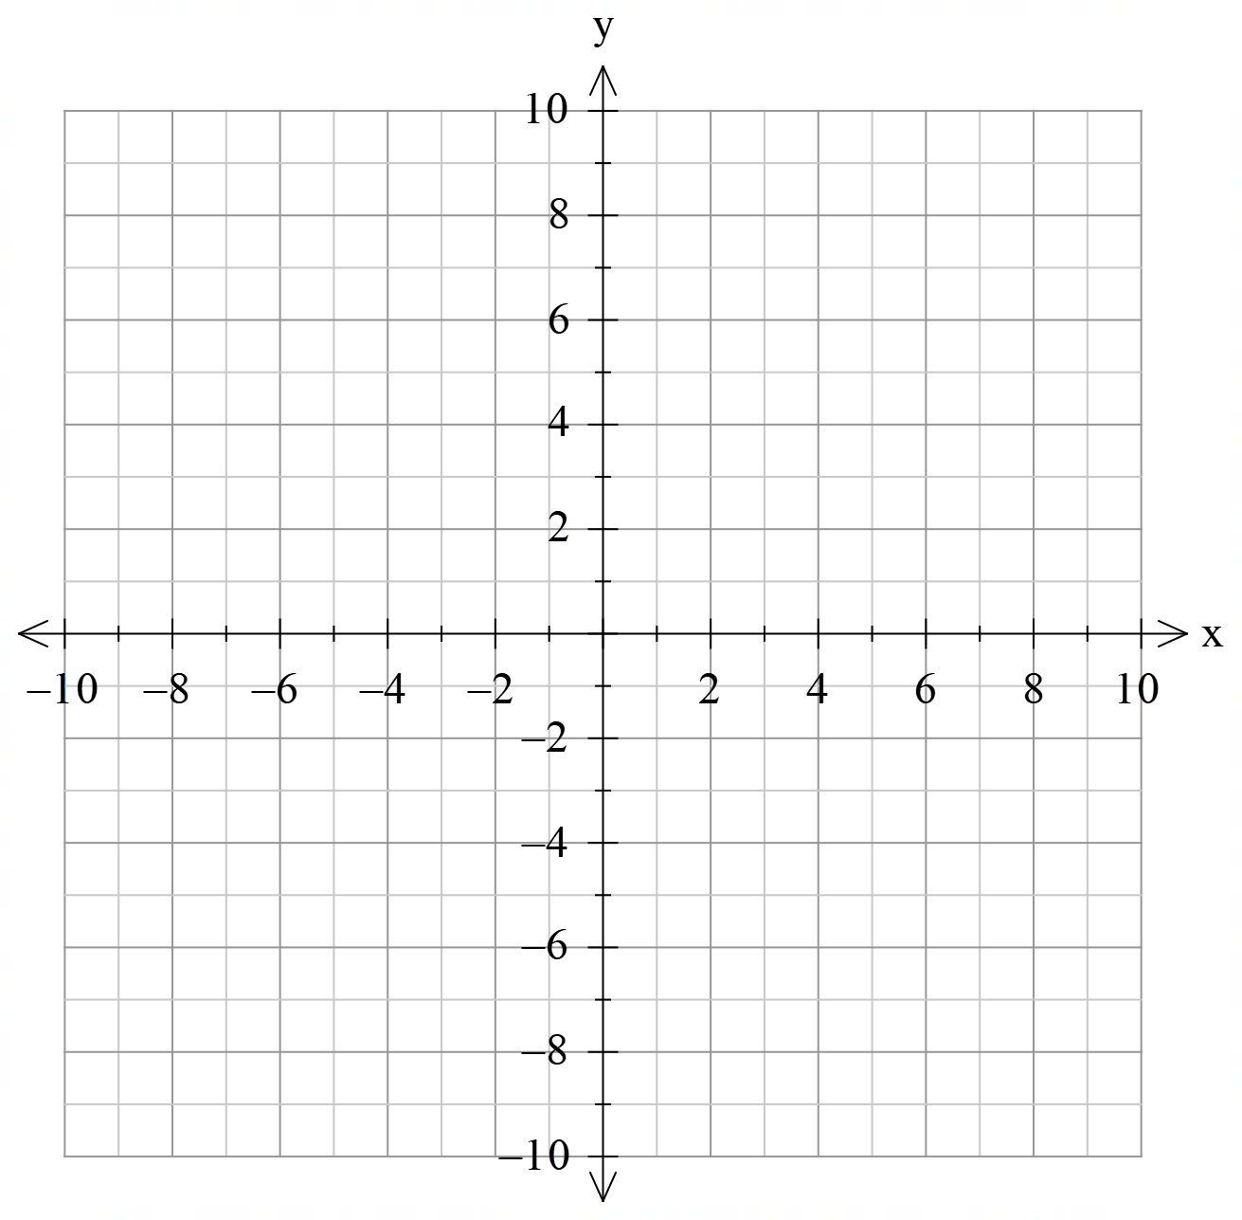

b) Draw a line connecting these two points. Find the gradient of line segment BC. Clearly show your method.

c) Write the equation of the line in the form y = mx + c.

[2,3,3 = 8 Marks]

Solution:
a)
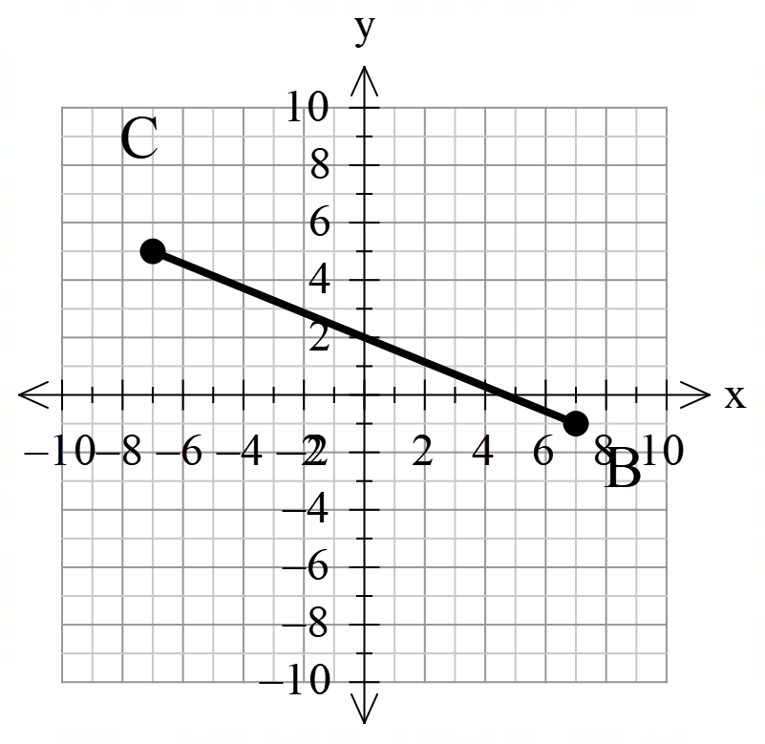

b) 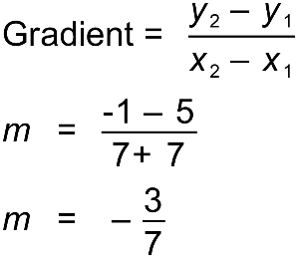
c) 