Summary:
100000+ variations. Coordinate geometry.

Question:
a) Write down the equation of a line which is parallel to the y-axis and passes through the point 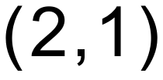
b) Find the equation of the line that passes through 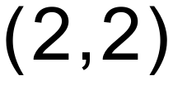 and has a gradient of .
c) Find the equation of the line passing through the point 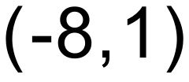 and 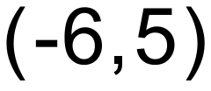.
d) Find the equation of a line that is perpendicular to 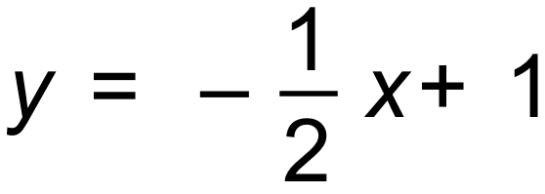 and contains the point 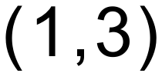.

Solution:
a) 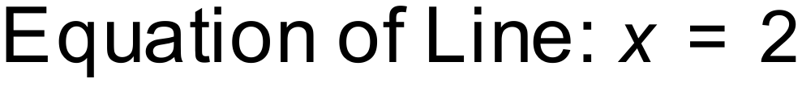
b) 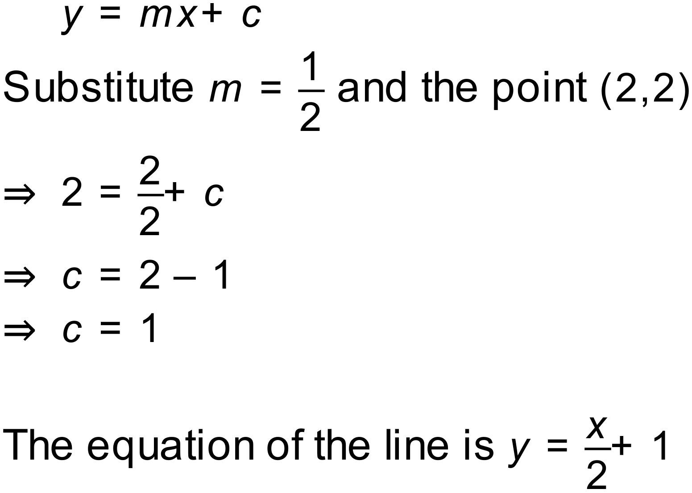
c) 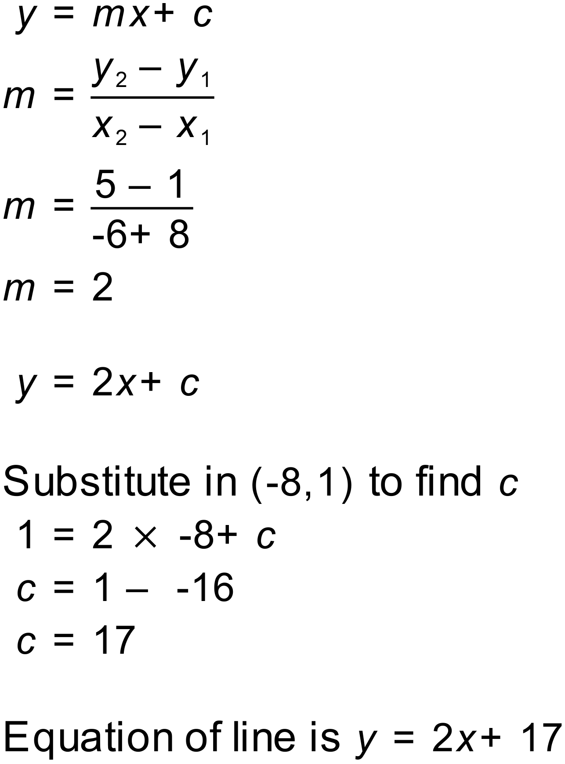
d) 