Summary:
>100000 variations. Bivariate data question. Least squares regression line, correlation coefficient.

Question:
Jo is researching a new mobile phone and has been recording the price of the phone (P) and the phone’s average rating from online reviews (r). The table below shows the price in dollars and the rating of 10 phones Jo is considering.
Jo is graphing the data on this graph but has not finished. Graph the remaining points onto the graph below.

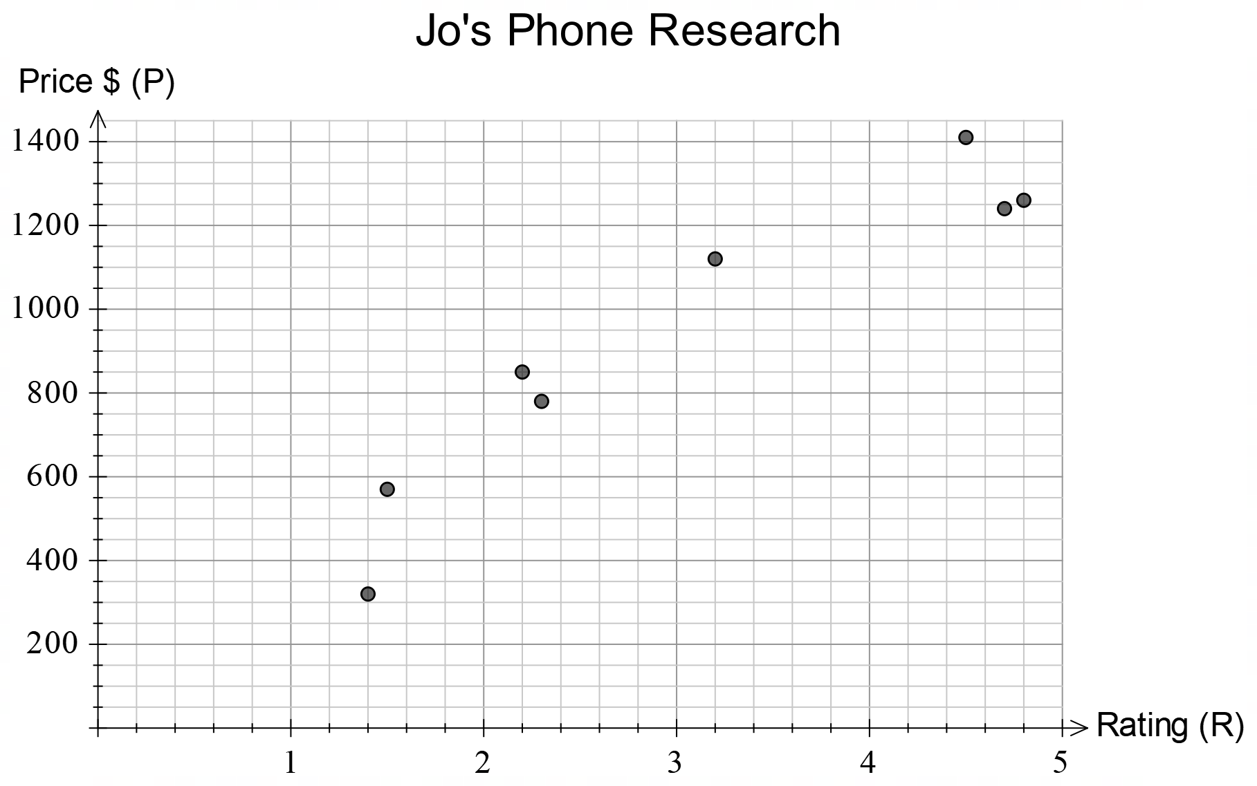

Jo has noticed a linear correlation between the price and the average rating.
- Using your calculator, find the equation of the line of regression and correlation coefficient for the data. Draw the line of regression onto the graph above.

Alan has done his own research into phones and compiled the following graph including the line of regression.
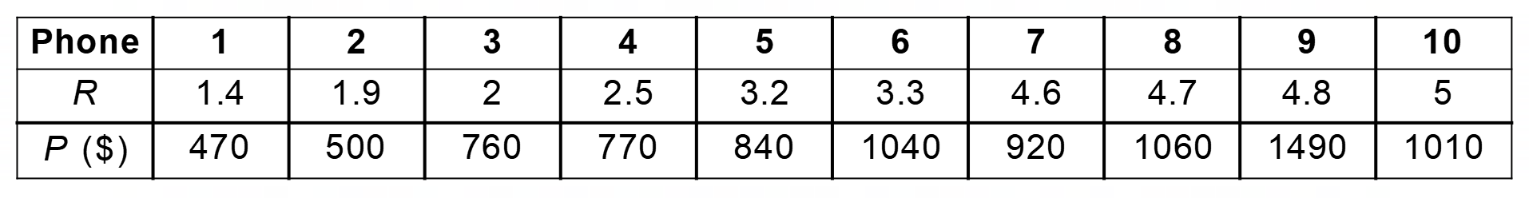
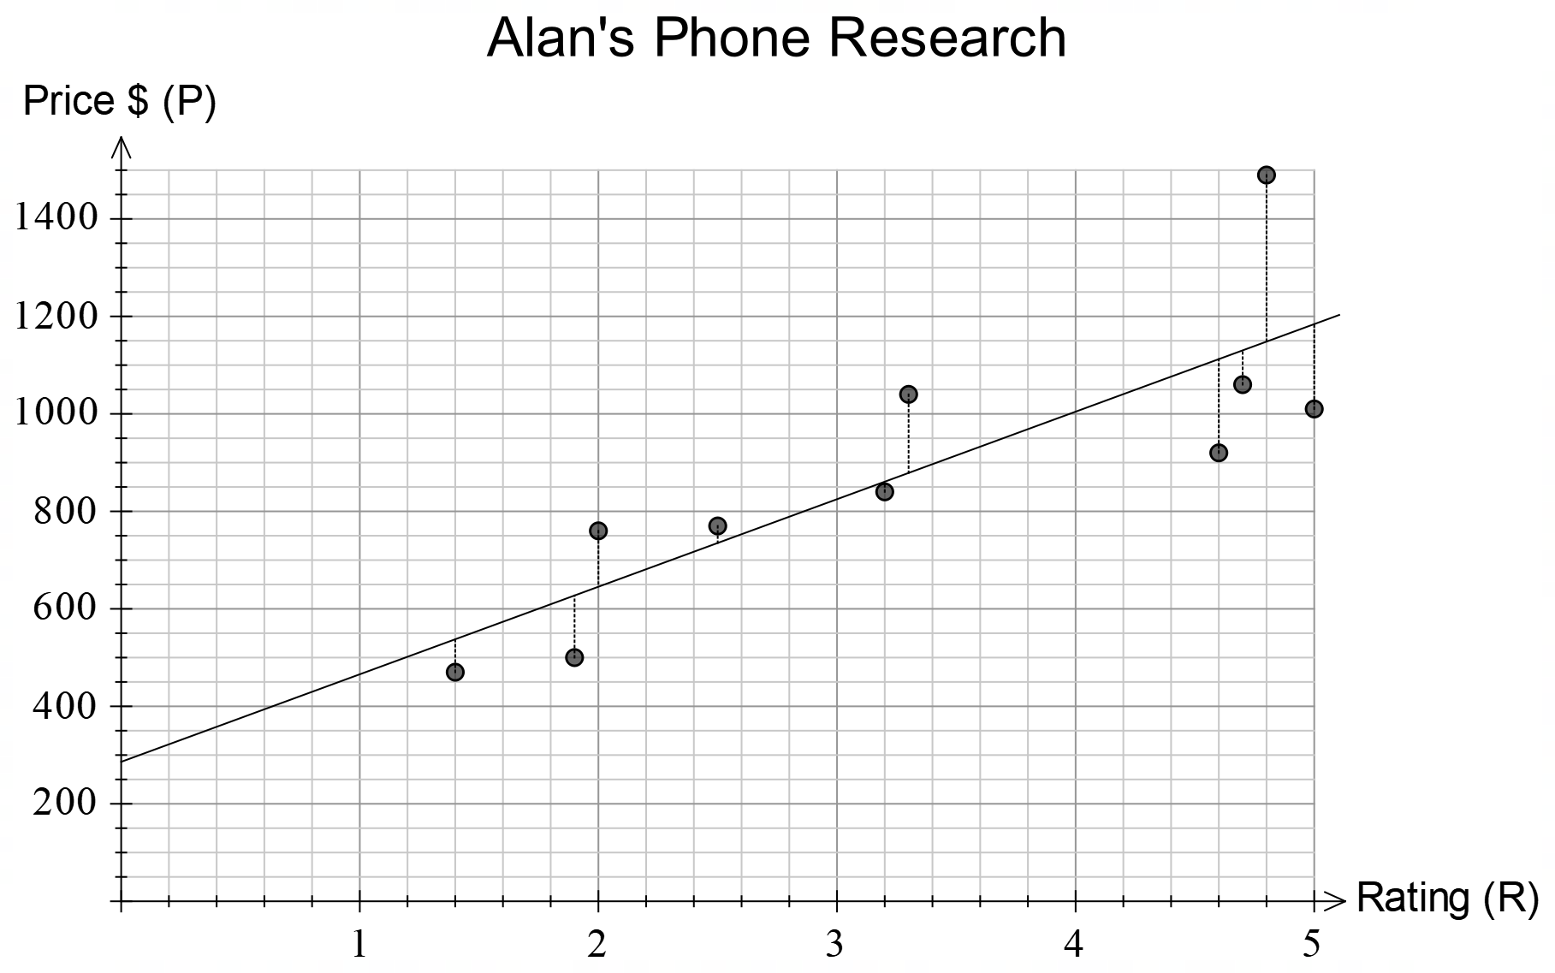
Alan has decided that the residuals might provide him with a good indication of the best phone to buy. He has calculated the residuals below.
- Explain how the residuals can provide you with information about the best phone to buy.

- Using the residuals, which is the best phone to buy?

Solution:

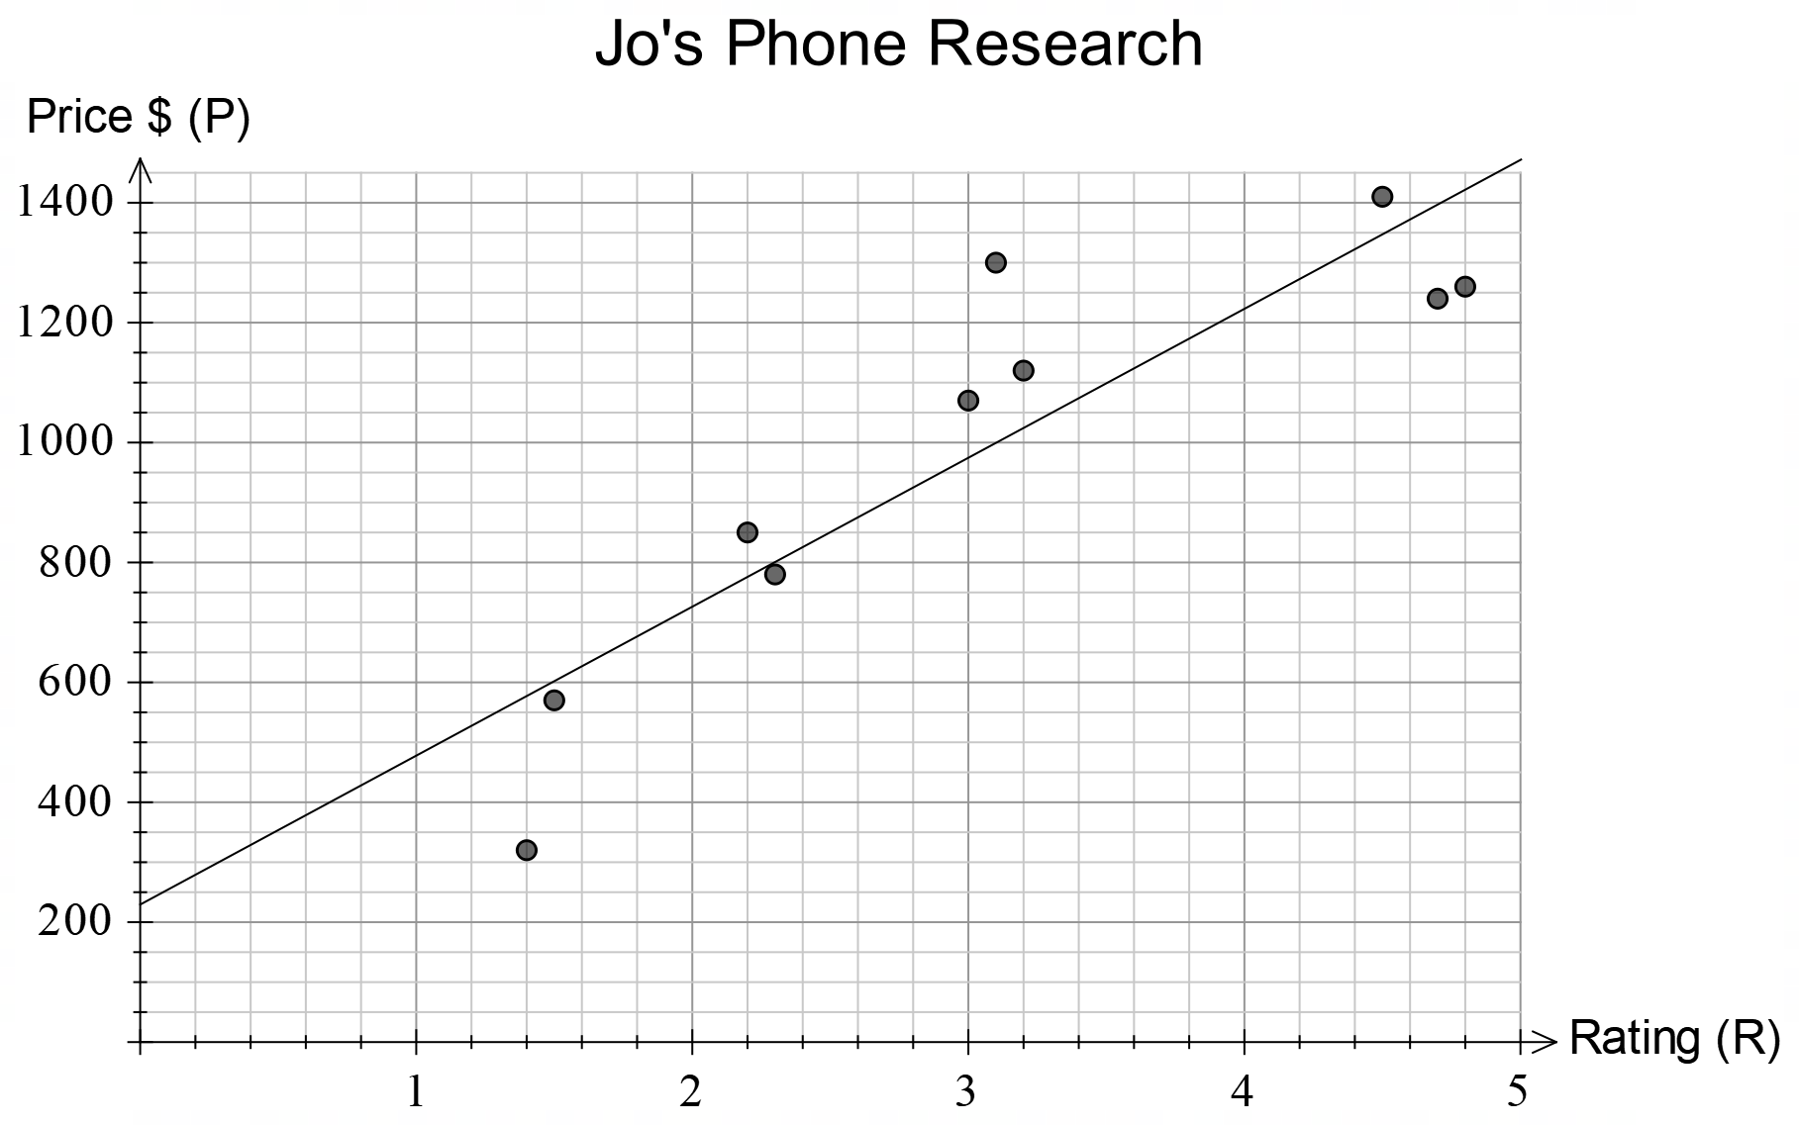

Line of best fit shown above.

- A negative residual means that the phone costs less than the line of regression is predicting. This means that you are getting better value for money. Based on this, the phone with the lowest negative residual is the best buy.

- The best phone is phone which costs 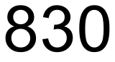 for 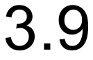 rating points.

