Spiralling Triangles

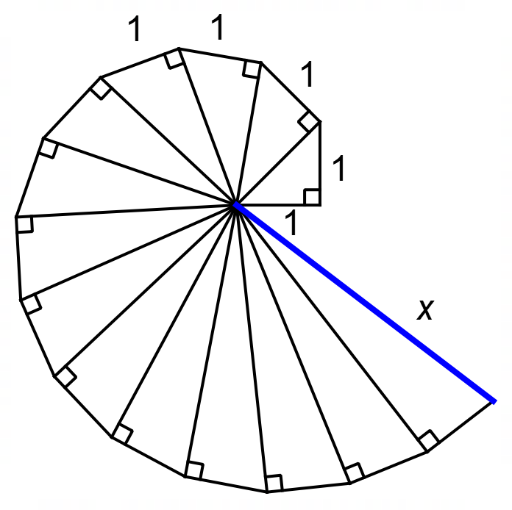

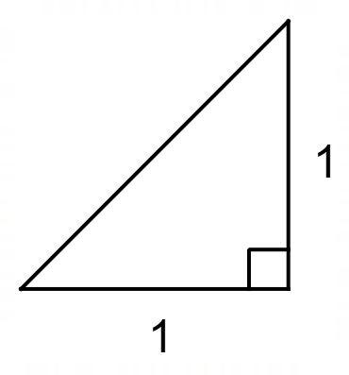
We have constructed a spiral shape using a simple process. We start with a right isosceles triangle with short sides 1 unit long.

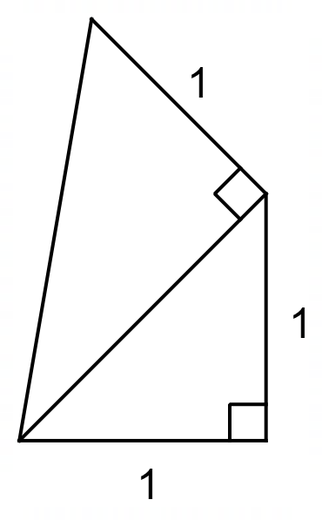
We then construct a new right triangle on the hypotenuse, keeping the outside edge 1 unit long.

We continue this process to construct the spiral shape at the top of the page.

- Calculate the exact length of x, the hypotenuse of the 14th triangle (the blue line on the original diagram).
[2 Marks]
- Describe a pattern that you could use to determine the exact length of the hypotenuses of the triangles in the spiral.
[2 Marks]
- Calculate the length of the hypotenuse of the 104th triangle in the spiral.
[2 Marks]
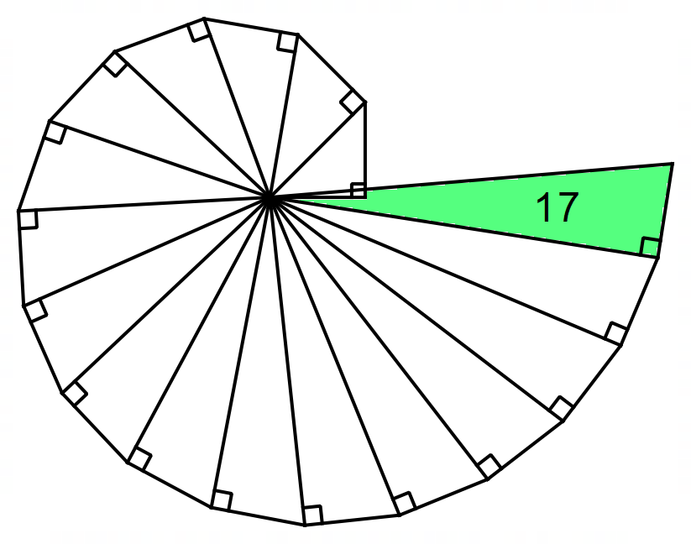

We have continued the pattern up to the 17th triangle and the triangles have begun to overlap. The spiral has completed one rotation. A student has hypothesized that, if the pattern was continued further, it would complete a second rotation after another 17 triangles – at triangle 34.

- Explain why the student is incorrect.
[1 Mark]
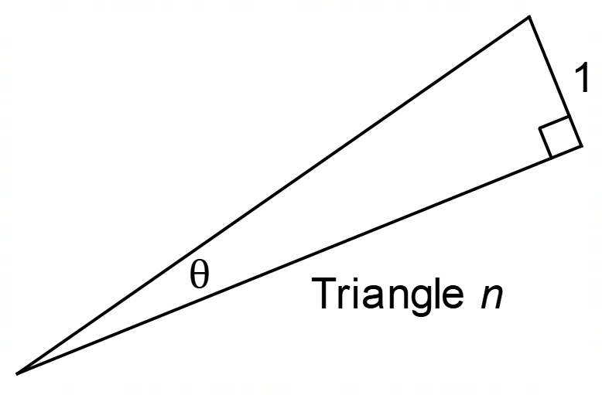

- Devise a formula that calculates the central angle of a triangle (θ) given the triangle number (n).
[2 Marks]
- Use your formula and a spreadsheet to complete this table. Provide full details of how you determined how many triangles were required to complete the rotations.

Number of Rotations | Triangle Number
1 | 17
2
3
4
5
[6 Marks]
- Calculate the radius of the spiral after five rotations
[1 Mark]

Spiralling Triangles - Solutions
1 and 2.
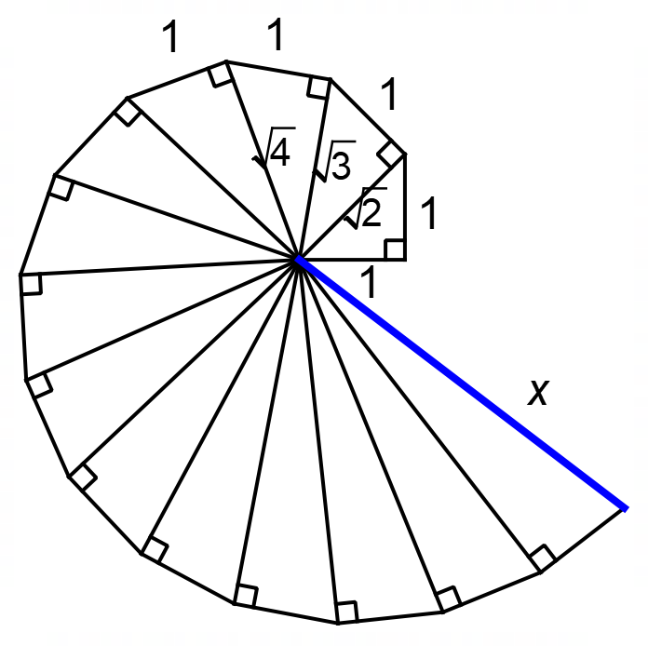
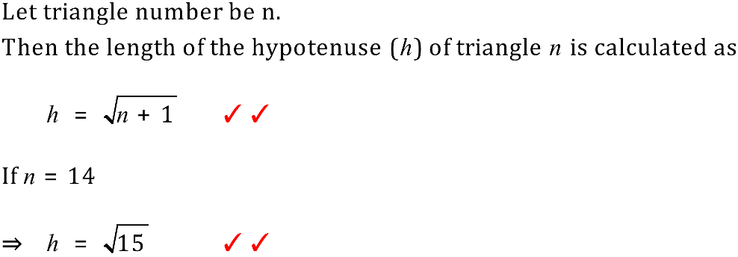

Discussion:
Triangle 1.

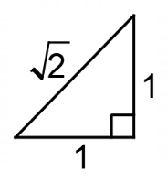

Triangle 2.

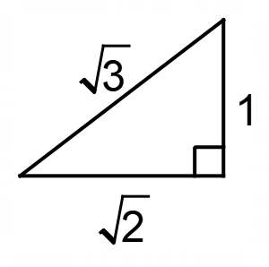

Triangle 3.

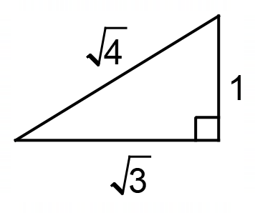

In general
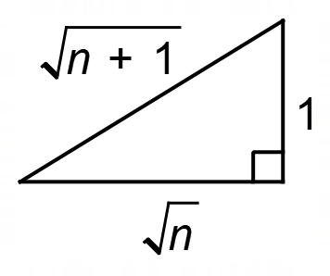

3. Using our formula the length of the hypotenuse of the 104th triangle will be 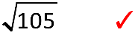

4. The student is incorrect because the central angle of each triangle is getting smaller. This means that it will take more than 34 triangles to complete two revolutions.

5.
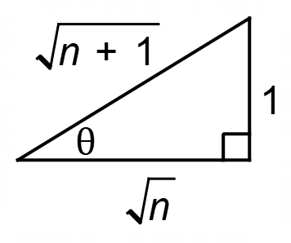
Theta is the central angle.
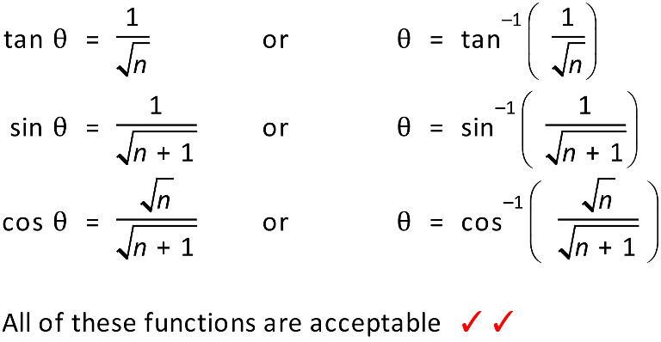

6.
Number of Rotations | Triangle Number
1 | 17
2 | 54
3 | 110
4 | 186
5 | 281
Students should provide evidence of using a spreadsheet to complete these values.

Link to sample Excel Spreadsheet.

7. 