Solving an Optimisation Problem

This worksheet will show you how to use algebra to solve a problem. There are a number of steps that you need to undertake. You can use this as a template for other questions.

Step 1 – Read The Problem

Find the dimensions of the rectangle with the largest area, that can fit inside the right triangle shown below.

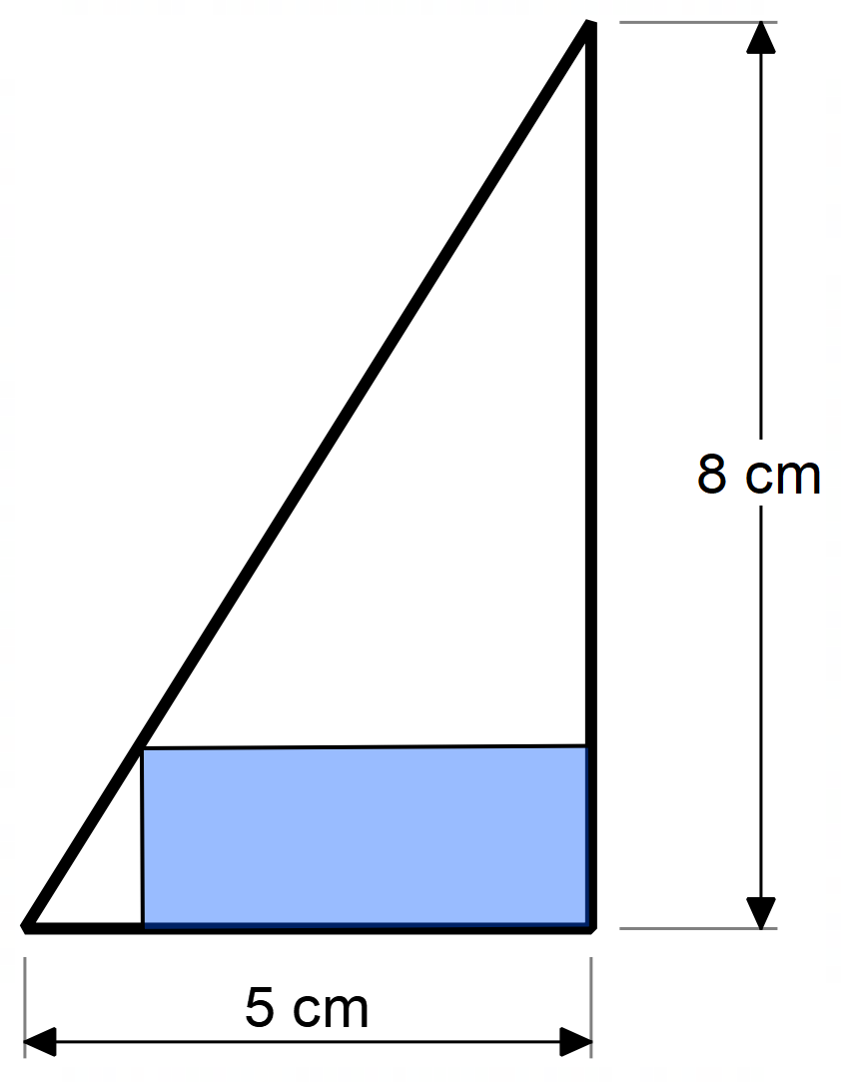
The first step is to make sure that you understand the problem. In this case the problem is fairly simple – the rectangles need to fit inside the triangle, touching the perpendicular sides, with the corner on the hypotenuse.

We need to find out the sizes of the biggest rectangle.

Step 2 – Try a Few Examples to Make Sure You Understand
I will try a few examples, work out the areas and see if I can see any patterns.

From my experiments, I can see that changing the rectangle does change the area and that the maximum area is at least 9.6cm². Most importantly, if I change the width, the height is determined by the triangle – I do not get to choose it separately to the width.

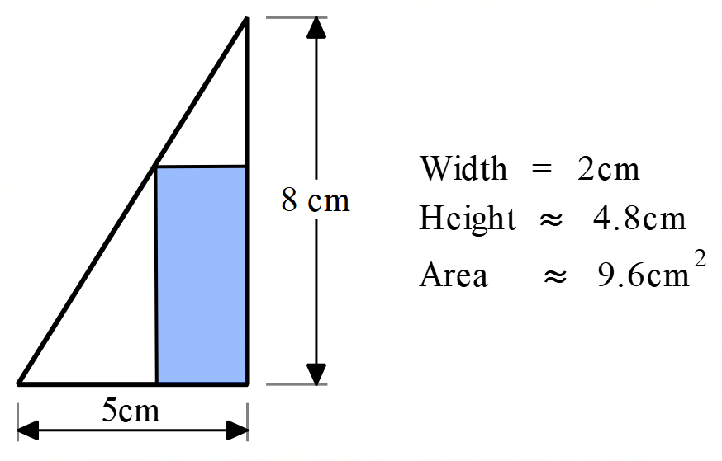 | 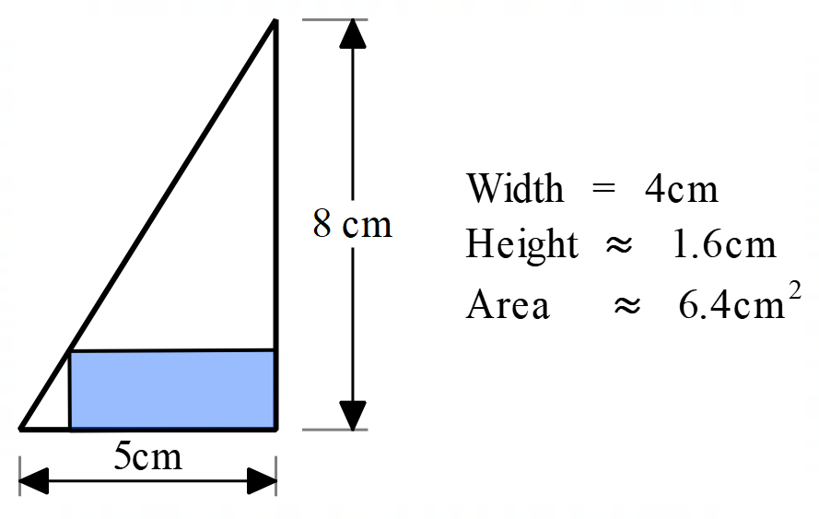
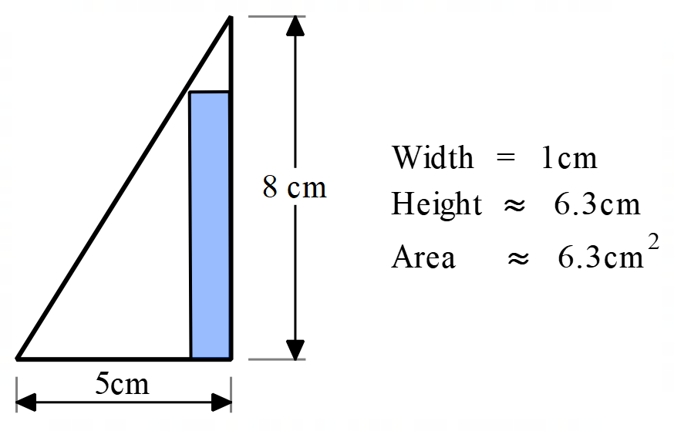 | 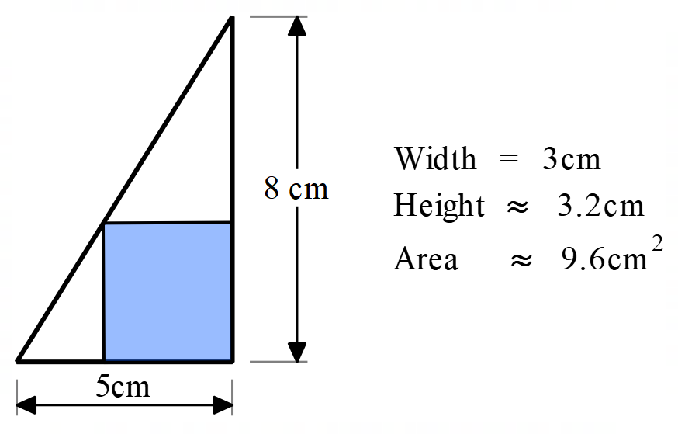

Step 3 – Choose ONE Thing to Change, Call it x
Often, when you change one thing, all the other things area affected. In my examples, I was changing the width and then measuring the height and calculating the area. I am going to base everything on the width of the rectangle and call that x. (I don’t have to use x, I could use w or any other letter. We just traditionally use x.)

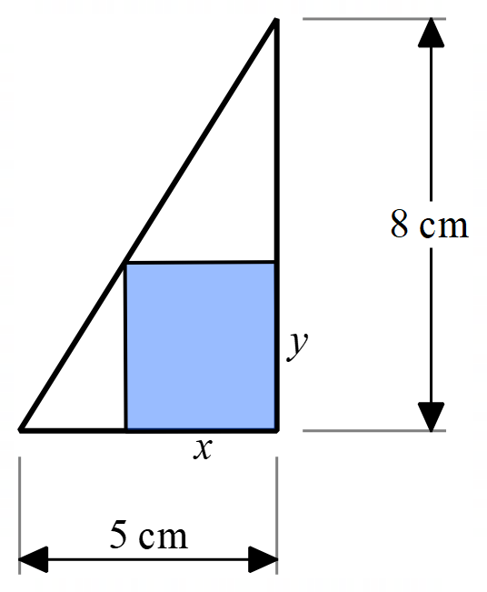
Step 4 – Work Out How Changing x Changes the Other Things. The Hard Bit!
It is always very tempting to add another letter (like y) and that is OK, providing you eventually get rid of the y and only end up with x’s. To do that, I need to work out what y has to be in terms of x. That means that I have to work out an equation for y that only has x’s in it.

In this example, I am going to do that using similar triangles.
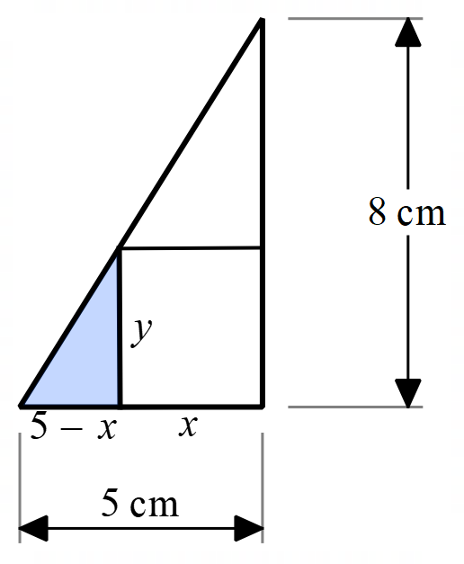
In the diagram, you can see that the little triangle has sides of (5-x) cm and y cm and it is also similar to the big triangle which has sides of 8cm and 5 cm. I know that similar triangles have sides in ratio.

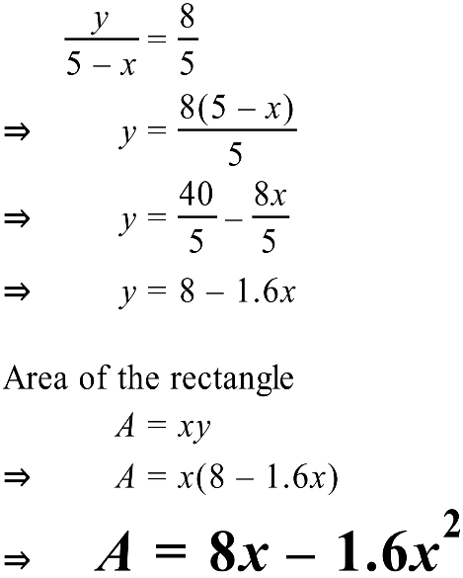

Step 5 – We Have an Equation, Now Graph It!
Graphs are number pictures and can let you see things that may not otherwise be obvious. Use a graphing calculator or graphing program to graph this function.

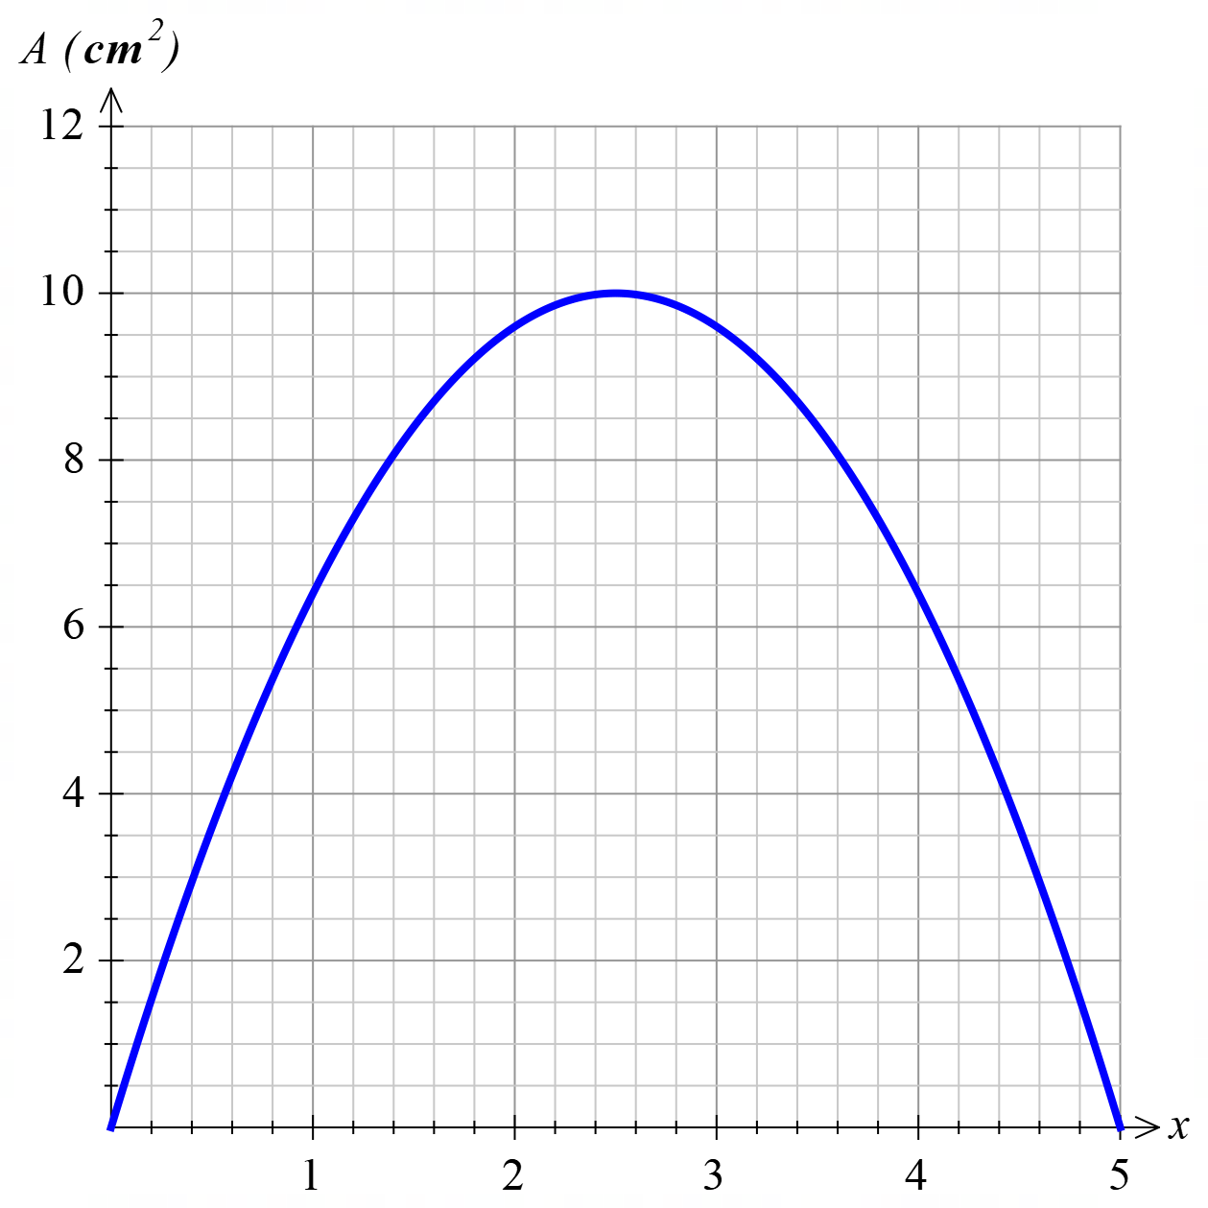

From my graph I can see that it appears that the maximum area is 10 square centimetres when the width is 2.5cm. The graph is a parabola and the function is quadratic, so I can use my knowledge of quadratic functions to be sure.

Step 6 – Use Some Algebra to Solve the Problem

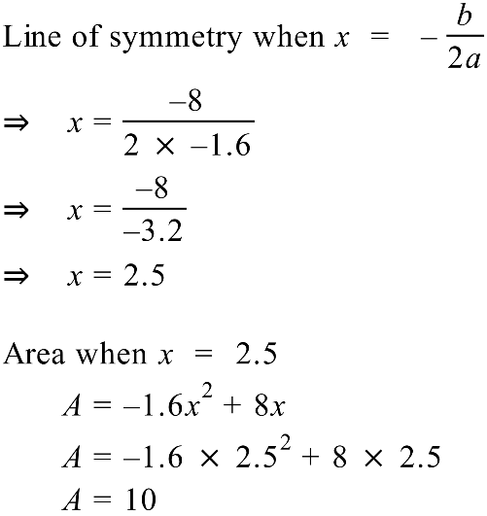
The line of symmetry of a parabola is calculated using 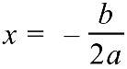 when the formula is in the form 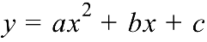 . I need to rearrange my equation to be 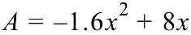 and then the line of symmetry and maximum area can be calculated.

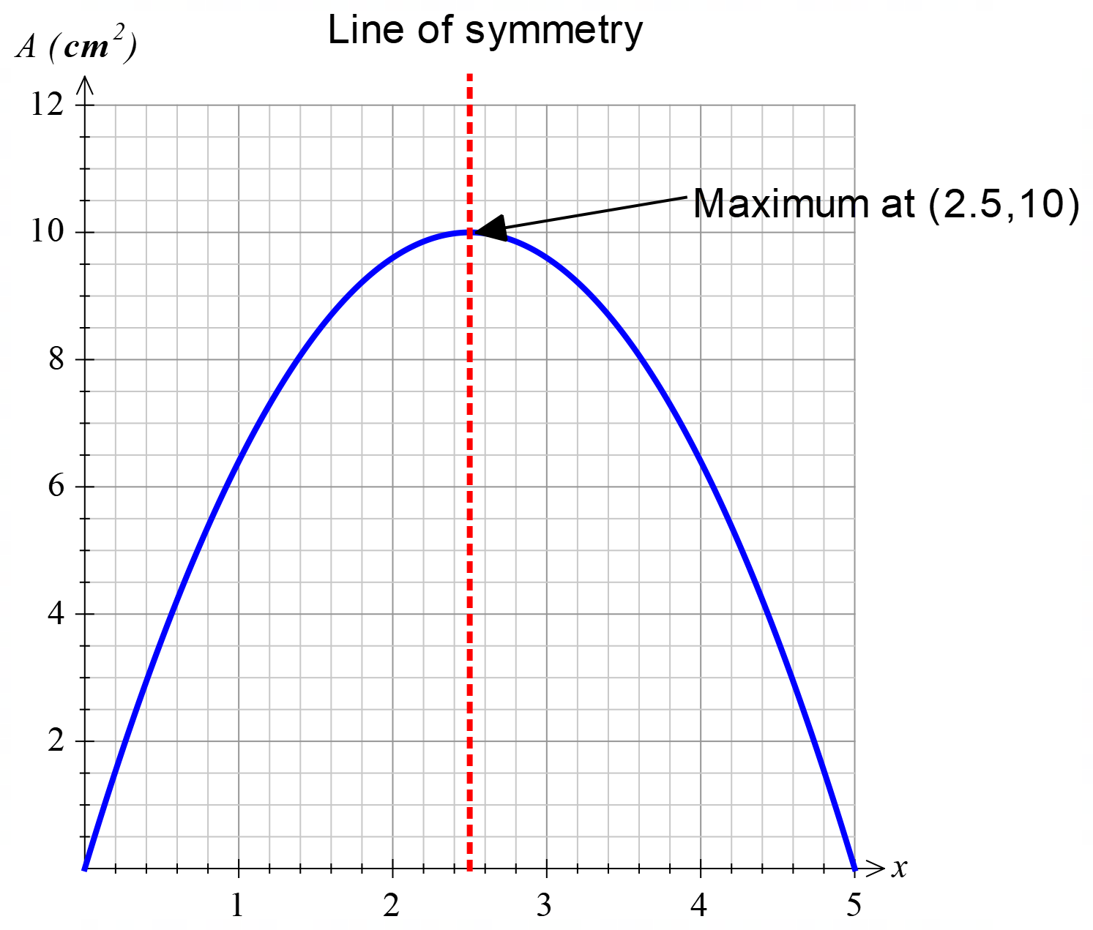

Step 7 – Answer the Question!

The last step is so simple that many people forget to do it!

The largest rectangle that can be fitted into the triangle has a width of 2.5cm and a height of 4cm and has an area of 10cm²

