FX Library Modules

Simultaneous Equations
2 Variable
Age 13-15

Copyright Information
If you are an Efofex subscriber and work in a school, you can copy and/or modify the FX Library materials and use them with your students. We hope that this material will help you write your tests, worksheets, exams, presentations and any other educational materials. You cannot claim copyright over the FX Library materials or present them as your own work.
FAQ

Who are the questions/materials for?
We are providing the materials for teachers in schools. If you are a teacher in a school (or similar context) you are welcome to use the questions/materials freely in just about any manner. Most other usages of our questions/materials are prohibited. In particular, you are expressly prohibited from using our materials in any context where the aim is to generate a profit.
Can I photocopy the questions/materials for use by my students?
YES.
Can I copy questions/materials and paste them into my own documents?
YES.
Do I have to include the Efofex Software copyright notice on my own documents if I have included some of your questions/materials?
NO.
Can I use your questions/materials to generate a profit?
NO.
Can I use the questions/materials on my website/PowerPoint presentation/Moodle...?
It depends. If your usage is within the context of a teacher of students at an educational institution, YES. If you want to use the materials for profit, NO.
I am a home-schooling parent. Can I use your materials?
YES.
I am a student and want to use your products for revision. Can I use them?
YES (but make sure to tell your teachers how good they are!)
Can I modify your questions/materials for my own use?
YES.
If I modify your questions, can I claim copyright?
It depends. If the modifications are substantial, YES. If the modifications are trivial or superficial, NO. Using the Parameter Regeneration feature of our products is NOT a substantial modification
I am a professional tutor. Can I use your materials with my students?
NO.
Can I republish your materials?
NO.
I think that I might be able to use your materials but don't seem to fit any of your FAQs. What do I do?
Send us an email describing what you want to do (to info@efofex.com) and we will get back to you as soon as possible.

How To Use This Material
Copy a question from this document and paste (with reparametizing) into your document. This allows you to quickly build a collection of regeneratable questions into a test, worksheet, presentation, or exam.

Question
Solve these equations simultaneously. Show all of your working
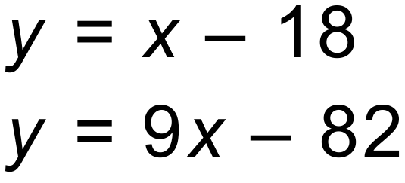
Solution
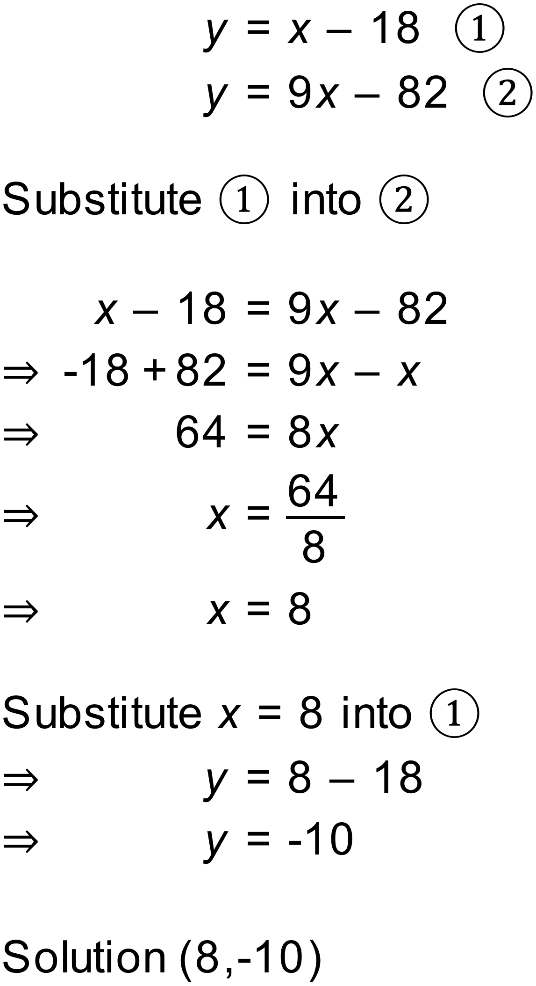r
Notes
21600 variations.
Simultaneous equations. Substitution. Integer Solutions
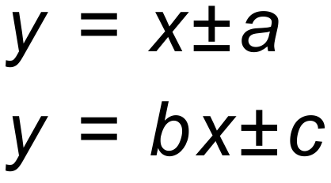

Question
Solve these equations simultaneously. Show all of your working
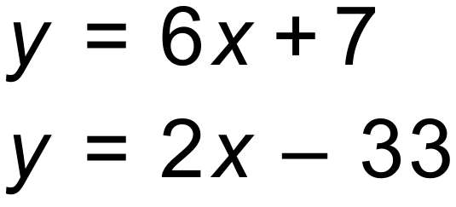
Solution
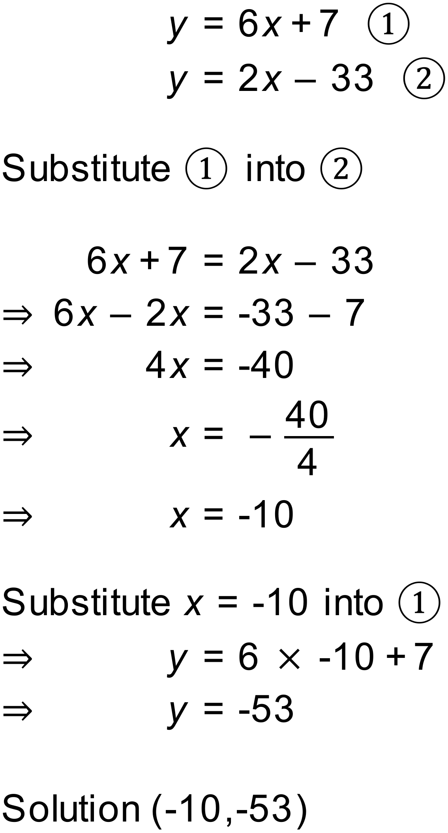
Notes
100000+ variations.
Simultaneous equations. Substitution. Integer Solutions
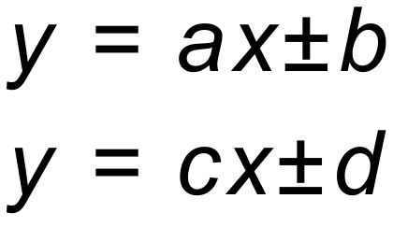

Question
Solve these equations simultaneously. Show all of your working
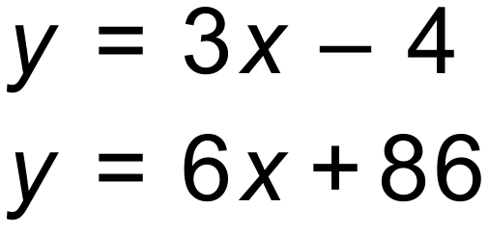
Solution
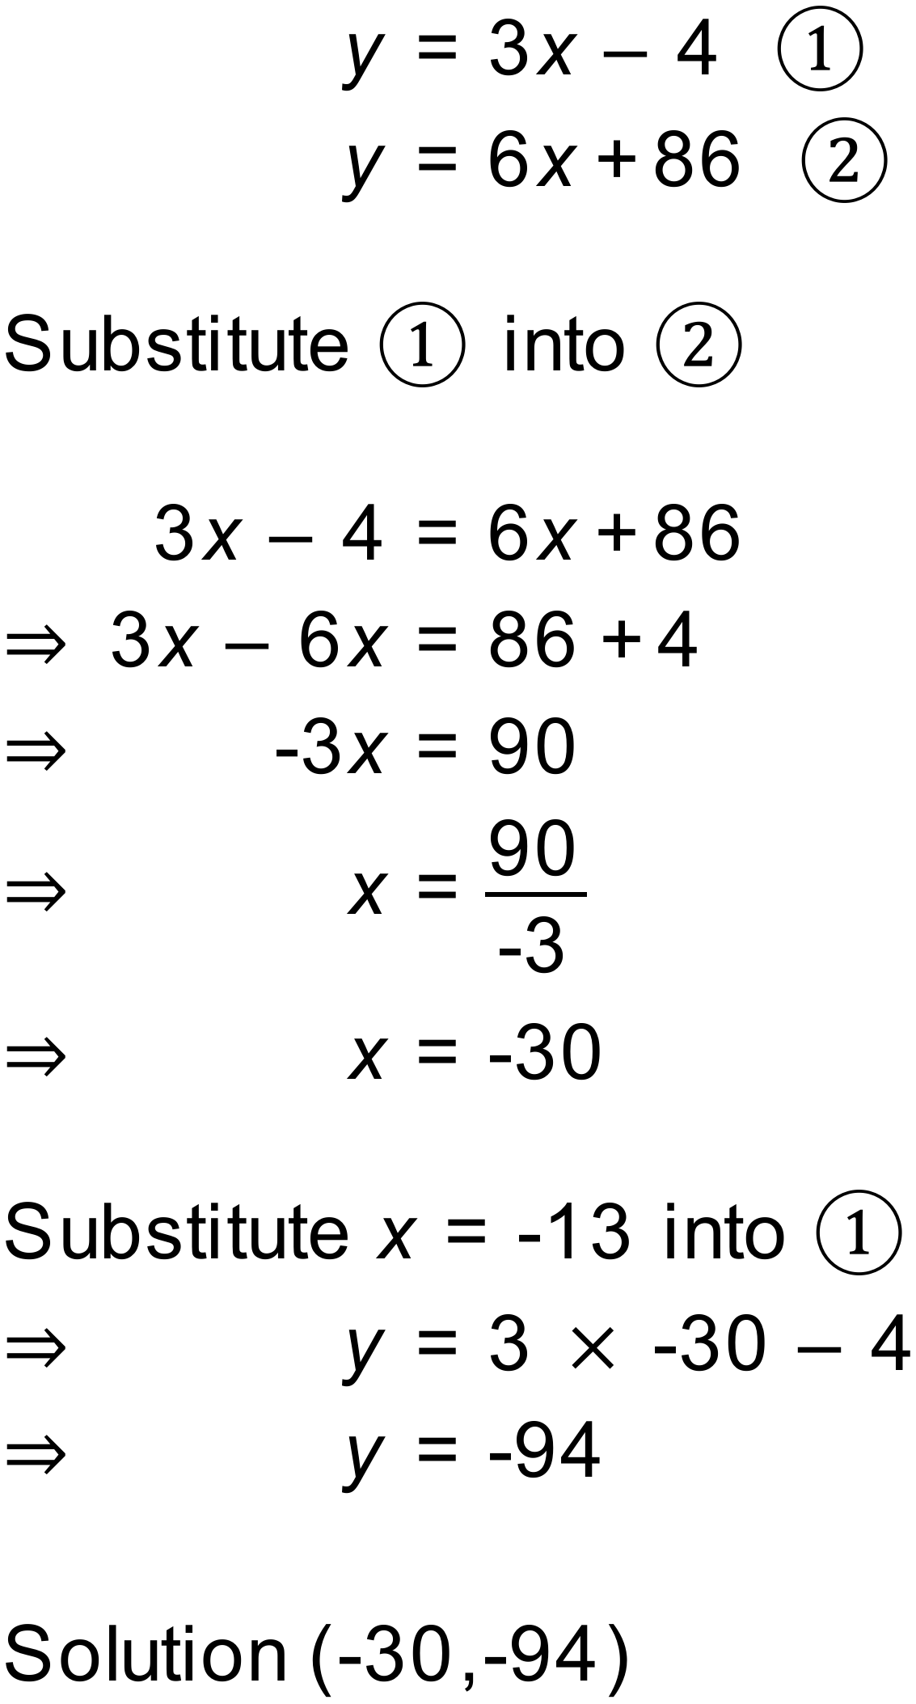
Notes
100000+ variations.
Simultaneous equations. Substitution. Rational Solutions

Question
Solve these equations simultaneously. Show all of your working
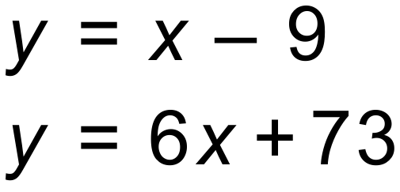
Solution
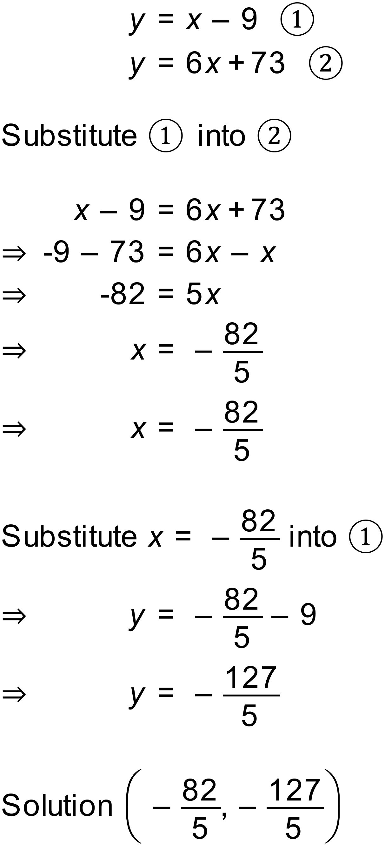
Notes
100000+ variations. Simultaneous equations. Substitution. Rational Solutions
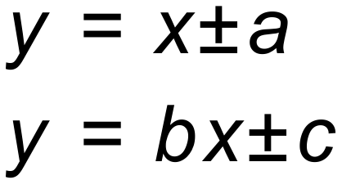

Question
Solve these equations simultaneously. Show all of your working
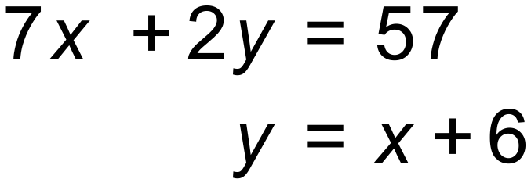
Solution
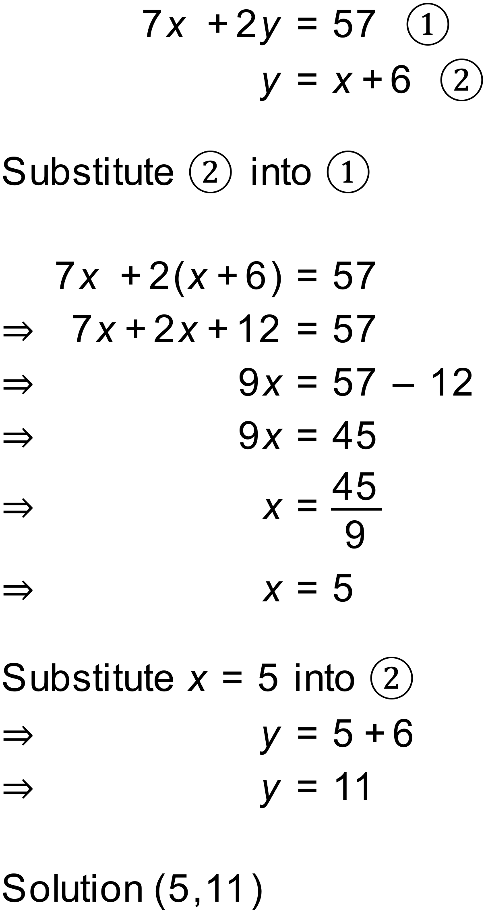
Notes
100000+ variations. Simultaneous equations. Substitution. Integer Solutions
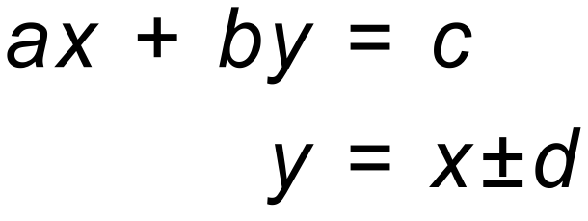

Question
Solve these equations simultaneously. Show all of your working
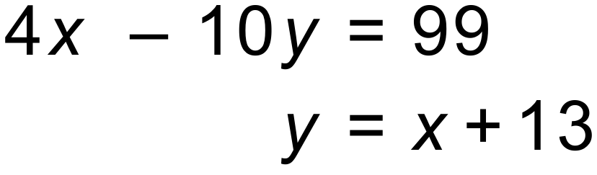
Solution
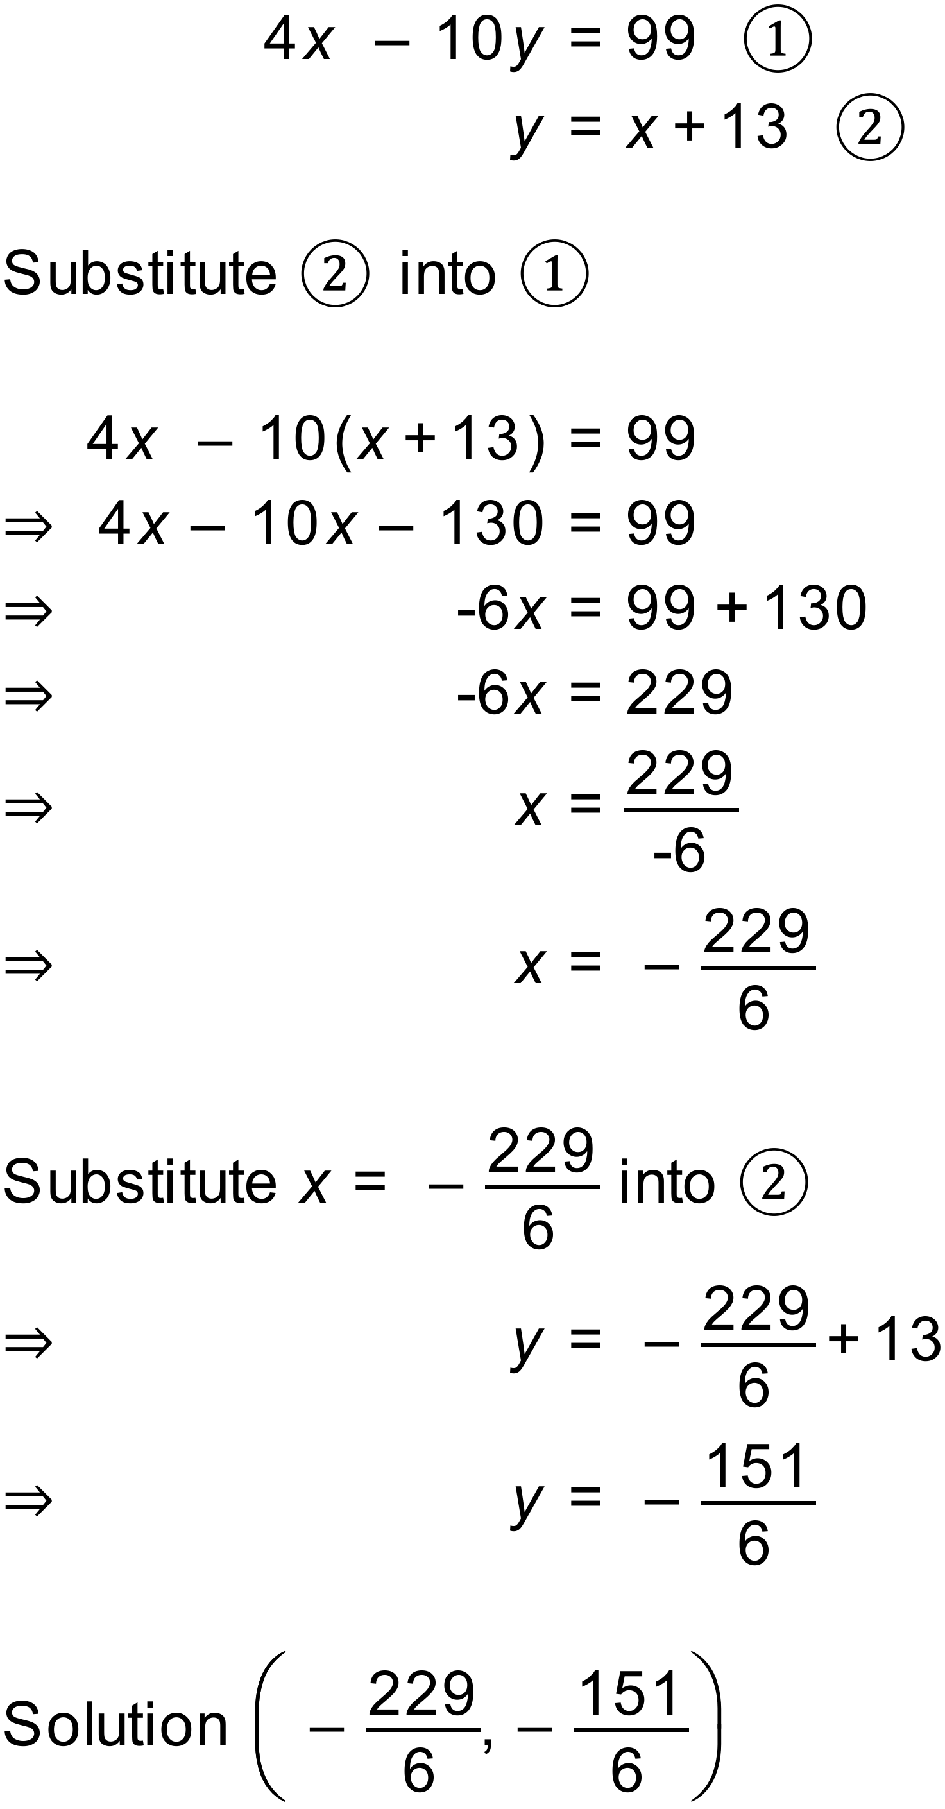
Notes
100000+ variations. Simultaneous equations. Substitution. Rational Solutions
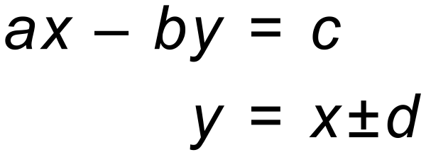

Question
Solve these equations simultaneously. Show all of your working
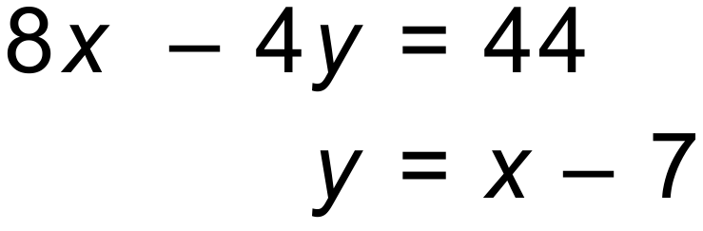
Solution
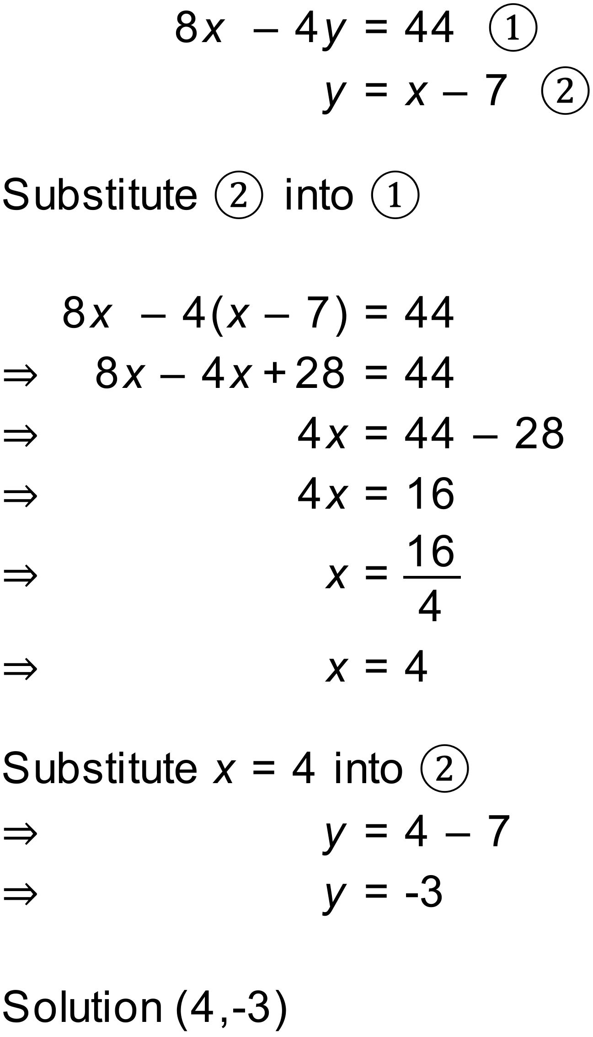
Notes
100000+ variations. Simultaneous equations. Substitution. Integer Solutions

Question
Solve these equations simultaneously. Show all of your working
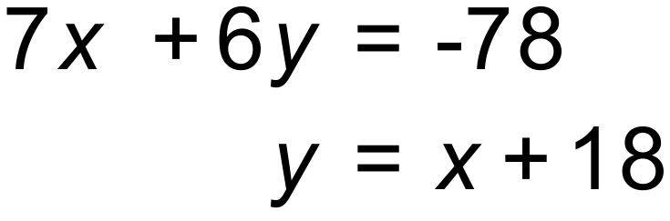
Solution
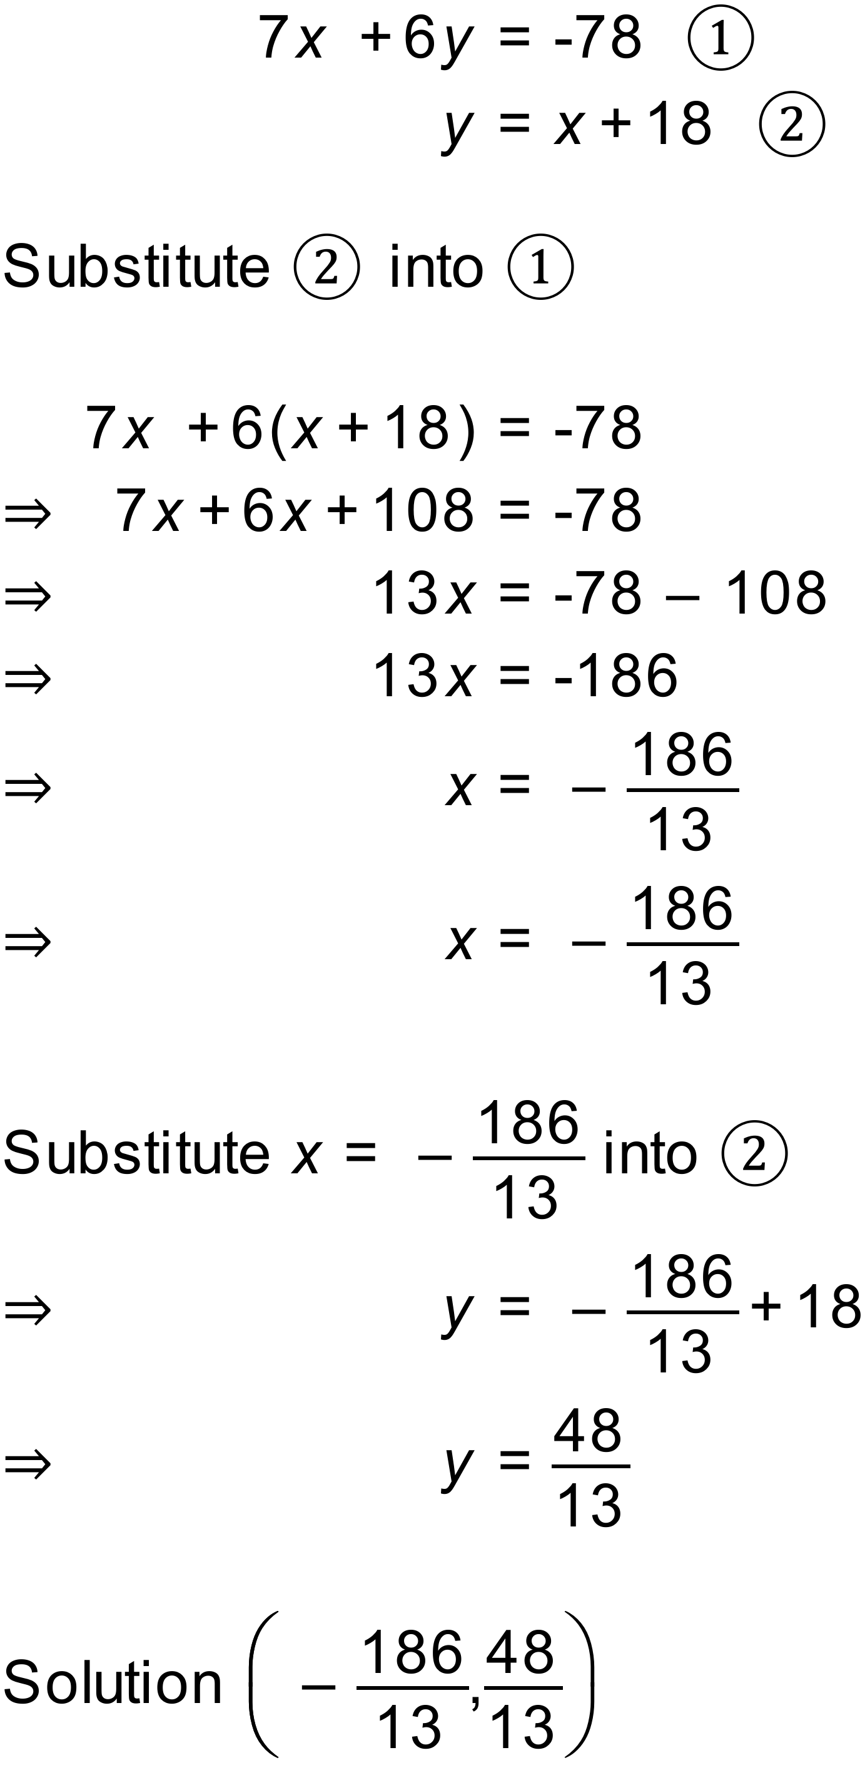
Notes
100000+ variations. Simultaneous equations. Substitution. Rational Solutions

Question
Solve these equations simultaneously. Show all of your working
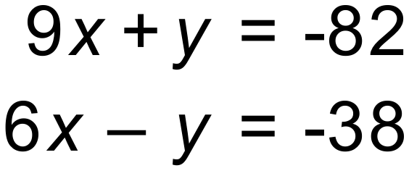
Solution
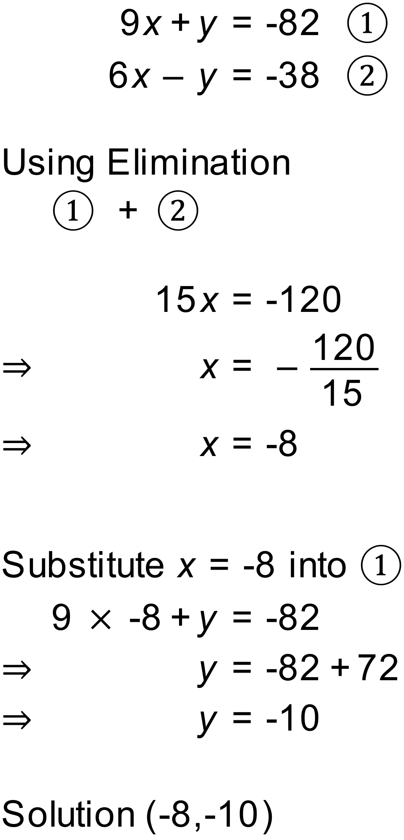
Notes
100000+ variations. Simultaneous equations. Substitution. Integer Solutions
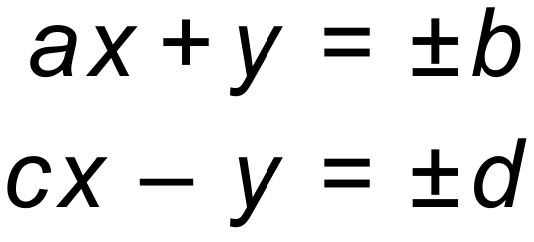

Question
Solve these equations simultaneously. Show all of your working
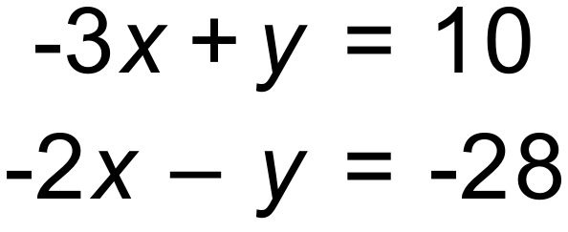
Solution
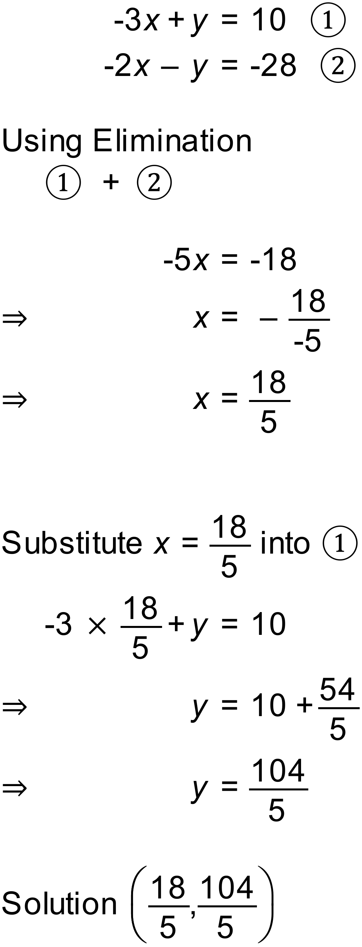
Notes
100000+ variations. Simultaneous equations. Elimination. Rational Solutions

Question
Solve these equations simultaneously. Show all of your working
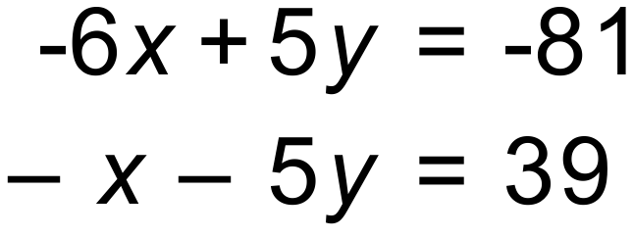
Solution
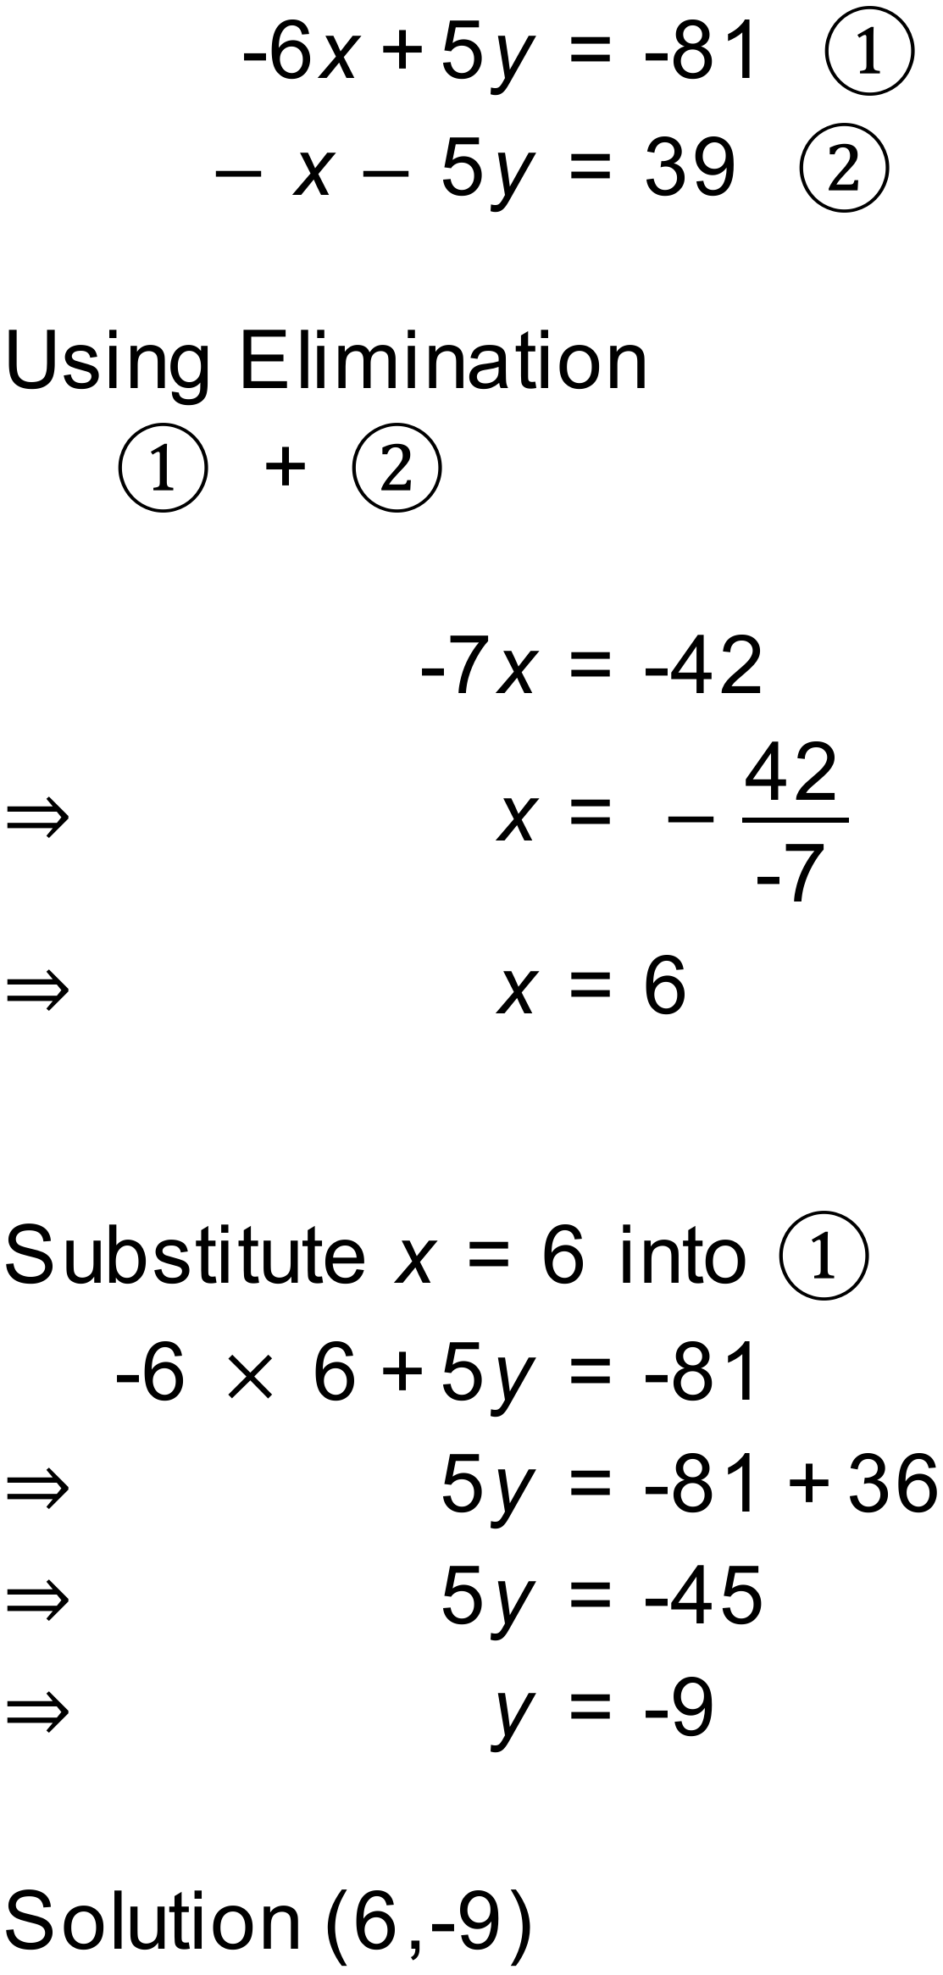
Notes
100000+ variations. Simultaneous equations. Elimination. Integer Solutions
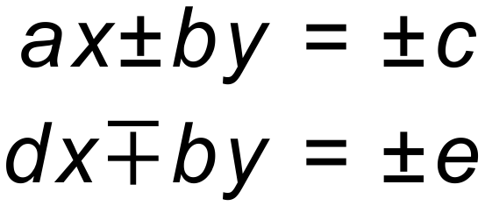

Question
Solve these equations simultaneously. Show all of your working
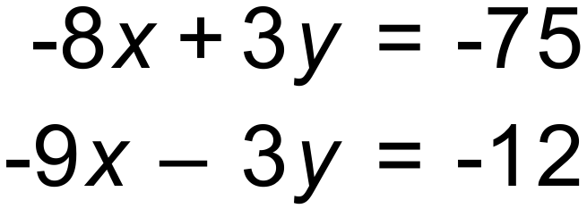
Solution
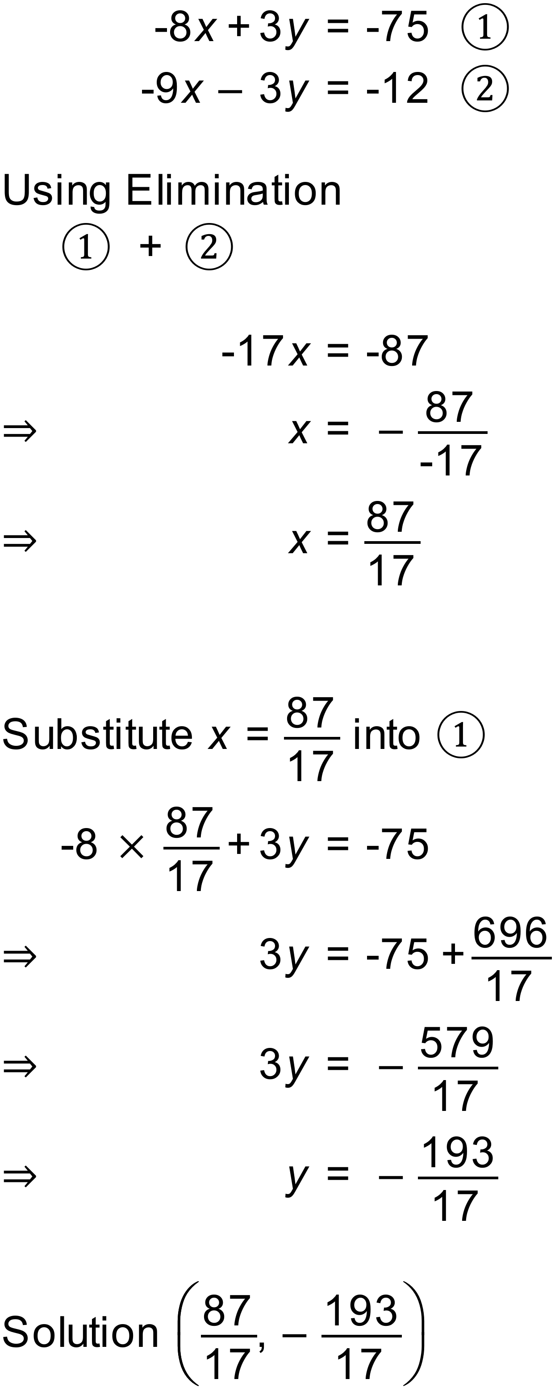
Notes
100000+ variations. Simultaneous equations. Elimination. Rational Solutions

Question
Solve these equations simultaneously. Show all of your working
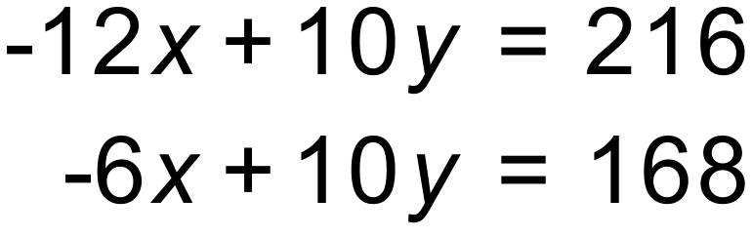
Solution
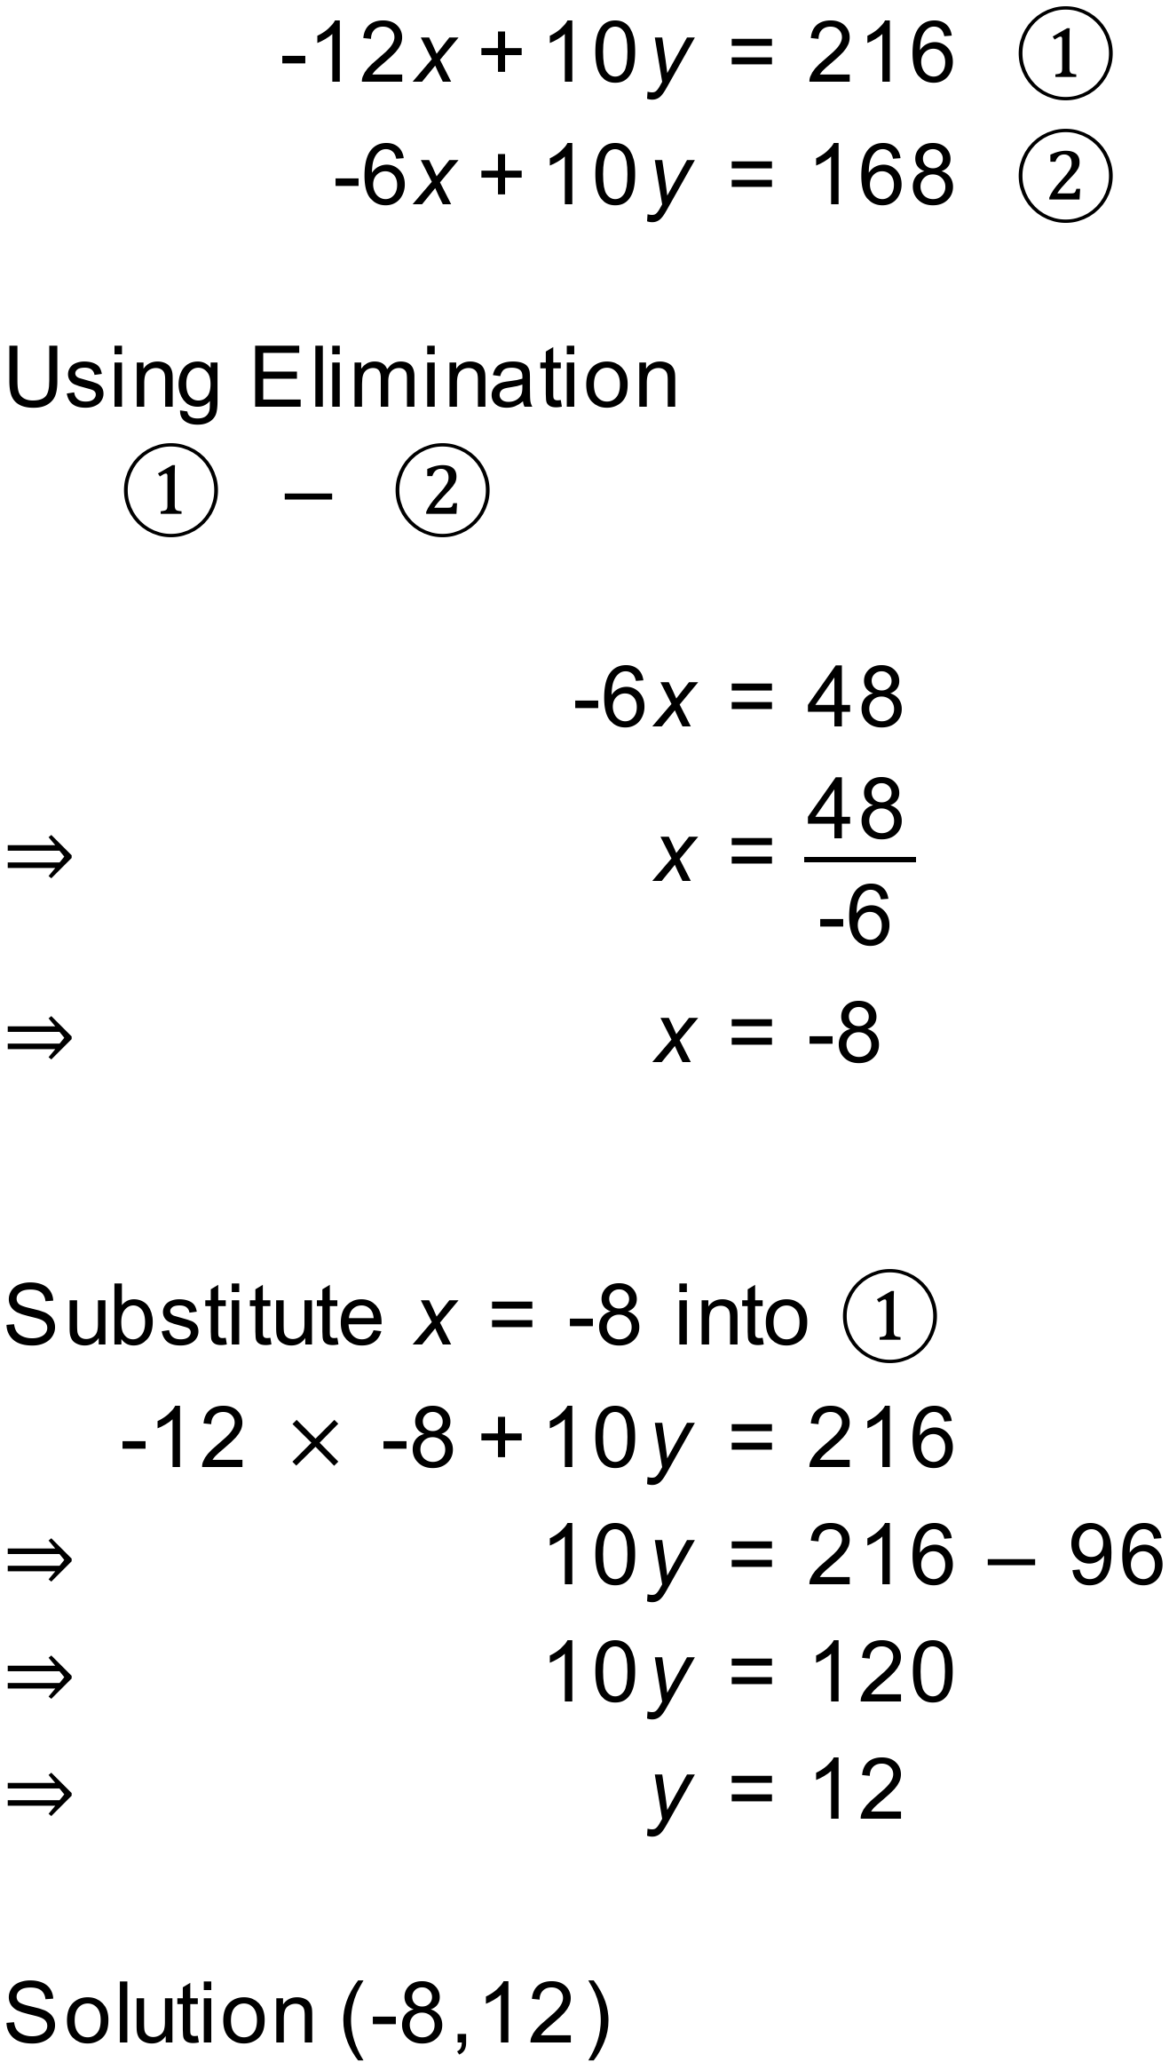
Notes
100000+ variations. Simultaneous equations. Elimination. Integer Solutions
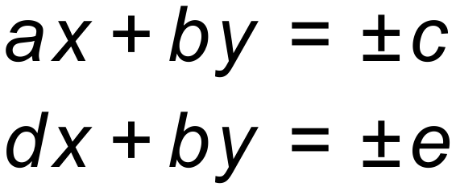

Question
Solve these equations simultaneously. Show all of your working
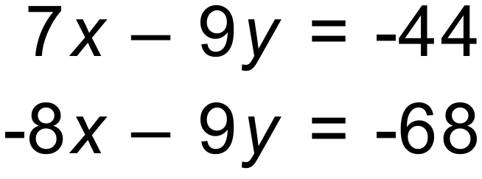
Solution
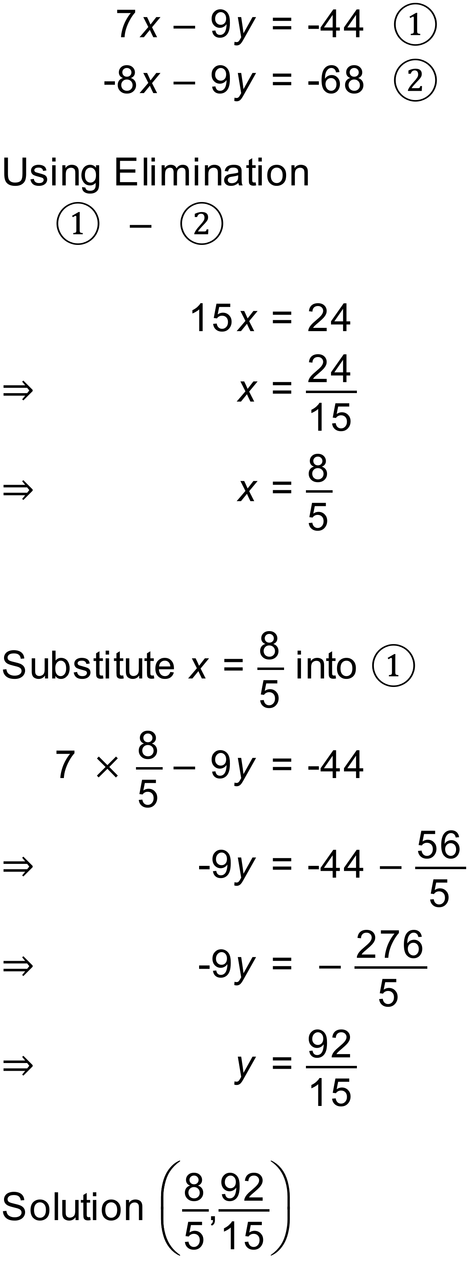
Notes
100000+ variations. Simultaneous equations. Elimination. Rational Solutions
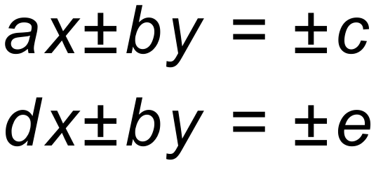

Question
Solve these equations simultaneously. Show all of your working
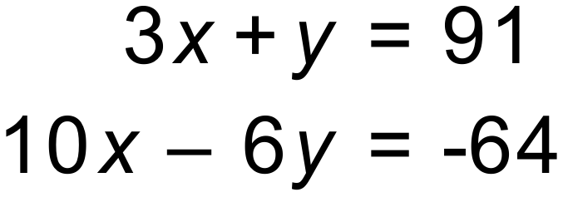
Solution
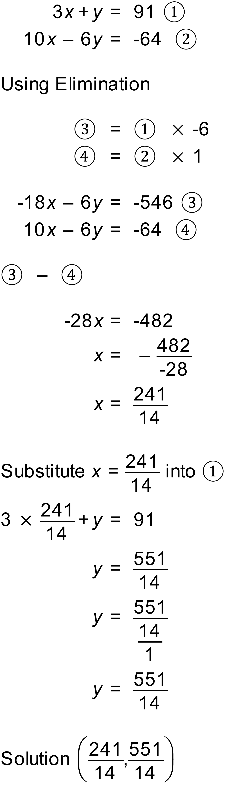
Notes
100000+ variations. Simultaneous equations. Elimination. Rational Solutions
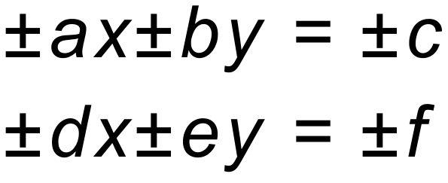

Question
Solve these equations simultaneously. Show all of your working
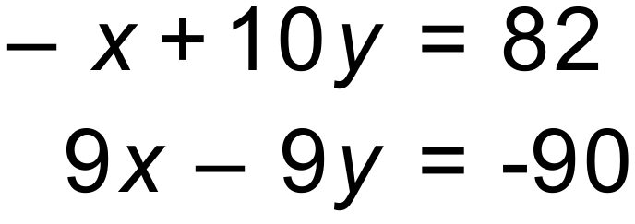
Solution
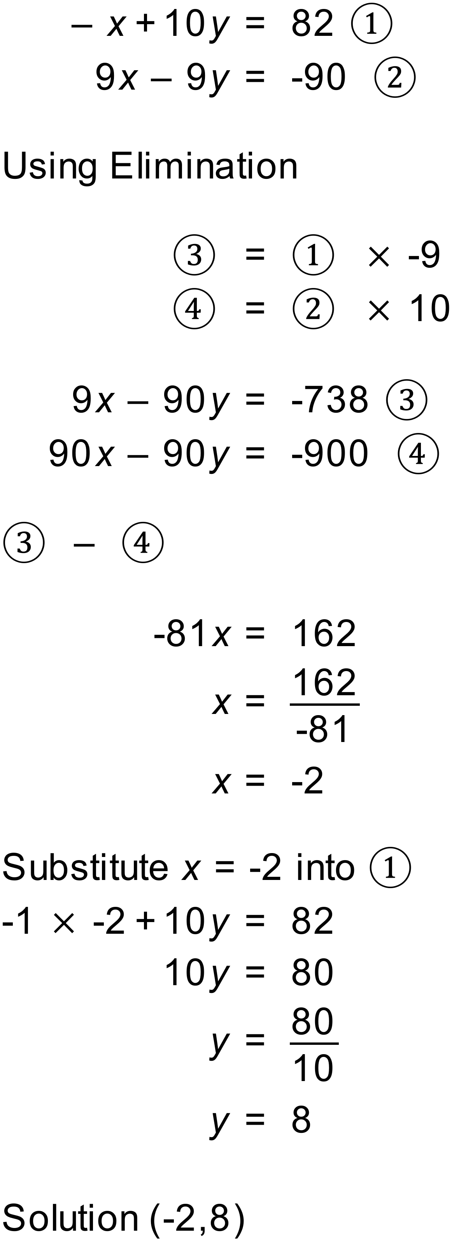
Notes
100000+ variations. Simultaneous equations. Elimination. Integer Solutions

Question
The sum of two numbers is 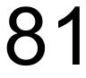 and their difference is 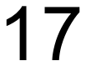. Find the two numbers.
Solution
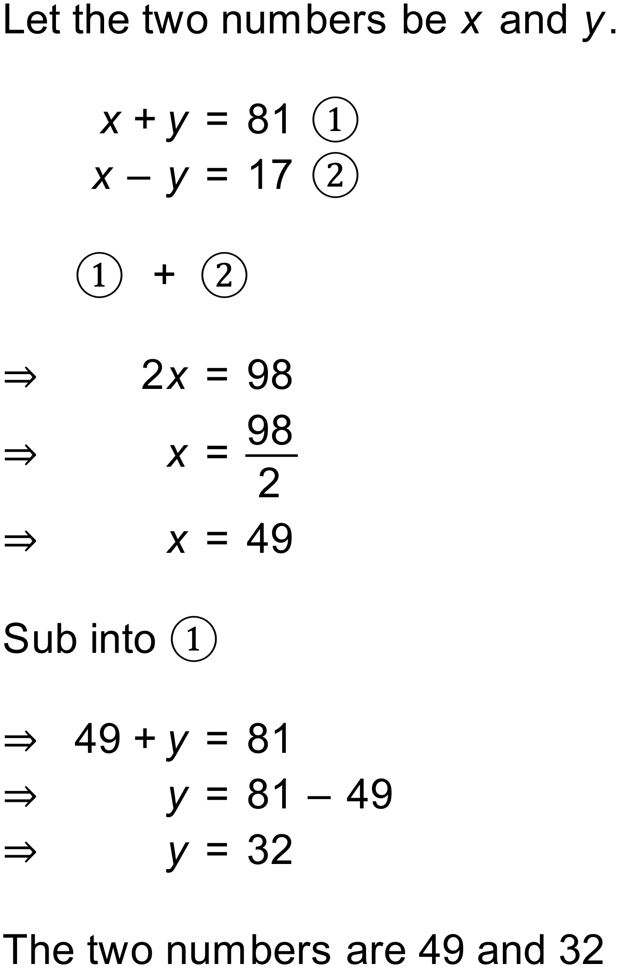
Notes
1500+ variations.

Question
Jamie visits the post office to by two types of stamps: and 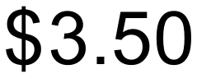. Jamie buys 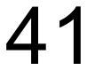 stamps for a total of . How many of each type of stamp did Jamie buy?
Solution
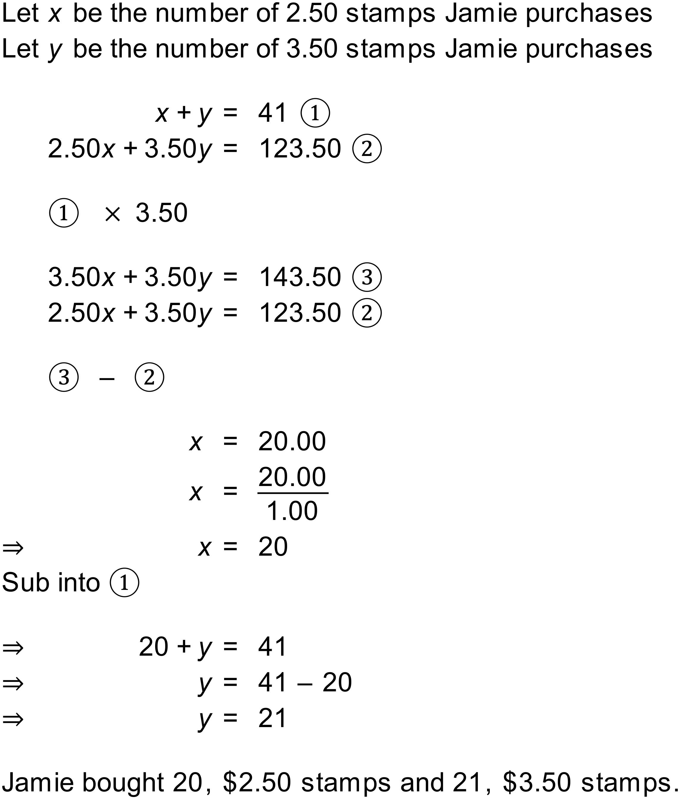
Notes
10000+ variations.
The parameter $p contains a list of available stamp prices. You can change this list to represent local stamp prices if you wish. As supplied, the stamp prices are Australian international small letter stamp prices as at February 2022.
The question uses the $$ code for currency which will automatically be updated to your local currency symbol.

Question
You have been offered two different jobs, by two different employers.
- Employer 1 pays a flat rate of 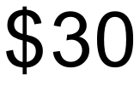per hour
- Employer 2 pays a fixed amount of 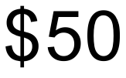 plus 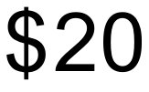 per hour.
Create and solve two simultaneous equations to answer the following questions:
- Find the numbers of hours worked for which the earnings are the same for the two employers.
- Find the amount earned when the earnings are the same from the two employers.
- If you expect to work 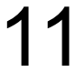 hours per week, which is the best employer to work for and who much extra can you earn?

Solution
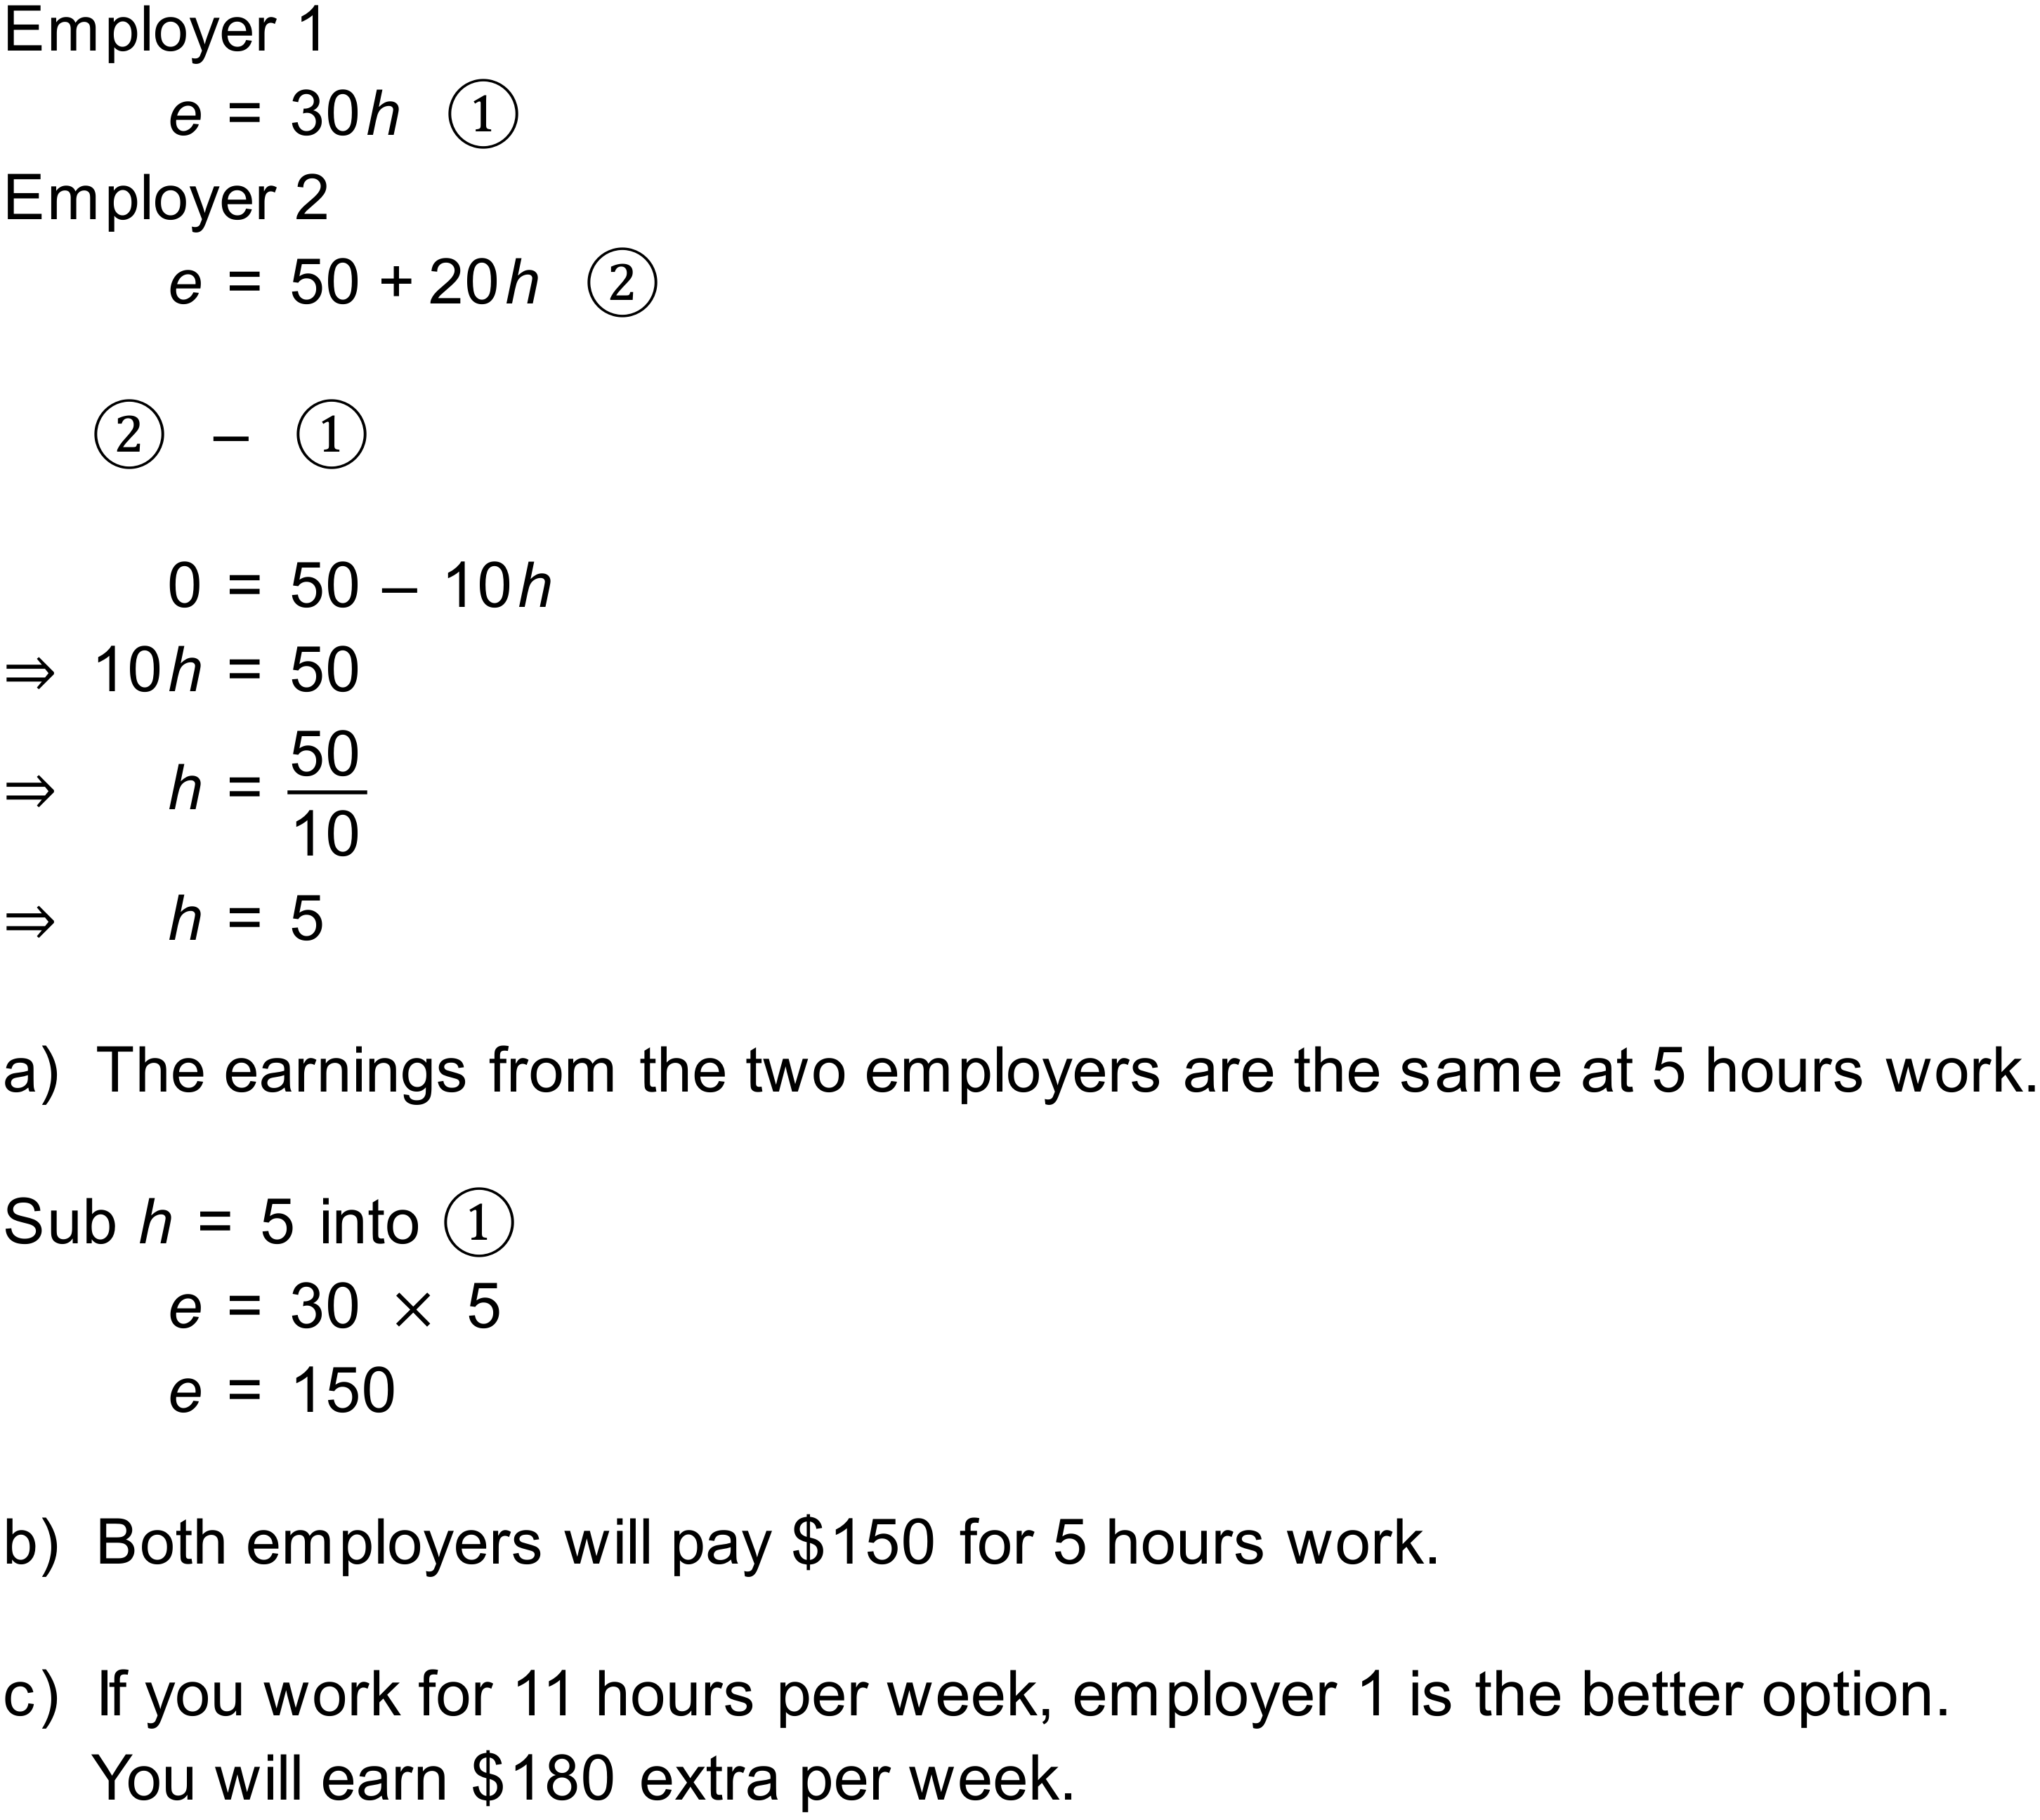
Notes
800+ variations.

Question
A rectangular block of land has a perimeter of 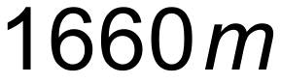 and its length is 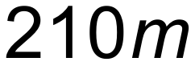 more than it’s width.
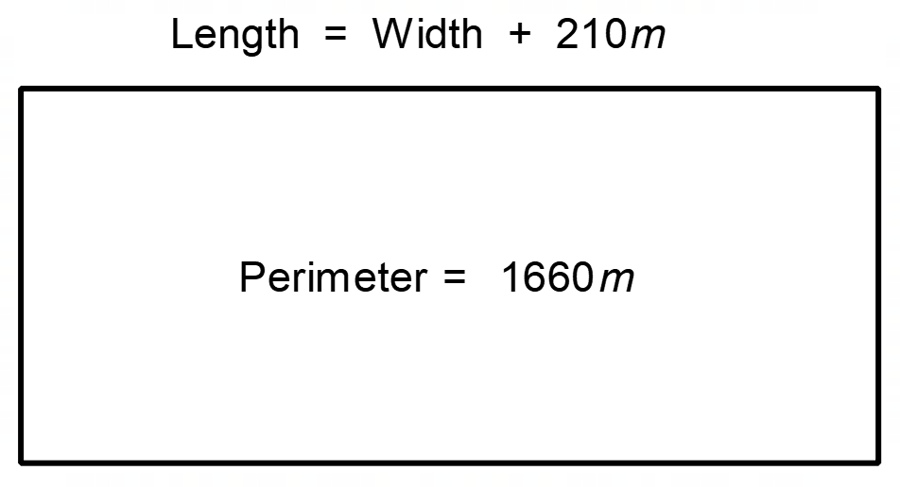
Find the area of the block.
Solution
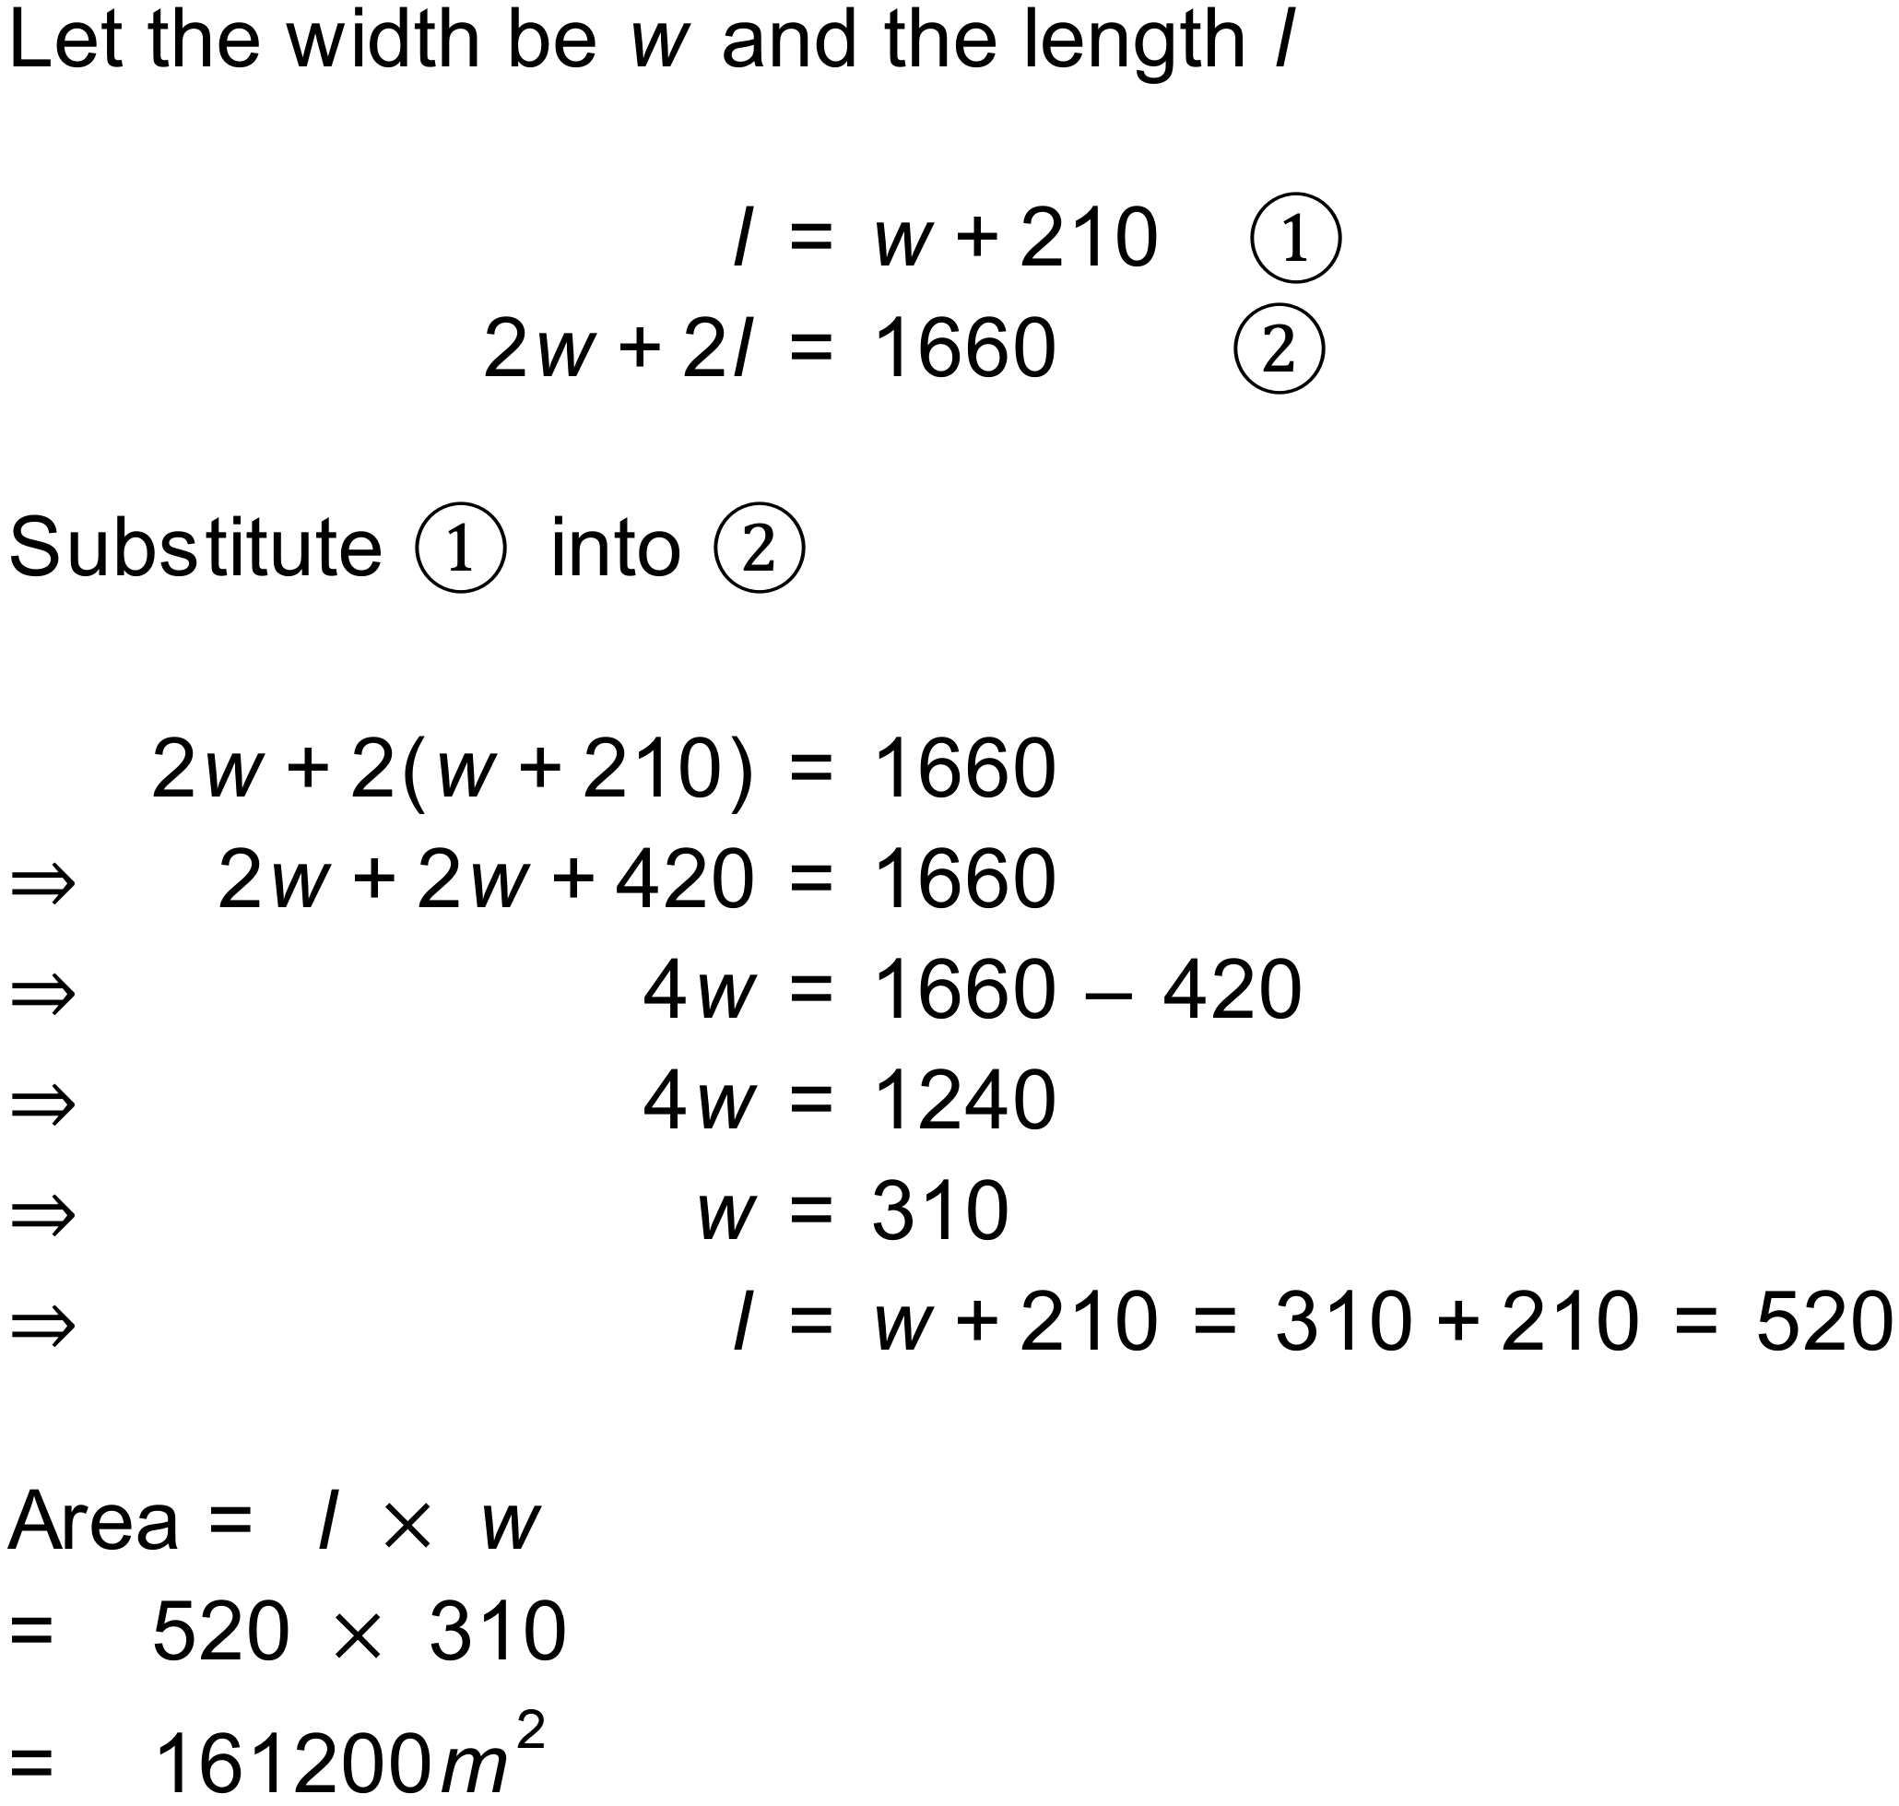
Notes
600+ variations.

Question
Tickets to a show can either be Premium or Standard, depending on where you sit. One group ordered premium tickets and standard tickets for a total of 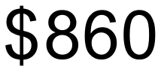 where a second group ordered premium tickets and standard tickets for a total of 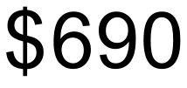. Use this information to find the cost of a premium ticket and a standard ticket.
Solution
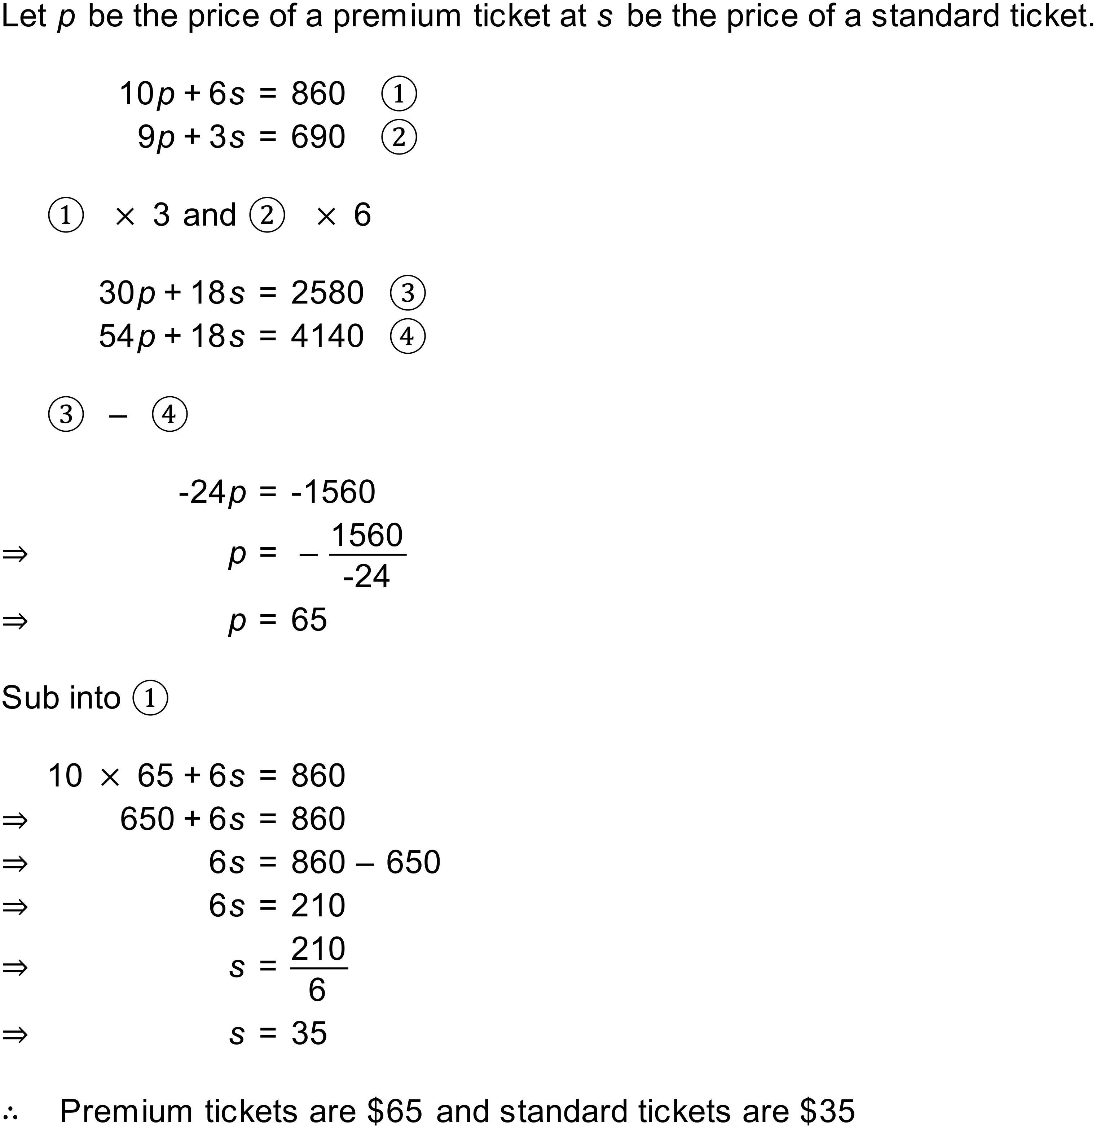
Notes
500000+ variations.

Question
The “All You Can Eat” buffet at a restaurant costs per adult and 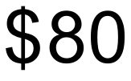 per child. On one particular night, the restaurant served 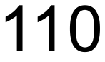 people for a total of . How many adults and how many children were served?
Solution
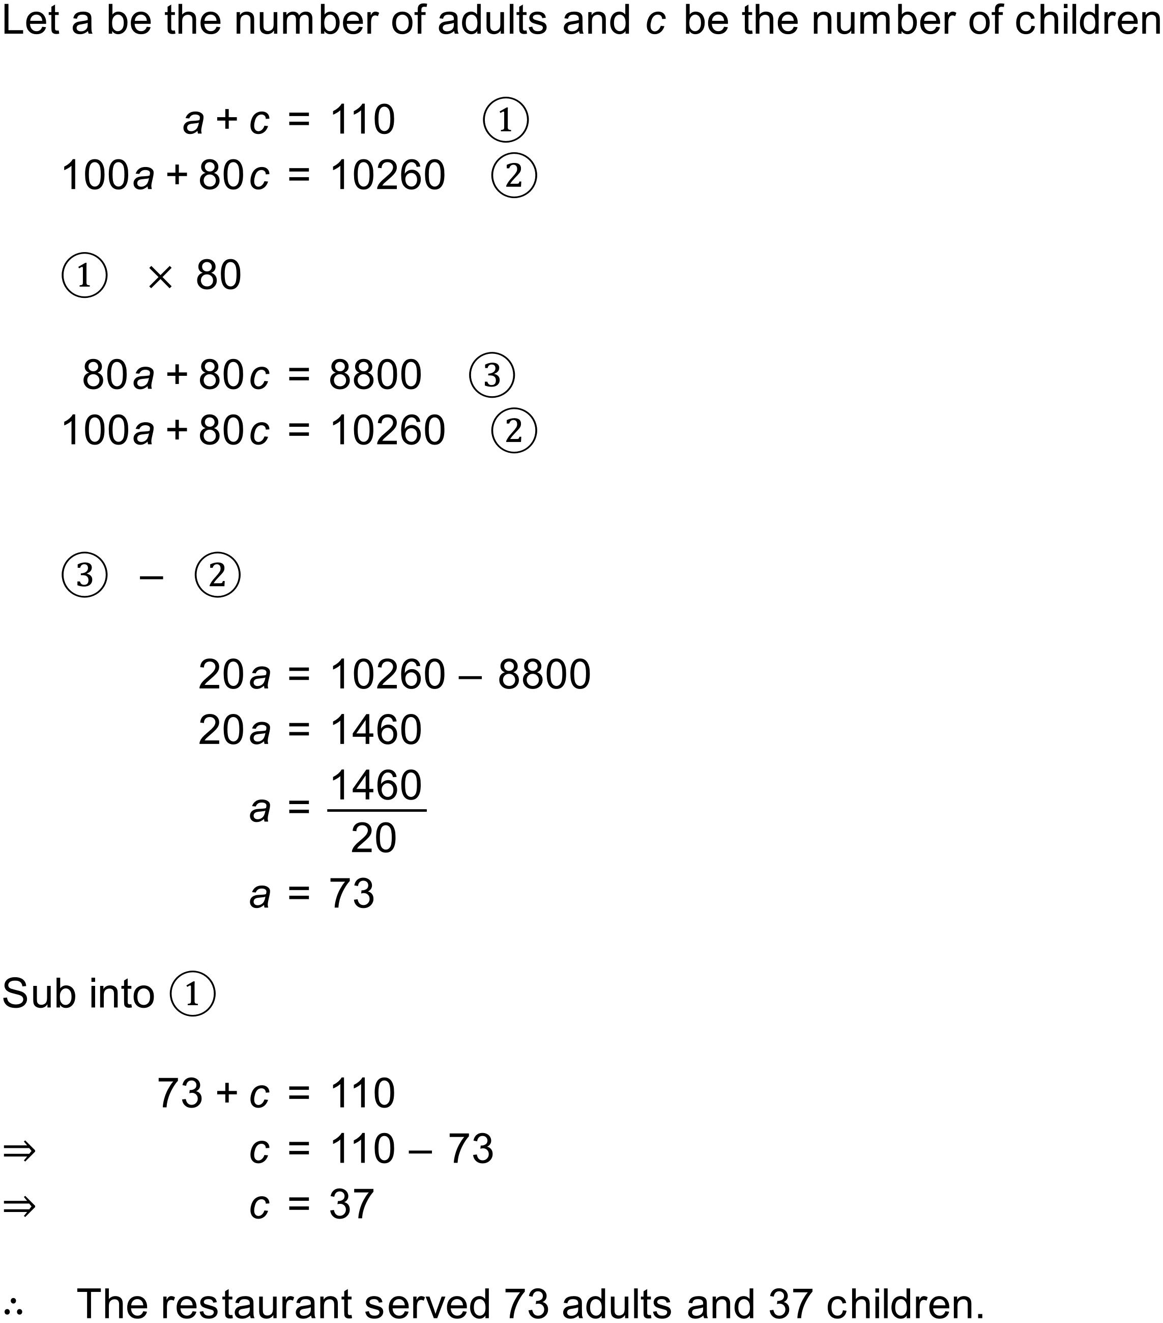
Notes
100000+ variations.

Question
A truck begins a journey travelling at . hours later, a car starts chasing the truck at 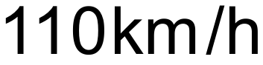. How long will it take the car to catch the truck?
Solution
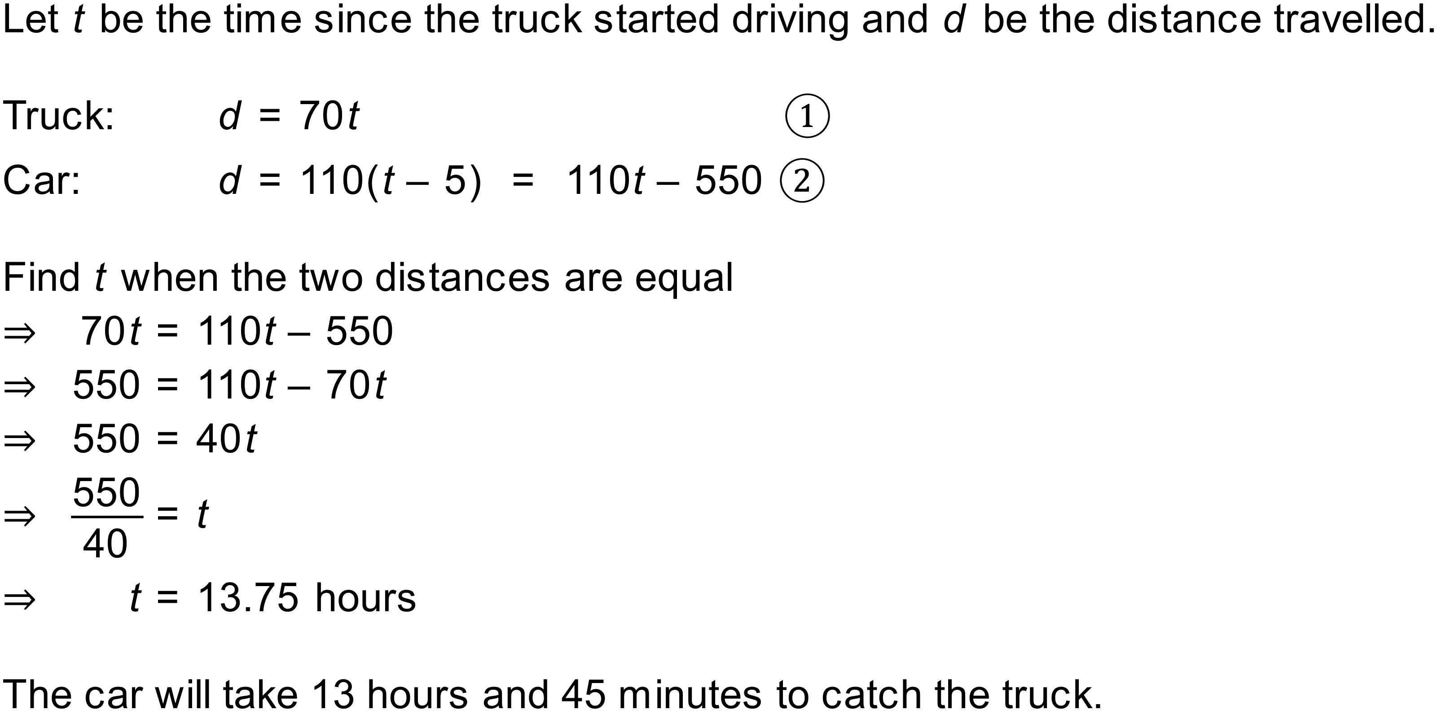
Notes
30 variations.

Question
A school lab technician has a premixed chemical solution with a concentration of . They wish to increase the concentration of the chemical to and do this by adding a different solution with a concentration of of the chemical . When they have finished mixing, they have of solution. How much of the higher concentration solution was added?
Solution
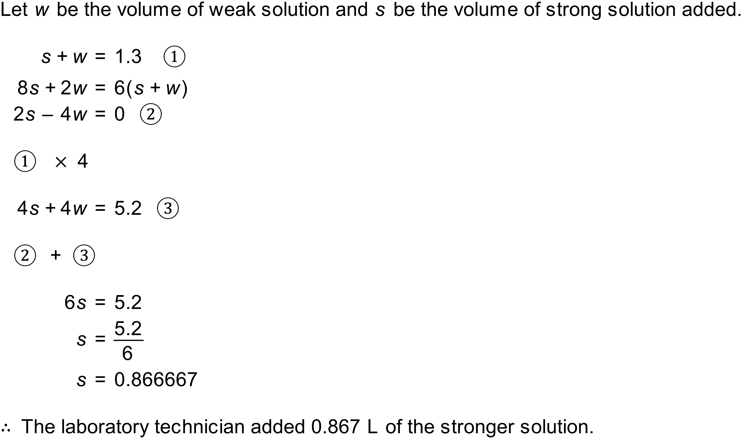
Notes
1500+ variations.

