FX Library Modules

Simple Probability
Age 14-15

Copyright Information
If you are an Efofex subscriber and work in a school, you can copy and/or modify the FX Library materials and use them with your students. We hope that this material will help you write your tests, worksheets, exams, presentations and any other educational materials. You cannot claim copyright over the FX Library materials or present them as your own work.
FAQ

Who are the questions/materials for?
We are providing the materials for teachers in schools. If you are a teacher in a school (or similar context) you are welcome to use the questions/materials freely in just about any manner. Most other usages of our questions/materials are prohibited. In particular, you are expressly prohibited from using our materials in any context where the aim is to generate a profit.
Can I photocopy the questions/materials for use by my students?
YES.
Can I copy questions/materials and paste them into my own documents?
YES.
Do I have to include the Efofex Software copyright notice on my own documents if I have included some of your questions/materials?
NO.
Can I use your questions/materials to generate a profit?
NO.
Can I use the questions/materials on my website/PowerPoint presentation/Moodle...?
It depends. If your usage is within the context of a teacher of students at an educational institution, YES. If you want to use the materials for profit, NO.
I am a home-schooling parent. Can I use your materials?
YES.
I am a student and want to use your products for revision. Can I use them?
YES (but make sure to tell your teachers how good they are!)
Can I modify your questions/materials for my own use?
YES.
If I modify your questions, can I claim copyright?
It depends. If the modifications are substantial, YES. If the modifications are trivial or superficial, NO. Using the Parameter Regeneration feature of our products is NOT a substantial modification
I am a professional tutor. Can I use your materials with my students?
NO.
Can I republish your materials?
NO.
I think that I might be able to use your materials but don't seem to fit any of your FAQs. What do I do?
Send us an email describing what you want to do (to info@efofex.com) and we will get back to you as soon as possible.

How To Use This Material
Copy a question from this document and paste (with reparametizing) into your document. This allows you to quickly build a collection of regeneratable questions into a test, worksheet, presentation or exam.

Question
A letter is chosen from the word Find the probability that the chosen letter is:
- A vowel
Solution
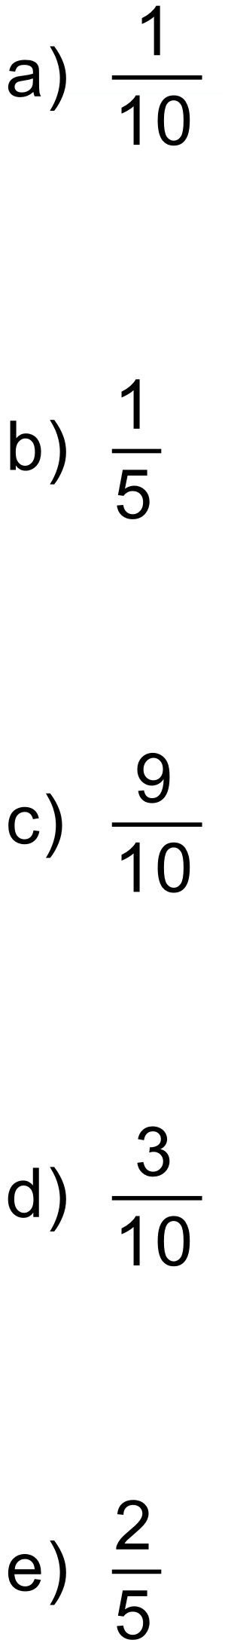
Notes
10000+ variations
Question
An experiment is conducted where three coins are tossed and the number of heads is recorded. The experiment is repeated 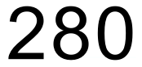 times and the results are shown below.
Number of heads | 0 | 1 | 2 | 3
Frequency | 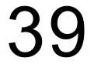 | 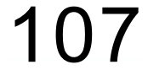 | 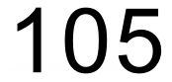 | 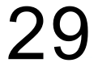

Using the information in the table, find the experimental probability of throwing:
- All heads

- One head.

- At least one head.

Solution
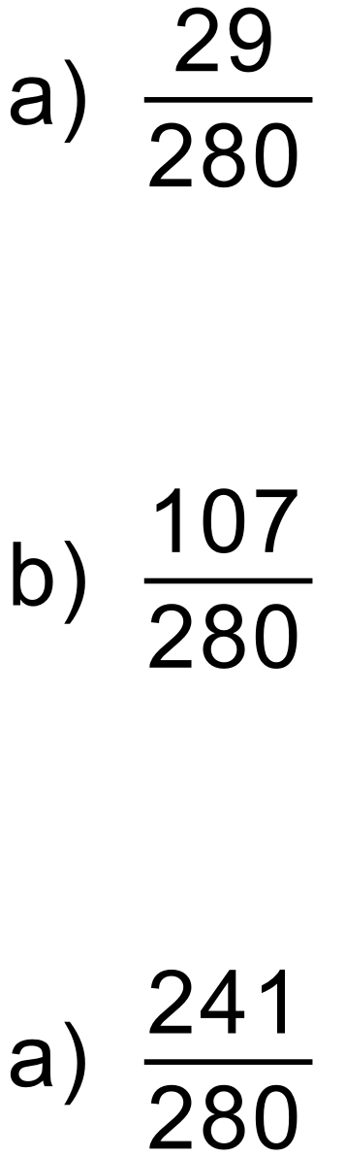
Notes
10000+ variations
Question
An online gaming company records how many failed connections there were to their servers during each hour. They have recorded the results for the past 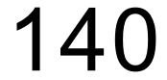 hours in the table below.
Failed Connections | 0 | 1 | 2 | 3 | 4 | 5
Frequency |  | 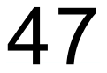 |  | 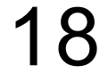 | 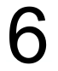

Determine the experimental probability that there will be:
- No failed connections during an hour.

- At most 2 failed connections during an hour.

If there are more than 3 failed connections in an hour, the server is automatically rebooted to ensure that gamers’ response times are kept to a minimum.
- What is the probability that a server will be automatically rebooted?

Solution
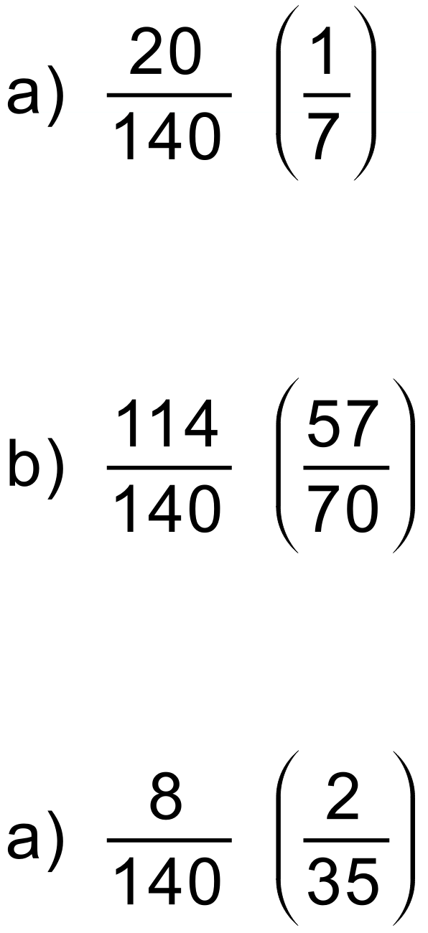
Notes
1000+ variations
Question
A bag contains red, green and blue marbles. A marble is drawn from the bag and then replaced. This happens times with a blue marble being drawn 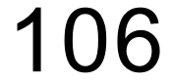 times.
Which of the following is the most likely combination of marbles in the bag?

Solution
Notes
10000+ variations
Question
Year 10 students were asked if they liked studying Mathematics and English. Of the group, 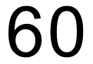 enjoyed studying Mathematics, 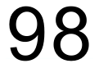 enjoyed studying English. Of those students, 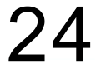 enjoyed studying both subjects.
- Show this information on a Venn diagram.

- How many students enjoyed studying Mathematics only?

- How many students did not enjoy studying either subject?

- If a student is chosen at random, what is the probability that they enjoy studying English?

- If a student is chosen at random, what is the probability that they enjoy studying both subjects?
Solution

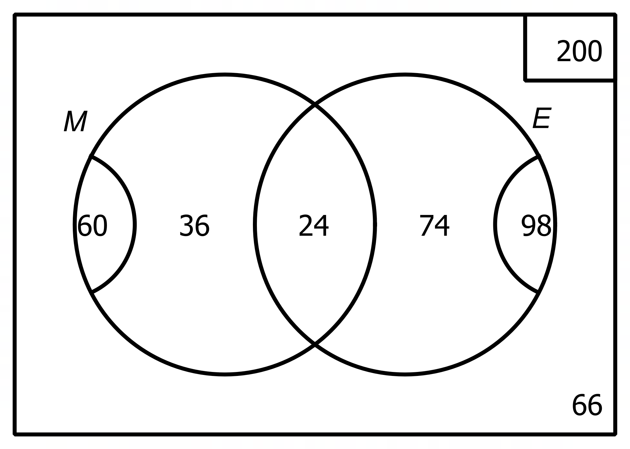

- 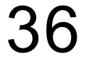

- 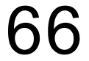

- 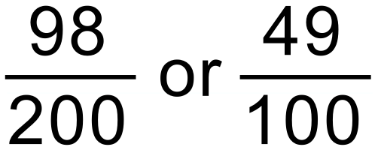

- 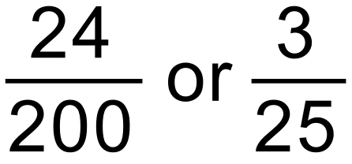
Notes
30000+ variations
Question
Sets A and B are numbers taken from the first 12 positive integers.
- List the numbers which are in

- List the numbers which are in

A number is chosen, at random, from the first 12 positive integers. Find:
- The probability that the number is in set A

- The probability that the number is in set B and not in set A

- The probability that the number is not in A or B
Solution
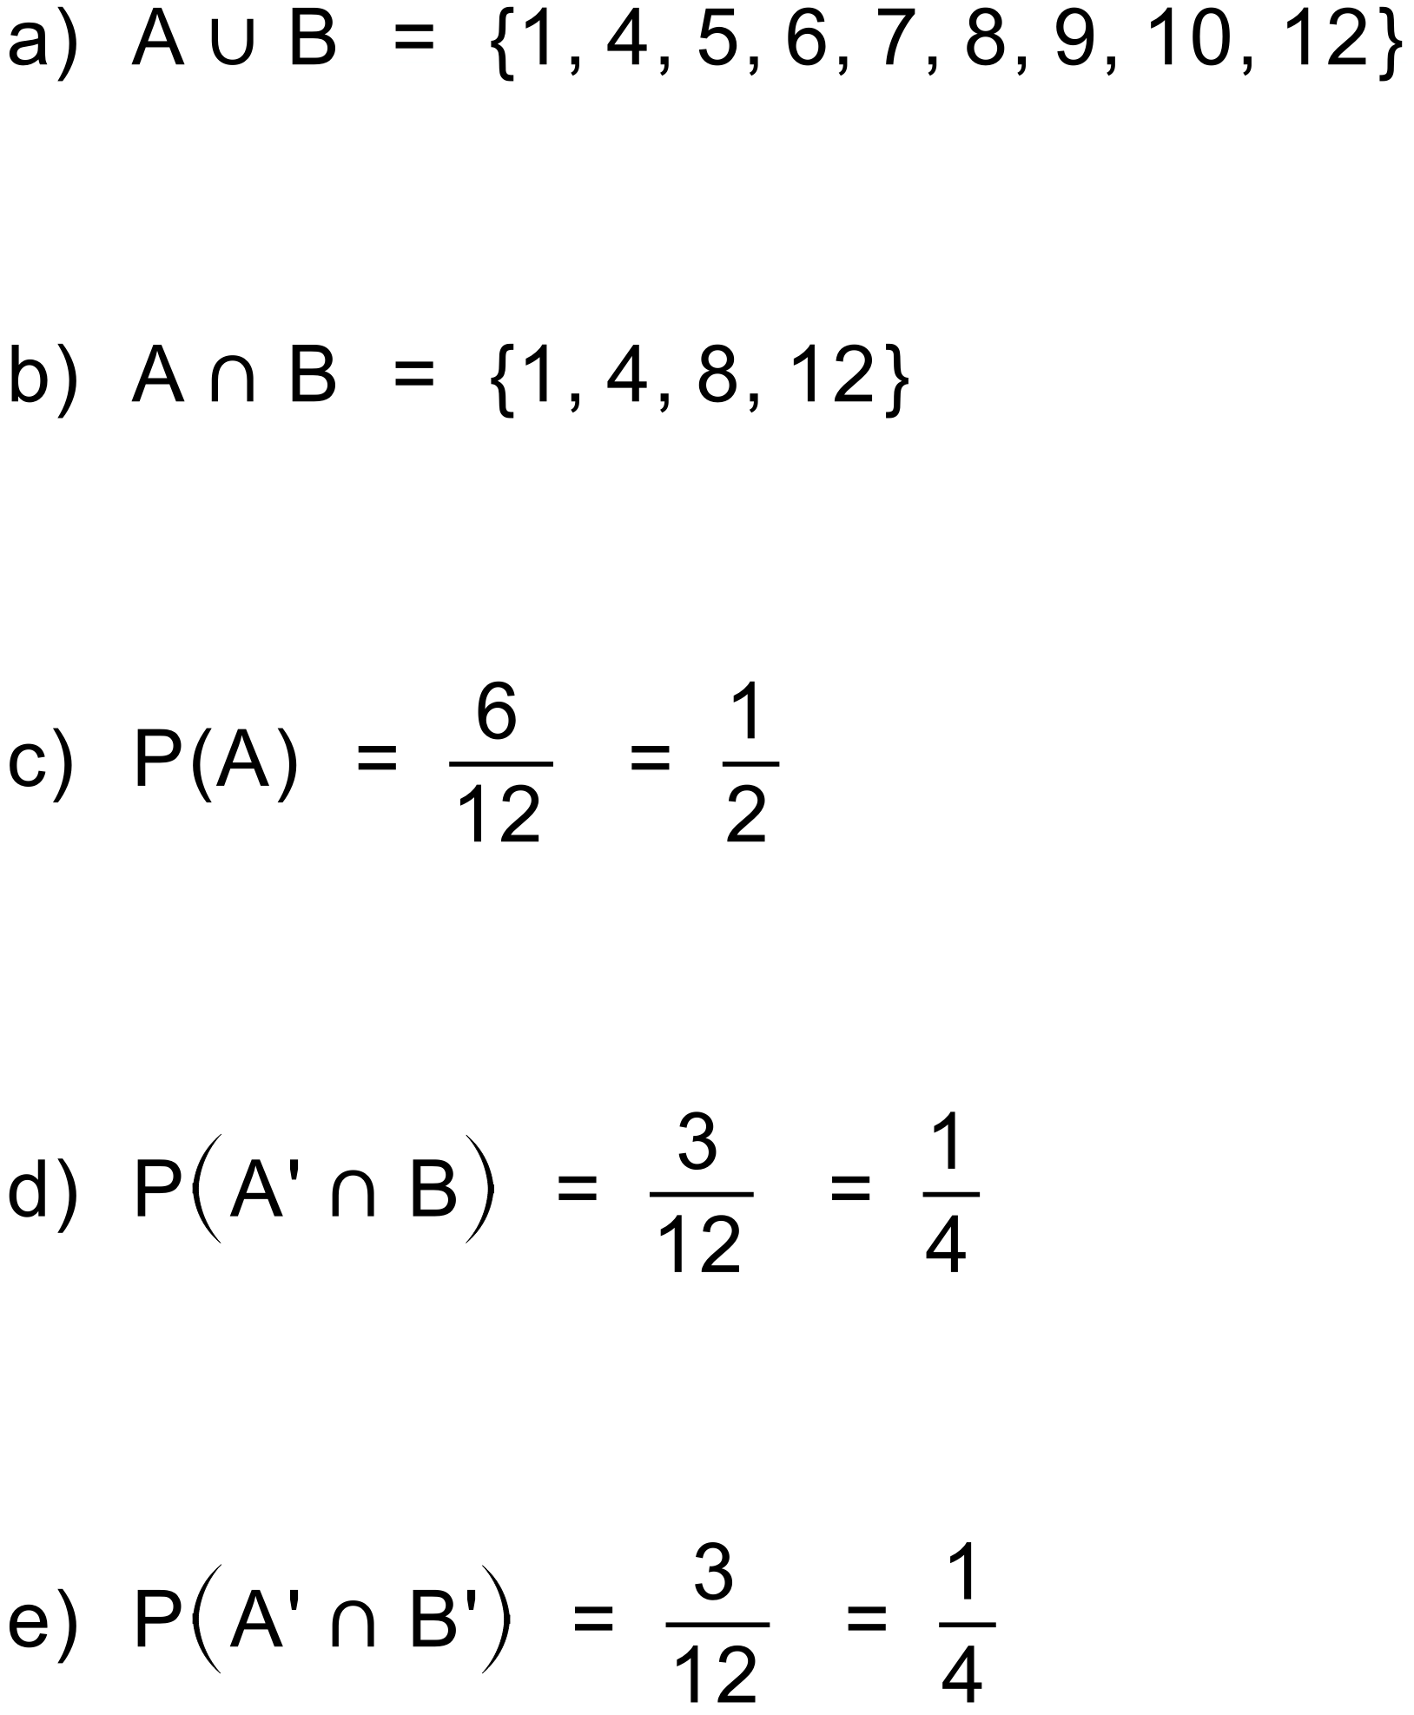
Notes
10000+ variations
Question
The Venn diagram below shows the number of elements in two sets, A and B.
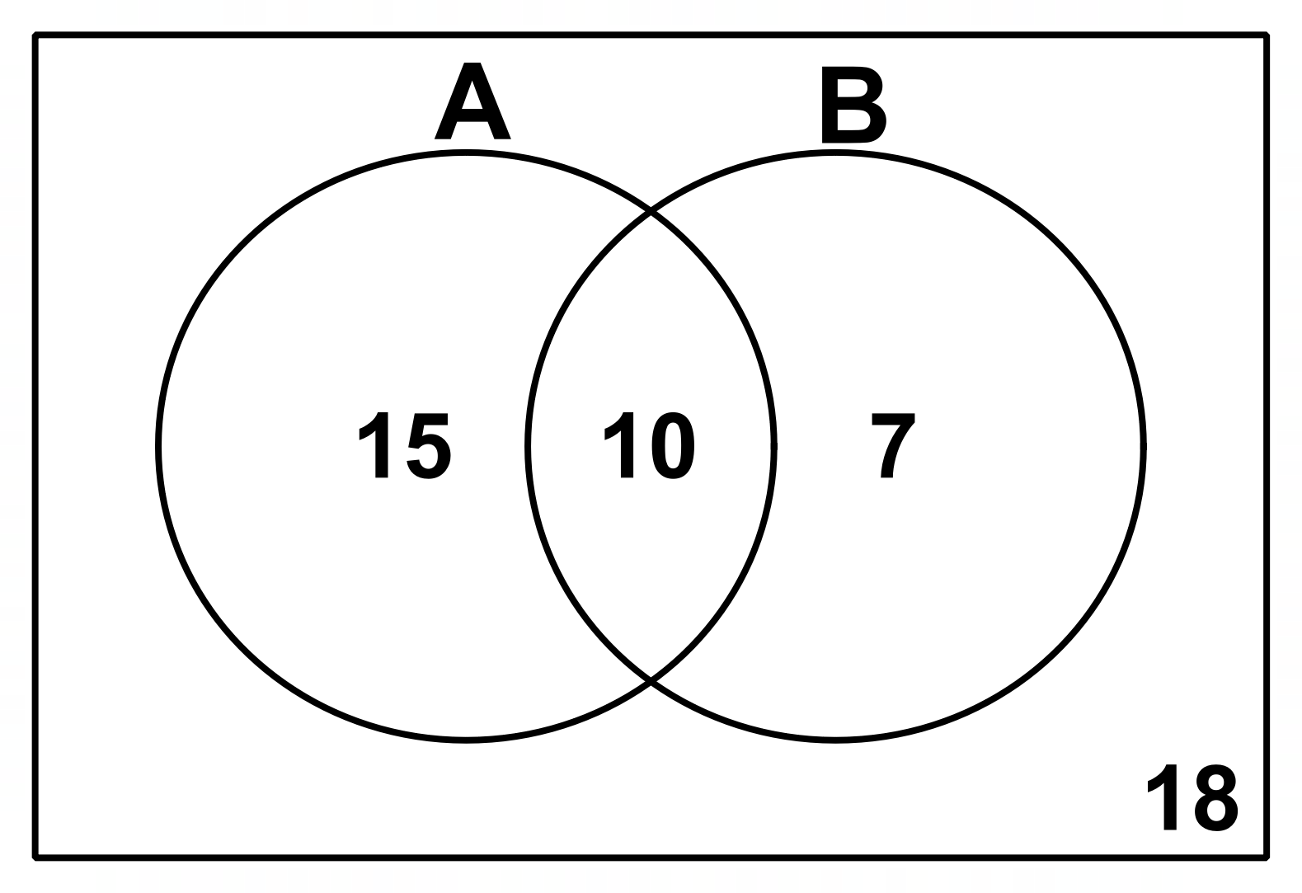
Find:
- 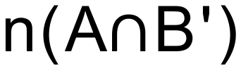

- 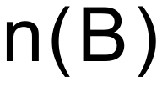

- 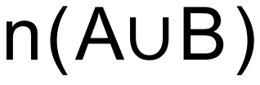

- 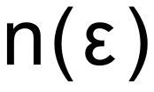

If a element is selected at random, find the following probabilities.

- 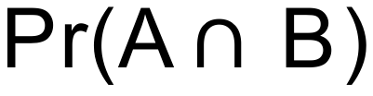
Solution
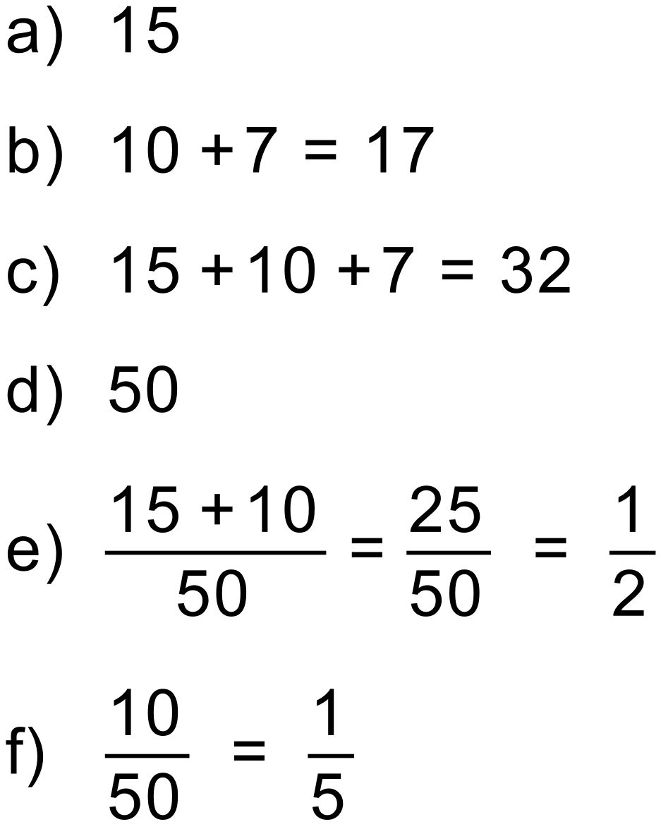
Notes
2000+ variations
Question
A survey of people showed that 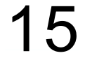 people liked tea (T), people liked coffee (C) and people liked both tea and coffee.
- Show this information on a Venn diagram.

- How many people did not like tea or coffee?

- Use your Venn diagram to find 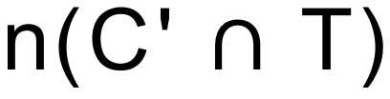

- Use your Venn diagram to find 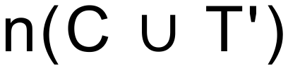
Solution
a)
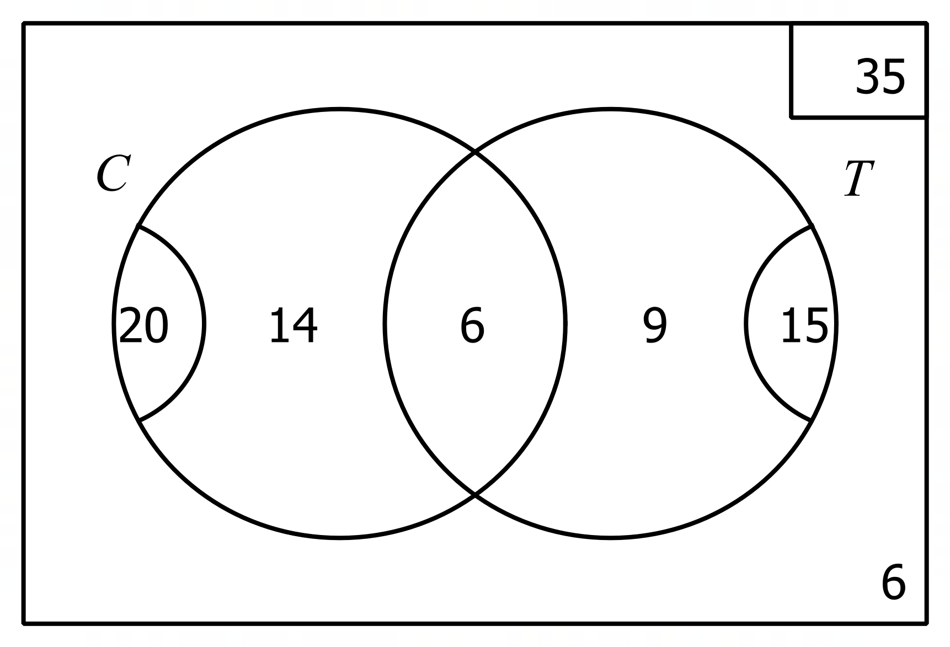
b)
c)
d) 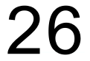
Notes
250+ variations

Question
Complete this two-way table.

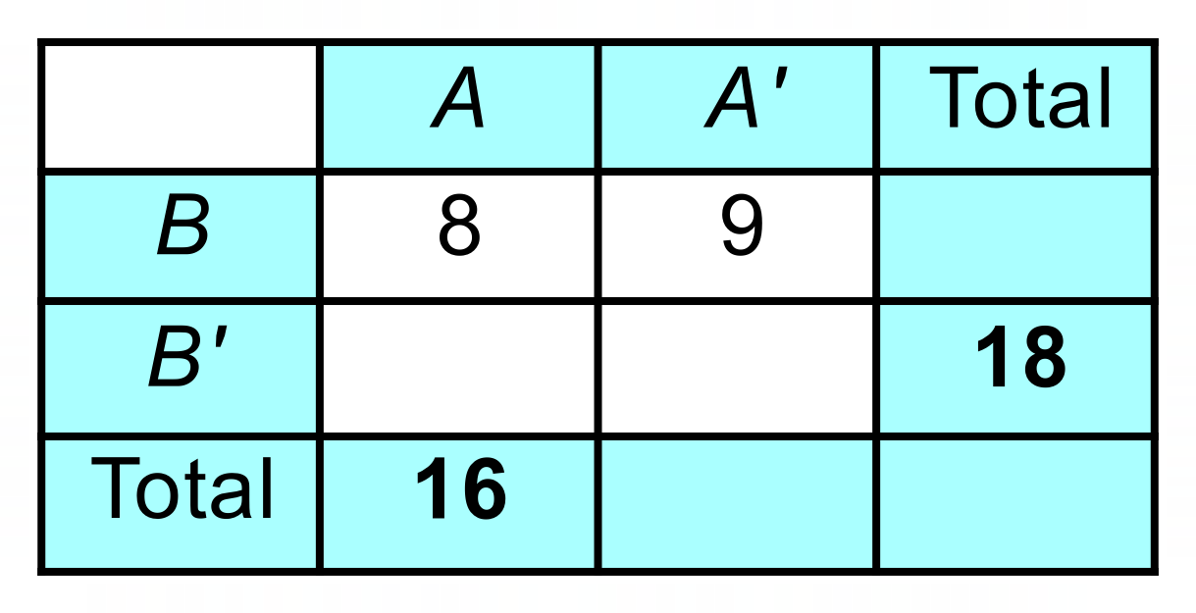
Use your complete two-way table to calculate these probabilities.

- 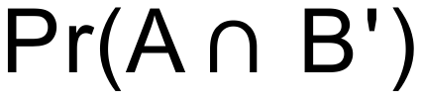

- 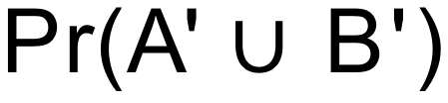
Solution

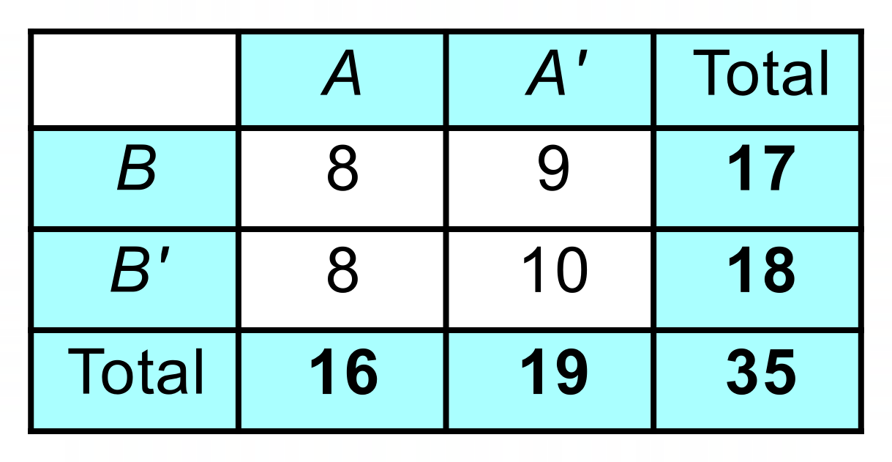
- 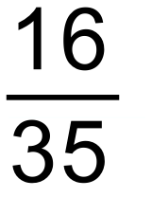
- 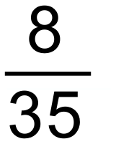
- 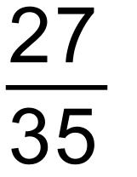
Notes
250+ variations

Question
If set A = 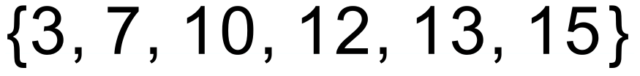 and set B = , what elements need to be removed from the two sets to make the sets mutually exclusive.
Solution
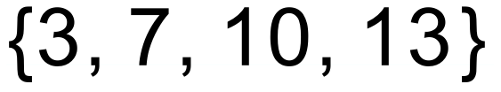
Notes
2000+ variations

Question
A card is selected at random from a standard deck of 52 playing cards.

Solution
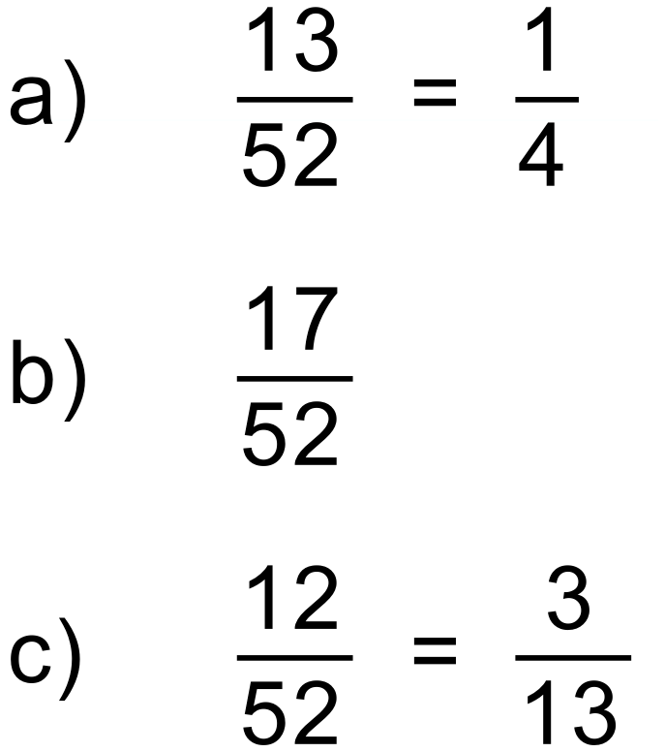
Notes
10 variations

Question
Two events, A and B, occur with the following probabilities:
Use this information to find:

- 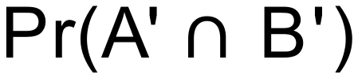

- 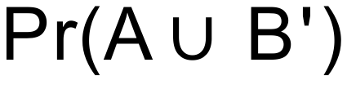
Solution
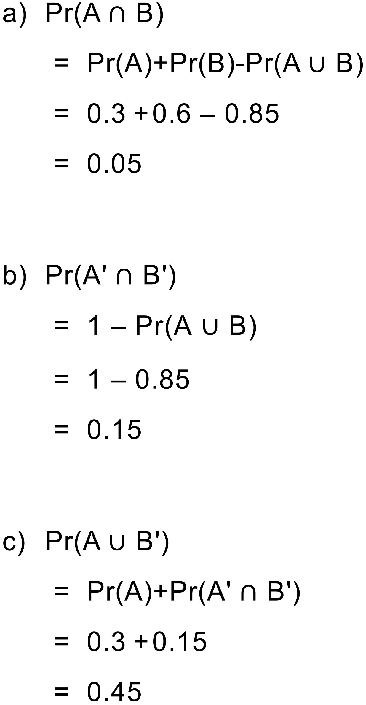
Notes
800+ variations
Question
Two six-sided dice are thrown, and the scores added together.
- Show the possible outcomes in a table.

- Find the probability that the scores add up to 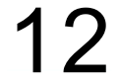.

- Find the probability that the scores add up to at least 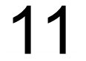.

- Find the probability that the scores add to an even number.

Solution
 | 1 | 2 | 3 | 4 | 5 | 6
1 | 2 | 3 | 4 | 5 | 6 | 7
2 | 3 | 4 | 5 | 6 | 7 | 8
3 | 4 | 5 | 6 | 7 | 8 | 9
4 | 5 | 6 | 7 | 8 | 9 | 10
5 | 6 | 7 | 8 | 9 | 10 | 11
6 | 7 | 8 | 9 | 10 | 11 | 12
a)
b) 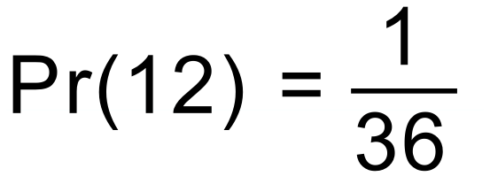
c) 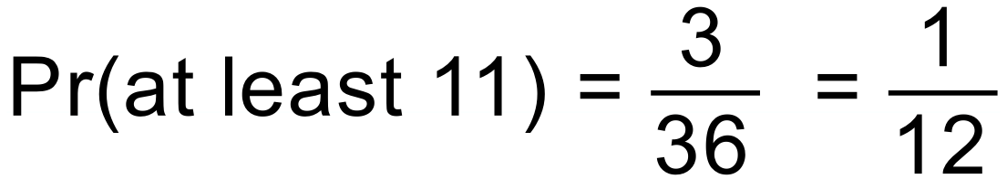
d) 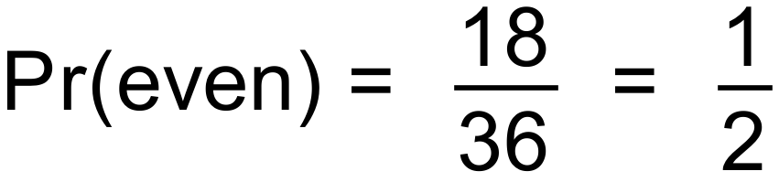
Notes
50+ variations

