FX Library

Semicircle Areas

Copyright Information
If you are an Efofex subscriber and work in a school, you can copy and/or modify the FX Library materials and use them with your students. We hope that this material will help you write your tests, worksheets, exams, presentations and any other educational materials. You cannot claim copyright over the FX Library materials or present them as your own work.
FAQ

Who are the questions/materials for?
We are providing the materials for teachers in schools. If you are a teacher in a school (or similar context) you are welcome to use the questions/materials freely in just about any manner. Most other usages of our questions/materials are prohibited. In particular, you are expressly prohibited from using our materials in any context where the aim is to generate a profit.
Can I photocopy the questions/materials for use by my students?
YES.
Can I copy questions/materials and paste them into my own documents?
YES.
Do I have to include the Efofex Software copyright notice on my own documents if I have included some of your questions/materials?
NO.
Can I use your questions/materials to generate a profit?
NO.
Can I use the questions/materials on my website/PowerPoint presentation/Moodle...?
It depends. If your usage is within the context of a teacher of students at an educational institution, YES. If you want to use the materials for profit, NO.
I am a home-schooling parent. Can I use your materials?
YES.
I am a student and want to use your products for revision. Can I use them?
YES (but make sure to tell your teachers how good they are!)
Can I modify your questions/materials for my own use?
YES.
If I modify your questions, can I claim copyright?
It depends. If the modifications are substantial, YES. If the modifications are trivial or superficial, NO. Using the Parameter Regeneration feature of our products is NOT a substantial modification
I am a professional tutor. Can I use your materials with my students?
NO.
Can I republish your materials?
NO.
I think that I might be able to use your materials but don't seem to fit any of your FAQs. What do I do?
Send us an email describing what you want to do (to info@efofex.com) and we will get back to you as soon as possible.

How To Use This Material
Copy a question from this document and paste (with reparametizing) into your document. This allows you to quickly build a collection of regeneratable questions into a test, worksheet, presentation, or exam.

Question
A series of shapes are constructed from semicircles. The first shape is one large semicircle on the bottom with two smaller semicircles – with radii exactly half of the bottom semicircle – on the top.
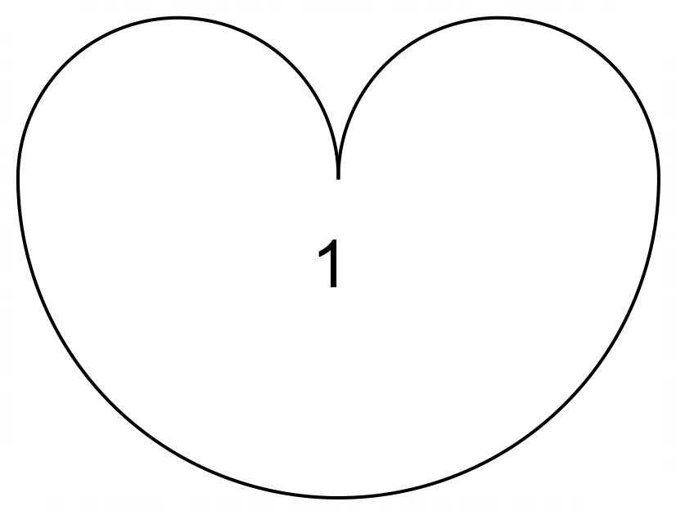
Each subsequent shape is produced by replacing the rightmost semicircle with two smaller semicircles of half the radius.

The next four shapes are shown below.
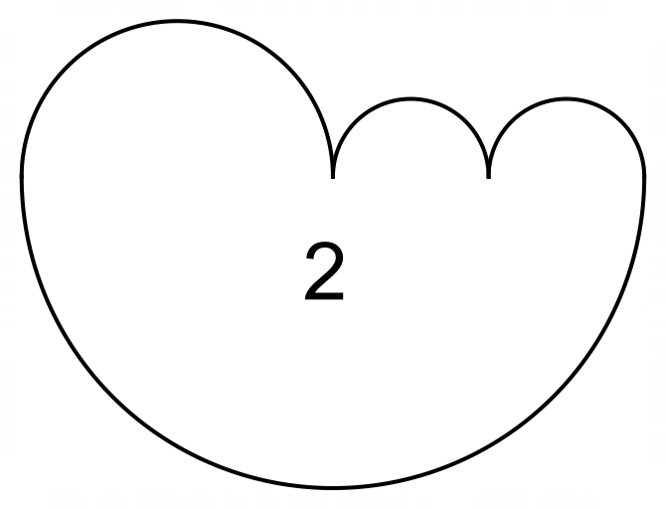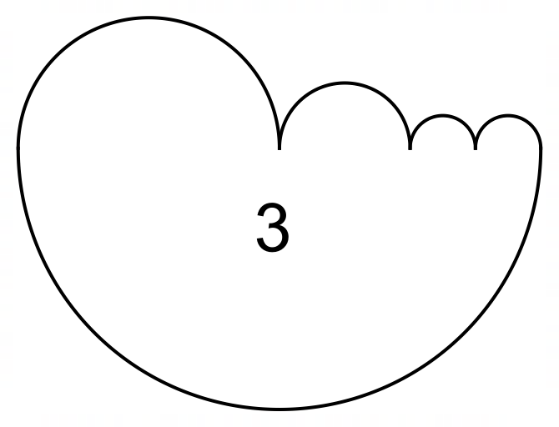
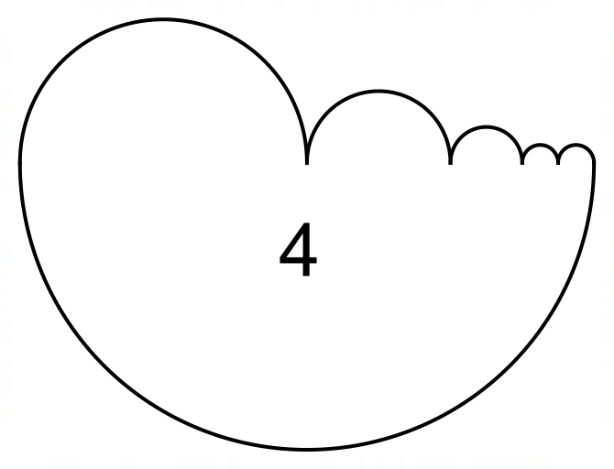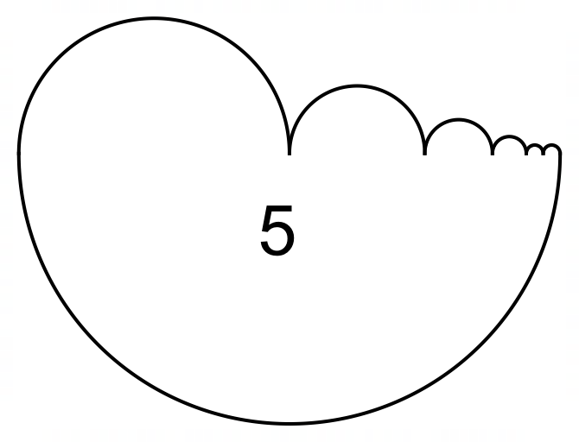
Assume that the radius of the first semicircle is 1.
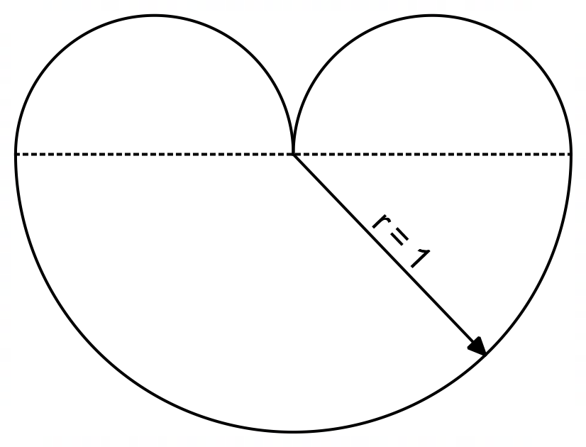
- Calculate the area of the first shape shown above.

As we build further shapes, the area will decrease.

- Calculate the areas of the next four shapes in the sequence. You need to show all working.

You may have noticed that the areas are almost based on a geometric sequence.

- Use your calculations, and your knowledge of geometric series, to devise a formula that allows you to calculate the area of the n^{th} shape in the sequence.

- Use your formula to calculate the area of the 7th shape in the series. Round your answer to 6 decimal places.

It is noted that you can continue this process an infinite number of times.

- Use your knowledge of infinite geometric series to calculate the area of the shape produced if you continue the process an infinite number of times. Comment on any assumptions you have made.

- Determine if the PERIMETER of the shapes converges or diverges.

Solution
For these solutions we are using the formula 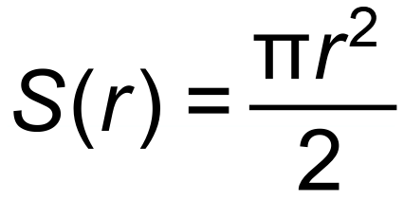 for the area of a semicircle.

- 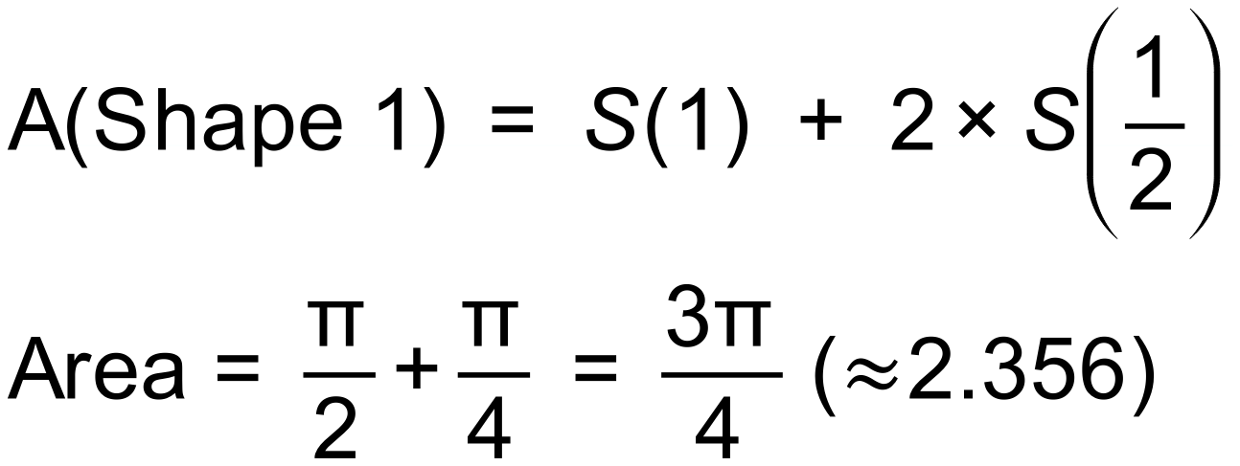

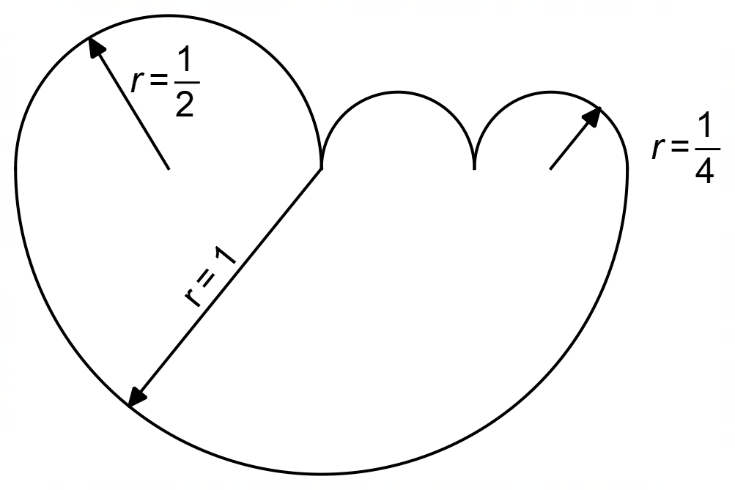
- 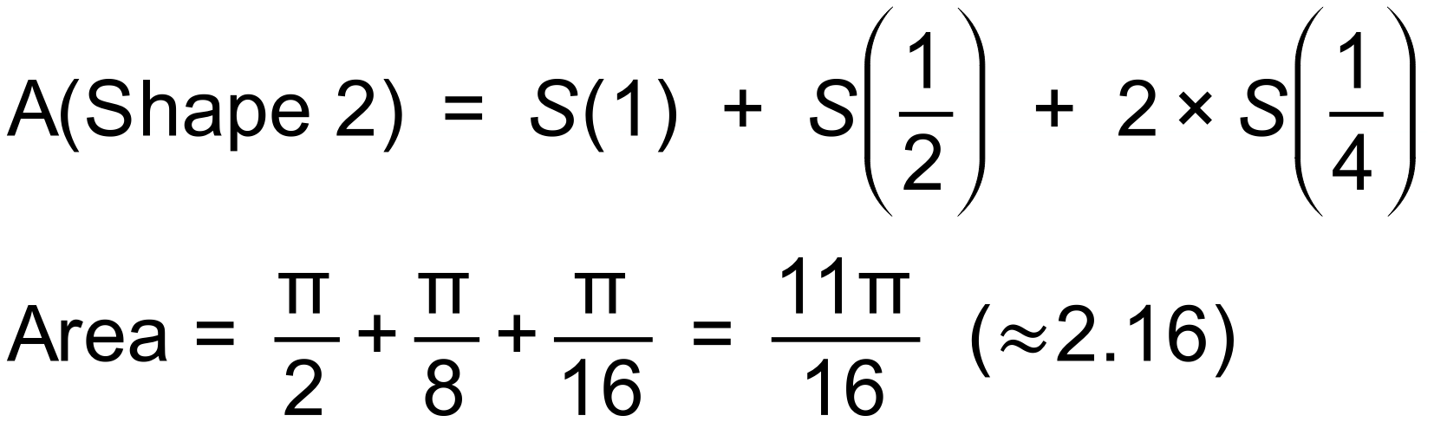

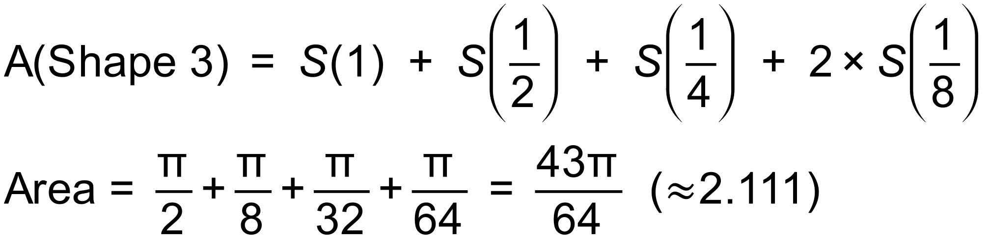

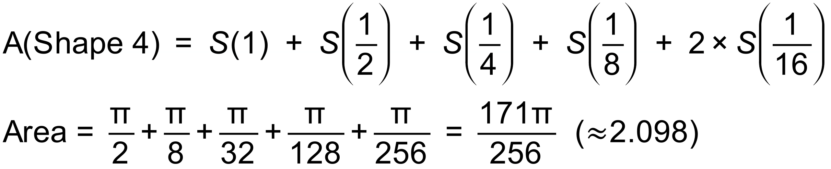

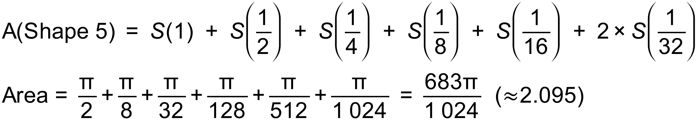

- The most crucial thing to note is that all but the last term in each sum is a geometric sequence where 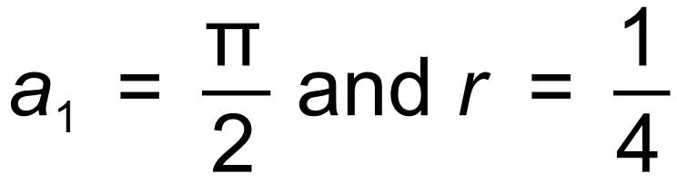. For example, for the 5th shape in the sequence:

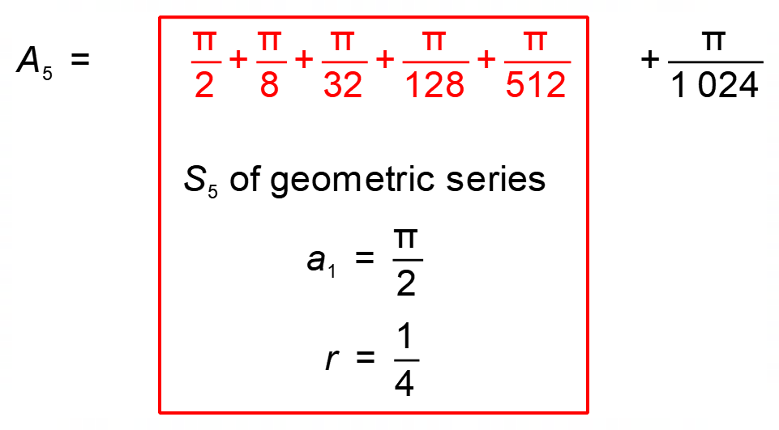

Alternatively, we can take a common factor out before looking at the sum.

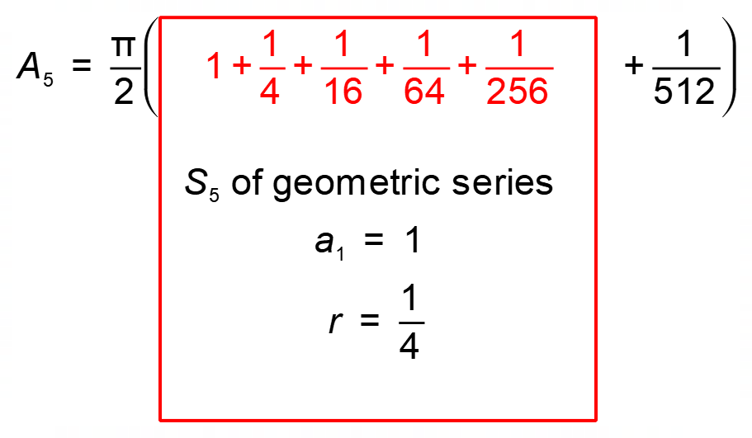

Using 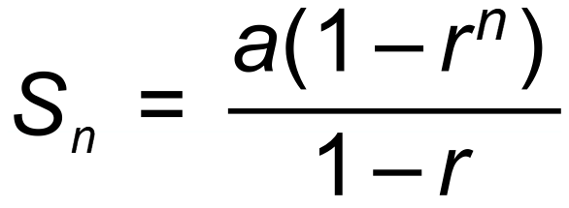
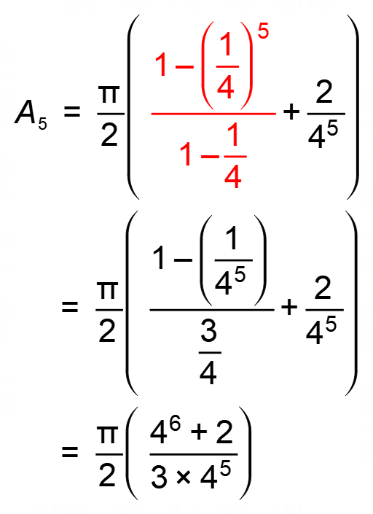
In general:
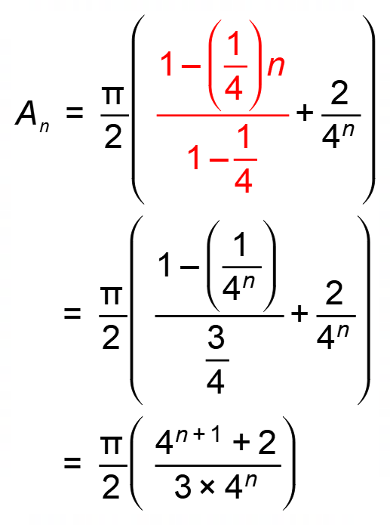

Note: There are numerous ways of simplifying this equation which could look quite different. Also note that both the numerator and denominator of the formula are divisible by 6 but this is an unlikely simplification for most students.

- Using our formula
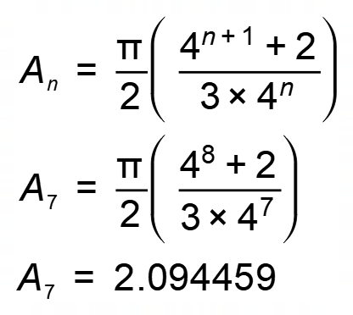

- Going back to our original construction of the formula, we noted that it was based on the sum of a geometric series.
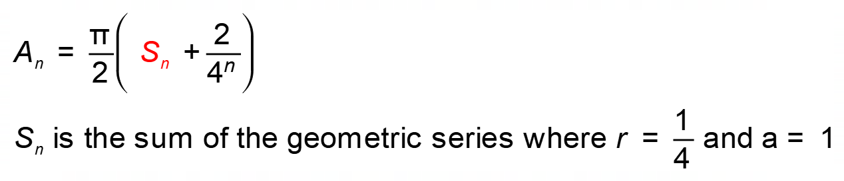
We can use this information to calculate the area of 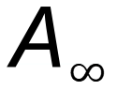.
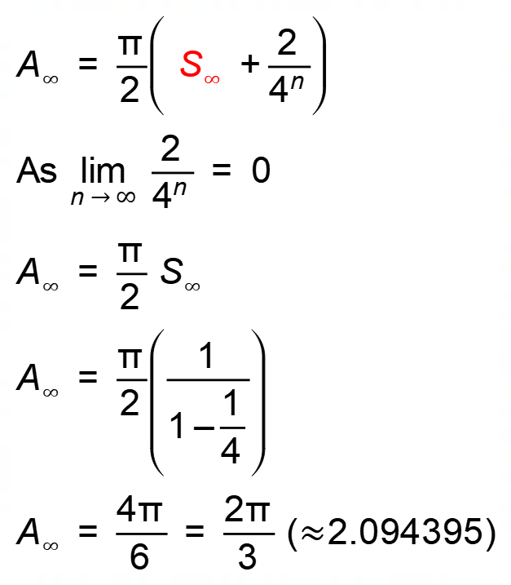

- Let’s examine the perimeters of shapes 1 and 2.
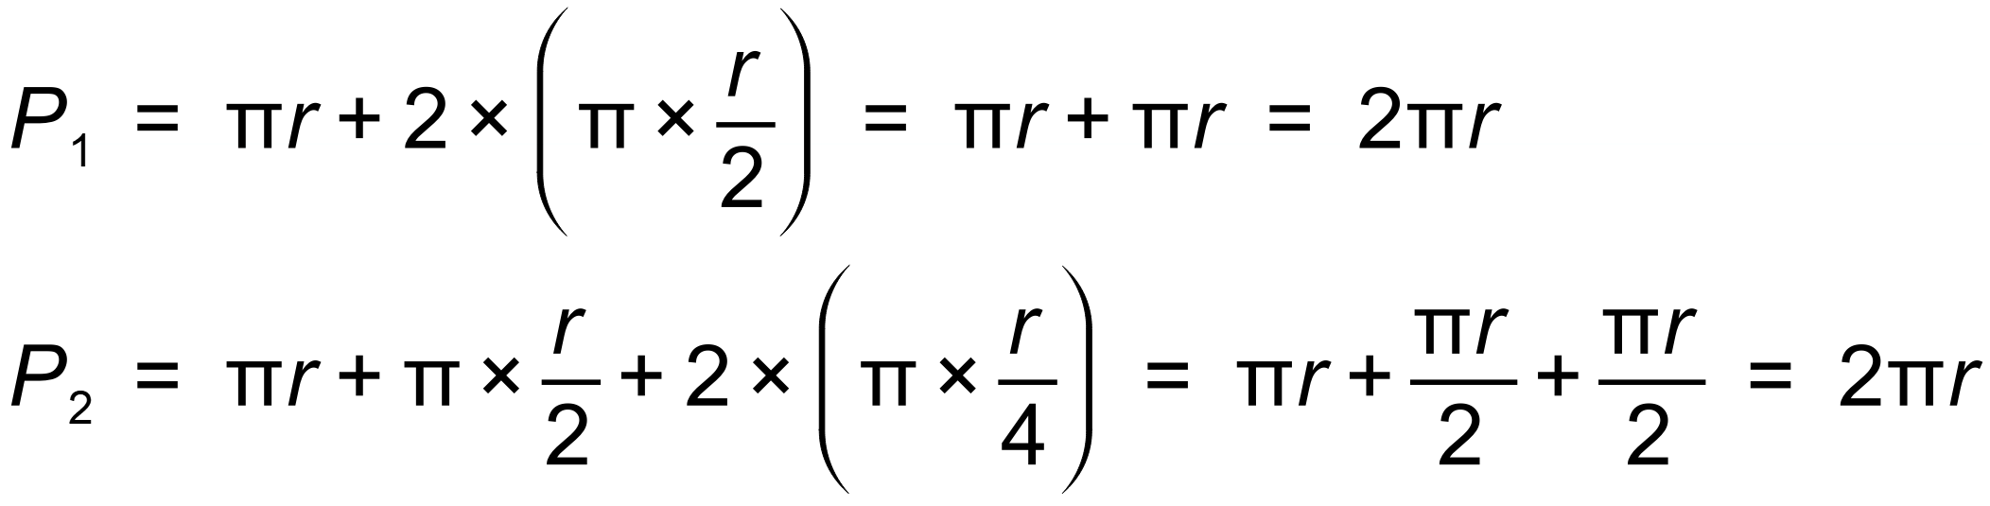
This leads to the interesting result that the procedure does not change the perimeter! It neither converges or diverges, it just stays the same.

Notes
This question is an interesting extension to the sum of a geometric series. It requires students to use their knowledge of geometric series in a new context.

