Quad Quandary
A farmer has portable fence made of four sections that are joined together. The sections are 5m, 9m, 8m and 7m long IN THAT ORDER. It is important to note that the order cannot be changed.

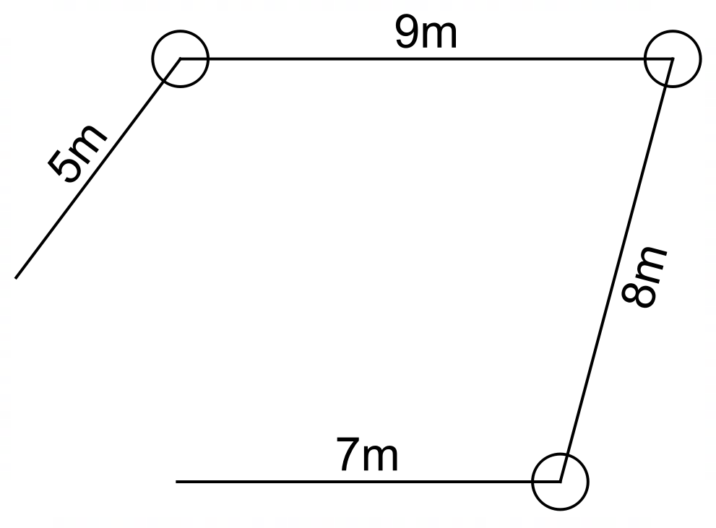
The sections are hinged together so that the shape can be changed and the 5m and 7m section can be joined to enclose a quadrilateral.

When the quadrilateral is formed, the sides can be moved to change the shape of the quadrilateral.

Determine how the sections should be placed so that the area of the quadrilateral is maximised and what is the maximum possible area. You will need to calculate the angles between the sides.

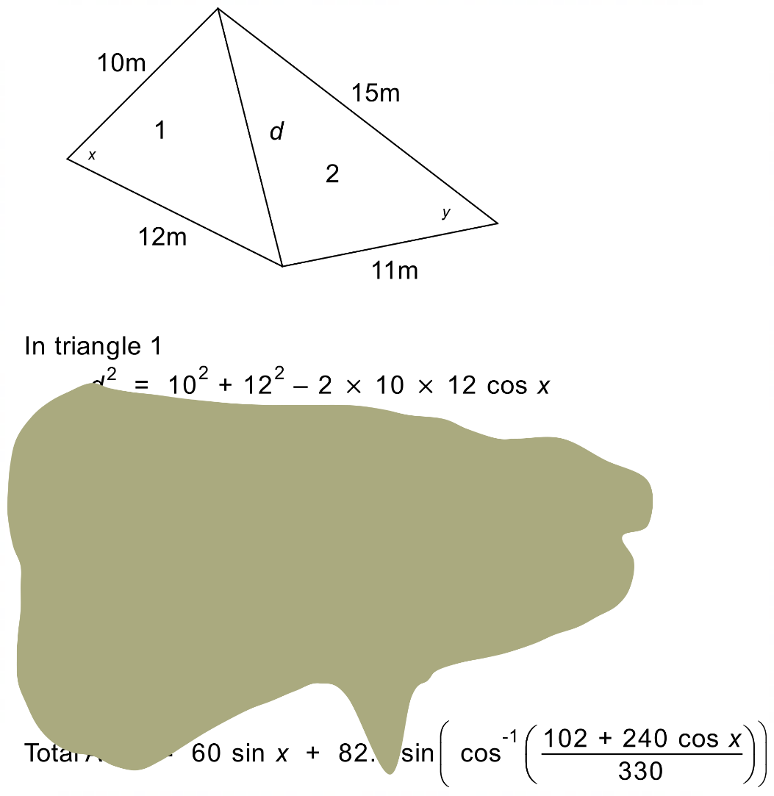
This is not as simple a problem as it first looks. You will need to perform multiple mathematical steps to find the maximum area and the angles that produce it. To help you, I have found part of a calculation a mathematical specialist performed for a different set of sections. Unfortunately, most of the important stuff has been obscured by a misplaced coffee stain but at least you should have something to work towards.

I also found this graph that the mathematical specialist has used. They must have used a graphics calculator to get it.

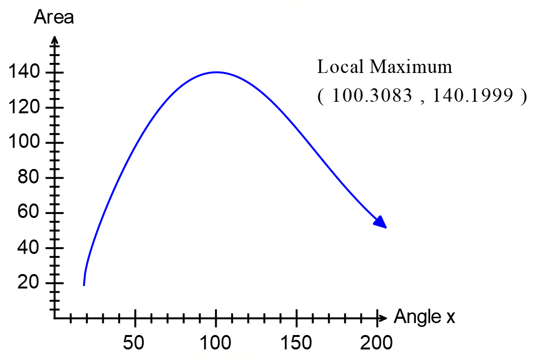

They also left this diagram as the design for the maximum area quadrilateral.

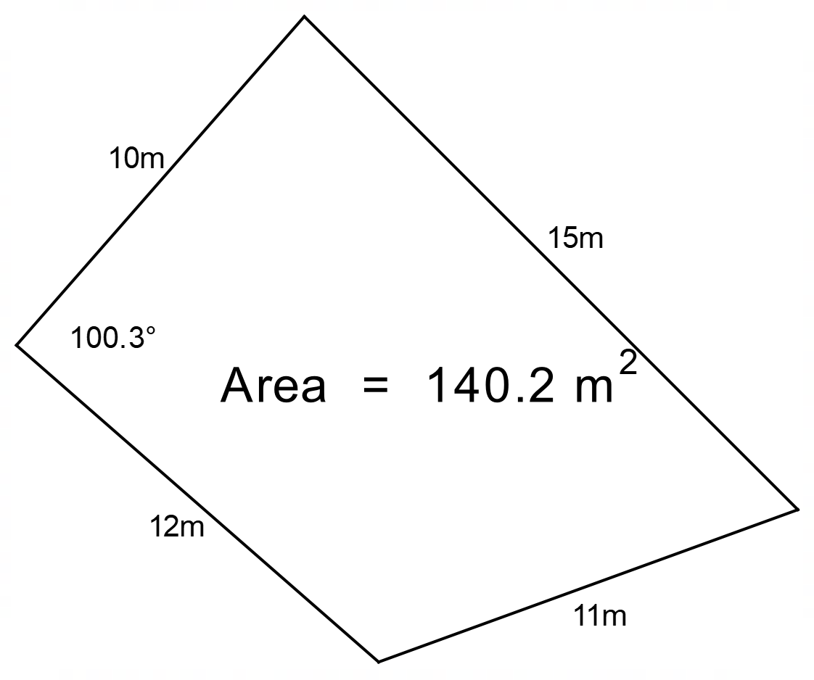

Use this information to determine the best quadrilateral for your farmer... Good luck!

There will be a validation test for this investigation.

Quad Quandary – Validation Test (>1000 000 Variations)
Name: /20

A farmer had a different set of fence sections as shown below.
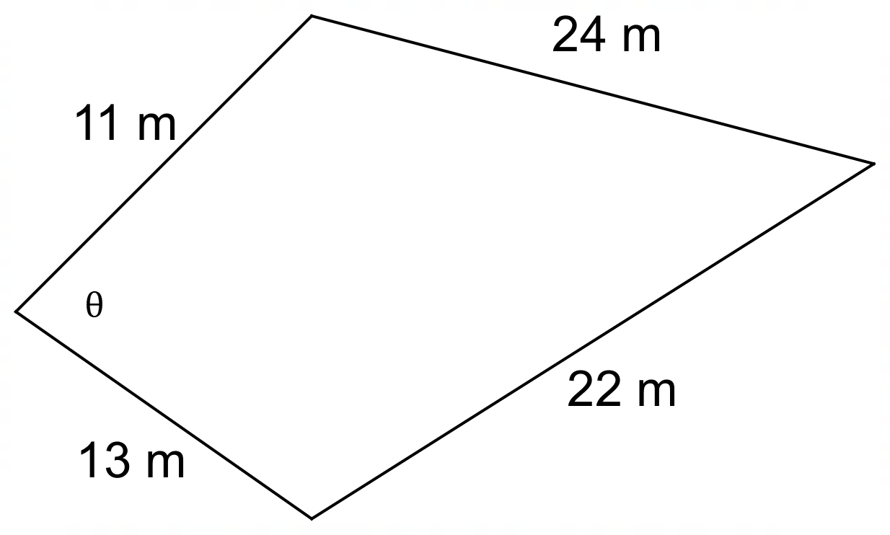
The farmer has found a formula for the area of this quadrilateral.

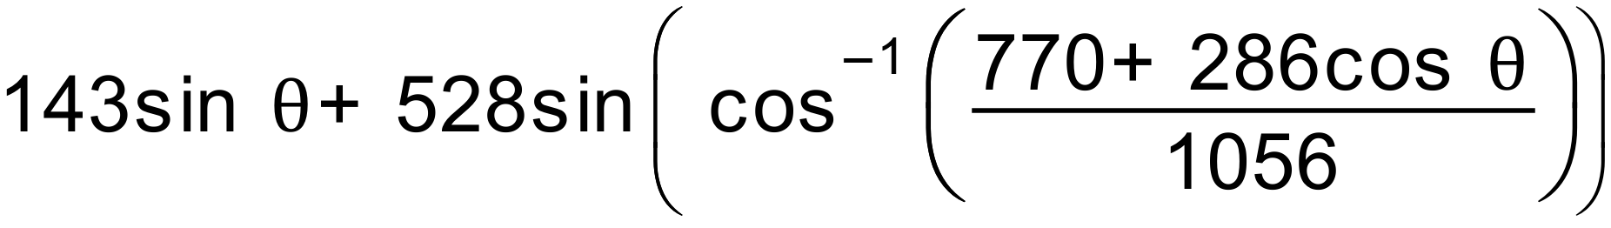

but is getting answers that are twice as big as they should be

1. What error has the farmer made?
[1]

2. Write a corrected version of the formula.
[2]

Yet another farmer has found the following correct formula for yet another set of fences.

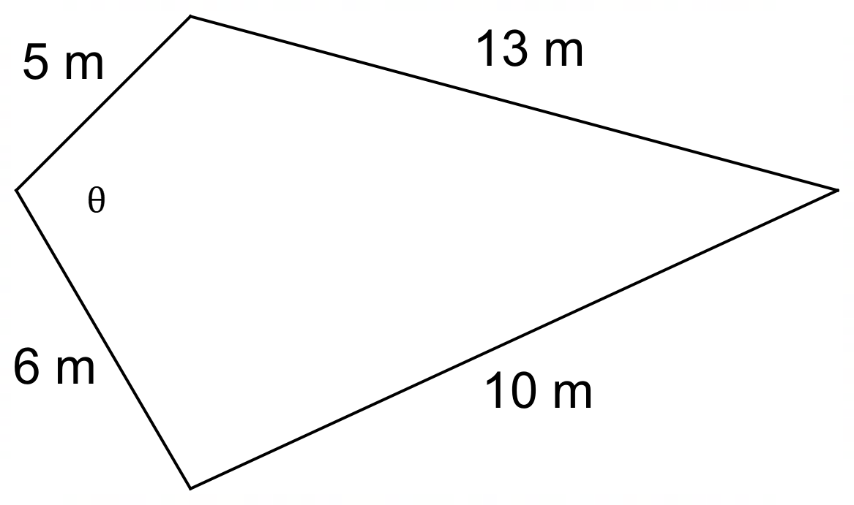

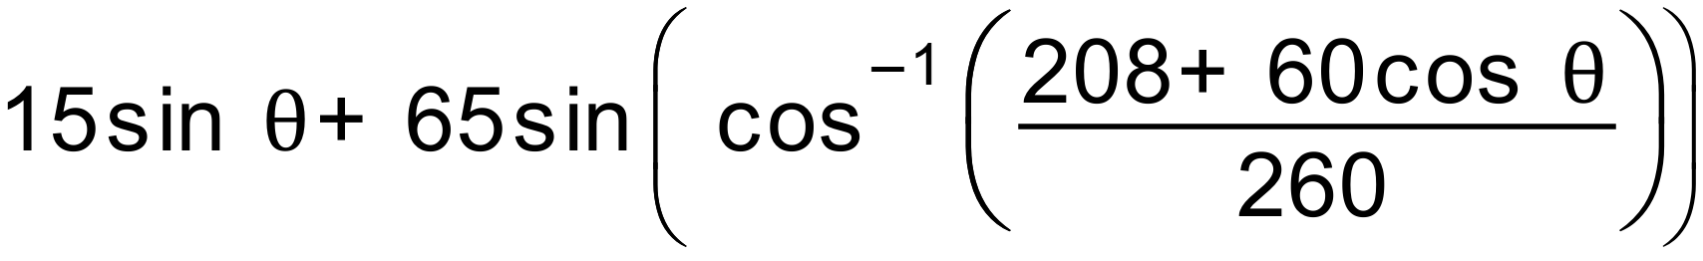

3. Use the formula and your graphics calculator to complete this table of values for angles and areas.

Angle (θ) | Area
80°
100°
120°
140°
160°

[4]

4. Use your graphics calculator to help you sketch a graph of the angle/area curve on the set of axes below. Clearly show the coordinates of the maximum point.

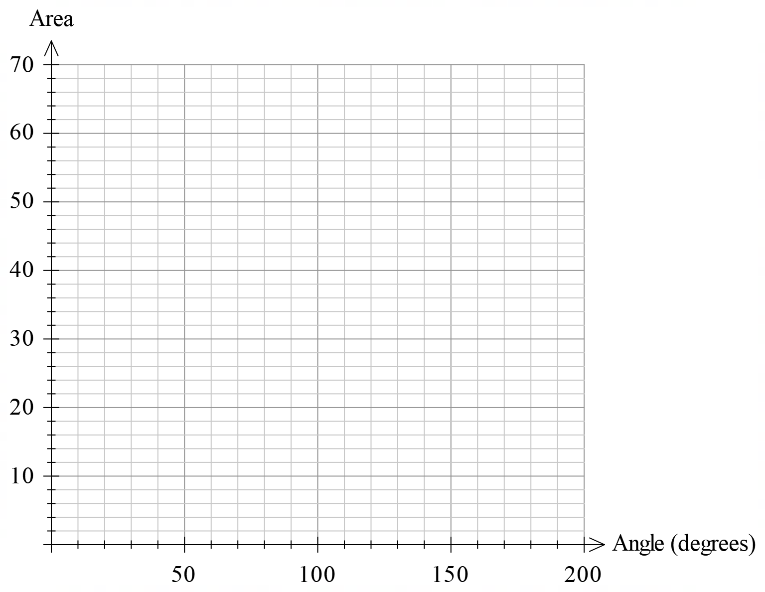

[5]

5. Translate what you have found into some meaningful instructions to the farmer that will allow them to set the fences correctly. Make sure that you clearly indicate the maximum area they can expect.
[4]

6. The farmer’s worker misinterprets your instructions and sets the fences up as shown below – using your angle (θ) in the indicated location. What area will be enclosed by this arrangement?
[4]
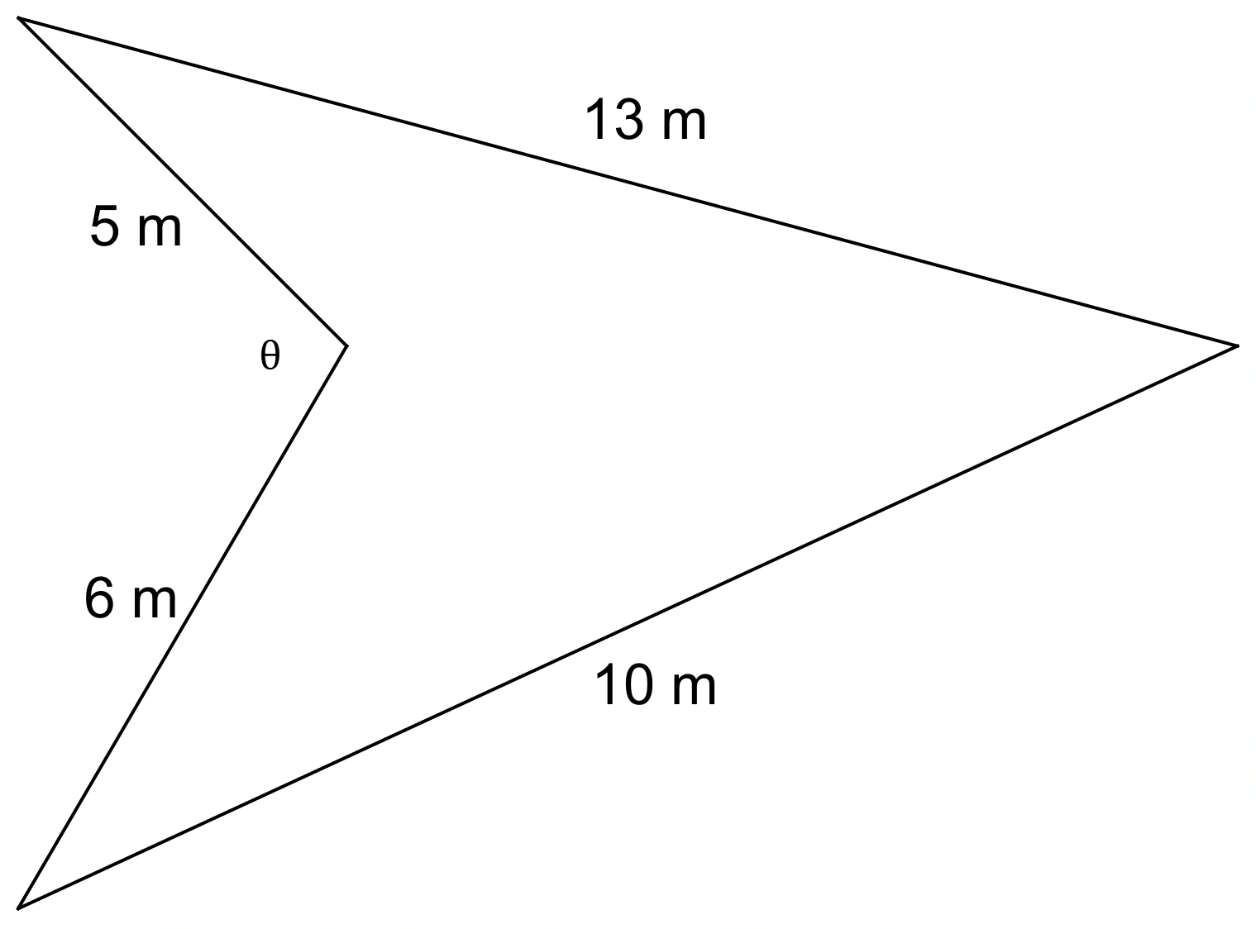

End of Test
Quad Quandary – Discussion of Pre-Test Section

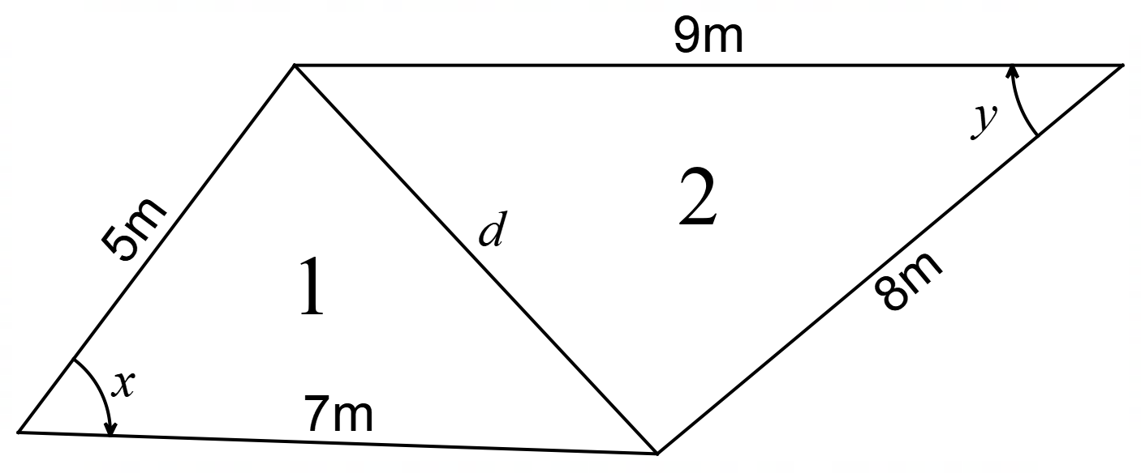

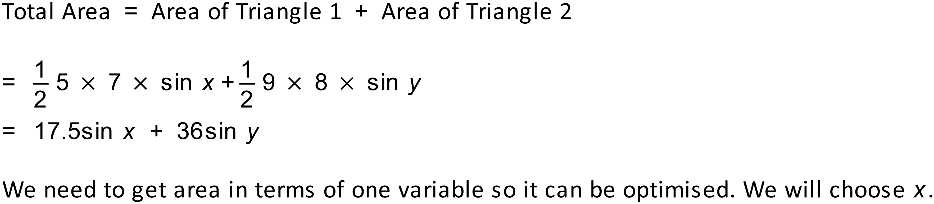

Using the cosine rule in triangle 1.
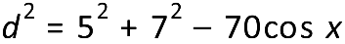
Using the cosine rule in triangle 2.
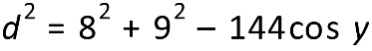

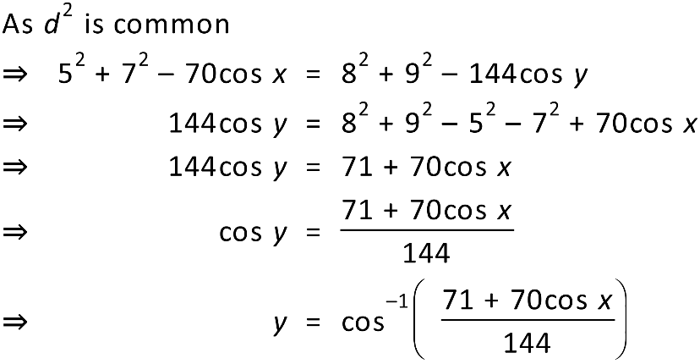

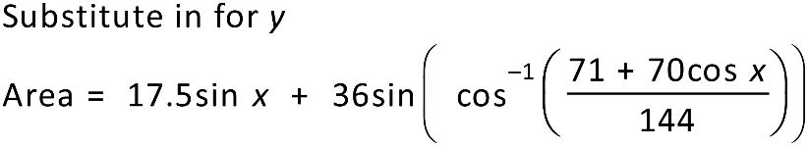

Graphing this function

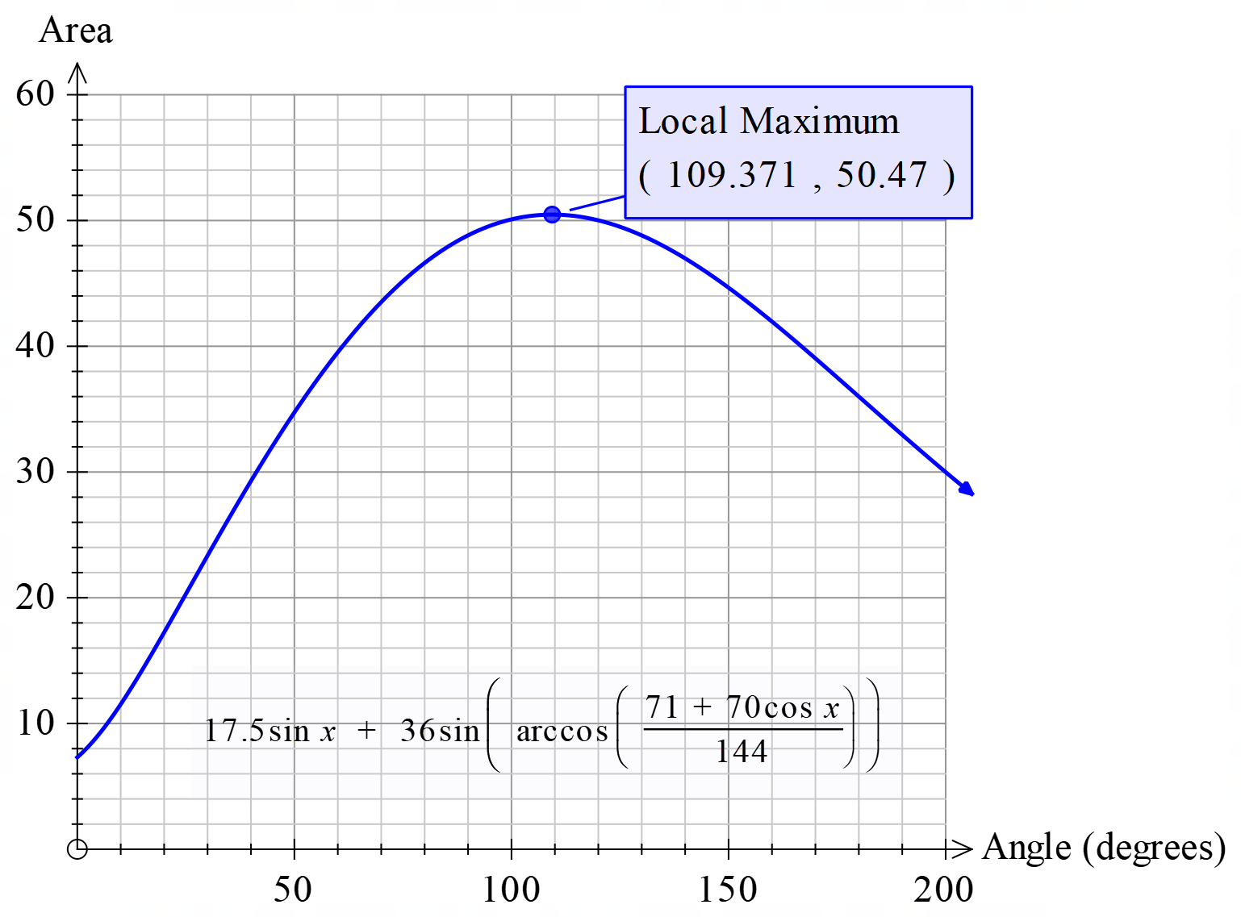

The maximum area of 50.47 square metres occurs when you set the angle between the 5m and 7m sides at 109.38 degrees.

We can generalise the formula.

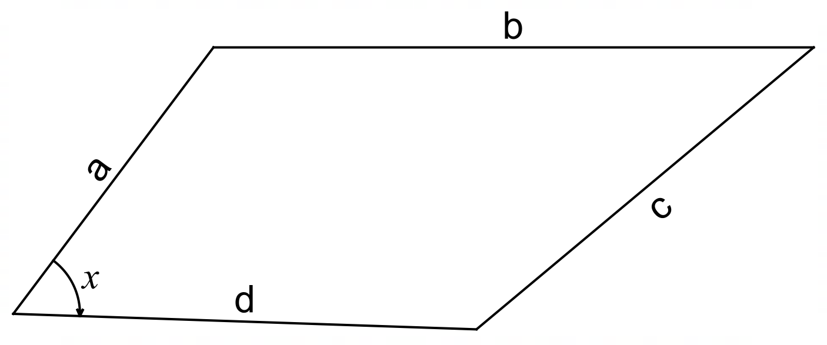

Test Solutions
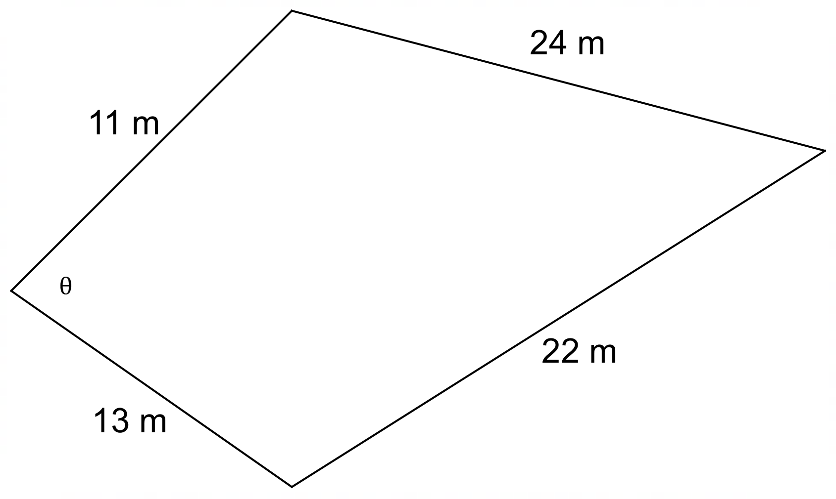

- The farmer has forgotten to halve the 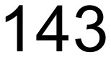 and 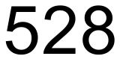 as the area formula for triangles is 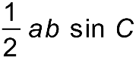. The farmer has instead just multiplied the two sides without halving.

- The corrected formula is 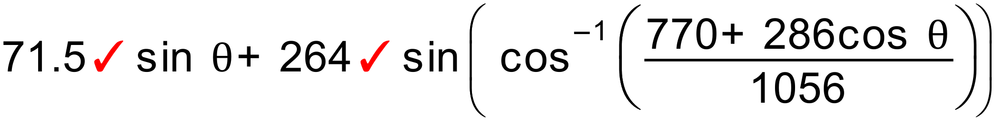

- Using the formula

Angle (θ) | Area
80° | 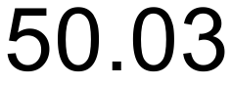
100° | 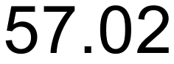
120° | 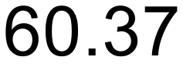
140° | 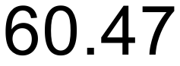
160° | 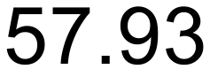

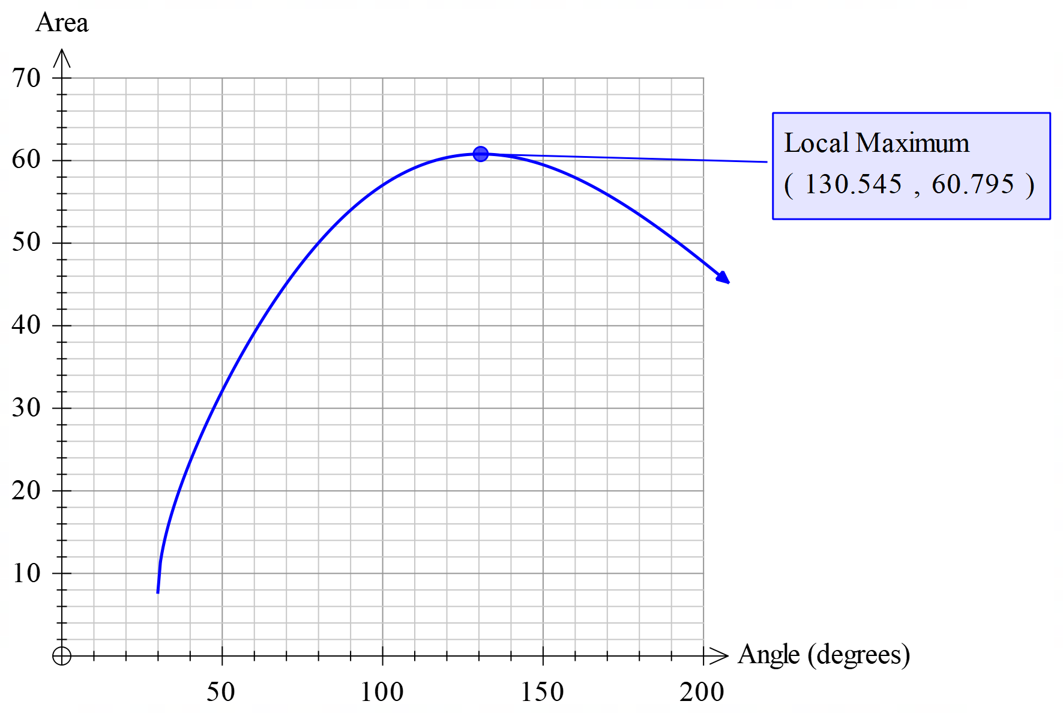

Graph must pass through calculated points
Local maximum correct and clearly marked

- The farmer should connect the four sides together and make the internal angle between the 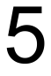 m and 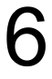 m sides equal to the 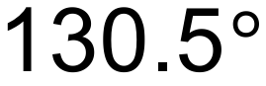 angle show in the graph above. This will produce an area of 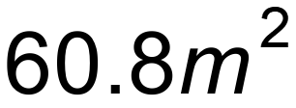.

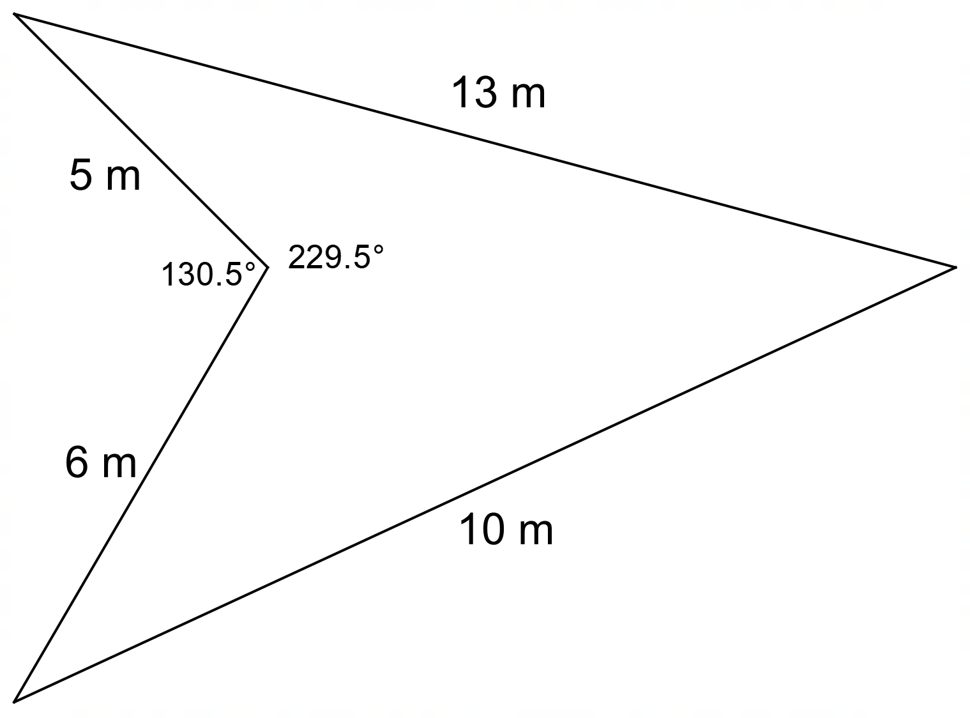

Substitute an angle of 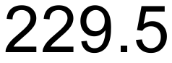° into the formula

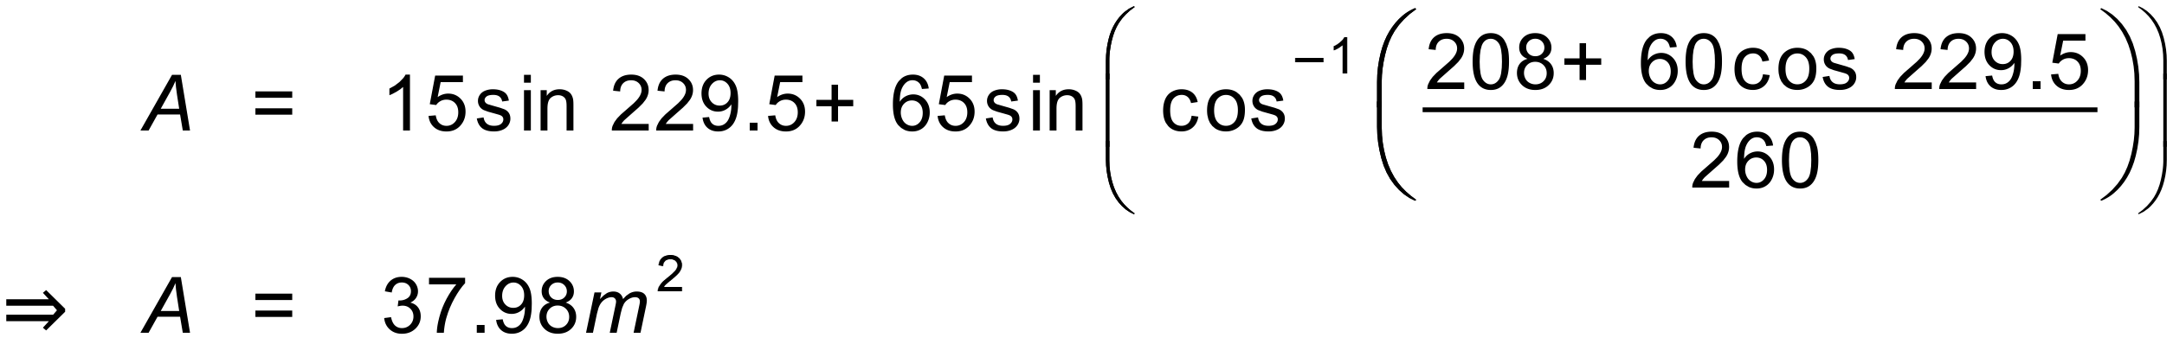

The area will be 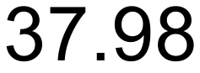 square metres.

