FX Library Modules

Pythagoras
Age 13-15

Copyright Information
If you are an Efofex subscriber and work in a school, you can copy and/or modify the FX Library materials and use them with your students. We hope that this material will help you write your tests, worksheets, exams, presentations and any other educational materials. You cannot claim copyright over the FX Library materials or present them as your own work.
FAQ

Who are the questions/materials for?
We are providing the materials for teachers in schools. If you are a teacher in a school (or similar context) you are welcome to use the questions/materials freely in just about any manner. Most other usages of our questions/materials are prohibited. In particular, you are expressly prohibited from using our materials in any context where the aim is to generate a profit.
Can I photocopy the questions/materials for use by my students?
YES.
Can I copy questions/materials and paste them into my own documents?
YES.
Do I have to include the Efofex Software copyright notice on my own documents if I have included some of your questions/materials?
NO.
Can I use your questions/materials to generate a profit?
NO.
Can I use the questions/materials on my website/PowerPoint presentation/Moodle...?
It depends. If your usage is within the context of a teacher of students at an educational institution, YES. If you want to use the materials for profit, NO.
I am a home-schooling parent. Can I use your materials?
YES.
I am a student and want to use your products for revision. Can I use them?
YES (but make sure to tell your teachers how good they are!)
Can I modify your questions/materials for my own use?
YES.
If I modify your questions, can I claim copyright?
It depends. If the modifications are substantial, YES. If the modifications are trivial or superficial, NO. Using the Parameter Regeneration feature of our products is NOT a substantial modification
I am a professional tutor. Can I use your materials with my students?
NO.
Can I republish your materials?
NO.
I think that I might be able to use your materials but don't seem to fit any of your FAQs. What do I do?
Send us an email describing what you want to do (to info@efofex.com) and we will get back to you as soon as possible.

How To Use This Material
Copy a question from this document and paste (with reparametizing) into your document. This allows you to quickly build a collection of regeneratable questions into a test, worksheet, presentation or exam.

Question
Find the length of the hypotenuse for each of these triangles.
- b)
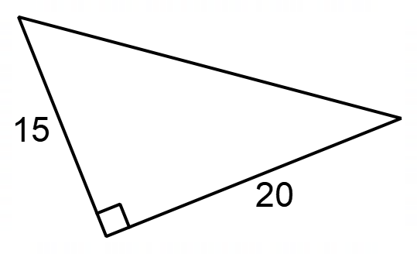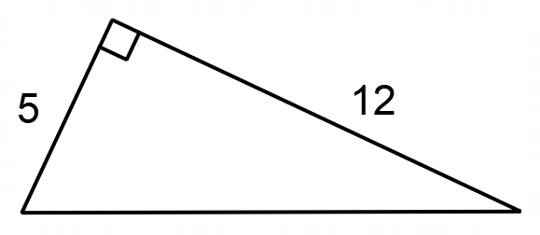

Solution
- 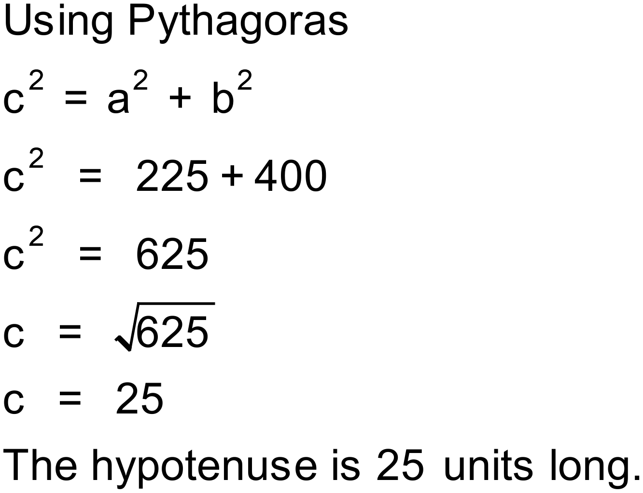 b) 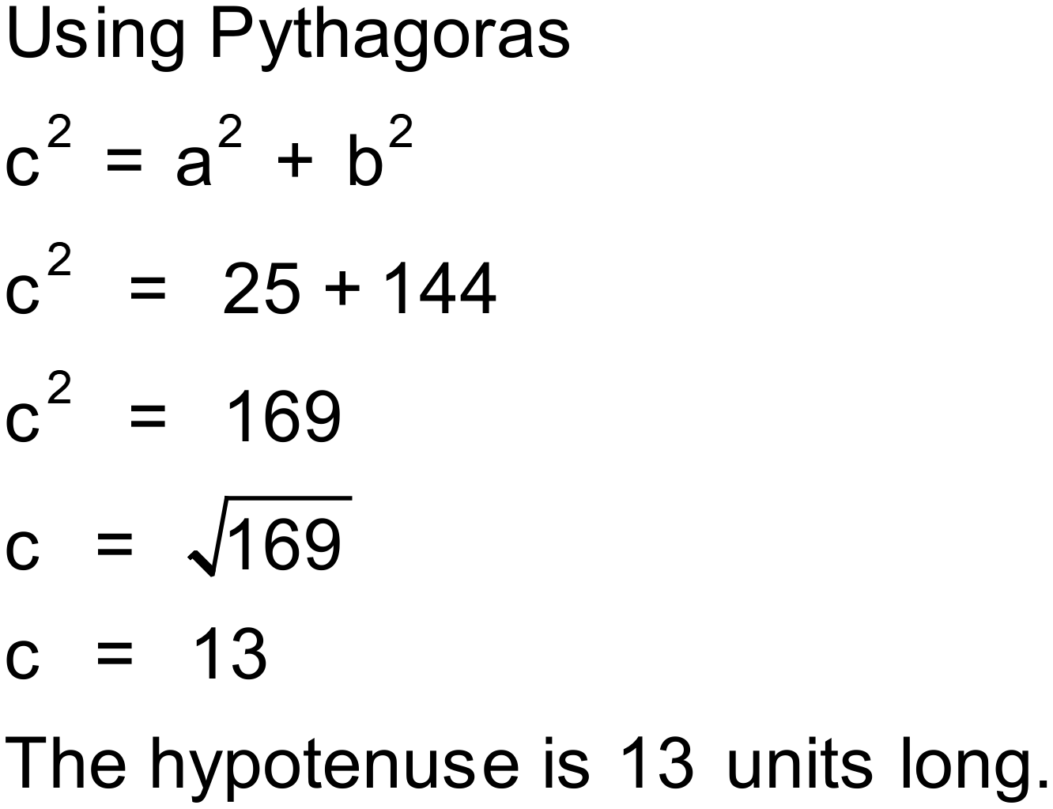
Notes
Multiples of Pythagorean triples 3,4,5 and 5,12,13. Part a has 8 variations. Part b has 9 variations.

Question
Find the length of the hypotenuse for each of these triangles correct to two decimal places.
a) b)
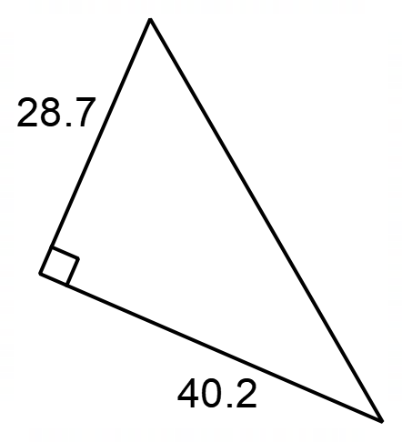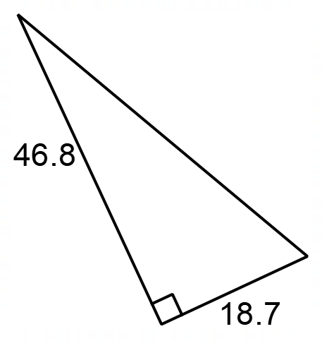

Solution
- 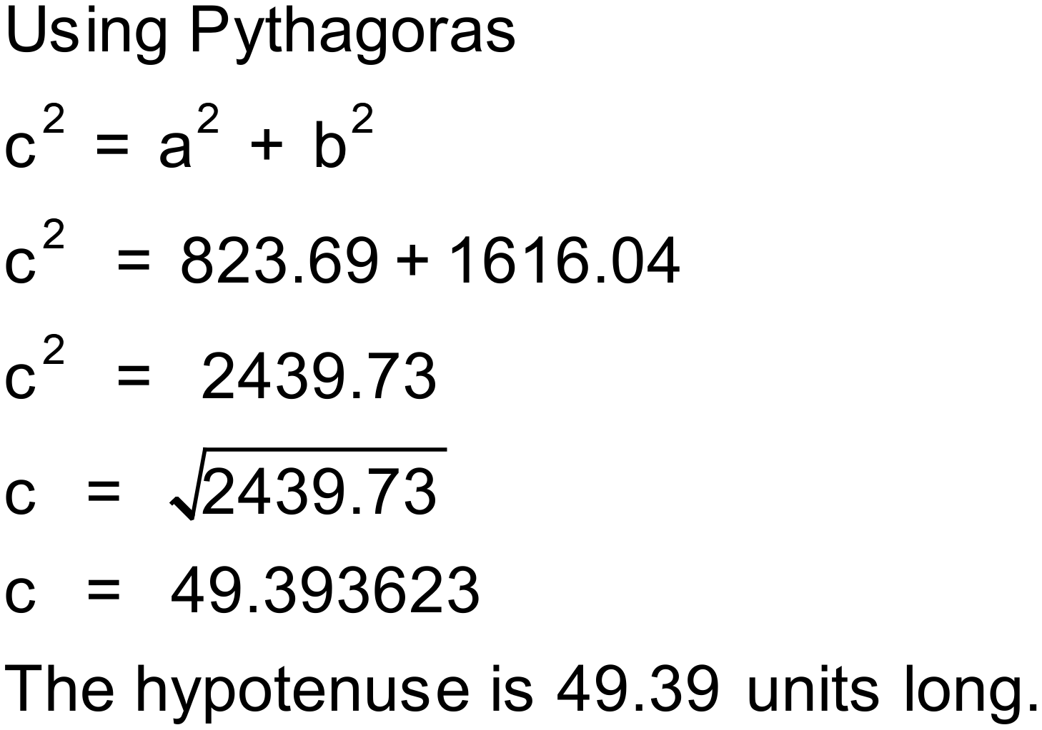 b) 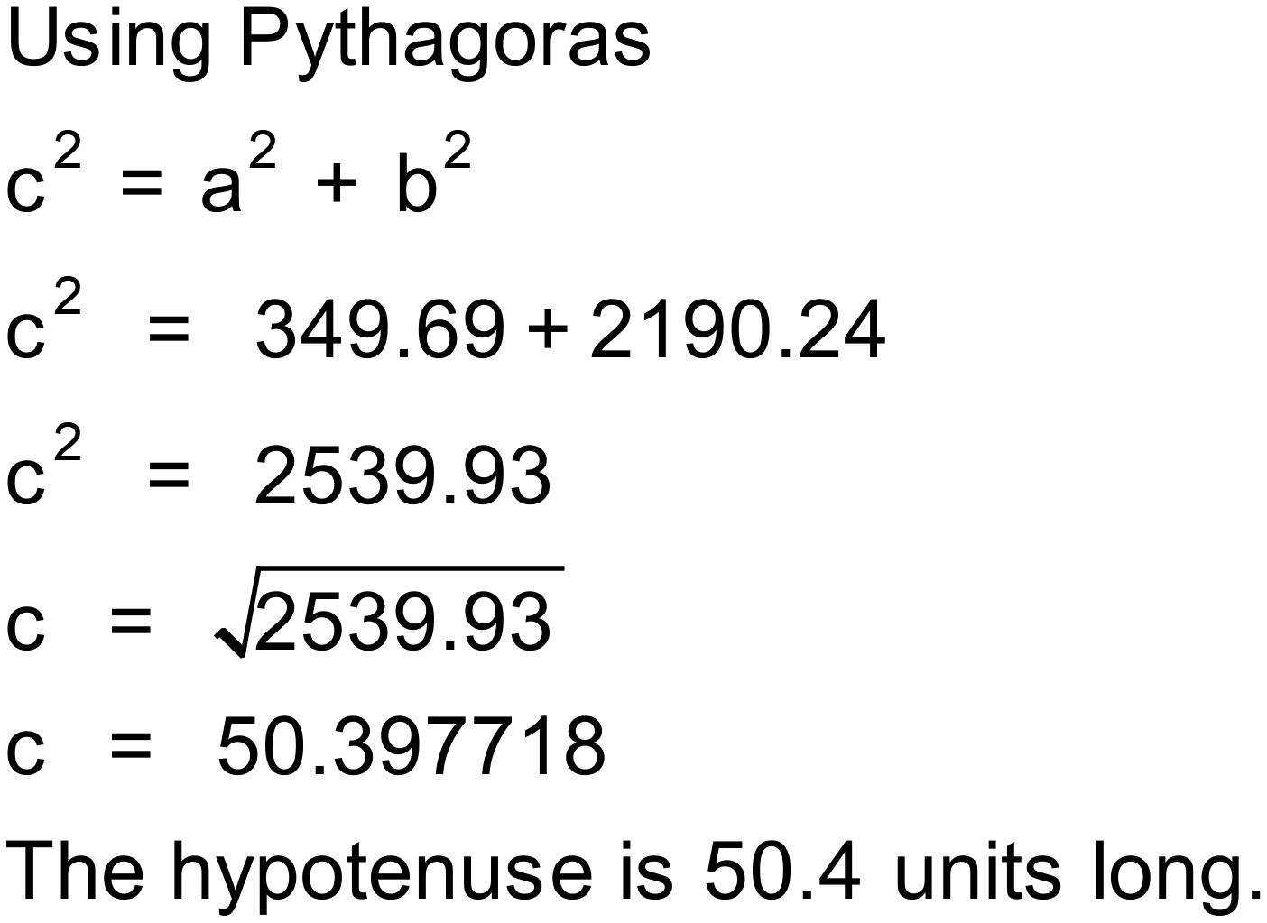
Notes
Part a has 1000+ variations. Part b has 2000+ variations.

Question
Find the length of the unknown side (in metres, correct to 2d.p.)
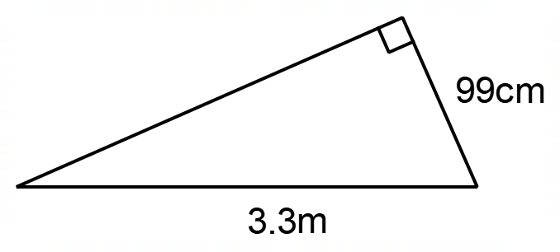

Solution
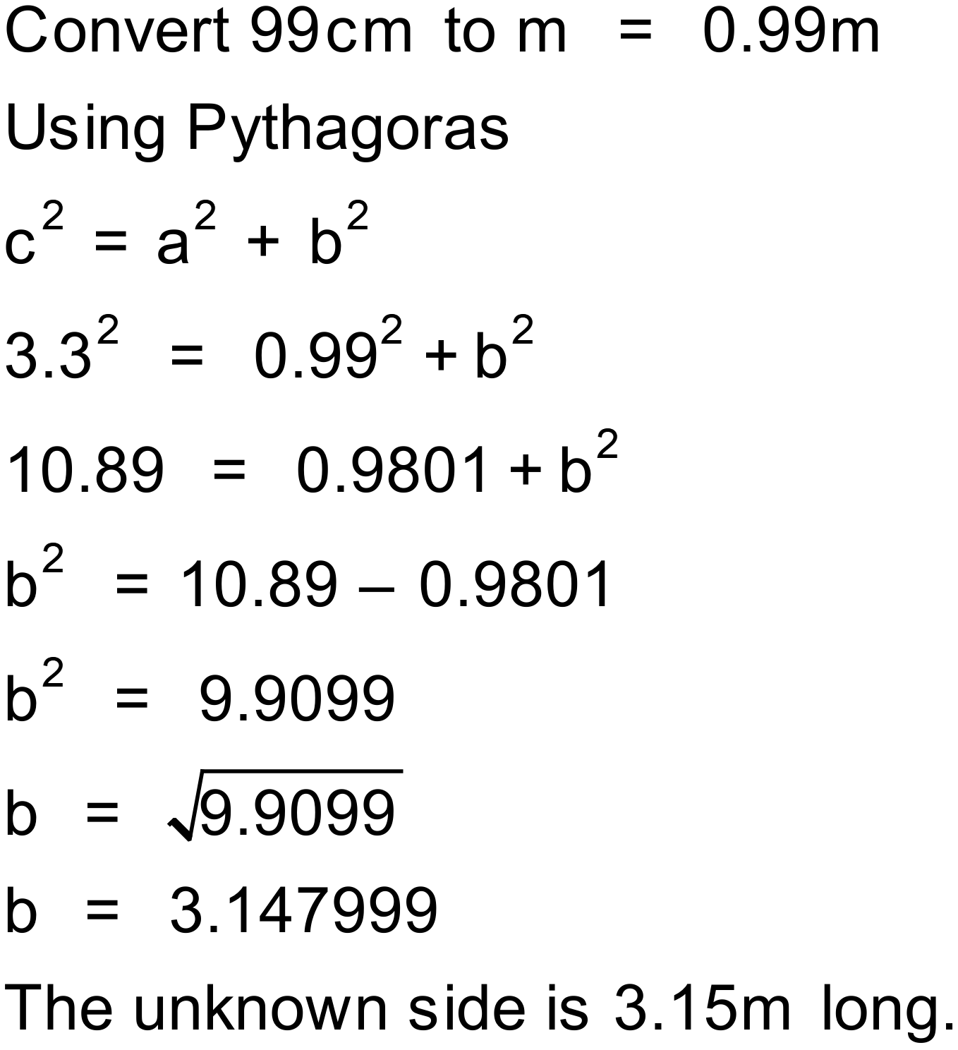
Notes
500+ variations

Question
Find the length of the unknown side (in centimetres to the nearest centimetre.)
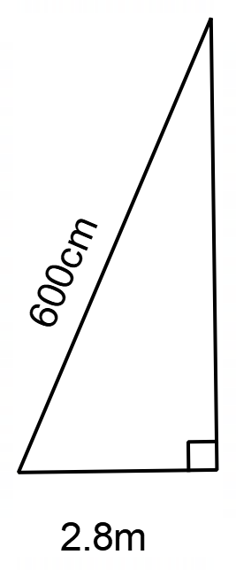

Solution
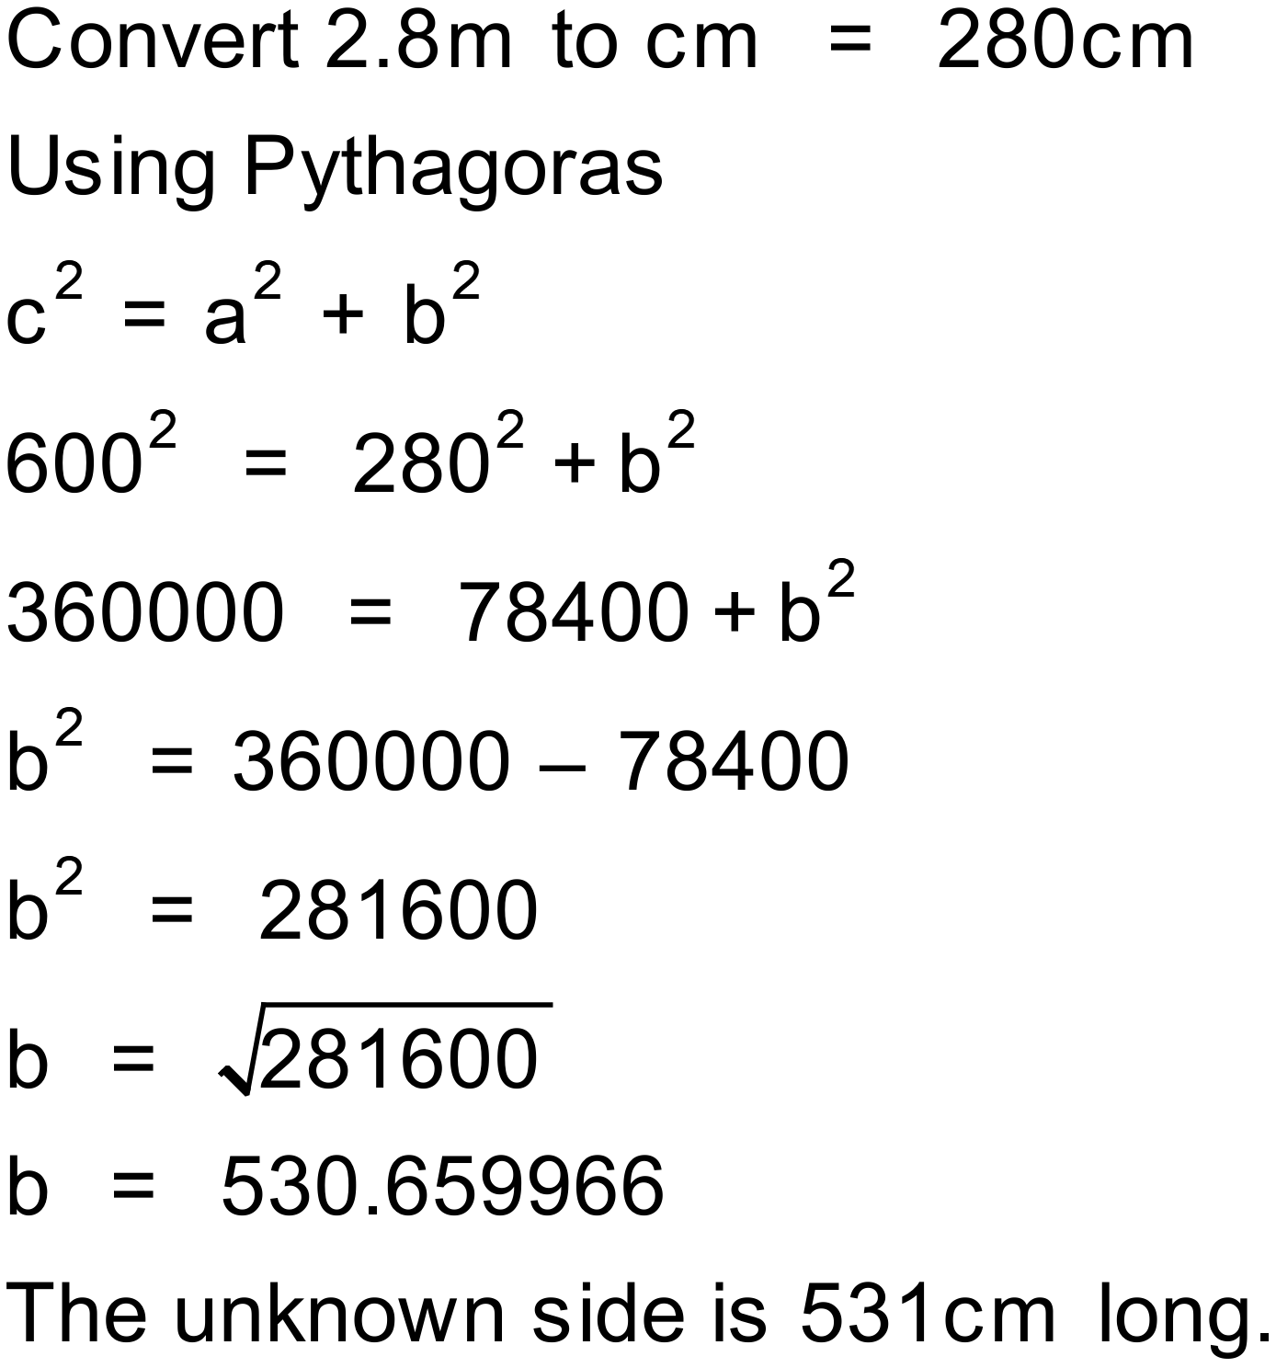
Notes
1000+ variations

Question
Find the length of the unknown side (in metres to the nearest metre.)
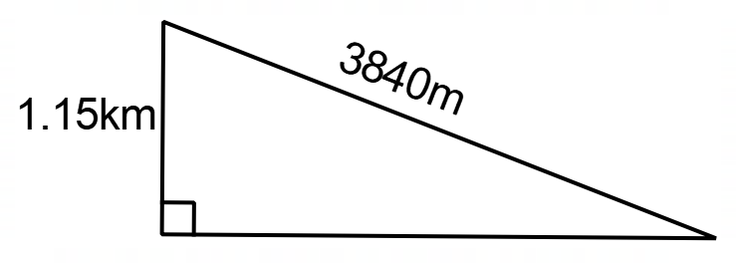

Solution
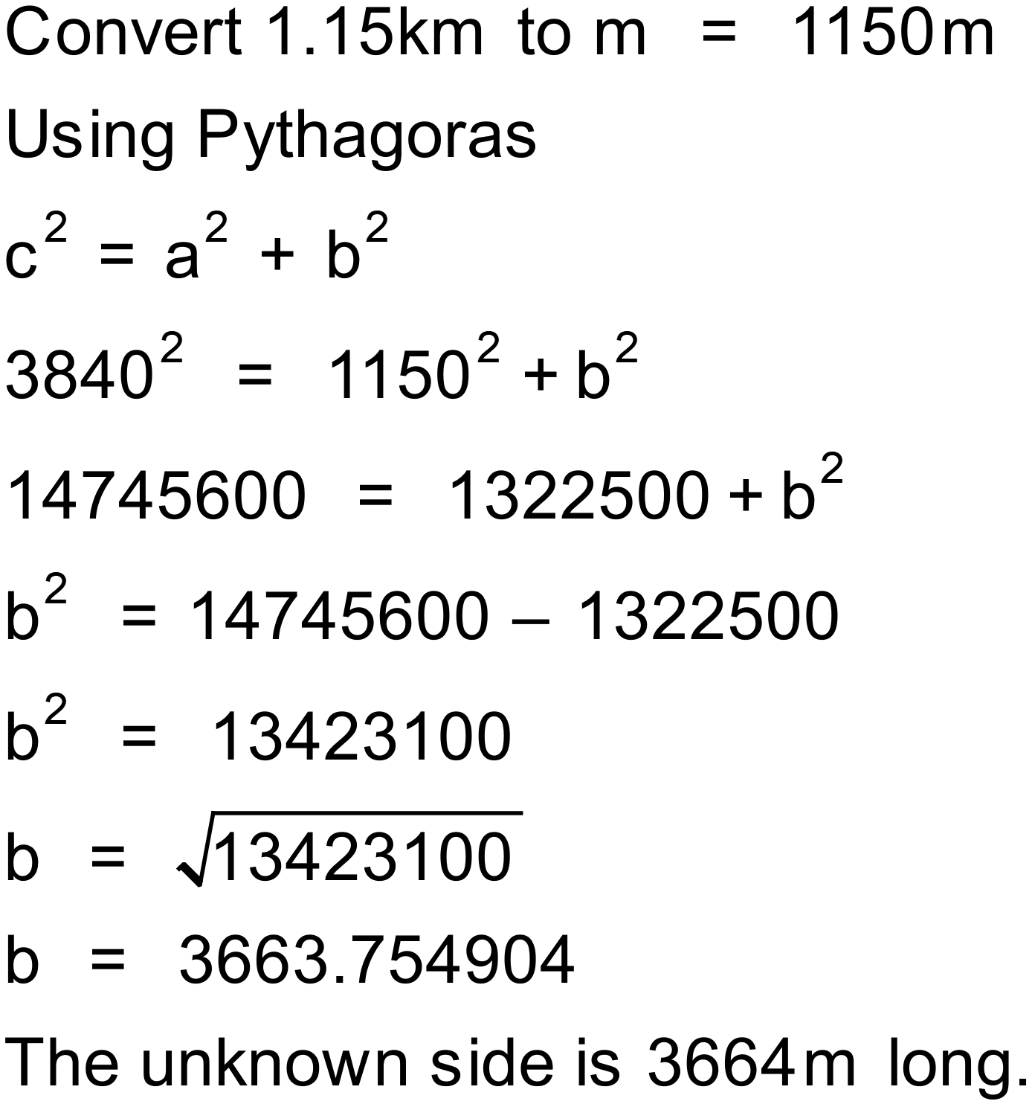
Notes
5000+ variations

Question
Calculate the perimeter of this triangle (correct to 2dp).
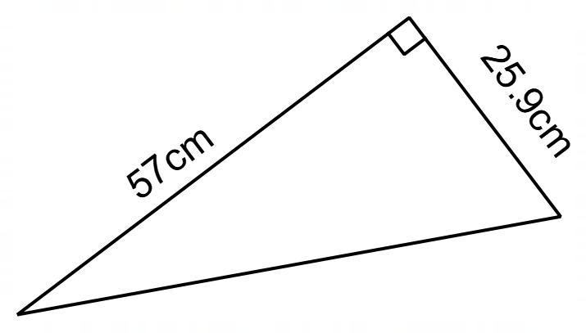
Solution
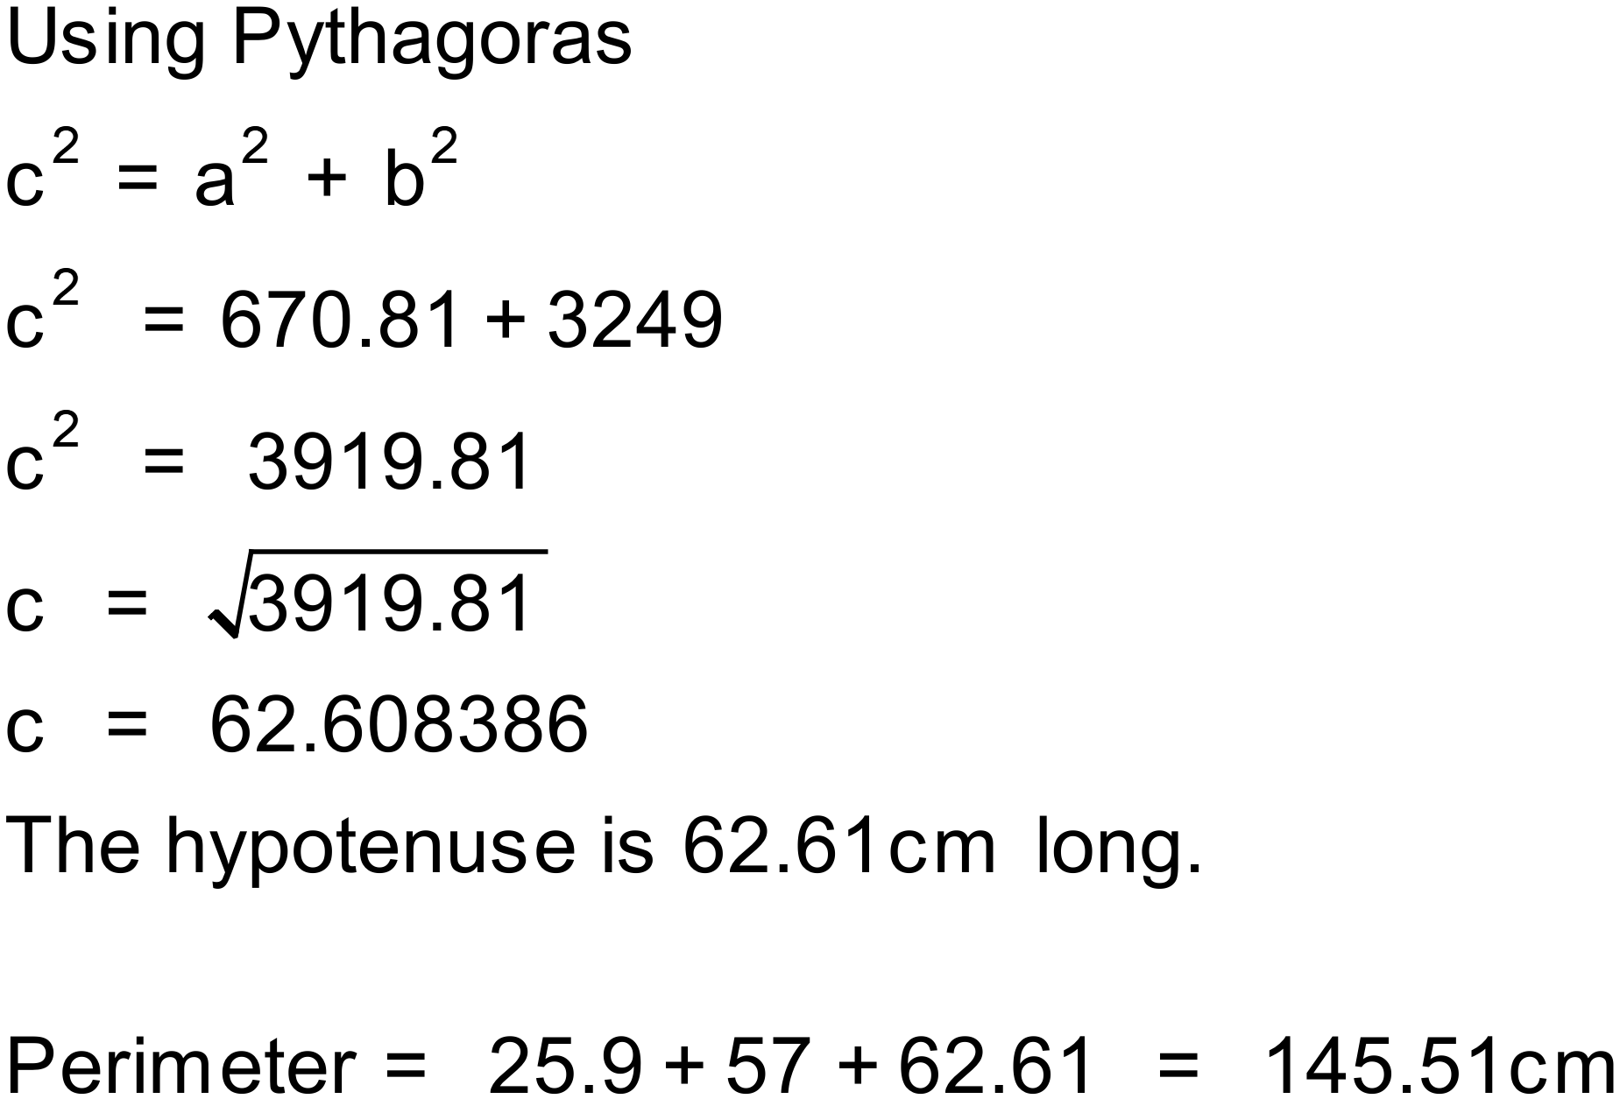
Notes
5000+ variations

Question
Calculate the perimeter of this triangle (correct to 2dp).
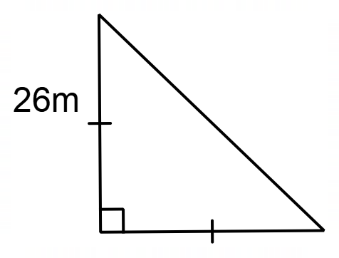
Solution
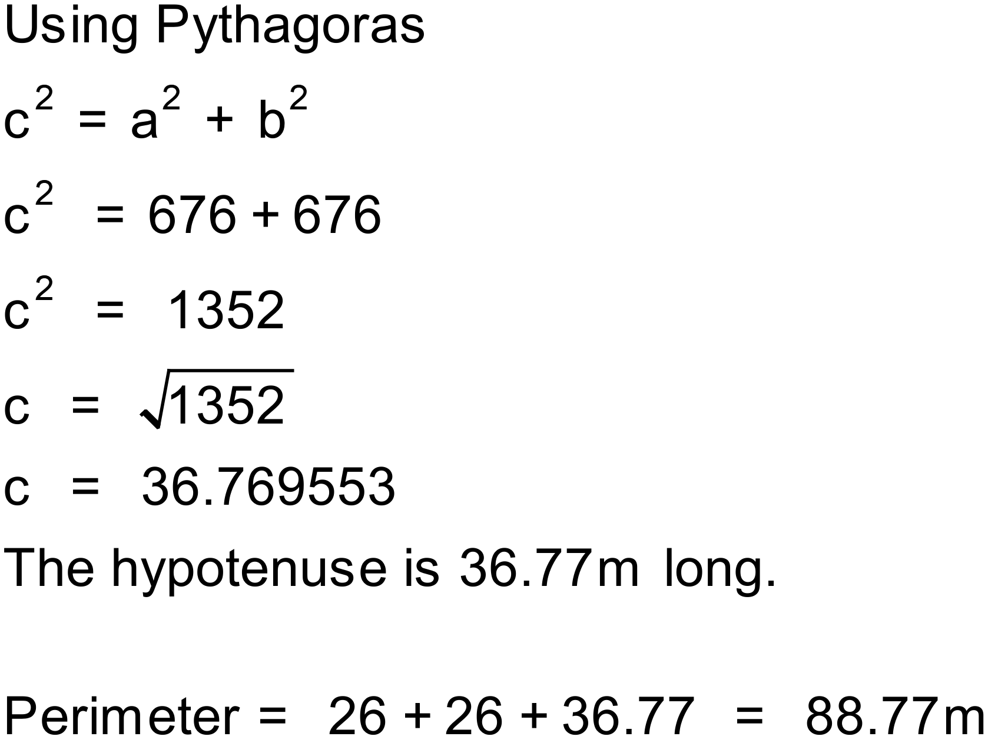
Notes
300+ variations

Question
Find the perimeter of this triangle.
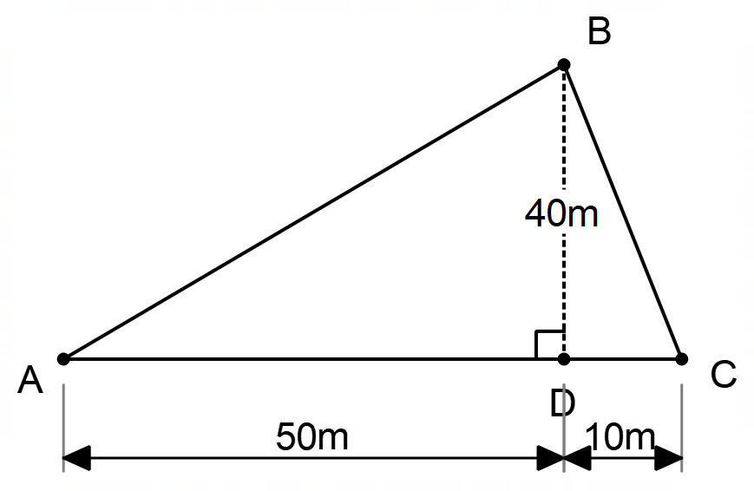
Solution
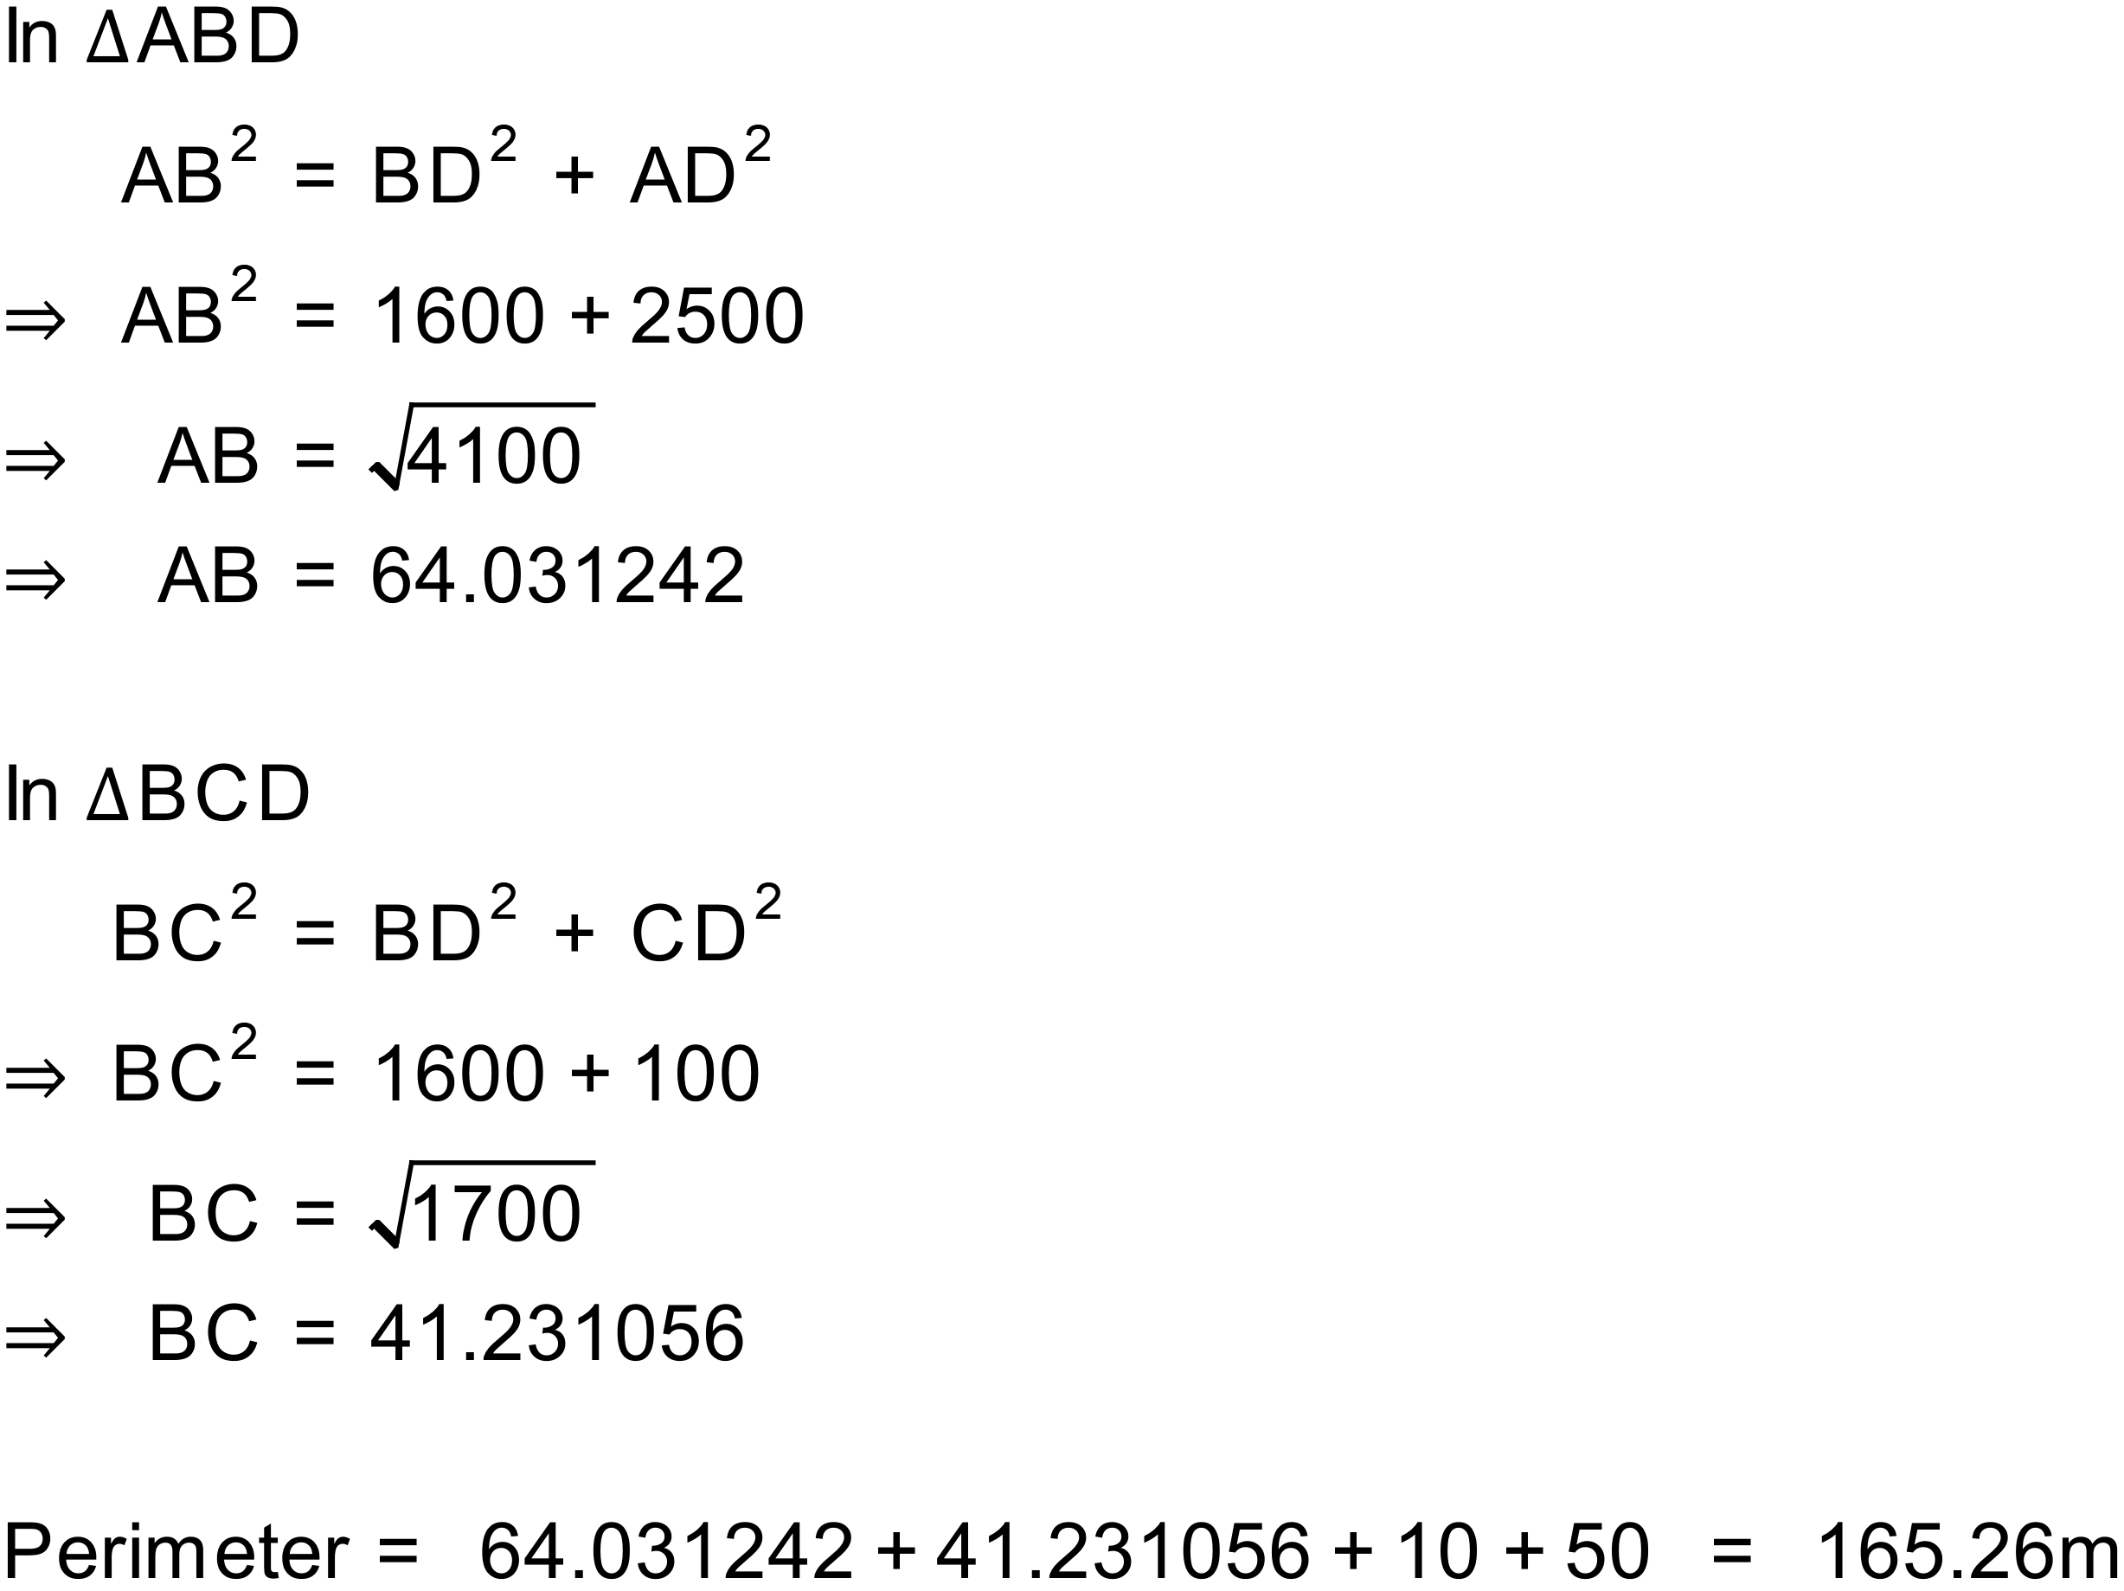
Notes
300+ variations

Question
A roof carpenter has built a truss for a roof as shown below. The truss is 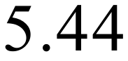m wide and 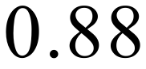m tall. They how need to order metal for the roof which will need to be at least as long as the side marked x in the diagram.
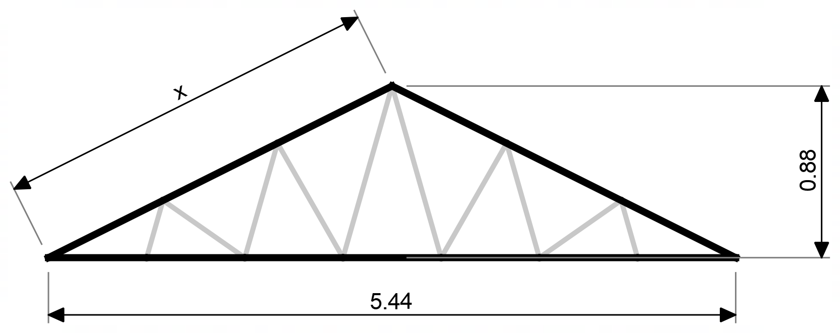
How long will the metal need to be?
Solution
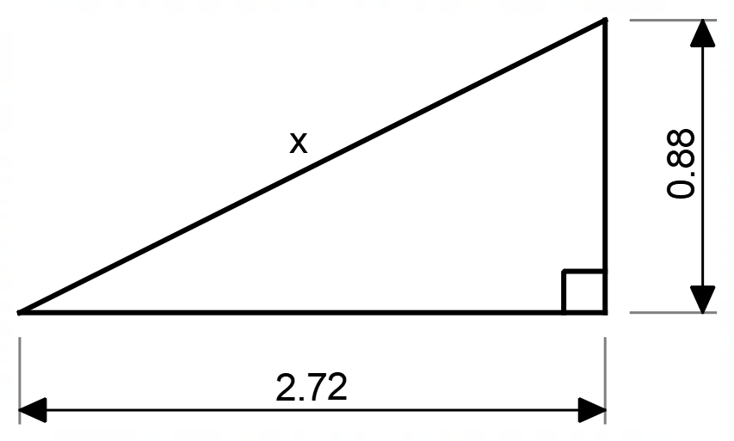
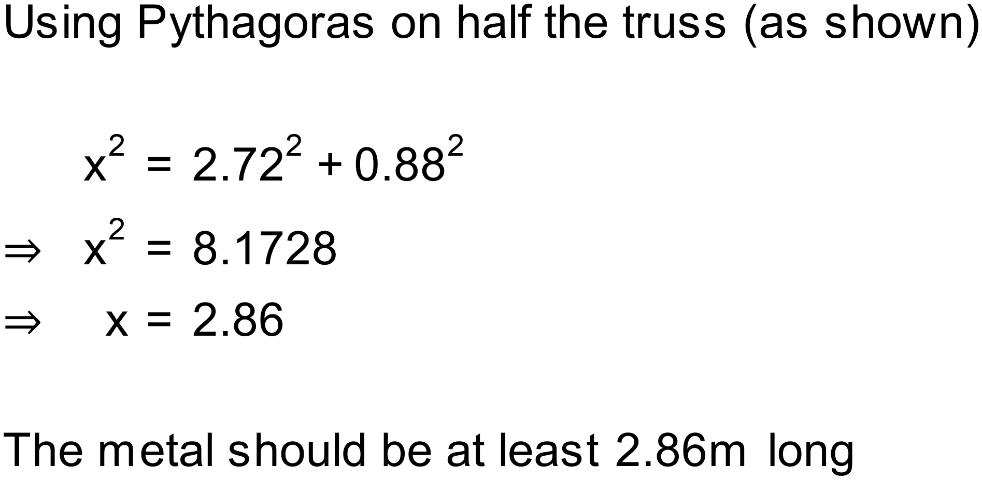

Notes
200+ variations

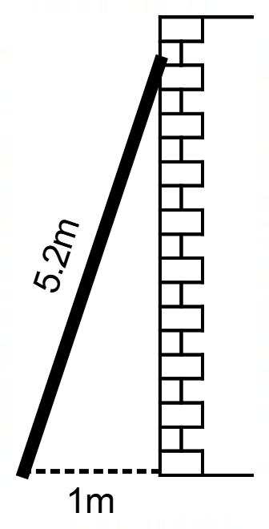
Question
A 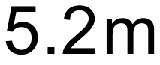 ladder is leaning against a wall. The base of the ladder is from the wall. How far up the wall does the ladder reach?

Solution
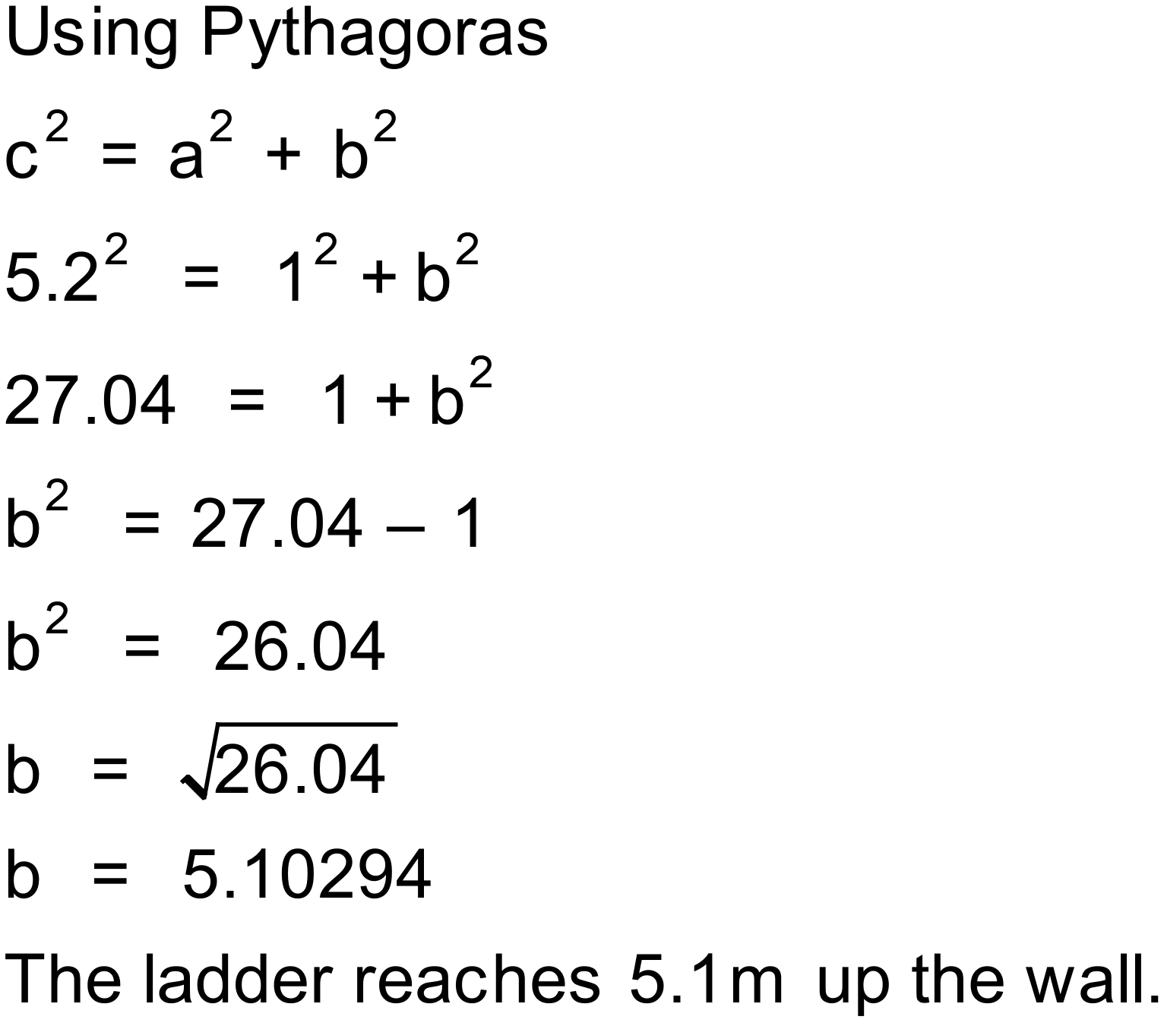

Notes
100+ variations

Question
TV screens are traditionally measured along the diagonal of the screen, in inches. We will perform our calculations in centimetres.
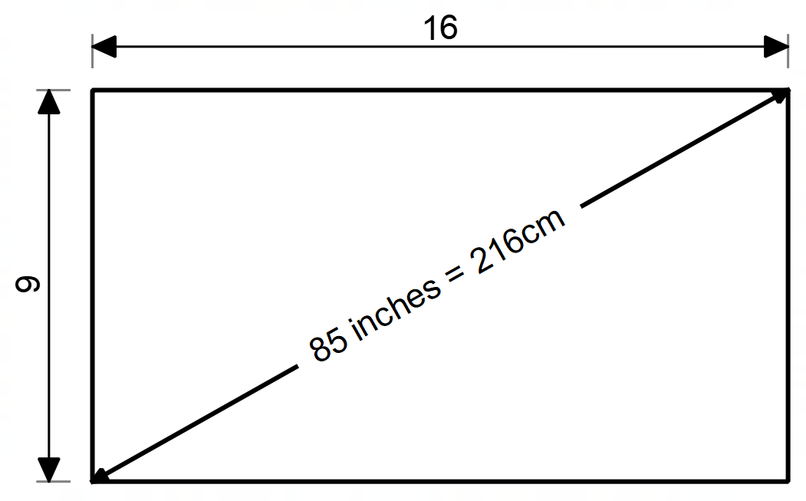
All modern televisions are produced with a 16:9 aspect ratio. This means that if the width of the screen is divided into 16 equal parts, the height of the screen should be 9 of those parts.
The width you have available for a TV screen is 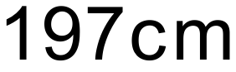. Determine if a 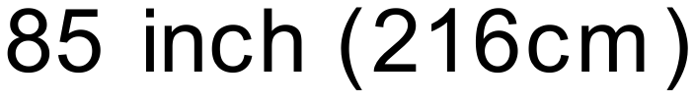 screen is too wide for the space. Show your working.

Solution
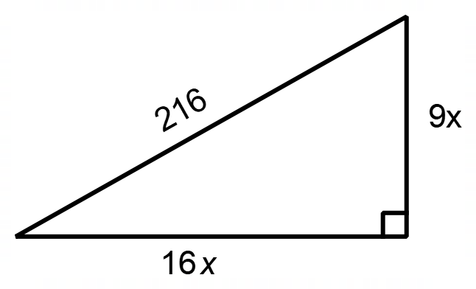
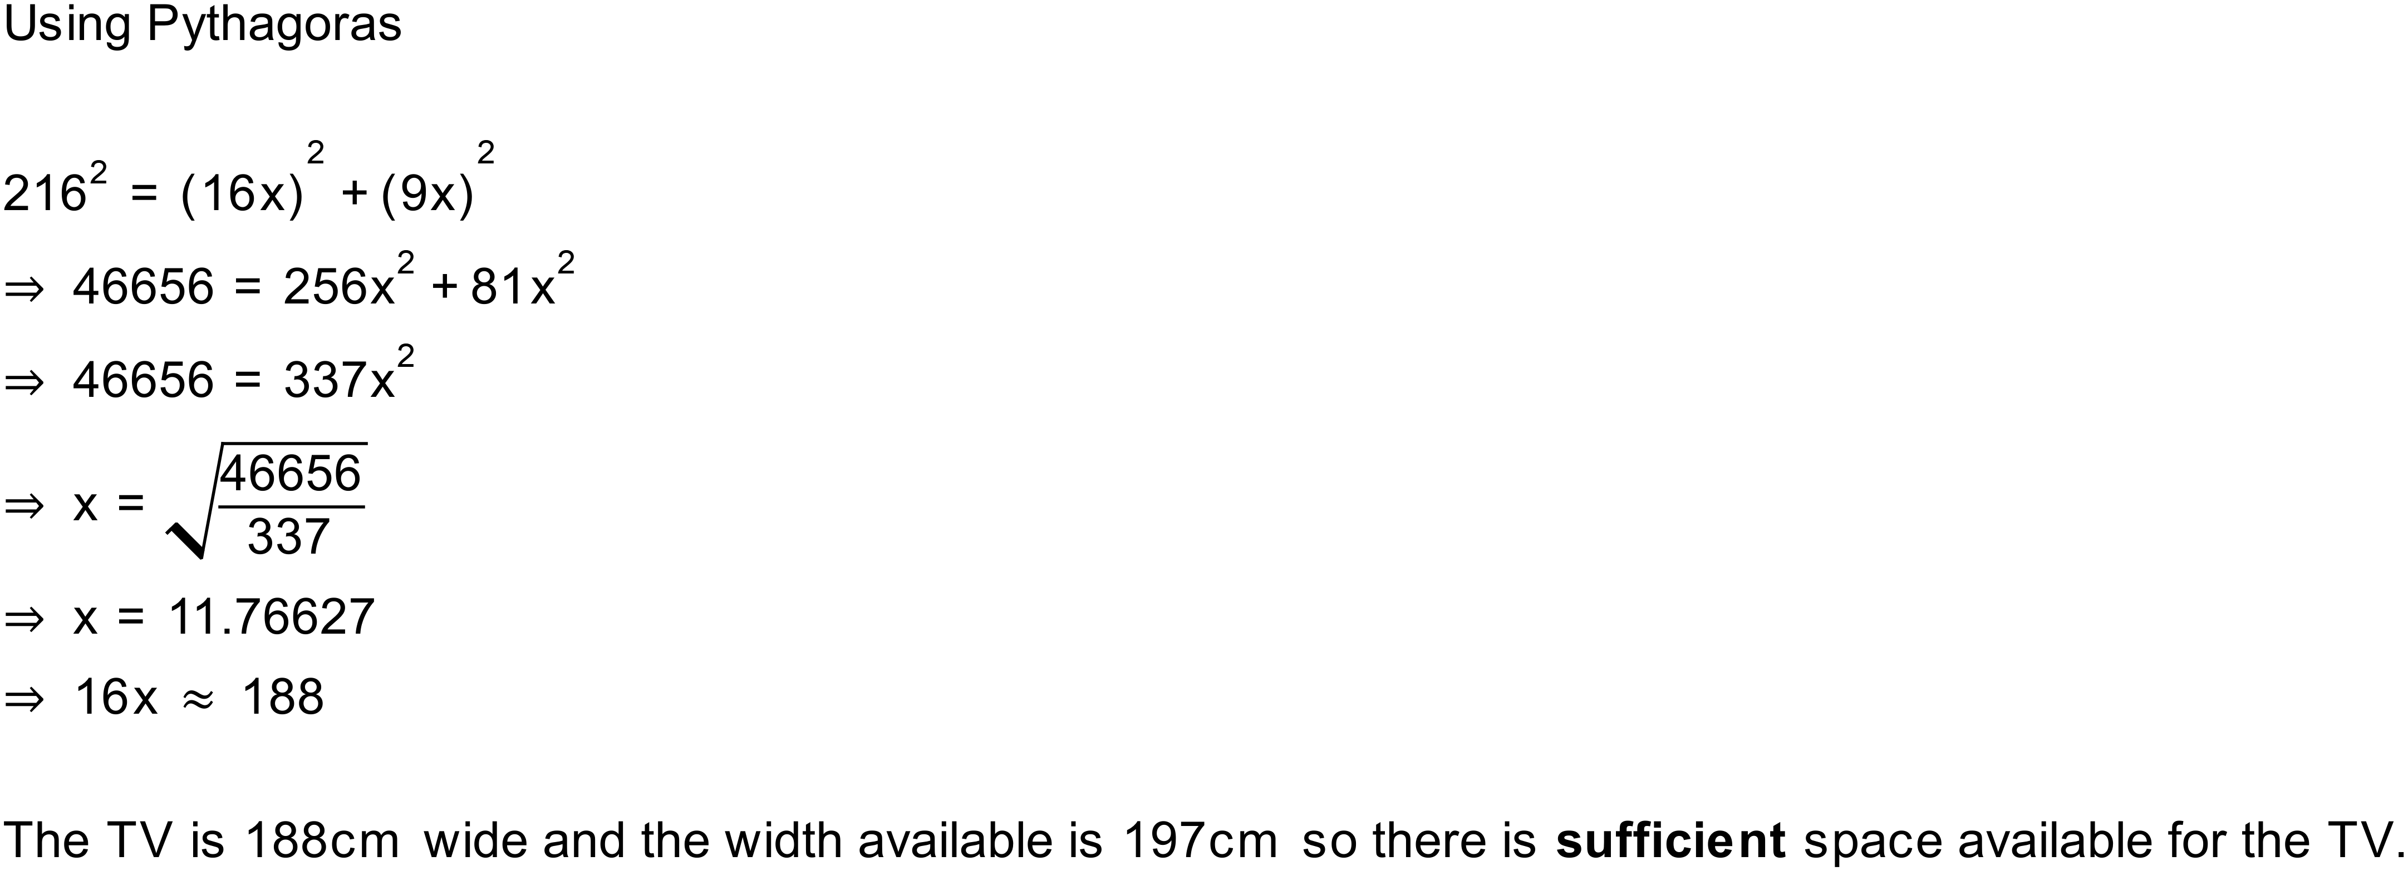
Notes
14 variations

Question
Find the value of x.
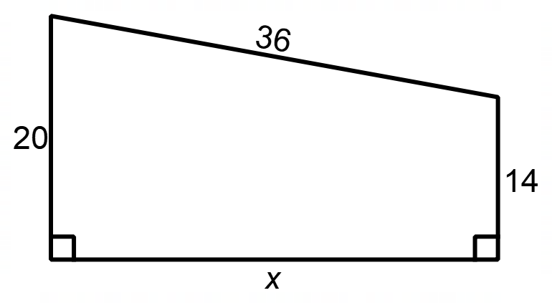
Solution
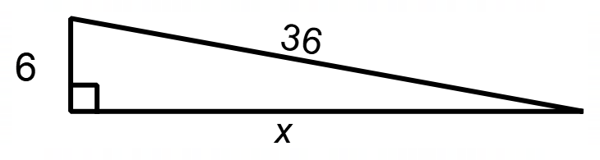
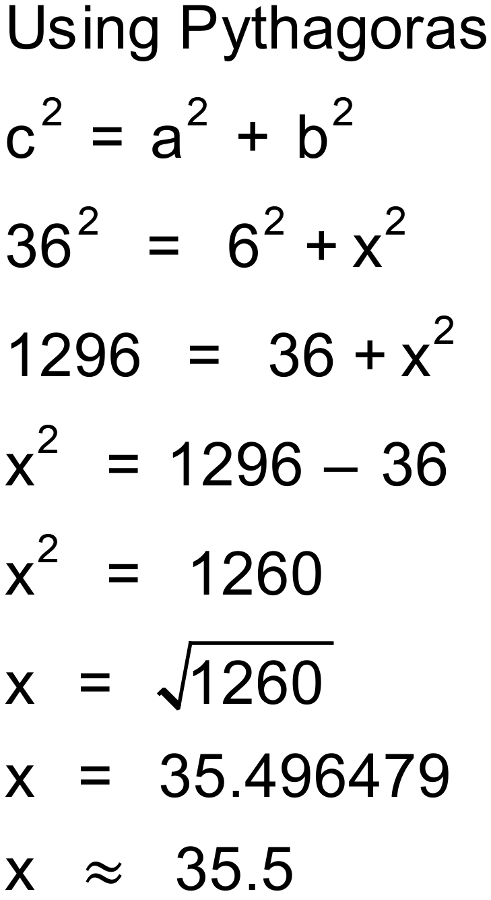
Notes
200+ variations

Question
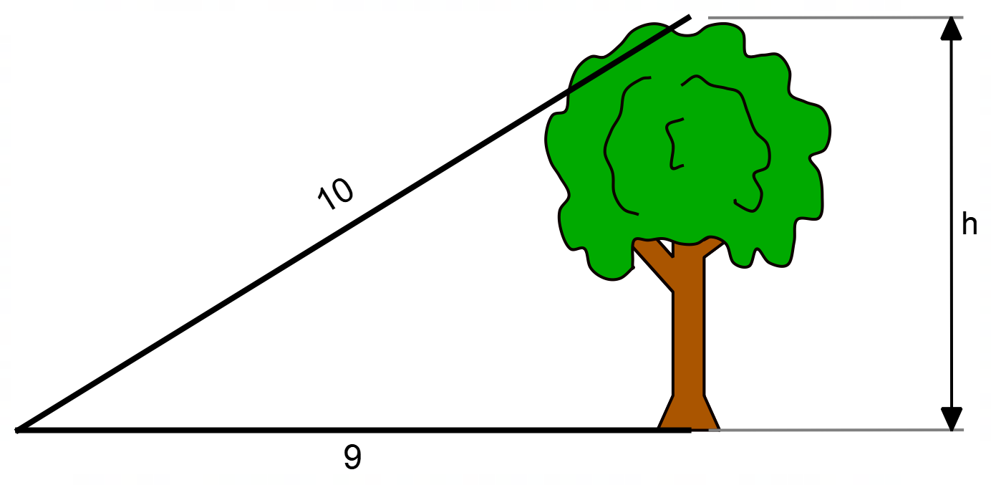
The distance from a point on the ground to the base of a tree is 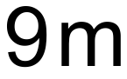. The distance from the same point to the top of the tree is 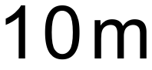. How tall is the tree?
Solution
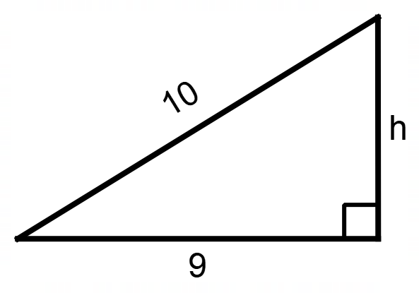
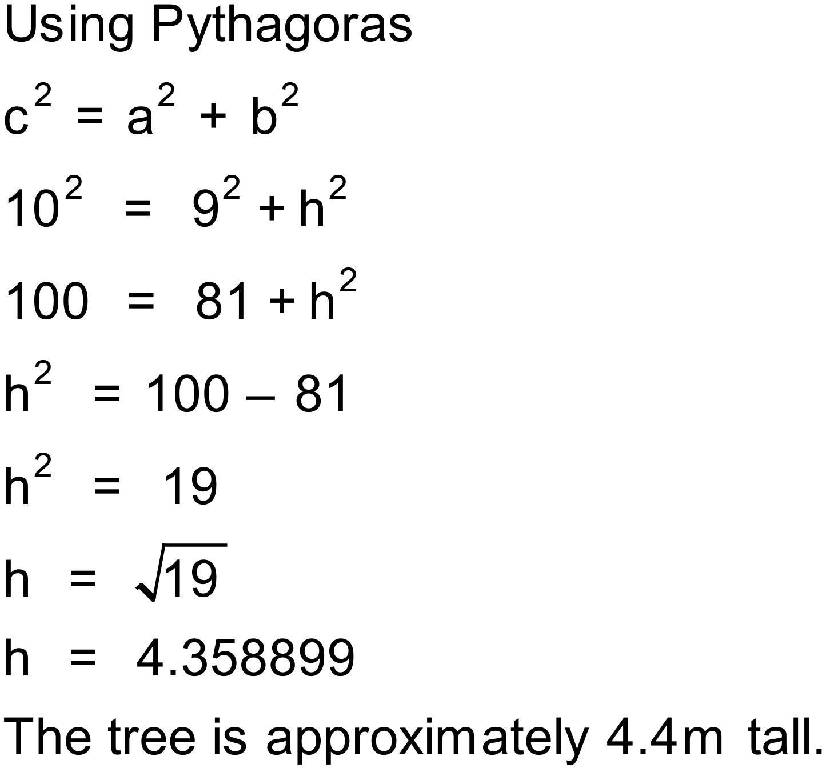
Notes
Any relevant information. Often useful to indicate if the question has integer solutions. Number of variations can go here.

Question
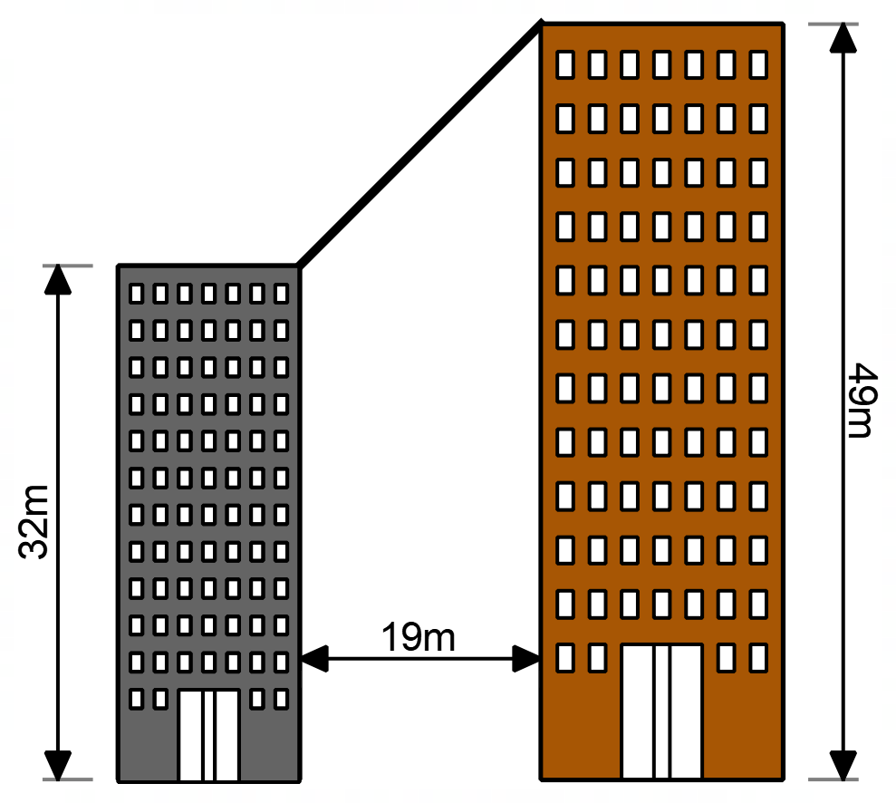
A cable is required to join two buildings which are 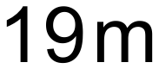 apart as shown in the diagram. The shorter building is 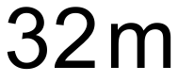 tall and the taller building is 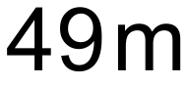 tall. How long does the cable need to be?

Solution
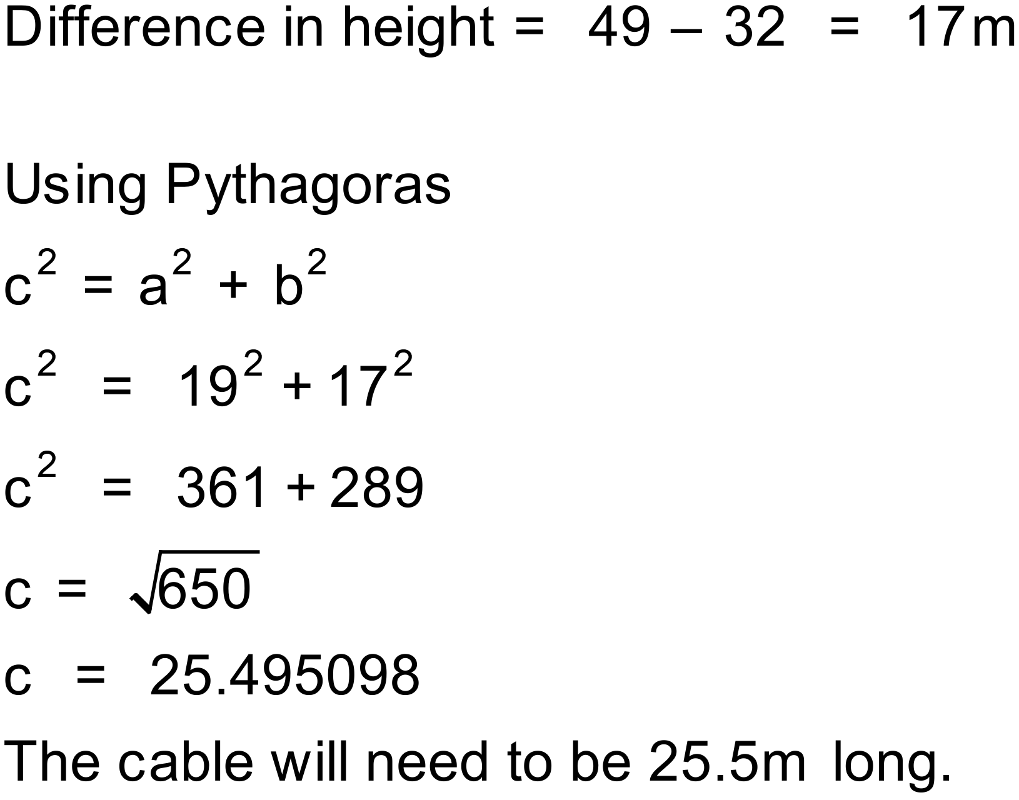
Notes
1000+ variations.

Question
Two towers are spaced 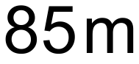 apart and a 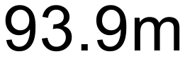 cable joins the top of the two towers. If the shorter tower is 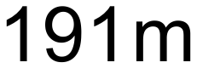 tall, how high is the taller tower?
Solution
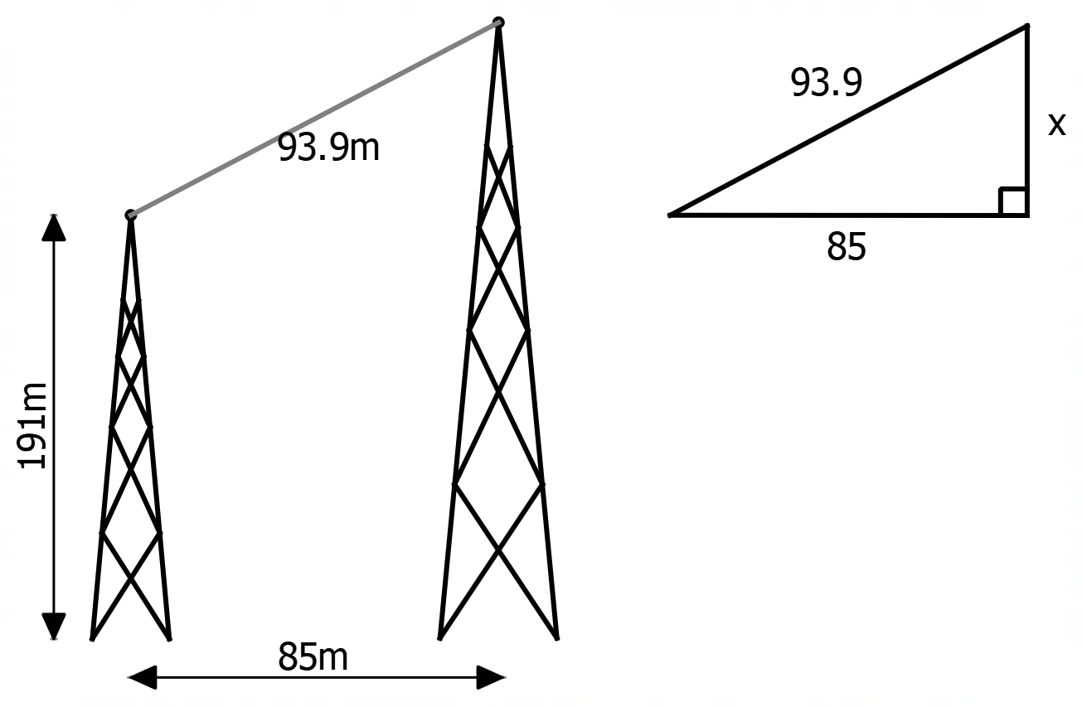
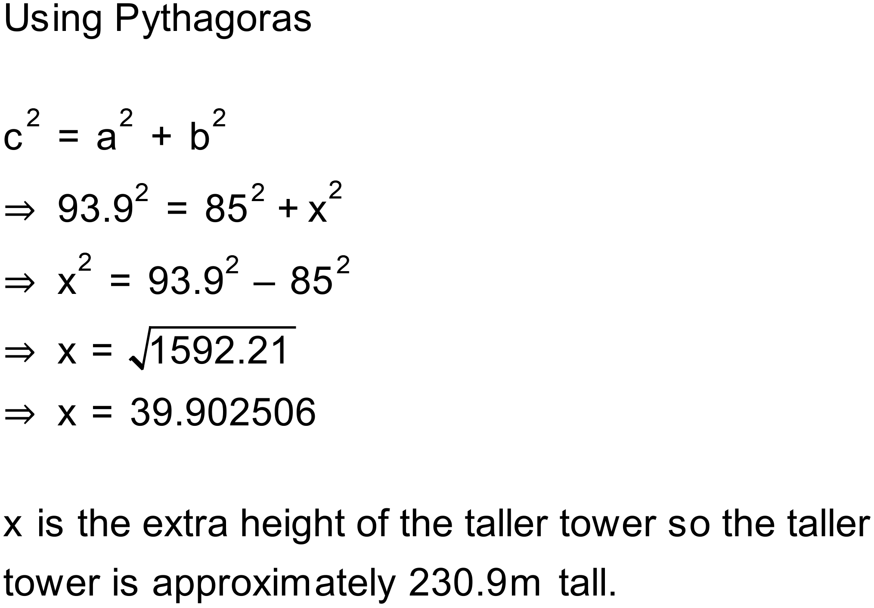
Notes
400 000+ variations

Question
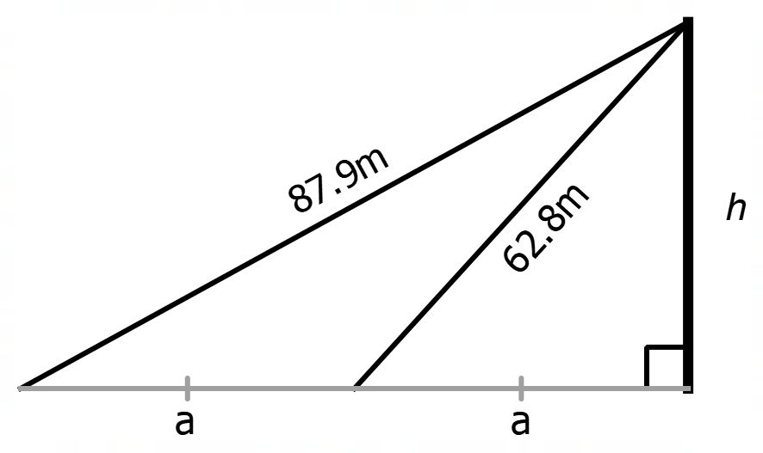
A tower has two supporting cables which are 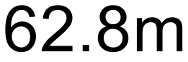 and 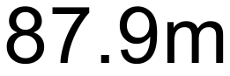 long. If you measure the distance from the base of the tower to the end of the longer cable, it is exactly twice the distance as the shorter cable. How tall is the tower?
Solution
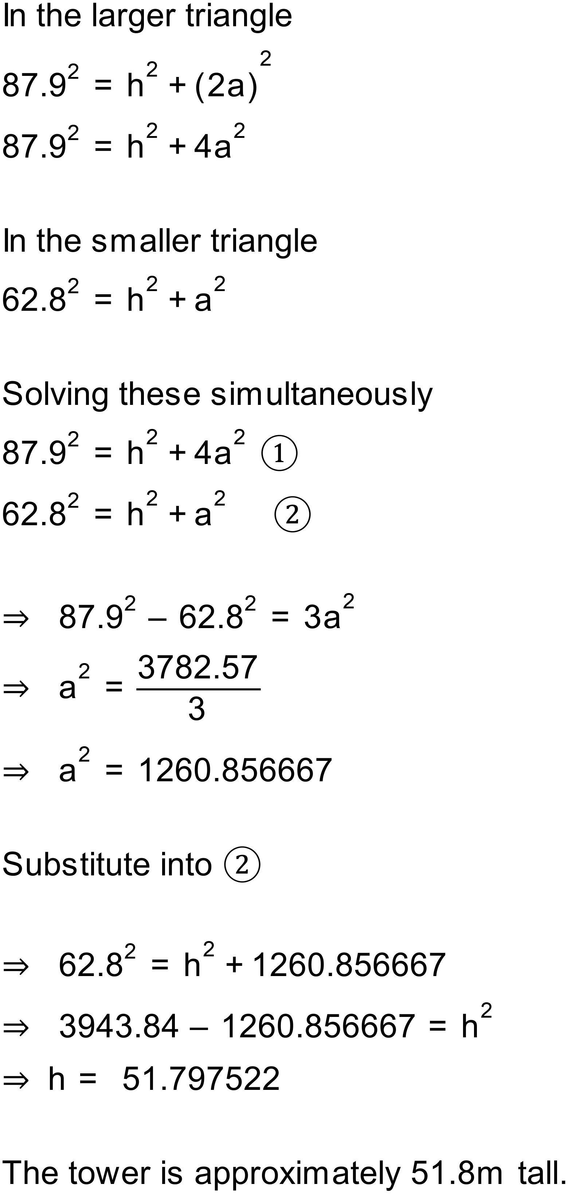
Notes
Challenge question involving use of simultaneous equations. 5000+ variations

