FX Library Modules

Percentages
Age 11-15

Copyright Information
If you are an Efofex subscriber and work in a school, you can copy and/or modify the FX Library materials and use them with your students. We hope that this material will help you write your tests, worksheets, exams, presentations and any other educational materials. You cannot claim copyright over the FX Library materials or present them as your own work.
FAQ

Who are the questions/materials for?
We are providing the materials for teachers in schools. If you are a teacher in a school (or similar context) you are welcome to use the questions/materials freely in just about any manner. Most other usages of our questions/materials are prohibited. In particular, you are expressly prohibited from using our materials in any context where the aim is to generate a profit.
Can I photocopy the questions/materials for use by my students?
YES.
Can I copy questions/materials and paste them into my own documents?
YES.
Do I have to include the Efofex Software copyright notice on my own documents if I have included some of your questions/materials?
NO.
Can I use your questions/materials to generate a profit?
NO.
Can I use the questions/materials on my website/PowerPoint presentation/Moodle...?
It depends. If your usage is within the context of a teacher of students at an educational institution, YES. If you want to use the materials for profit, NO.
I am a home-schooling parent. Can I use your materials?
YES.
I am a student and want to use your products for revision. Can I use them?
YES (but make sure to tell your teachers how good they are!)
Can I modify your questions/materials for my own use?
YES.
If I modify your questions, can I claim copyright?
It depends. If the modifications are substantial, YES. If the modifications are trivial or superficial, NO. Using the Parameter Regeneration feature of our products is NOT a substantial modification
I am a professional tutor. Can I use your materials with my students?
NO.
Can I republish your materials?
NO.
I think that I might be able to use your materials but don't seem to fit any of your FAQs. What do I do?
Send us an email describing what you want to do (to info@efofex.com) and we will get back to you as soon as possible.

How To Use This Material
Copy a question from this document and paste (with reparametizing) into your document. This allows you to quickly build a collection of regeneratable questions into a test, worksheet, presentation, or exam.

Question
Determine the original amount if 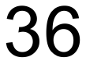% of the original amount is 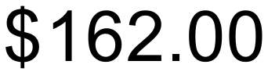
Solution
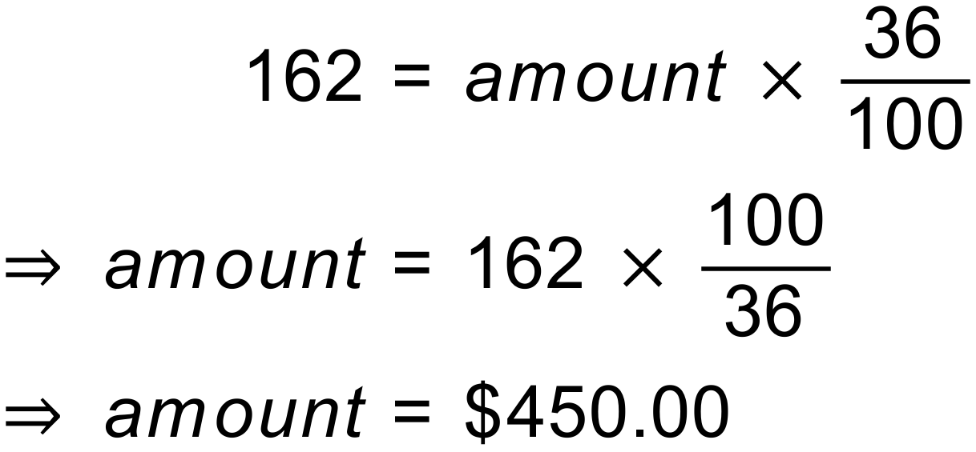
Notes
3000+ variations.

Question
A middle-aged man notices that he has gained 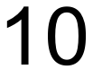kg and now weighs 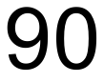kg.
- What percentage of his current weight is weight-gain?
- What percentage of his original weight did he gain?
Calculate your answers to the nearest whole percentage.
Solution
- 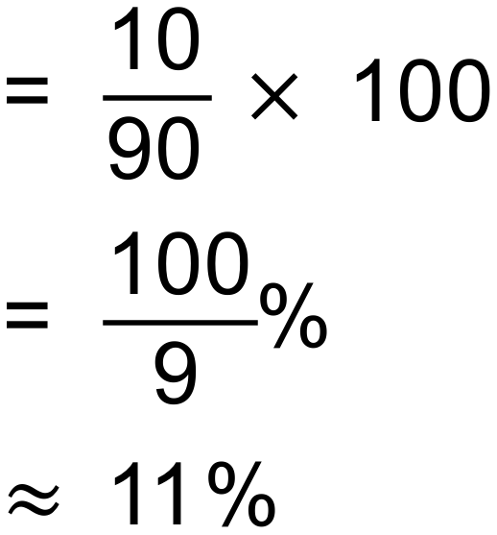
- 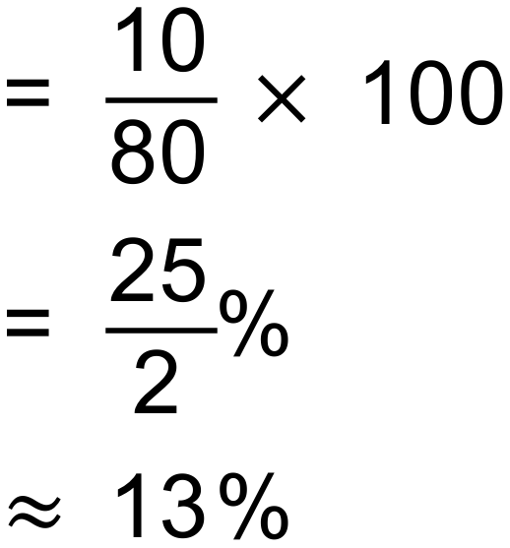
Notes
21 variations.

Question
A food manufacturer has discovered that % of their packets are not being filled correctly and are underweight. If the manufacturer packs 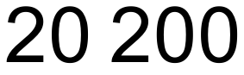 packets per week, how many are likely to be underweight?
Solution
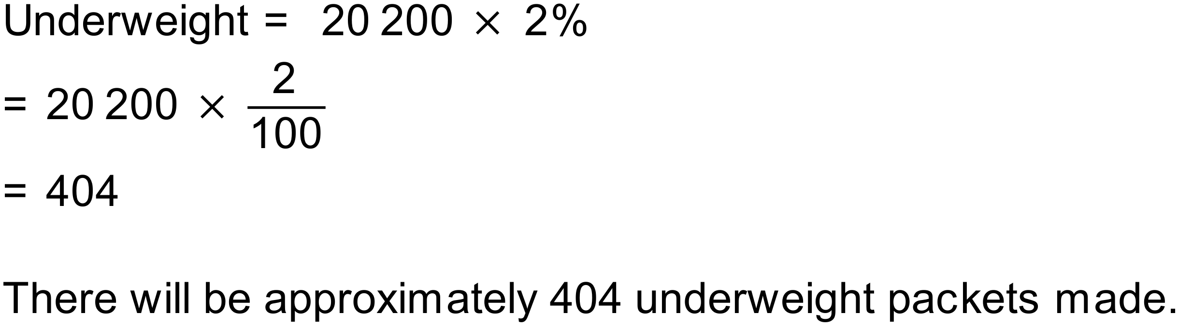
Notes
4000+ variations.

Question
Jane has a weekly salary of 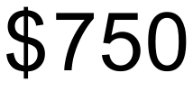. Last week she spent 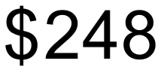 on food. What percentage of Jane’s income is spent on food?
Solution
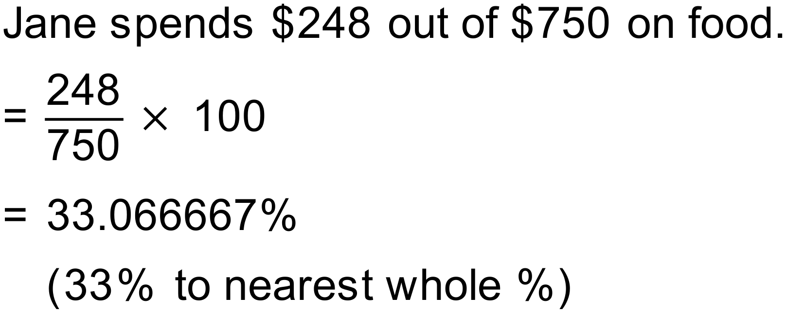
Notes
200+ variations.

Question
Jack received his test results and found that he had scored 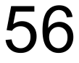 out of a possible 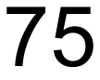. Convert Jack’s mark to a percentage (round to the nearest whole number).
Solution
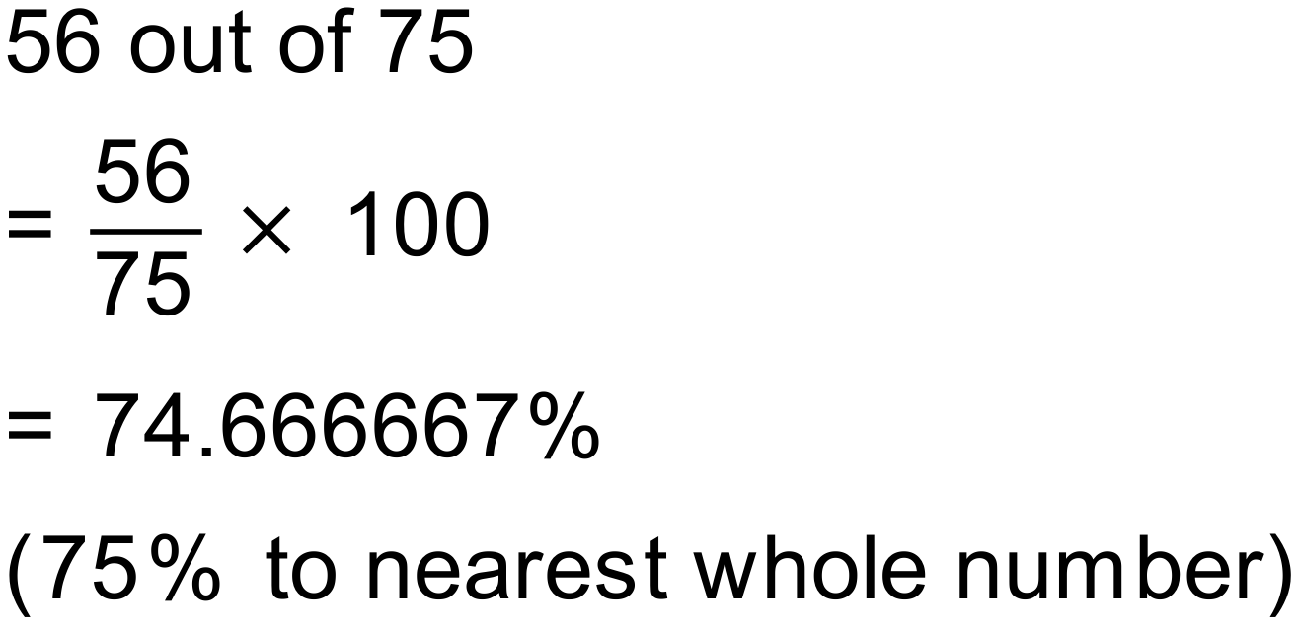
Notes
200+ variations.

Question
An alloy contains 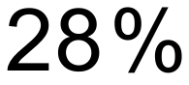 nickel. If a sample of the alloy weighs 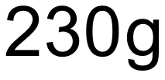, how much of the sample is nickel?
Solution
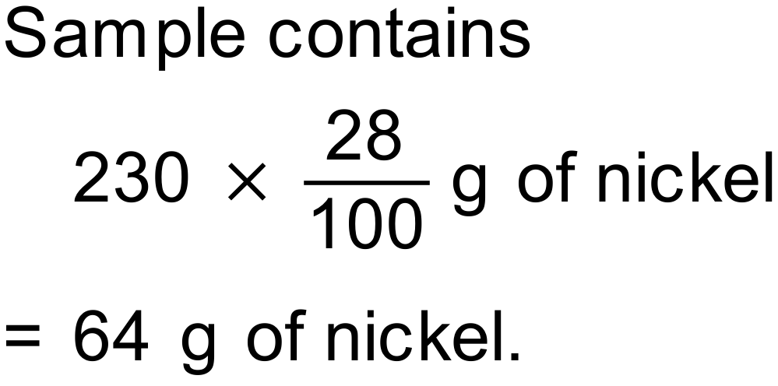
Notes
3000+ variations.

Question
Hematite iron ore contains between 54% and 66% iron. The percentage of iron in the ore is called the “grade” of the ore. A geologist has collected a 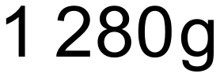 sample of hematite and is analysing its iron content.
- Calculate the highest and lowest expected values for the grams of iron in the sample.

- The geologist finds that their sample contains 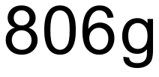 of iron. Find the grade of the iron ore (to the nearest whole number).
Solution
- 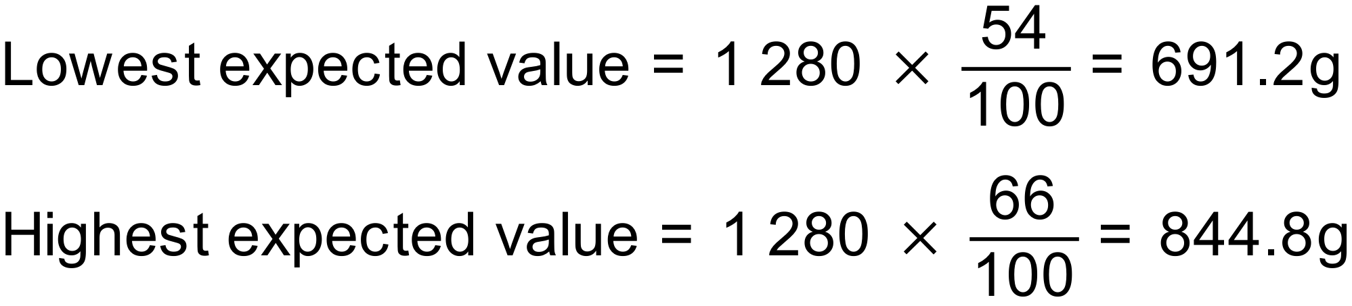

- 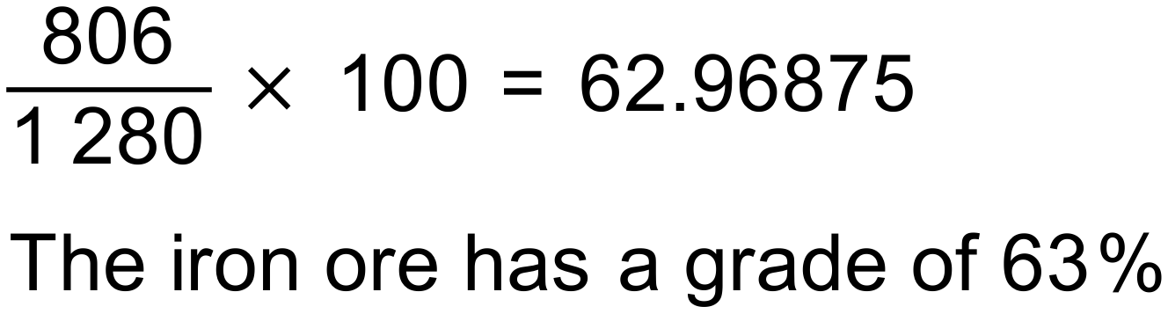
Notes
3000+ variations.

Question
Chris scored 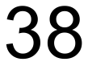 out of 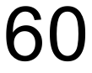 on his History exam and 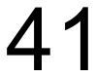 out of 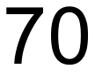 on his Geography exam. On which exam did Chris perform the best?
Solution
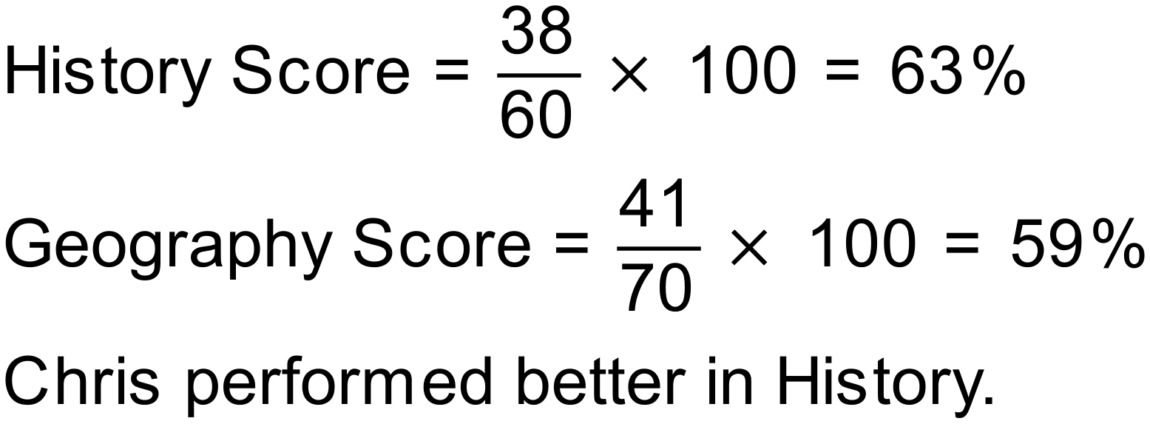
Notes
15000+ variations.

Question
Complete the table:
Decimal | Fraction | Percentage
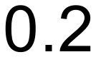
 |  | 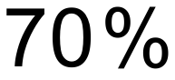
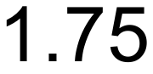
 |  | 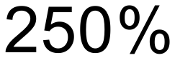

Solution
Decimal | Fraction | Percentage
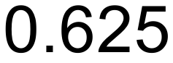 |  | 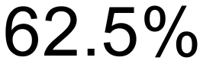
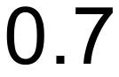 | 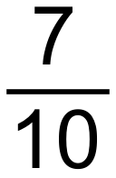
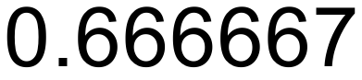 |  | 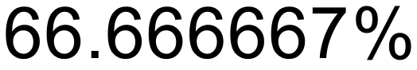
 |  | 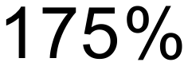
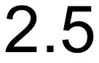
Notes
8000+ variations.
Question
A sports stadium has sold 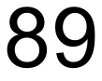% of its seats. If the capacity of the stadium is 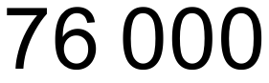, how many of the seats have not been sold?
Solution
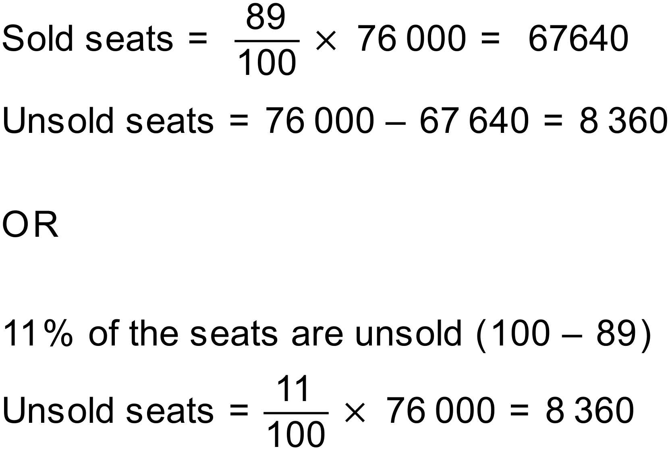
Notes
500+ variations.

Question
Increase 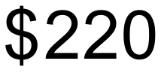 by 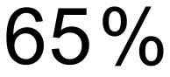
Solution
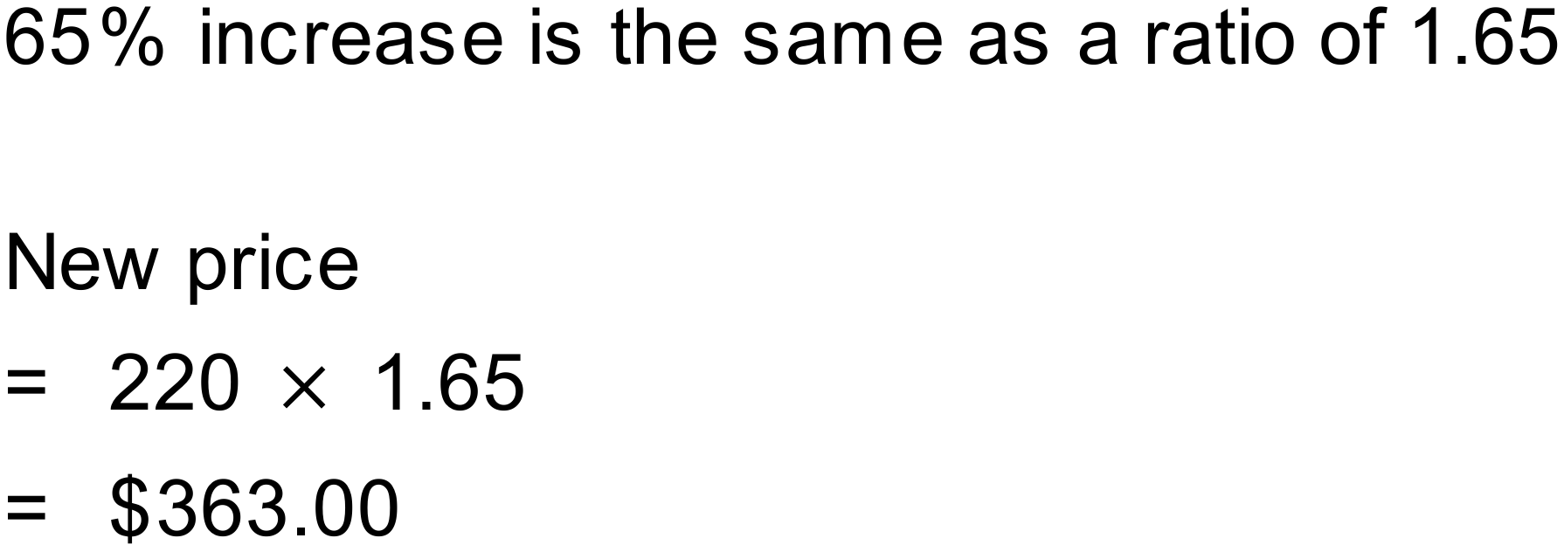
Notes
300+ variations.

Question
Decrease 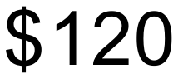 by 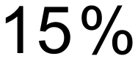
Solution
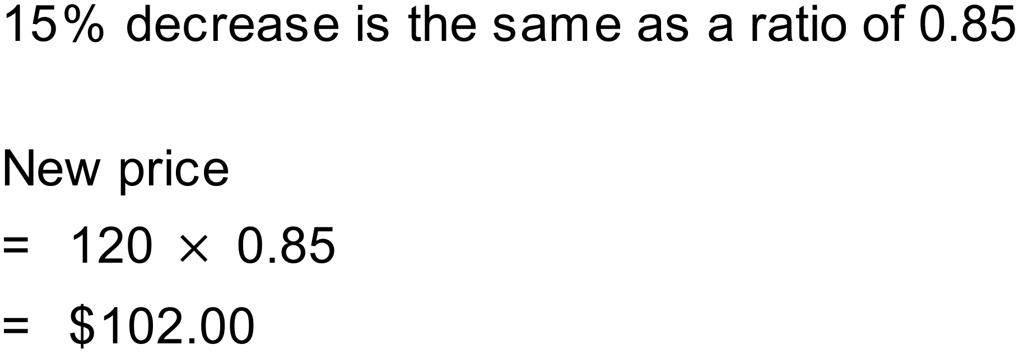
Notes
300+ variations.

Question
A news report has said that the number of babies born in the last year had increased by 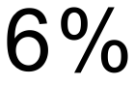 to 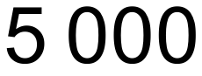. Approximately (to the nearest 10) how many babies had been born in the year before the increase?
Solution
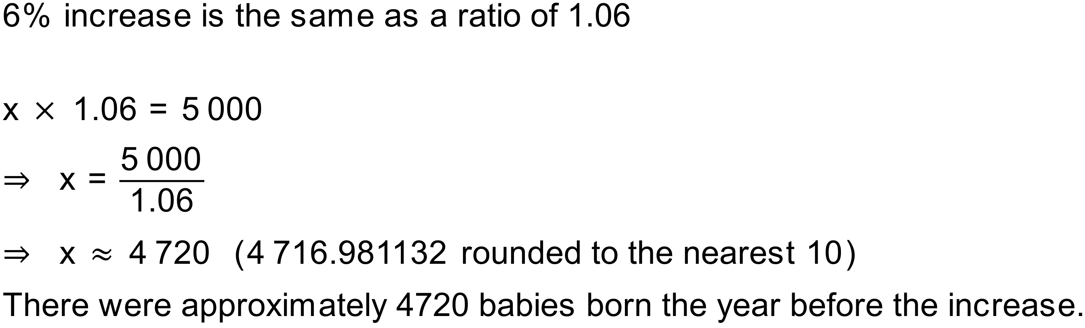
Notes
10000+ variations.

Question
The price of entry into a theme park was recently increased by 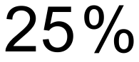 to 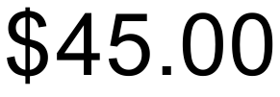. What was the original price charged to enter the park?
Solution
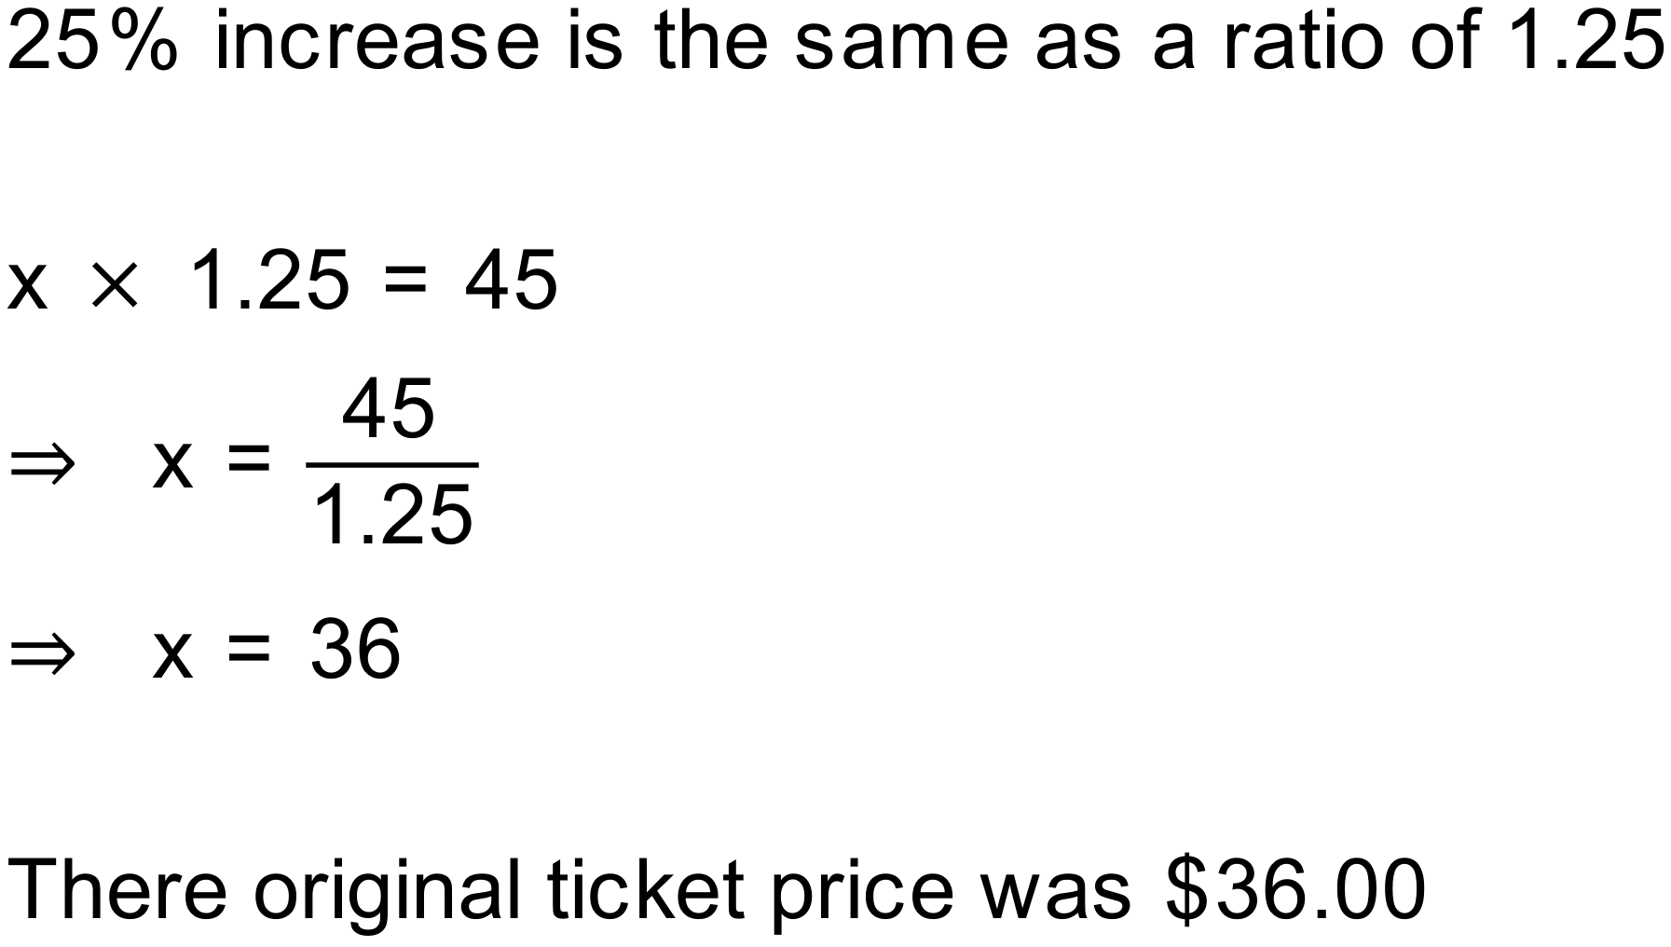
Notes
150+ variations.

Question
A farmer has reduced the amount of land that they planted with wheat by to 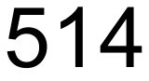 hectares. How much land (to the nearest hectare) did they originally have planted with wheat?
Solution
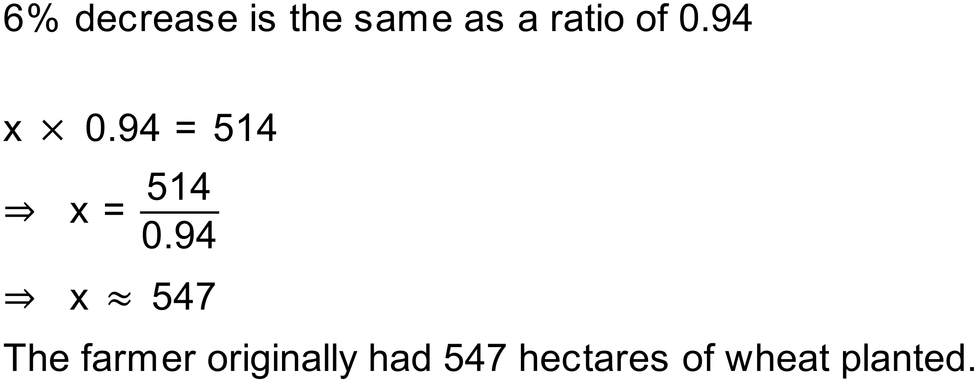
Notes
5000+ variations.
Question
The price of a particular new car has increased from 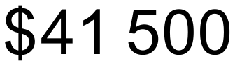 to 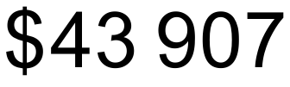. Find the percentage increase (to 1dp).
Solution
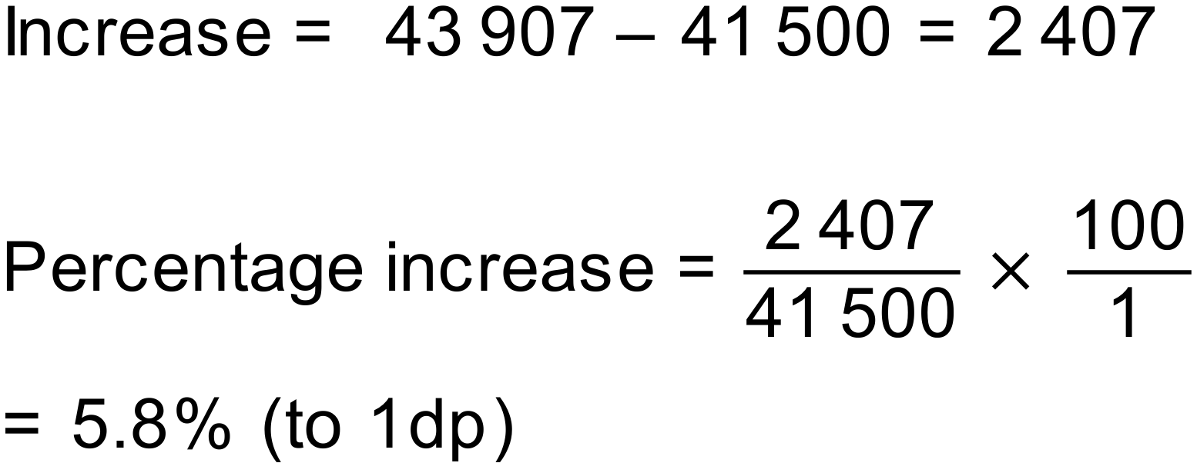
Notes
500+ variations.
Question
The population of a town decreased from 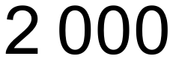 to 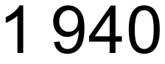. Find the percentage increase (to 1dp).
Solution
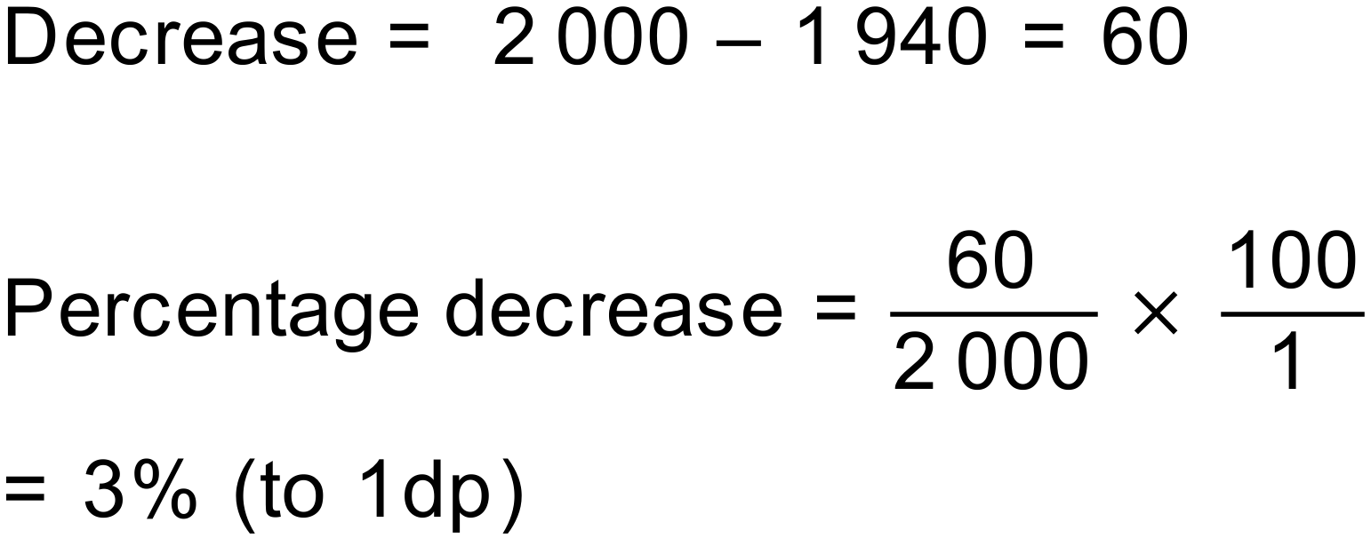
Notes
250000+ variations.
Question
Over the summer holidays James had a growth spurt, growing from 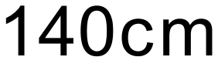 to 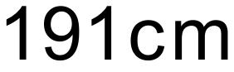. What was the percentage increase in James’ height? (to 1dp)
Solution
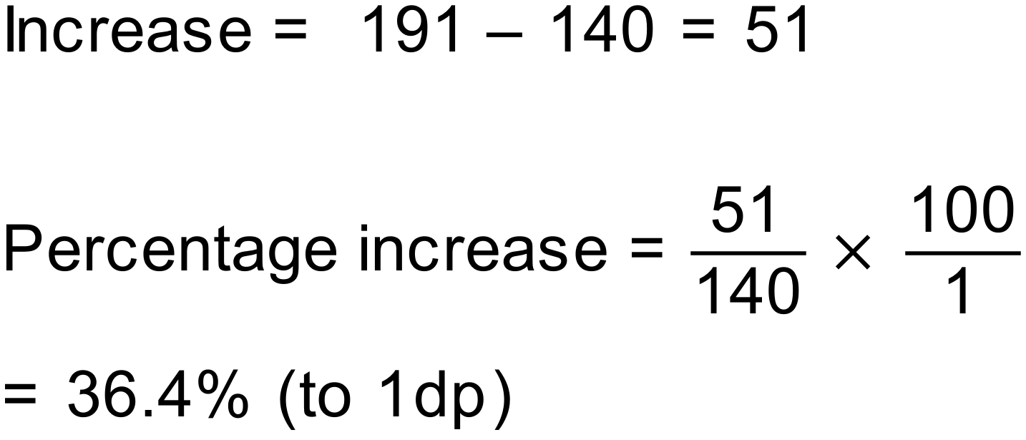
Notes
400+ variations.
Question
The total price of an item including GST (at 10%) is 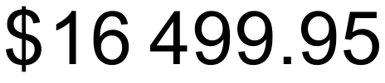. How much of the purchase price is GST (to the nearest cent).
Solution
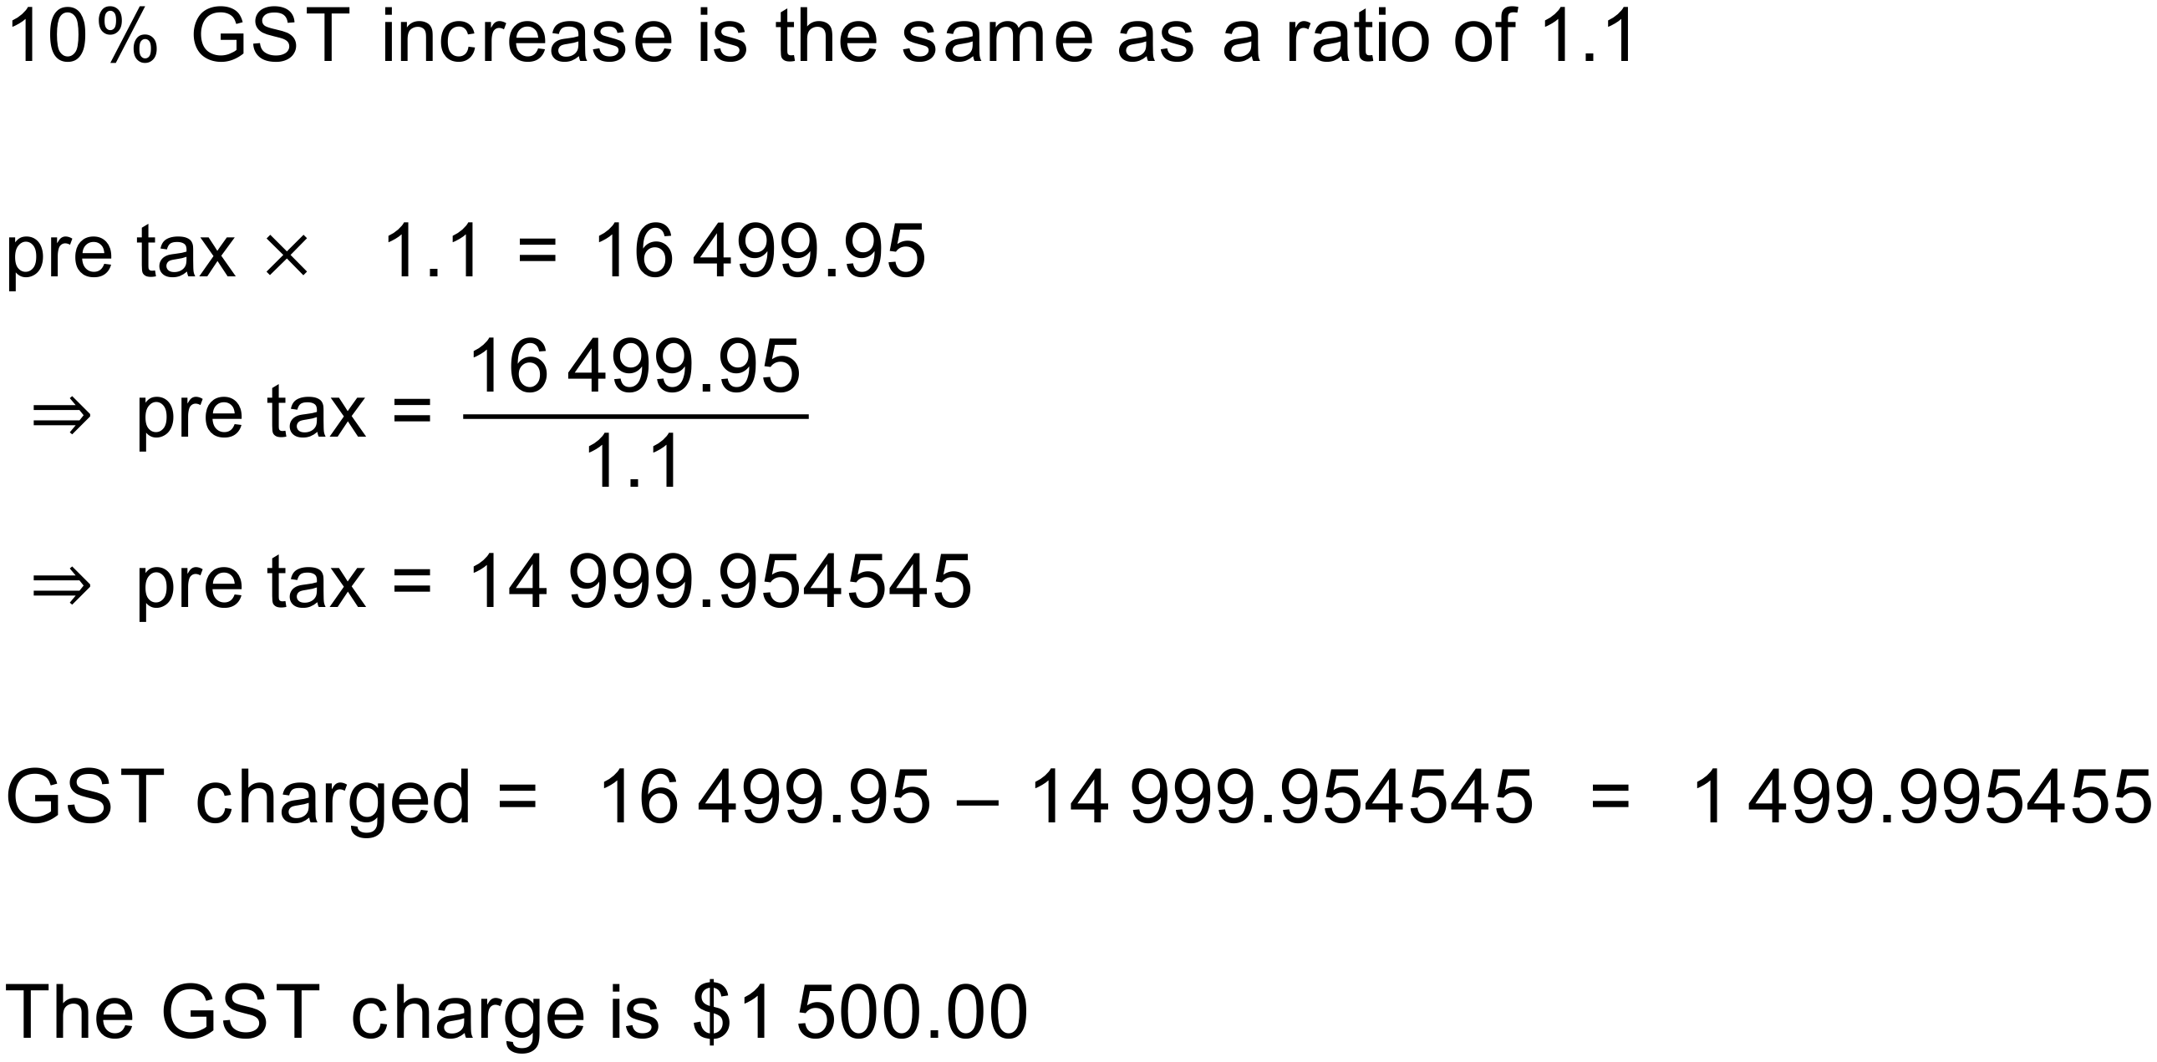
Notes
150+ variations.

Question
A stock investor buys 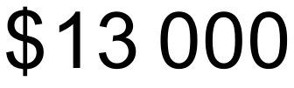 worth of shares on Monday. On Tuesday, the share price drops by 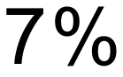.
- What are the shares worth after Tuesday’s drop in price?
On Wednesday, the shares jump back up in value and are again worth at the end of the day.
- What percentage rise did the shares experience on Wednesday (to 2dp)?
Solution
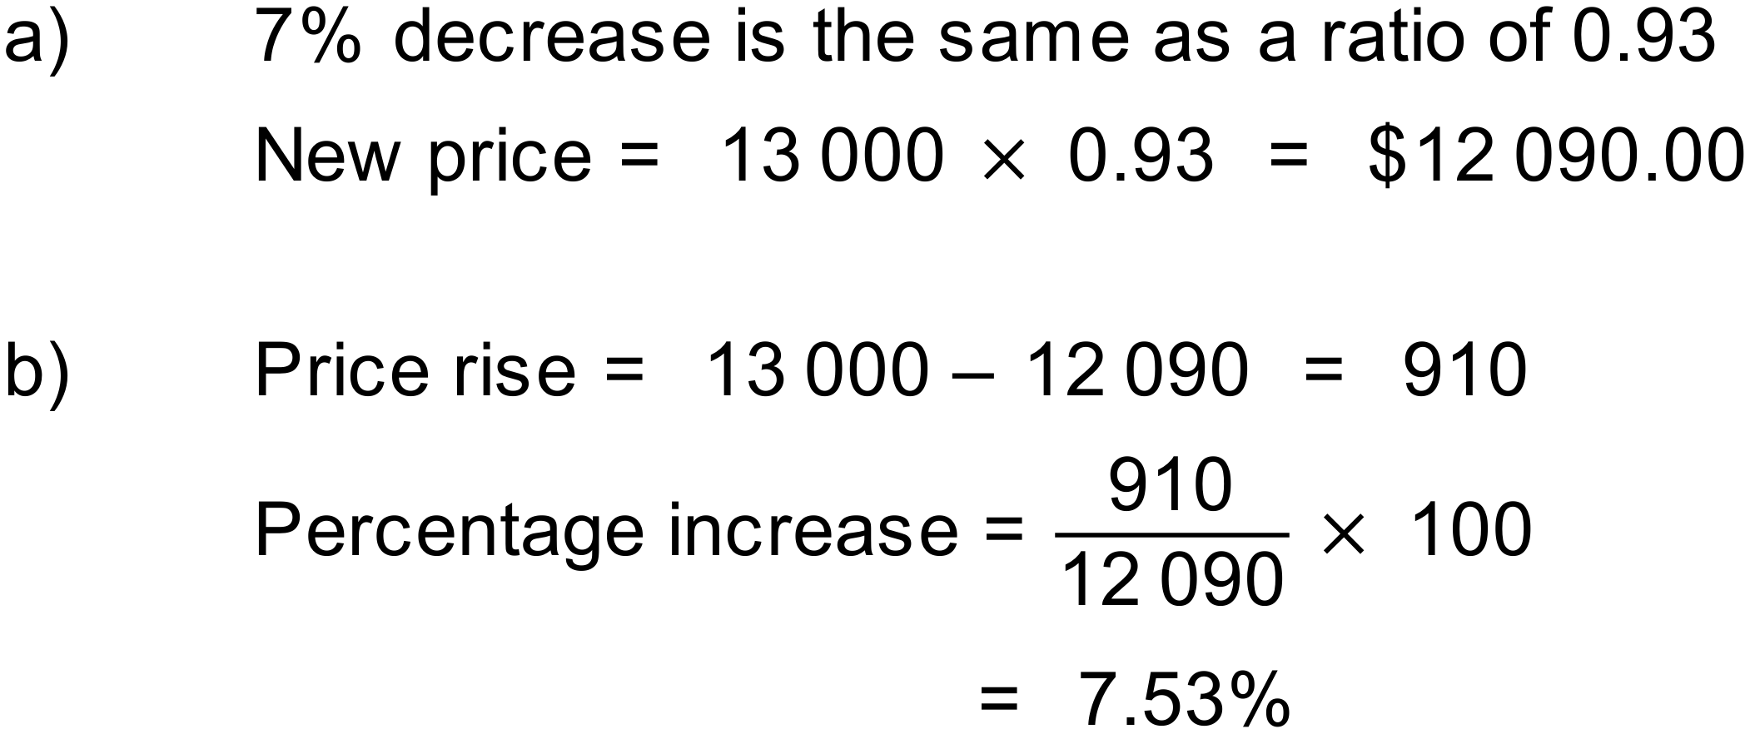
Notes
900+ variations.

Question
The price of a new car has risen 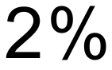 per year, every year for the last three years. If the car cost 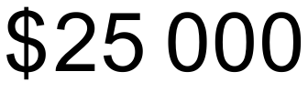 three years ago, how much does it cost now (to the nearest $100)?
Solution
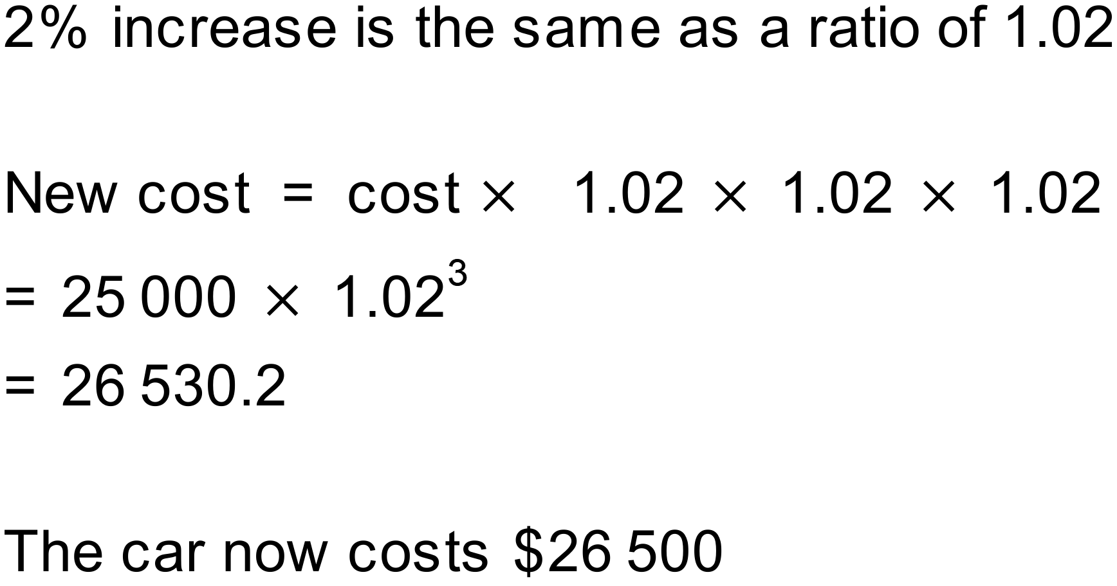
Notes
100+ variations.

Question
The average house price in a popular seaside town has risen from 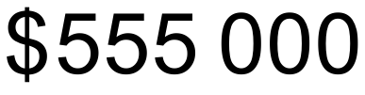 to 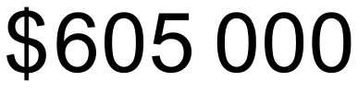 in the last year. What is this increase as a percentage (to the nearest whole number)?
Solution
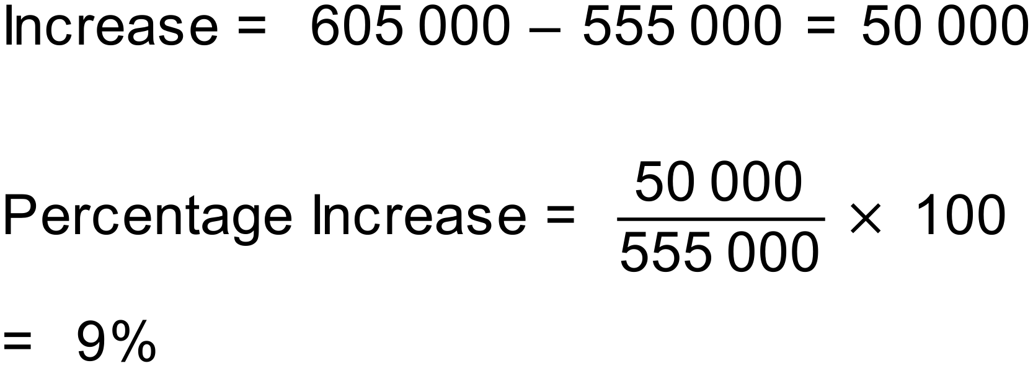
Notes
3000+ variations.

