Investigation – Measuring Heights and Depths
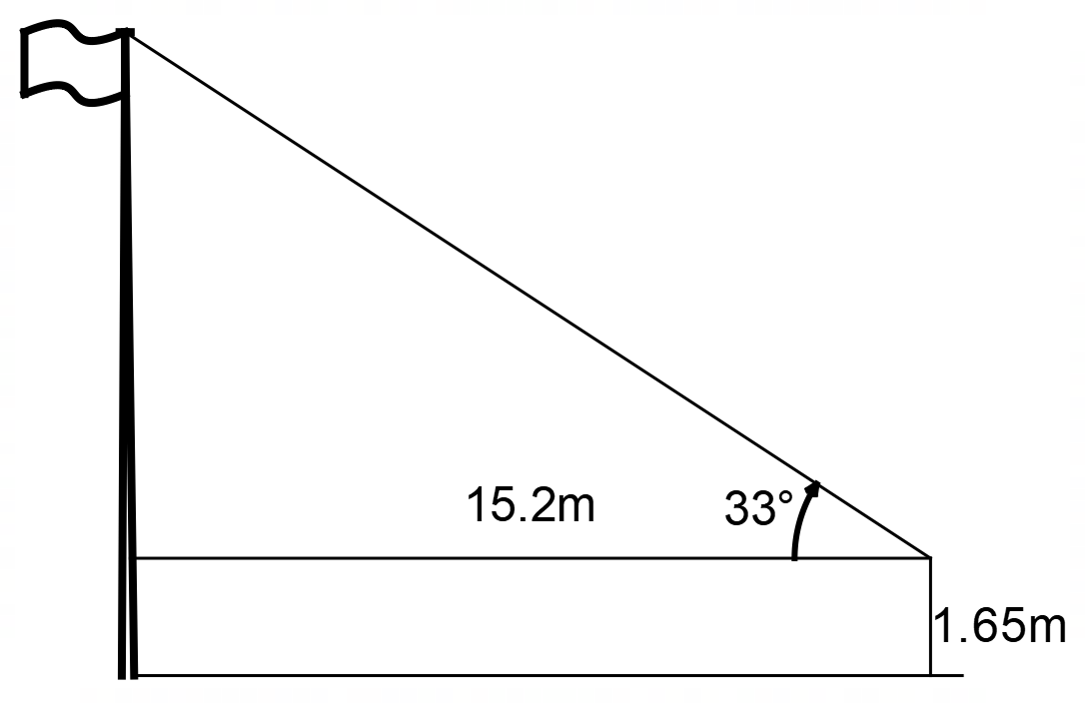
Trigonometry is very effective for measuring the heights of objects. For example, using an inclinometer and a tape measure it is very easy to measure the height of something like a flagpole.

1. Use trigonometry to calculate the total height of the flagpole shown on the right. The surveyor’s eye is 1.65m from the ground. Show your working clearly.

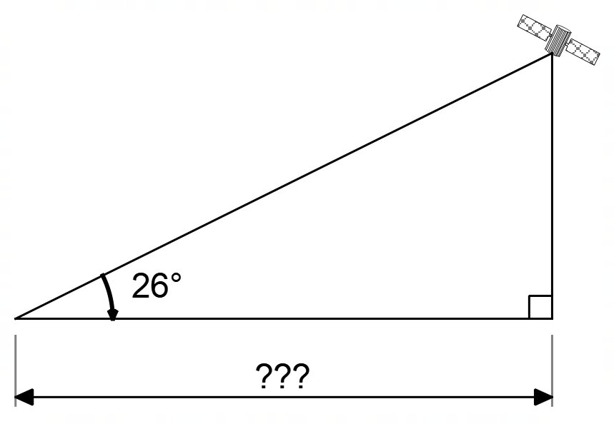
Unfortunately, the method used above requires the surveyor to measure the distance from their observation point to the base of the object. This is rarely possible or convenient. For example, how would we measure the height of a mountain or the altitude of a satellite? In both cases measuring the distance marked ??? is difficult or impossible.
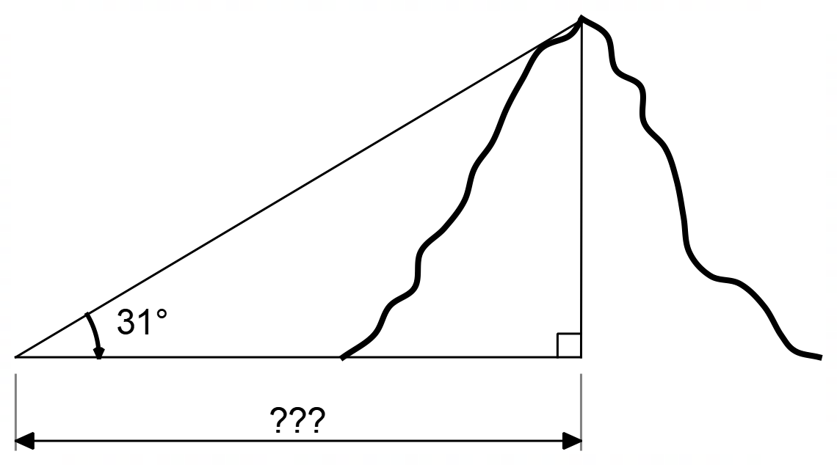
To solve this problem, surveyors use a different technique as shown below.
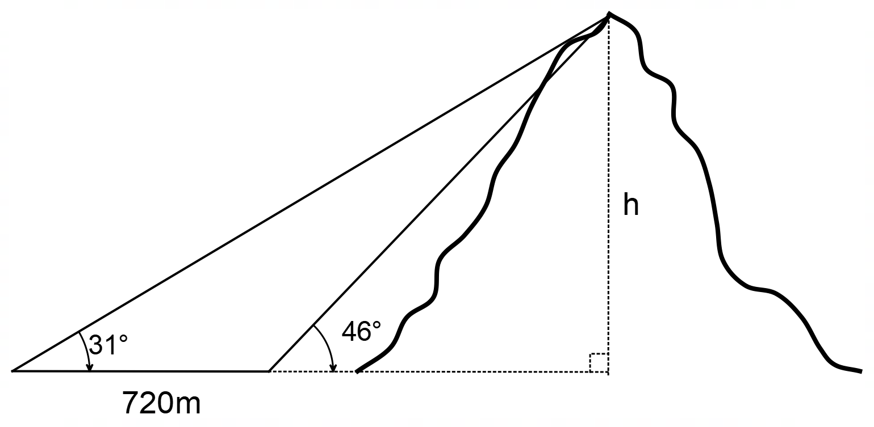

The surveyor measures the angle of elevation of the peak of the mountain at two different locations and measures the distance between the locations. A bit of trigonometry and algebra and they can quickly calculate the height.

2. Use the information provided to calculate the height of the mountain. Show all working.

Like most mathematically minded people, surveyors like to minimise the amount of work that they do and would like a formula that allowed them to put in the data they measure and calculate the height of the mountain.

3. Devise a formula that allows the surveyor to perform their calculation. Explain why the formula is correct.

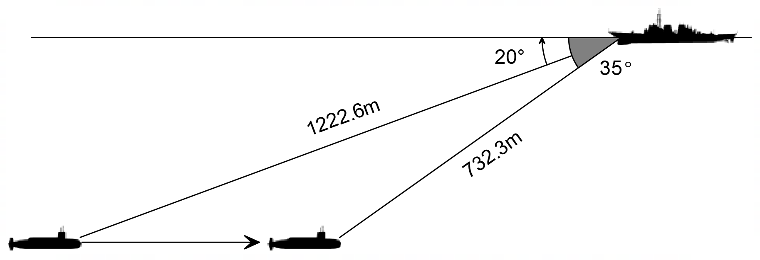
A similar problem exists for warships trying to track submarines.

A warship’s sonar can detect range to a target and angle of depression. Using information taken at two different times, the warship can calculate the speed of the submarine.

4. The two readings shown above were taken at an interval of thirty seconds. Use this information to calculate the speed of the submarine in m/s, km/h and knots.

5. How long before the submarine passes directly below the warship?

6. At what depth is the submarine travelling?

Ocean speeds are measured in knots so it is vital that the submarine’s speed is quoted using these units.

7. Devise a formula that would take two sets of measurements (taken 30 seconds apart) as shown above and will calculate the submarine’s speed in knots. You will need to research how to convert your calculated speed to knots.

The example of the submarine used above contains many assumptions that would not be correct in real life. In real life, the warship’s job is much harder than this example.

8. Make a list of assumptions that have been made in the example and why they would not occur in real life.

Your answers to these questions will be part of your mark for this investigation

Validation Test Date: ________________________
Validation – Measuring Heights and Depths /15
Name:
1. Using your formula, or otherwise, determine the altitude of the satellite.

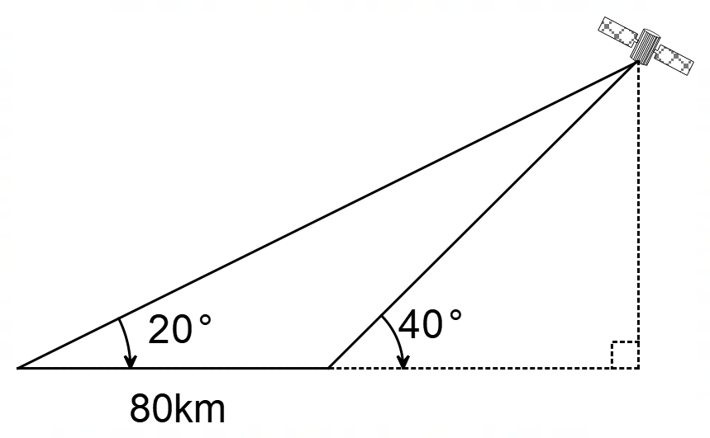

[6 Marks]
2. Using your formula, or otherwise, determine the speed and depth of the submarine in knots if the two measurements were taken 30 seconds apart.

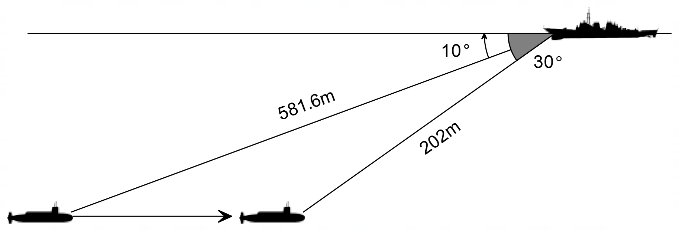
[6 Marks]
3. The sonar operator performing the calculation in question 2 realised that the angle of depression of the second measurement was 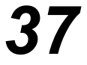 degrees rather than 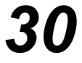 degrees. What can you say about the submarine’s motion?

[3 Marks]

Investigation Solutions
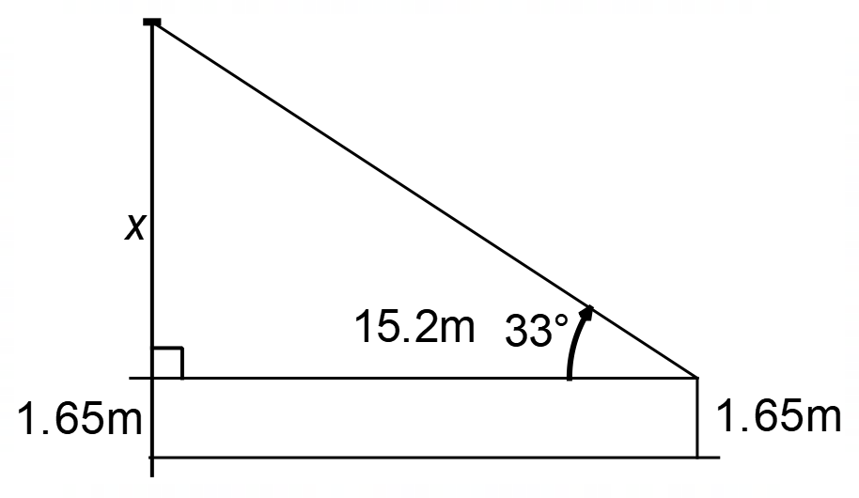
- 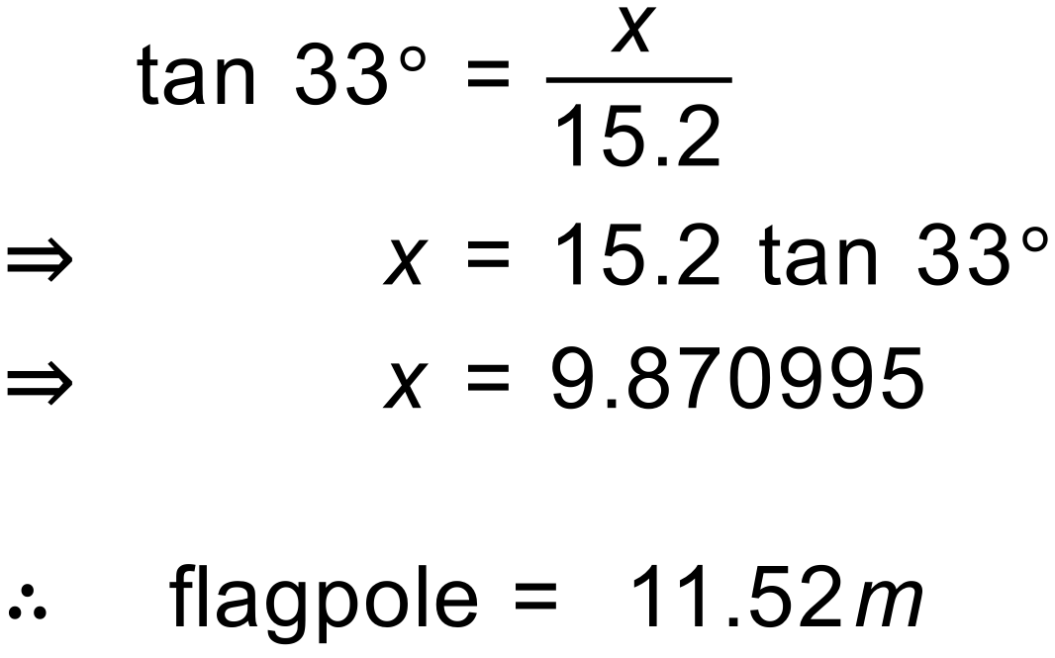

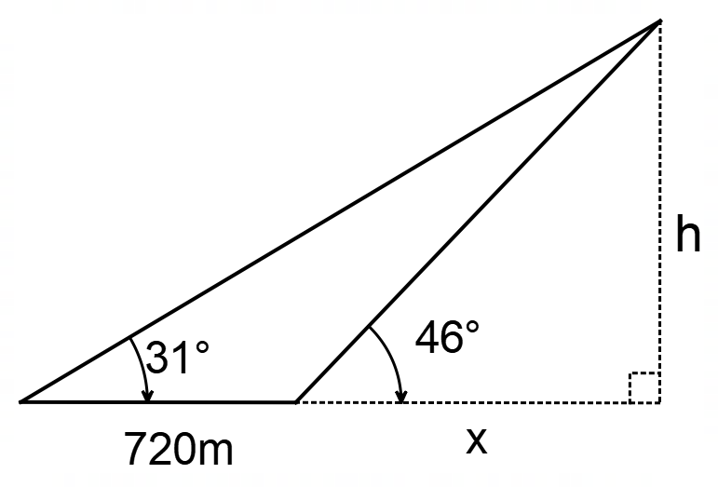
- 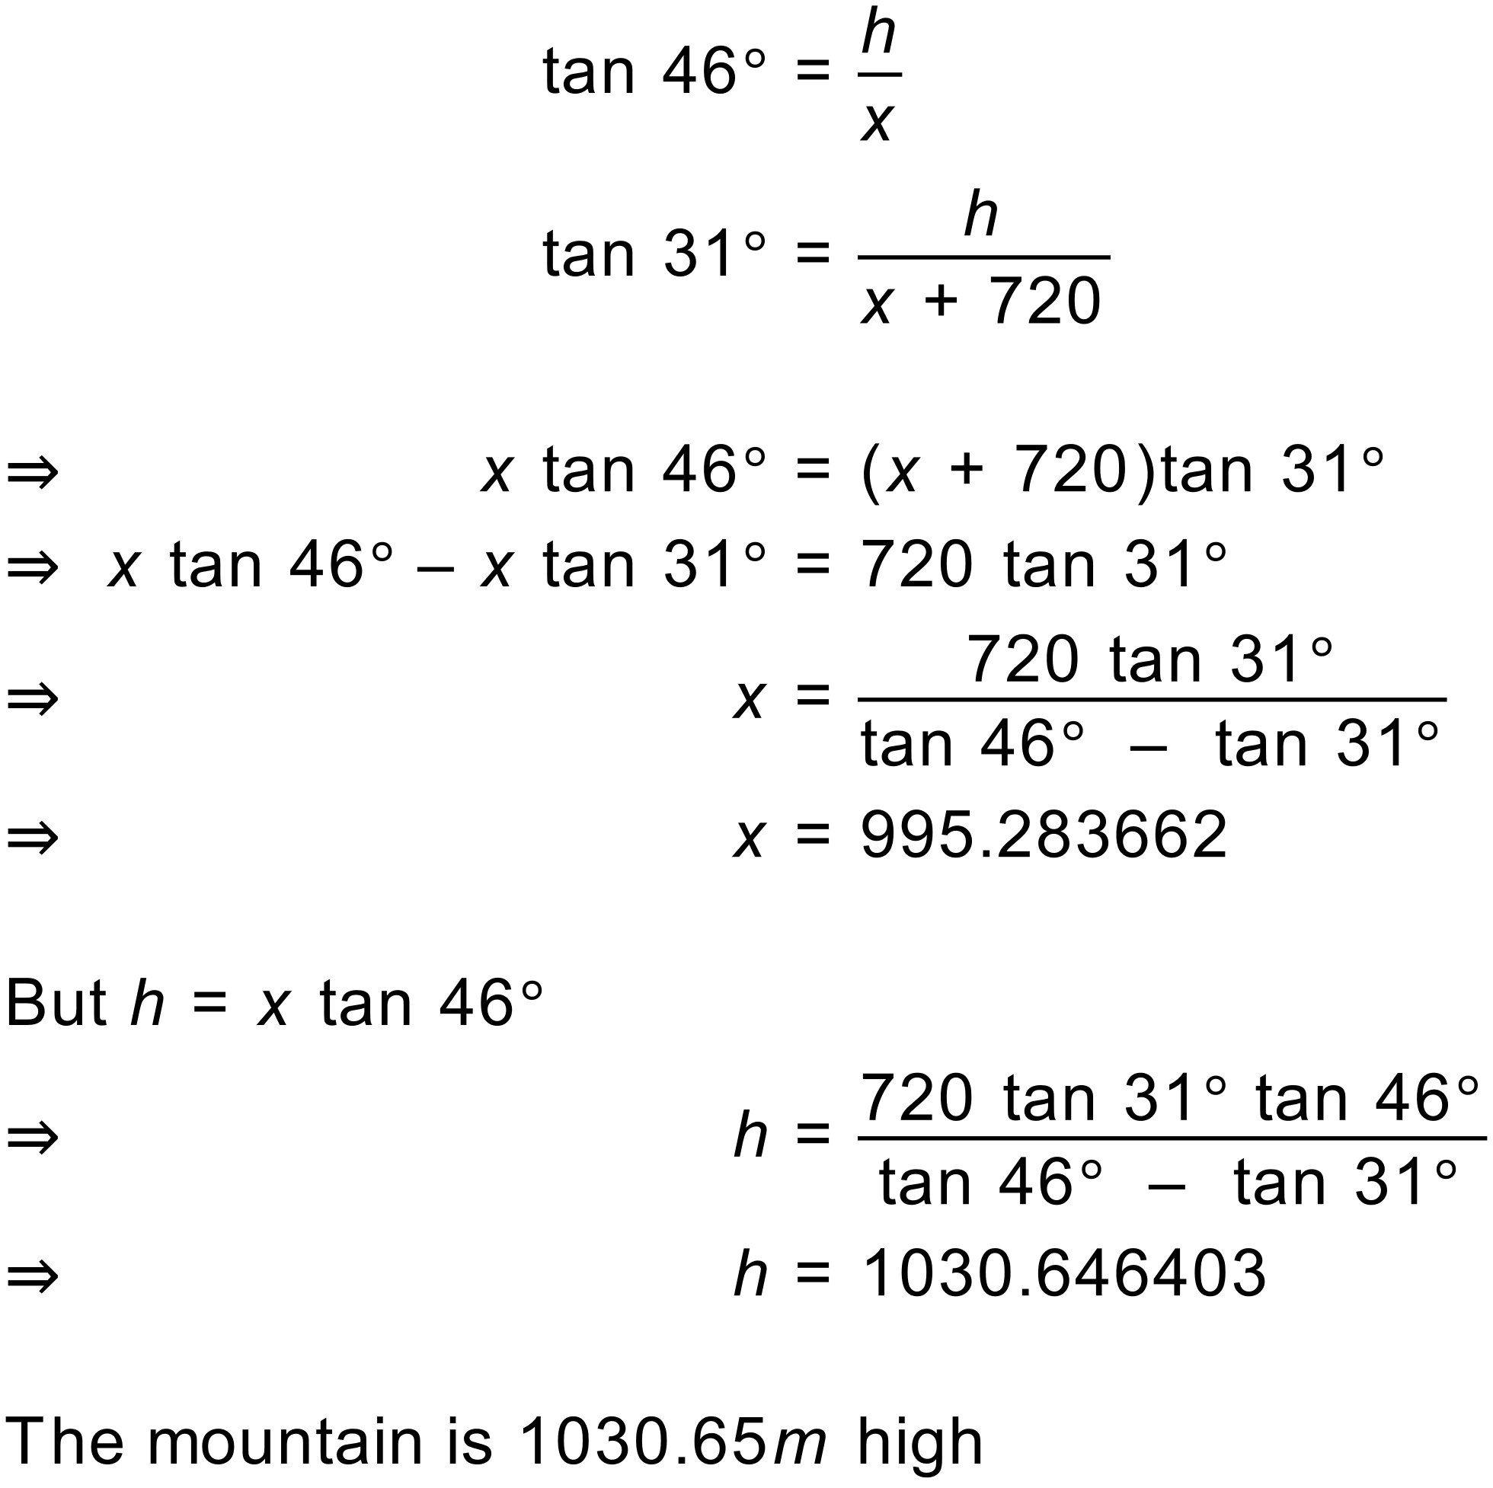

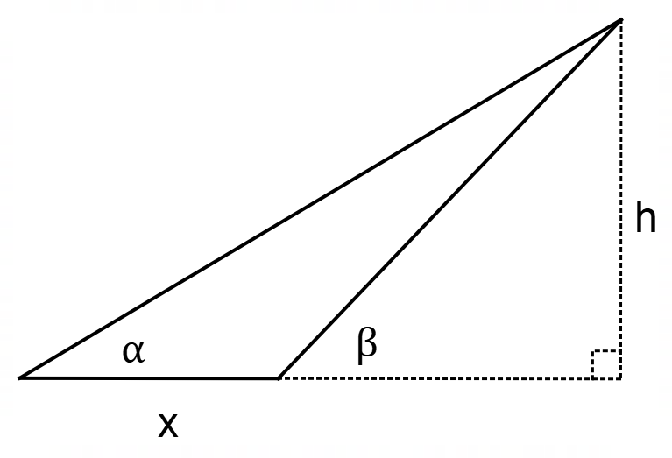
- 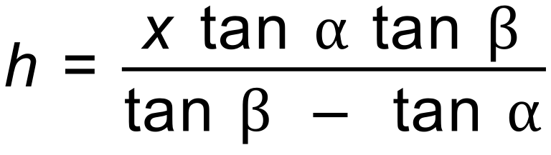

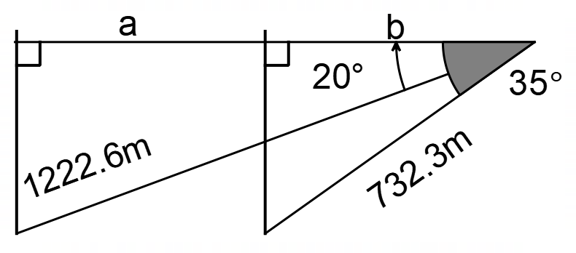
- 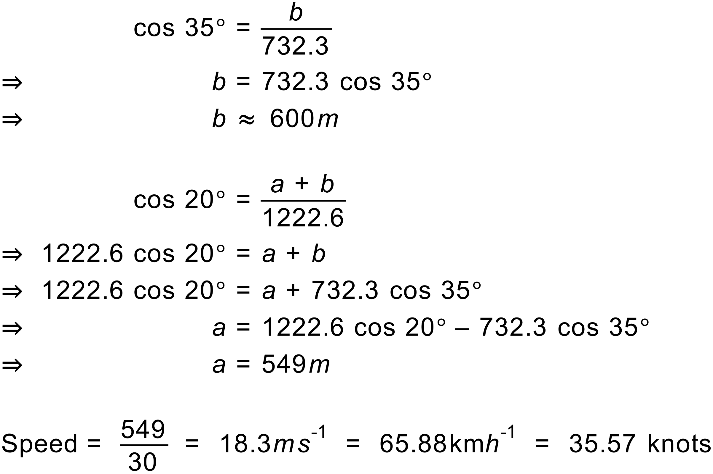

- 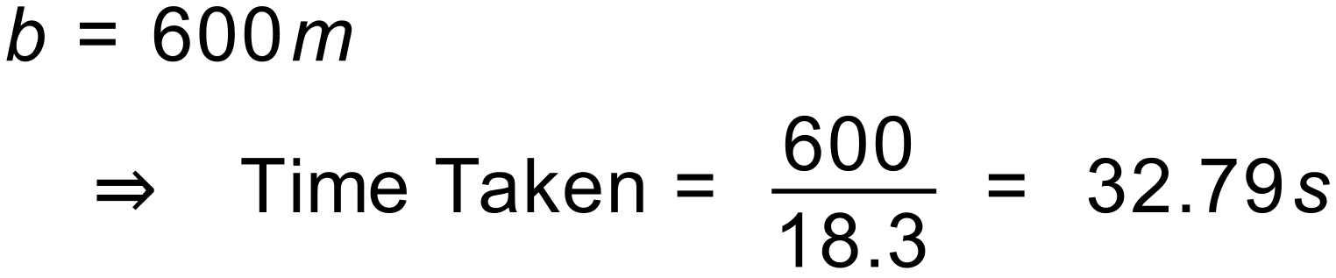

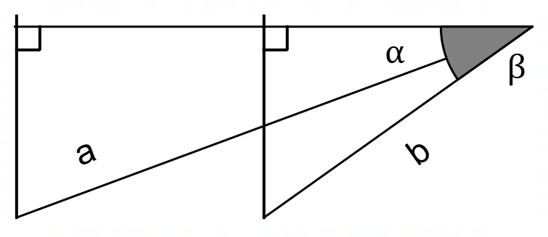
- 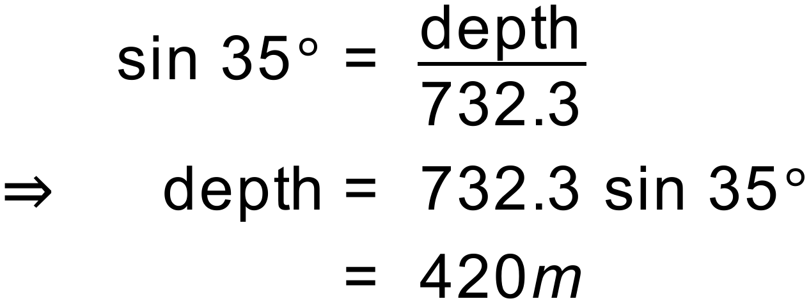

- Using the answer to Q4 as a basis.
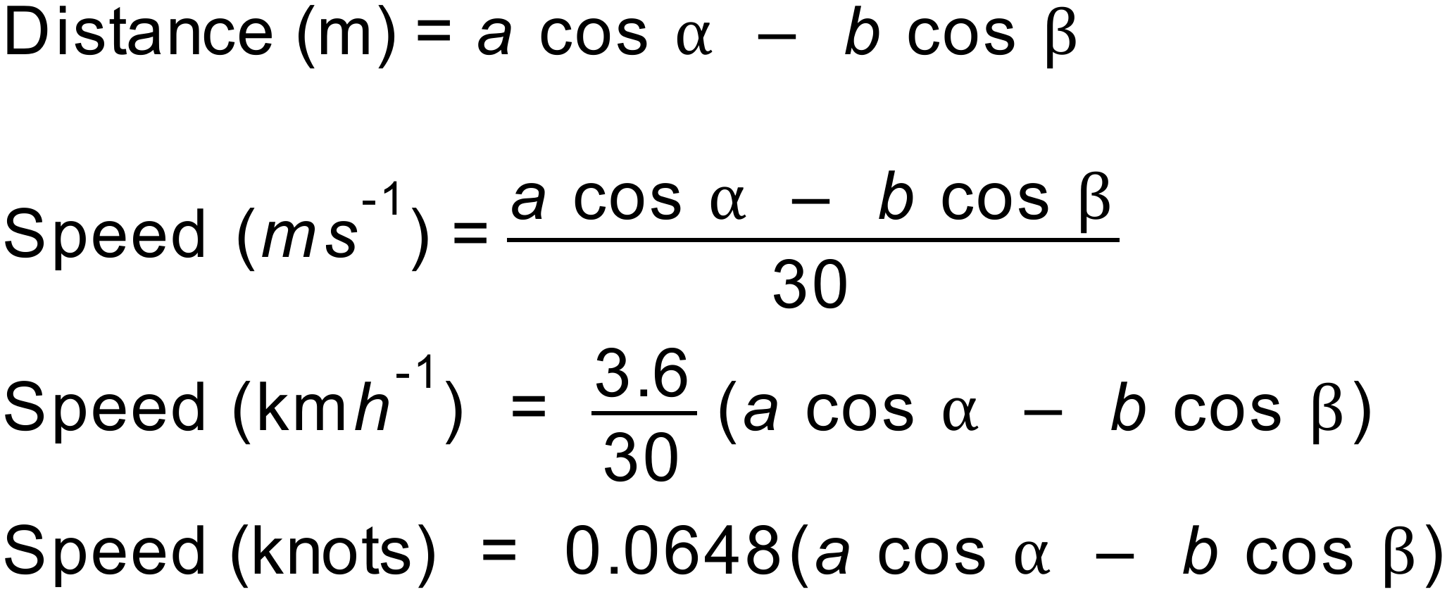

- Assumptions Made
  - Constant depth
  - Constant speed
  - Travelling directly under ship
  - Travelling in a constant direction.

Validation Solutions

- 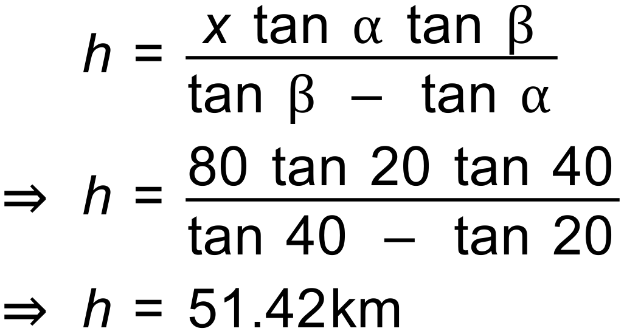

- 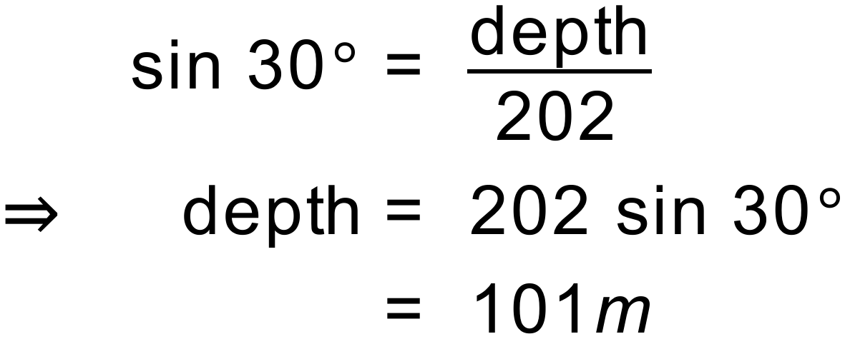

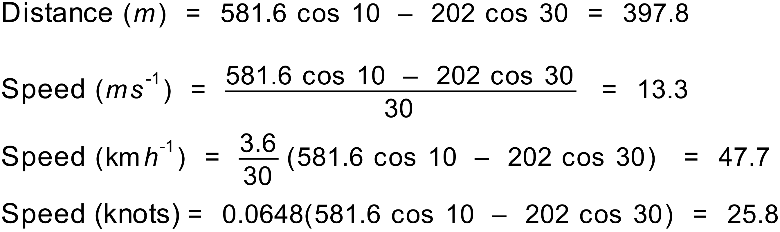

- The submarine must be descending.

