Is Faster More Efficient? – Out of Class Section

http://www.visualexpert.com/Resources/reactiontime.html

It is often said that “Speed Kills” and the Police department often has advertising promotions indicating that perhaps it is not worth someone’s life just to get there a few minutes quicker.

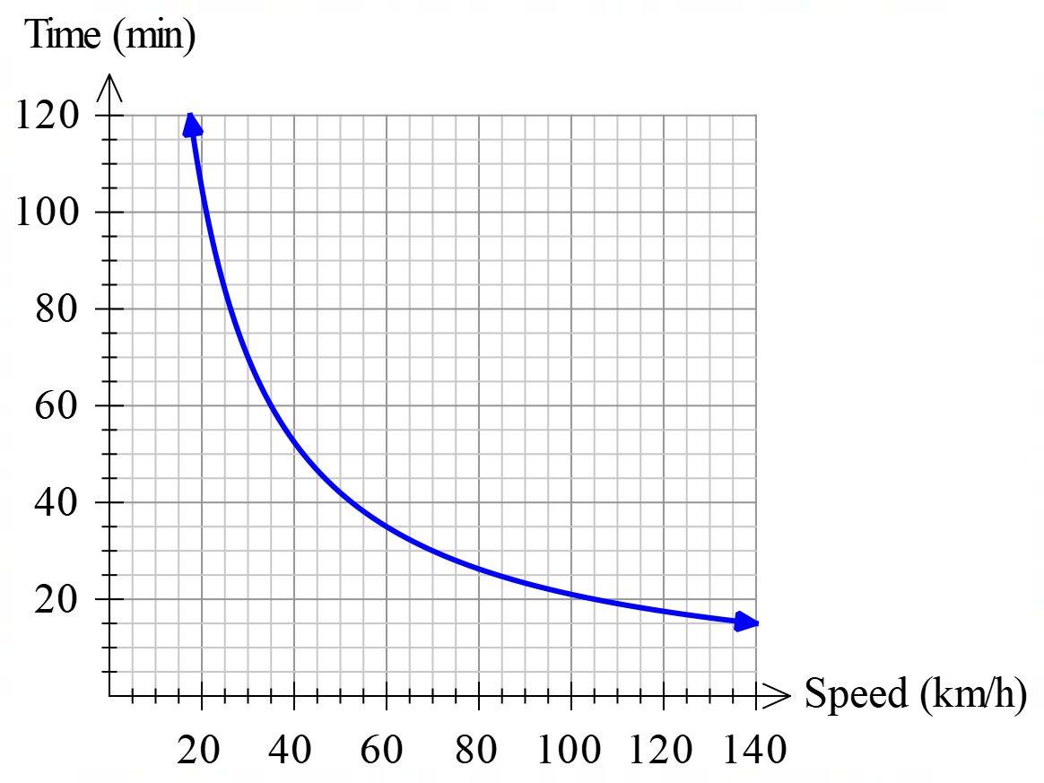
For example, suppose you want to travel from Ocean Reef to Perth, a distance of about 35 km. How long will it take, travelling at different speeds? This function is graphed on the right.

- Find the equation for this function given the graph on the right and the information above.

- Assuming that you are travelling on the freeway, how much time do you save by increasing your speed from 100 km/h to 120 km/h?

Certainly, travelling faster can save you some time, but is the time saved worth the risk?

Many people believe that travelling faster has two benefits

- Individuals get to their destinations more quickly
- The roads are used more efficiently. In other words, more people can use the roads because each person is on the road for less time.

It is the second of these points that we will be examining.

Police recommend that when travelling behind another vehicle, you should leave a 2-second gap. Another way of thinking about this is that you should not reach the same place a car in front of you passes for 2 seconds. The faster you travel, the greater distance you will travel in 2 seconds.

- Show how to calculate the 2-second gap for a given speed in km/h.

Before we can continue much further, we will need to make some assumptions. For this investigation, you can assume:

- A vehicle is 4 m long.
- Everybody drives consistently at the stated speed (no passing or lane changing).
- Everybody maintains the correct 2-second gap for a given speed.
Using these assumptions, we can examine how efficiently a road is being used.
For example: If the speed limit is 30 km/h, the 2-second gap should be 16.67 m. This allows 48.39 vehicles to fit into 1 km of roadway (check this.) If they are travelling at 30 km/h, this will mean that 1451.61 vehicles will pass a point in one hour.
- Copy & complete this table

Speed | 2-Second Gap | Number of Vehicles per kilometre | Pass a point in 1 hour.
10
20
30 |  | 48.39 | 1451.61
40
50
60 |  | 26.79
70
80
90 |  |  | 1666.67
100
110
120

Looking at the table, it is obvious that increasing the speed increases the number of vehicles using the road per hour. To examine this more closely, we need to find a function that allows us to quickly find the number of vehicles given the speed. I have determined that if the speed is x, the number of vehicles passing a point (n) can be found using this formula.

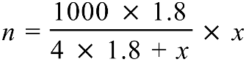 or 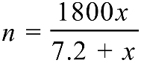

These two equations are equivalent.

In the first equation, the 4 represents the assumed length of the vehicles, the 1000 is the number of m in a kilometre and the 1.8 is derived from the 2-second gap in this way:

Convert km/h to m/s by dividing by 3.6 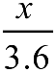

2-second gap = 2 seconds multiplied by the speed in m/s 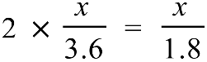

For the in-class section you will be using and modifying this formula.

- Graph this function on your graphics calculator and describe the shape of the graph. (You will need to modify the range to 0 < x < 200, 0 < y < 2000). Are there any interesting features you can identify?

- If vehicles could travel as fast as they like (speed limit = ∞ km/h), how efficient could the roads be?
Is Faster More Efficient? – In Class Section
In the out of class section of this assignment, you were asked how efficient the roads could be if vehicles were permitted to travel as fast as they like. The result you found in question 6 is called the limit of the function as ( x approaches infinity).

The police department is not sure that the average length of 4 m is accurate, and they are concerned that this will affect the results. They are interested on how changing the average length will affect the efficiency of the road at 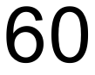 km/h and the maximum possible efficiency of the road. They have asked you to examine the effects of having average vehicle lengths of
3 m, 3.5 m, 4 m, 4.5 m and 5 m

- Copy and complete this table using your graphics calculator to investigate how changing the average vehicle length affects the number of vehicles using the road at 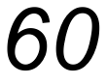 km/h and the limit of the function as . Do NOT modify the two-second gap. You will need to modify the formulae
or
to answer these questions.

Average Vehicle Length | Number of Vehicles passing a point at km/h | Limit as
3 m
3.5 m
4 m
4.5 m
5 m
[10 Marks]
- Write a short description on how changing the average vehicle length affects the number of vehicles that can travel on the road.
[4 Marks]

A company has designed a new computer aided driving system. The new system allows the allowable gap between cars to be decreased. The company believes that the gap could be decreased to as low as half a second.

- Copy and complete this table using your graphics calculator to investigate how changing the size of the “gap” affects the number of vehicles using the road at km/h and the limit of the function as . For each case assume an average vehicle length of 4 m.

Gap Length | Number of Vehicles passing a point at km/h | Limit as
2 seconds
1.5 seconds
1 second
0.5 seconds
[8 Marks]
- Write a short description showing how changing the gap length affects the number of vehicles that can travel on the road.
[3 Marks]

