FX Library Modules

Graphing Quadratics
Age 13-15

Copyright Information
If you are an Efofex subscriber and work in a school, you can copy and/or modify the FX Library materials and use them with your students. We hope that this material will help you write your tests, worksheets, exams, presentations and any other educational materials. You cannot claim copyright over the FX Library materials or present them as your own work.
FAQ

Who are the questions/materials for?
We are providing the materials for teachers in schools. If you are a teacher in a school (or similar context) you are welcome to use the questions/materials freely in just about any manner. Most other usages of our questions/materials are prohibited. In particular, you are expressly prohibited from using our materials in any context where the aim is to generate a profit.
Can I photocopy the questions/materials for use by my students?
YES.
Can I copy questions/materials and paste them into my own documents?
YES.
Do I have to include the Efofex Software copyright notice on my own documents if I have included some of your questions/materials?
NO.
Can I use your questions/materials to generate a profit?
NO.
Can I use the questions/materials on my website/PowerPoint presentation/Moodle...?
It depends. If your usage is within the context of a teacher of students at an educational institution, YES. If you want to use the materials for profit, NO.
I am a home-schooling parent. Can I use your materials?
YES.
I am a student and want to use your products for revision. Can I use them?
YES (but make sure to tell your teachers how good they are!)
Can I modify your questions/materials for my own use?
YES.
If I modify your questions, can I claim copyright?
It depends. If the modifications are substantial, YES. If the modifications are trivial or superficial, NO. Using the Parameter Regeneration feature of our products is NOT a substantial modification
I am a professional tutor. Can I use your materials with my students?
NO.
Can I republish your materials?
NO.
I think that I might be able to use your materials but don't seem to fit any of your FAQs. What do I do?
Send us an email describing what you want to do (to info@efofex.com) and we will get back to you as soon as possible.

How To Use This Material
Copy a question from this document and paste (with reparametizing) into your document. This allows you to quickly build a collection of regeneratable questions into a test, worksheet, presentation, or exam.

Question
Find the turning point and line of symmetry for these two parabolas.
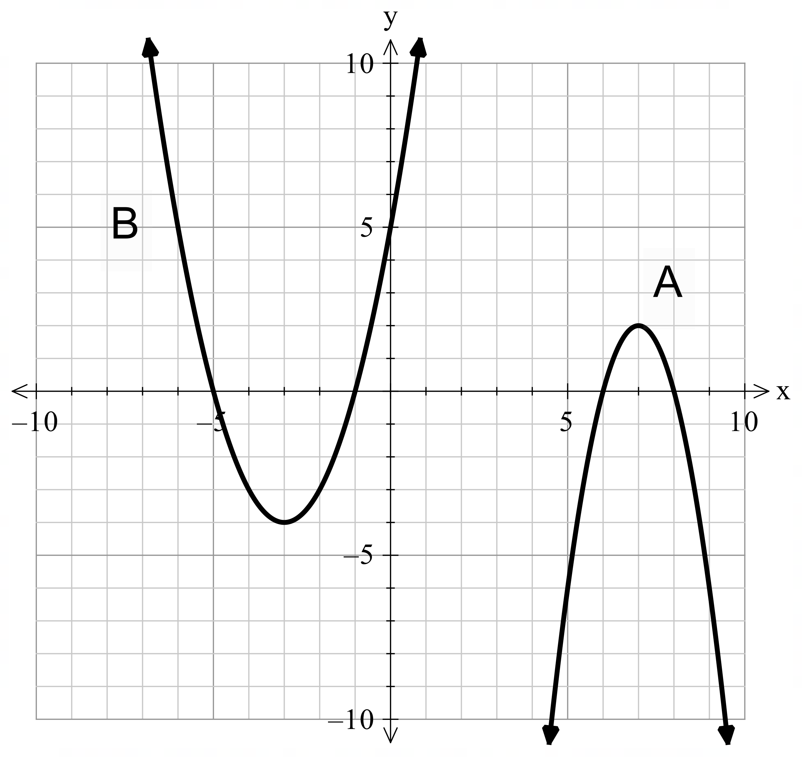
Solution
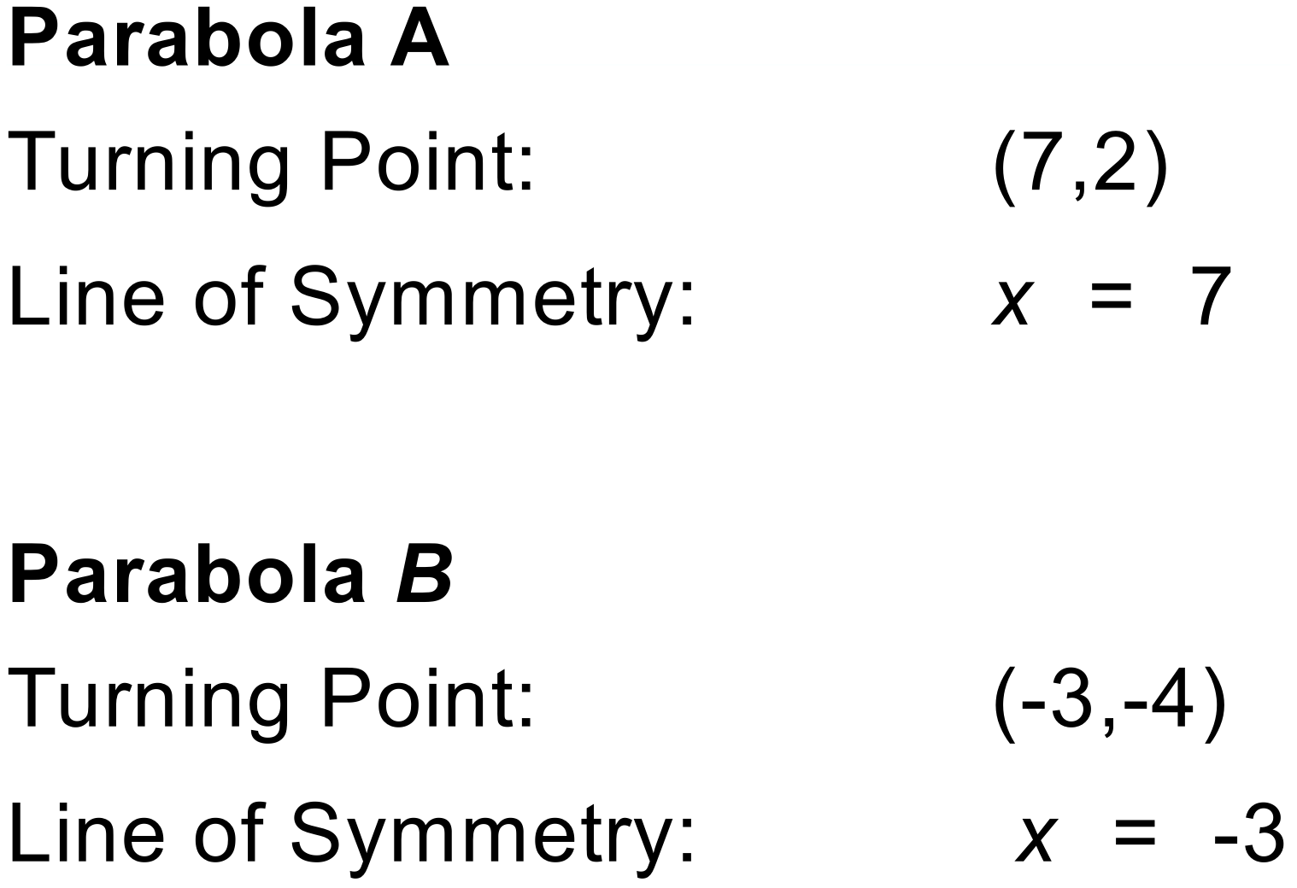
Notes
2000+ variations.

Question
Graph the following quadratic function on this set of axes.
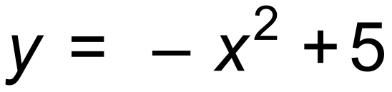
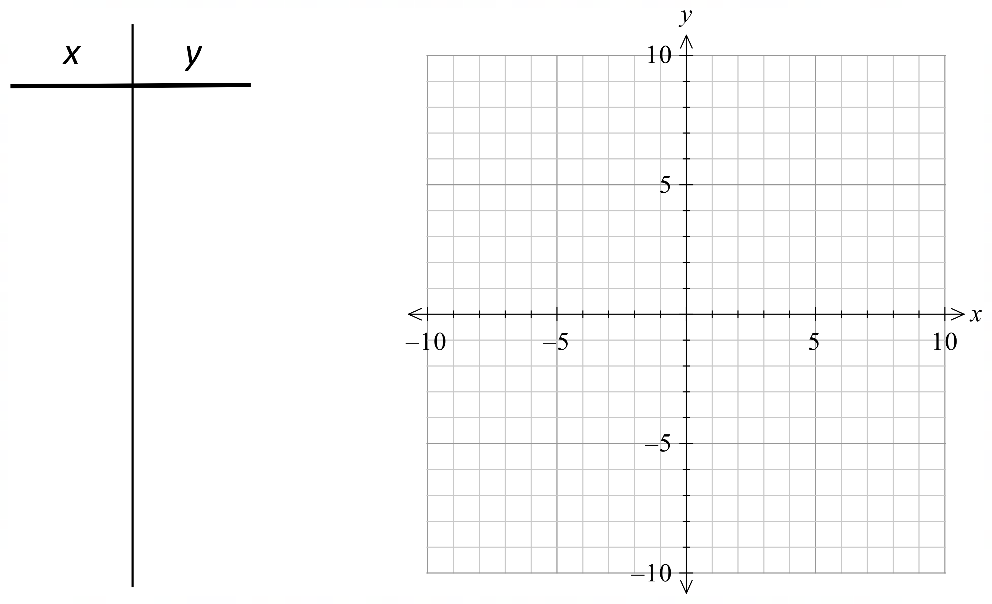
Solution
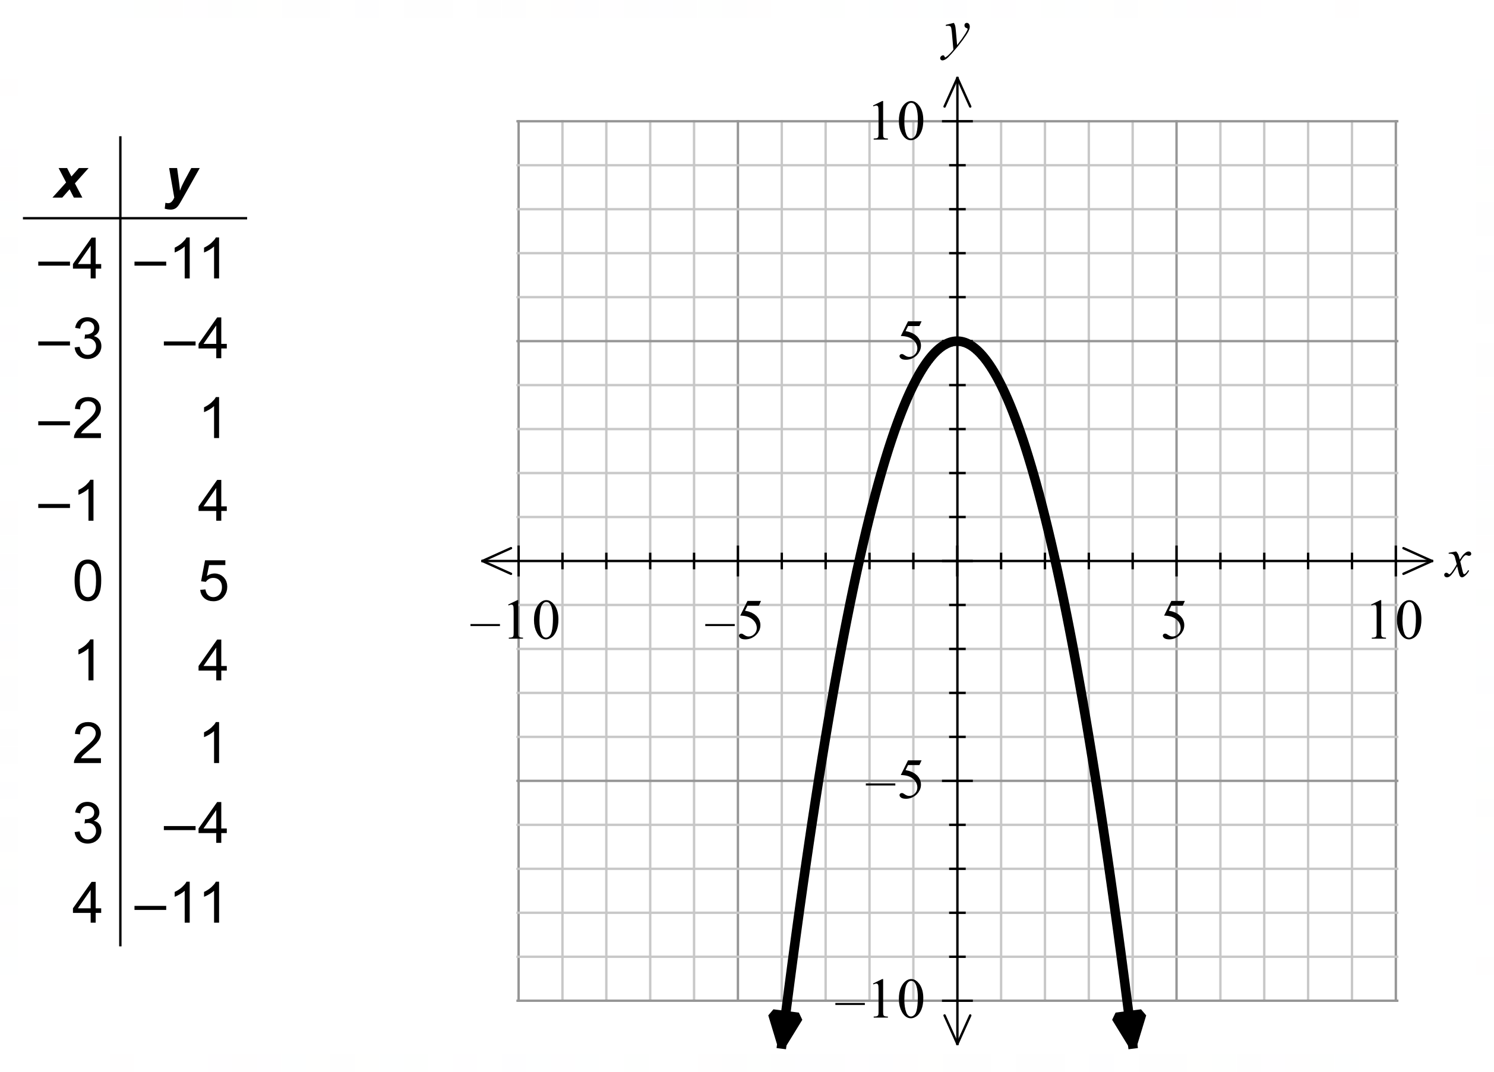
Notes
18 variations.

Question
Graph the following quadratic function on this set of axes. State the coordinates of the turning point.
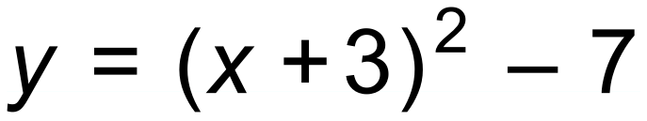
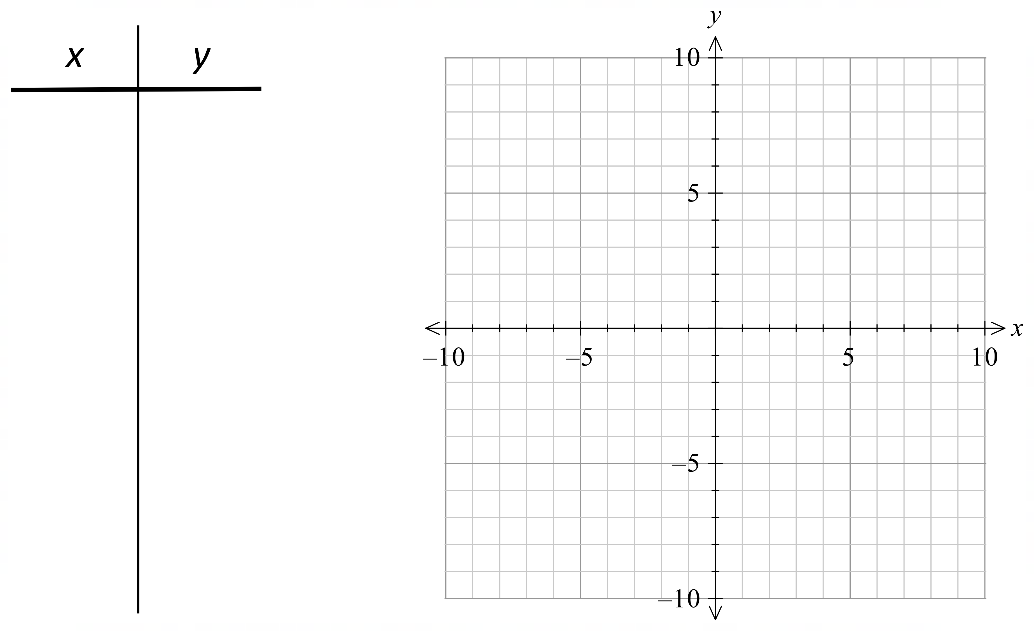
Solution
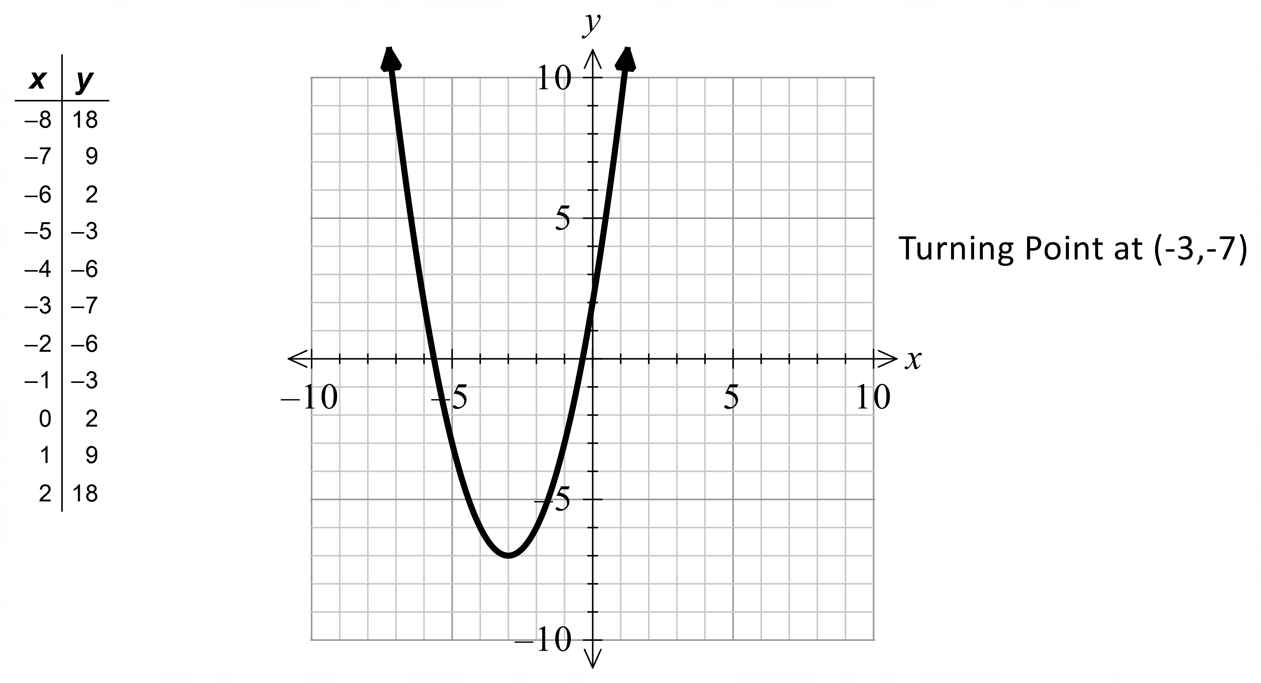
Notes
180 variations.
Question
Graph the following quadratic function on this set of axes. State the coordinates of the turning point.
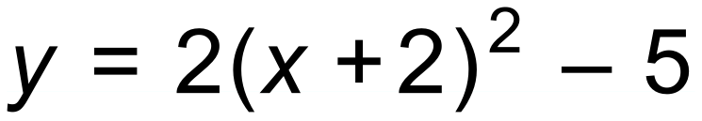
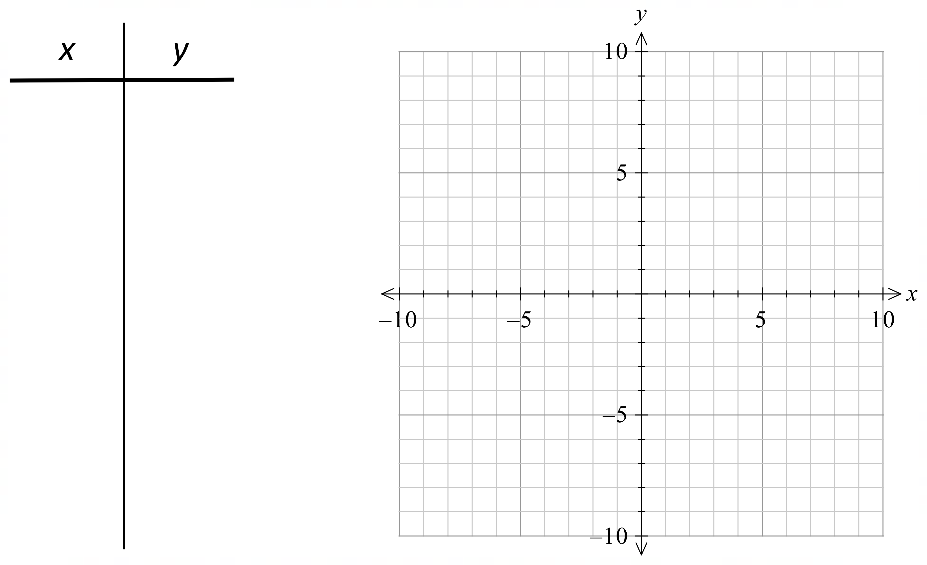
Solution
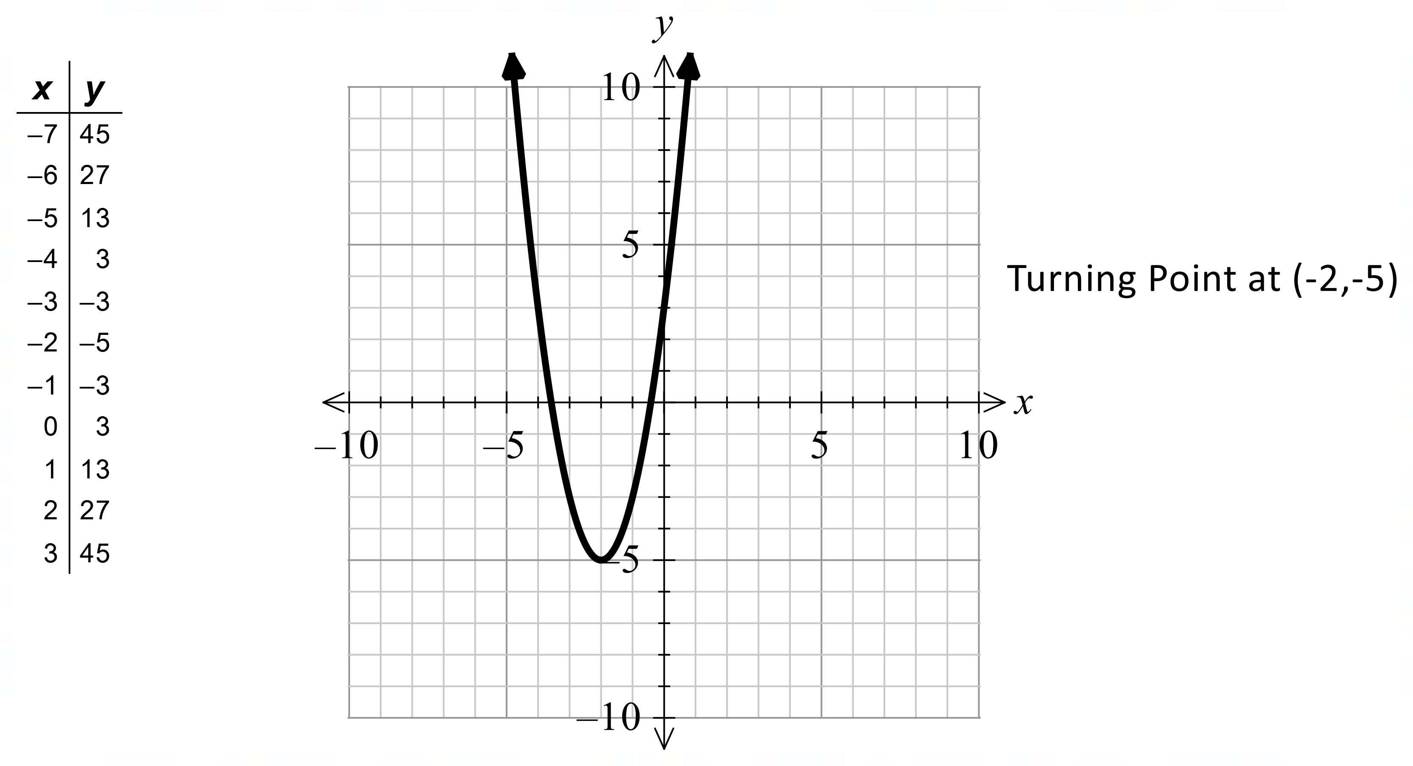
Notes
360 variations.
Question
Graph the following quadratic function on this set of axes. State the coordinates of the turning point.
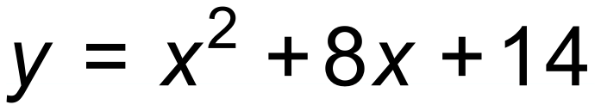
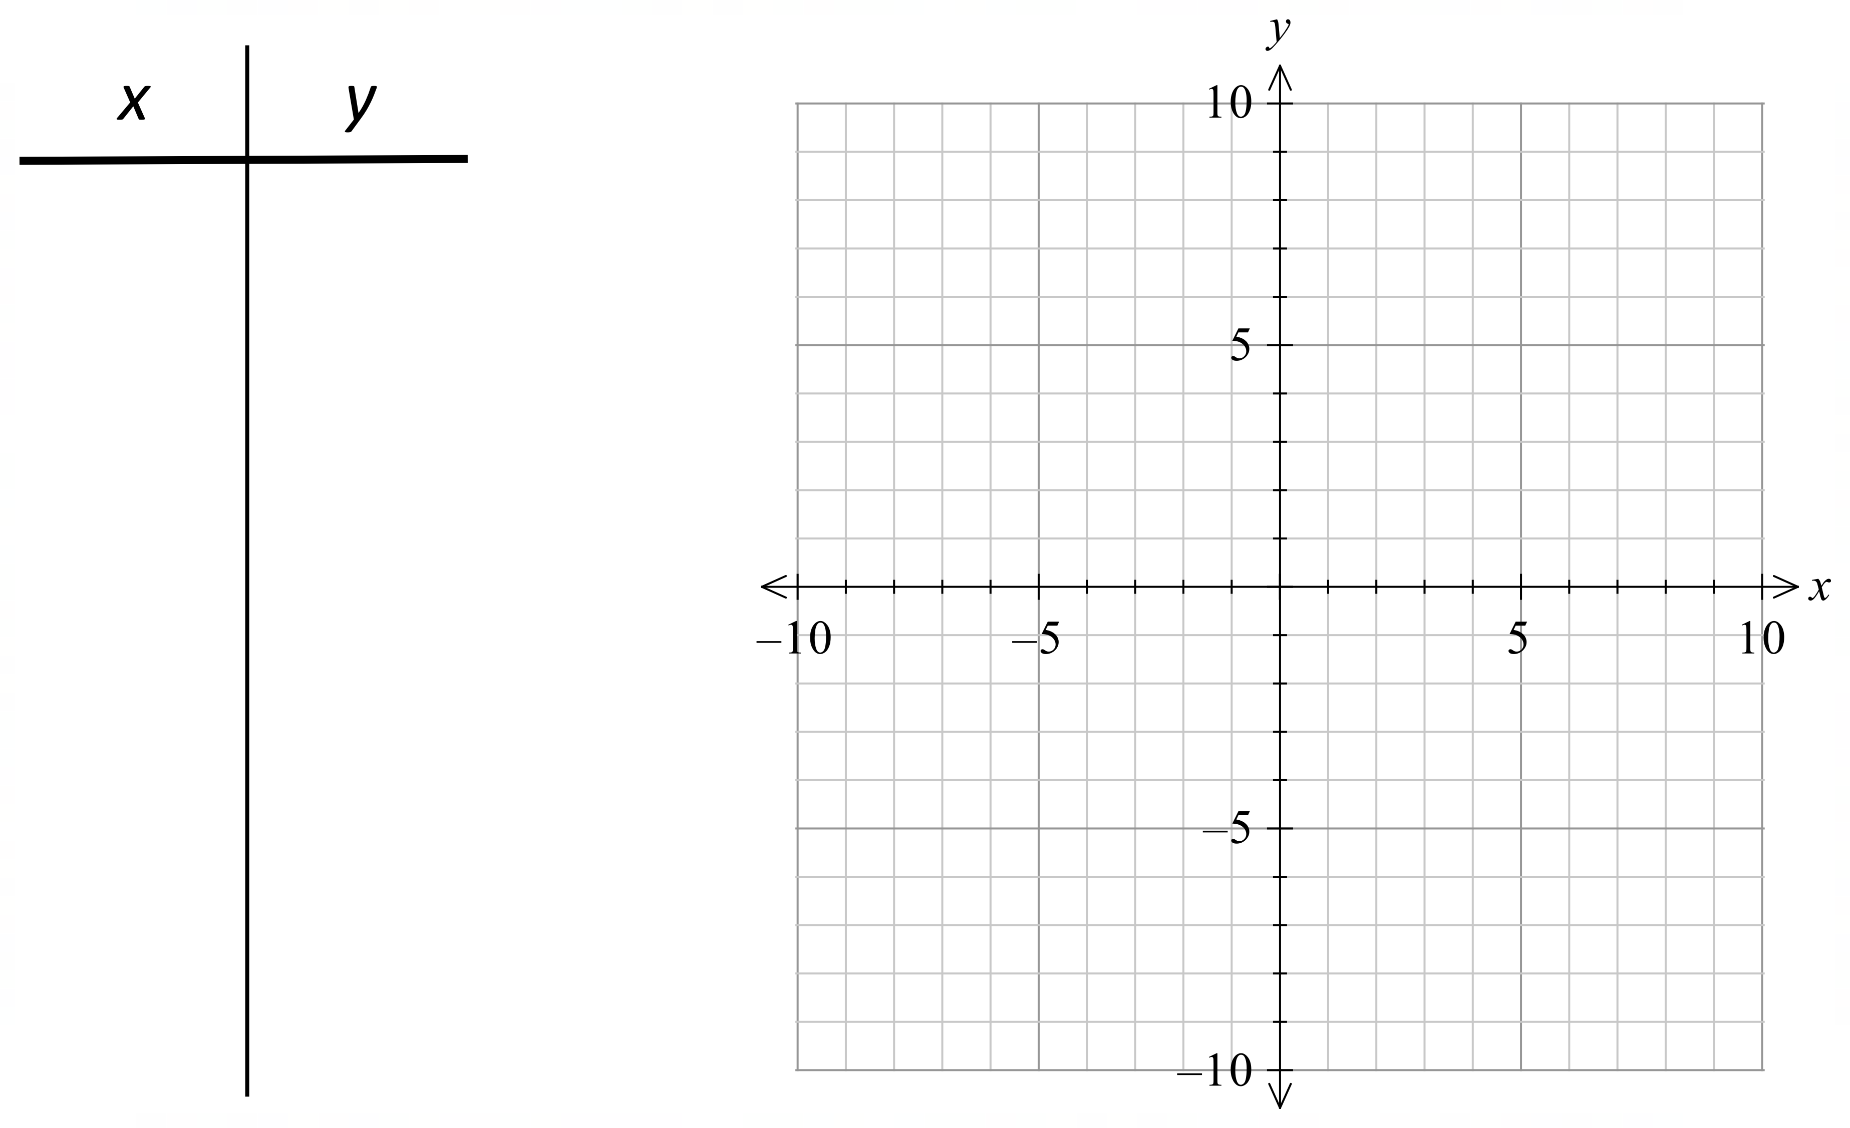
Solution
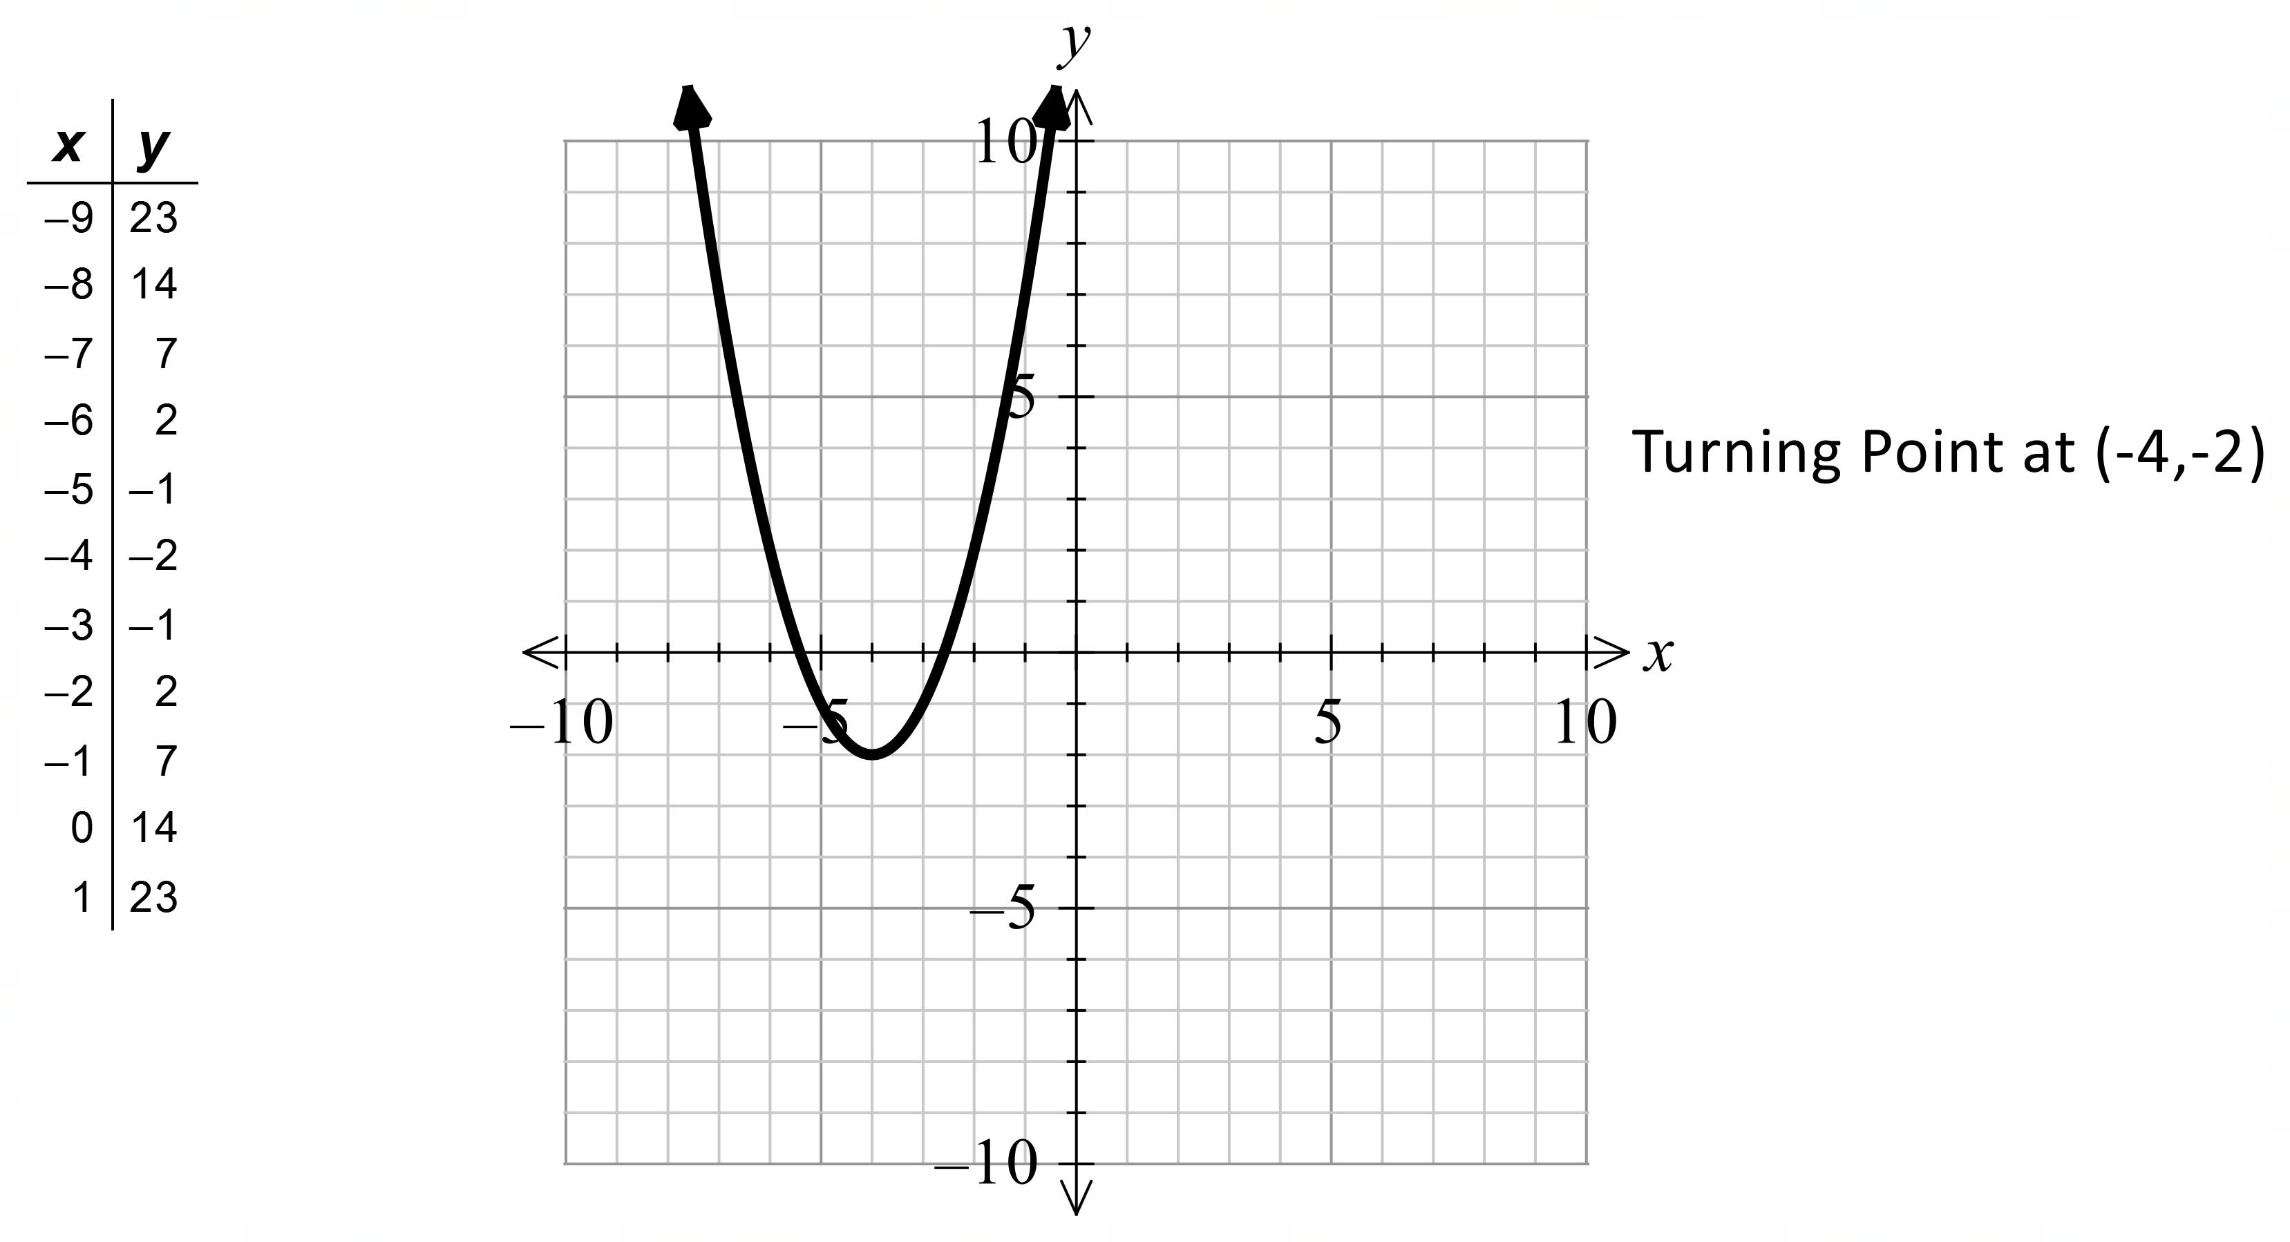
Notes
180 variations.
Question
Graph the following quadratic function on this set of axes. State the coordinates of the turning point.
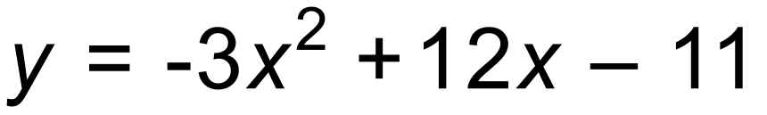
Solution
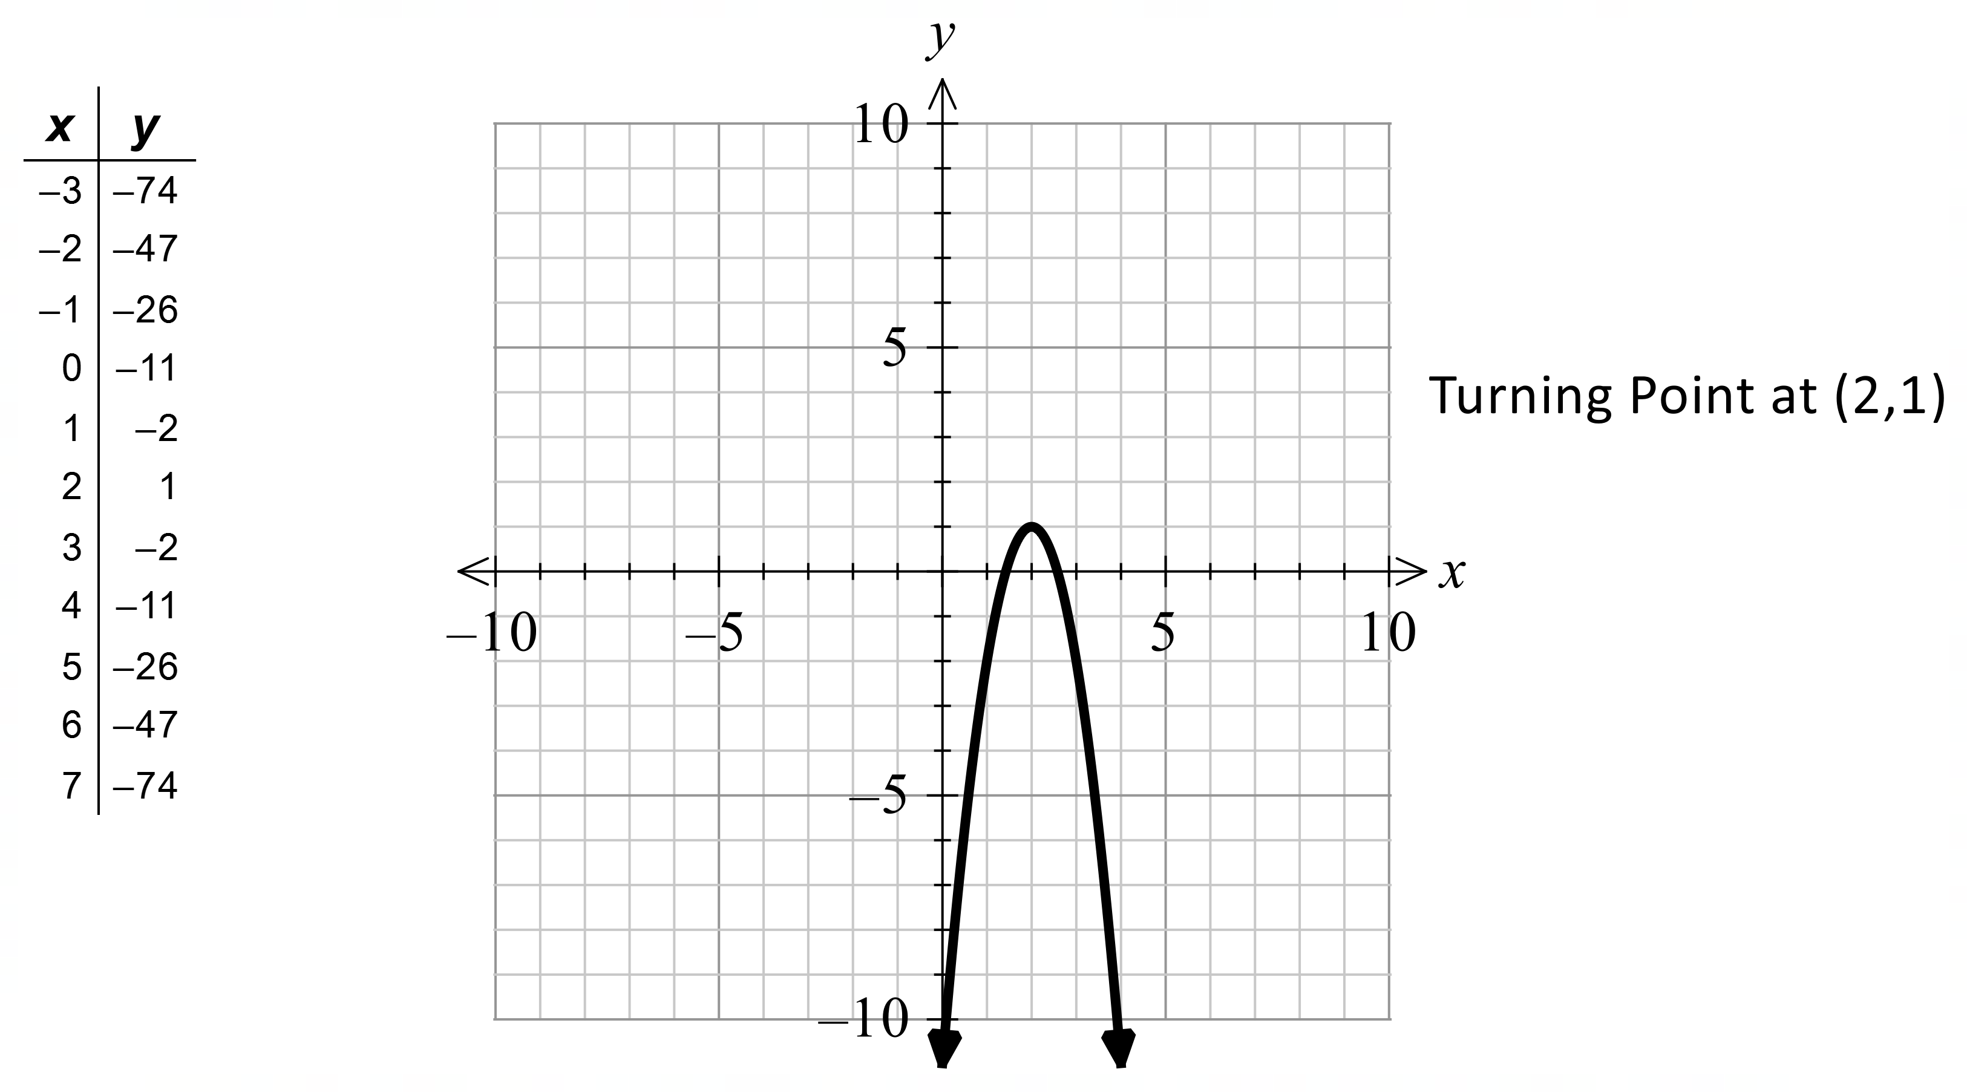
Notes
360 variations.
Question
Find the turning point and the equation of the line of symmetry for this quadratic function.
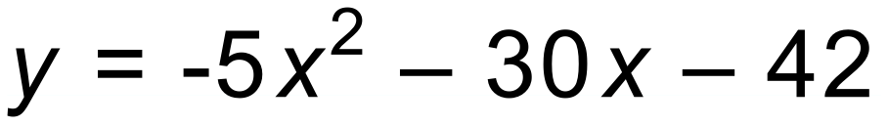

Solution
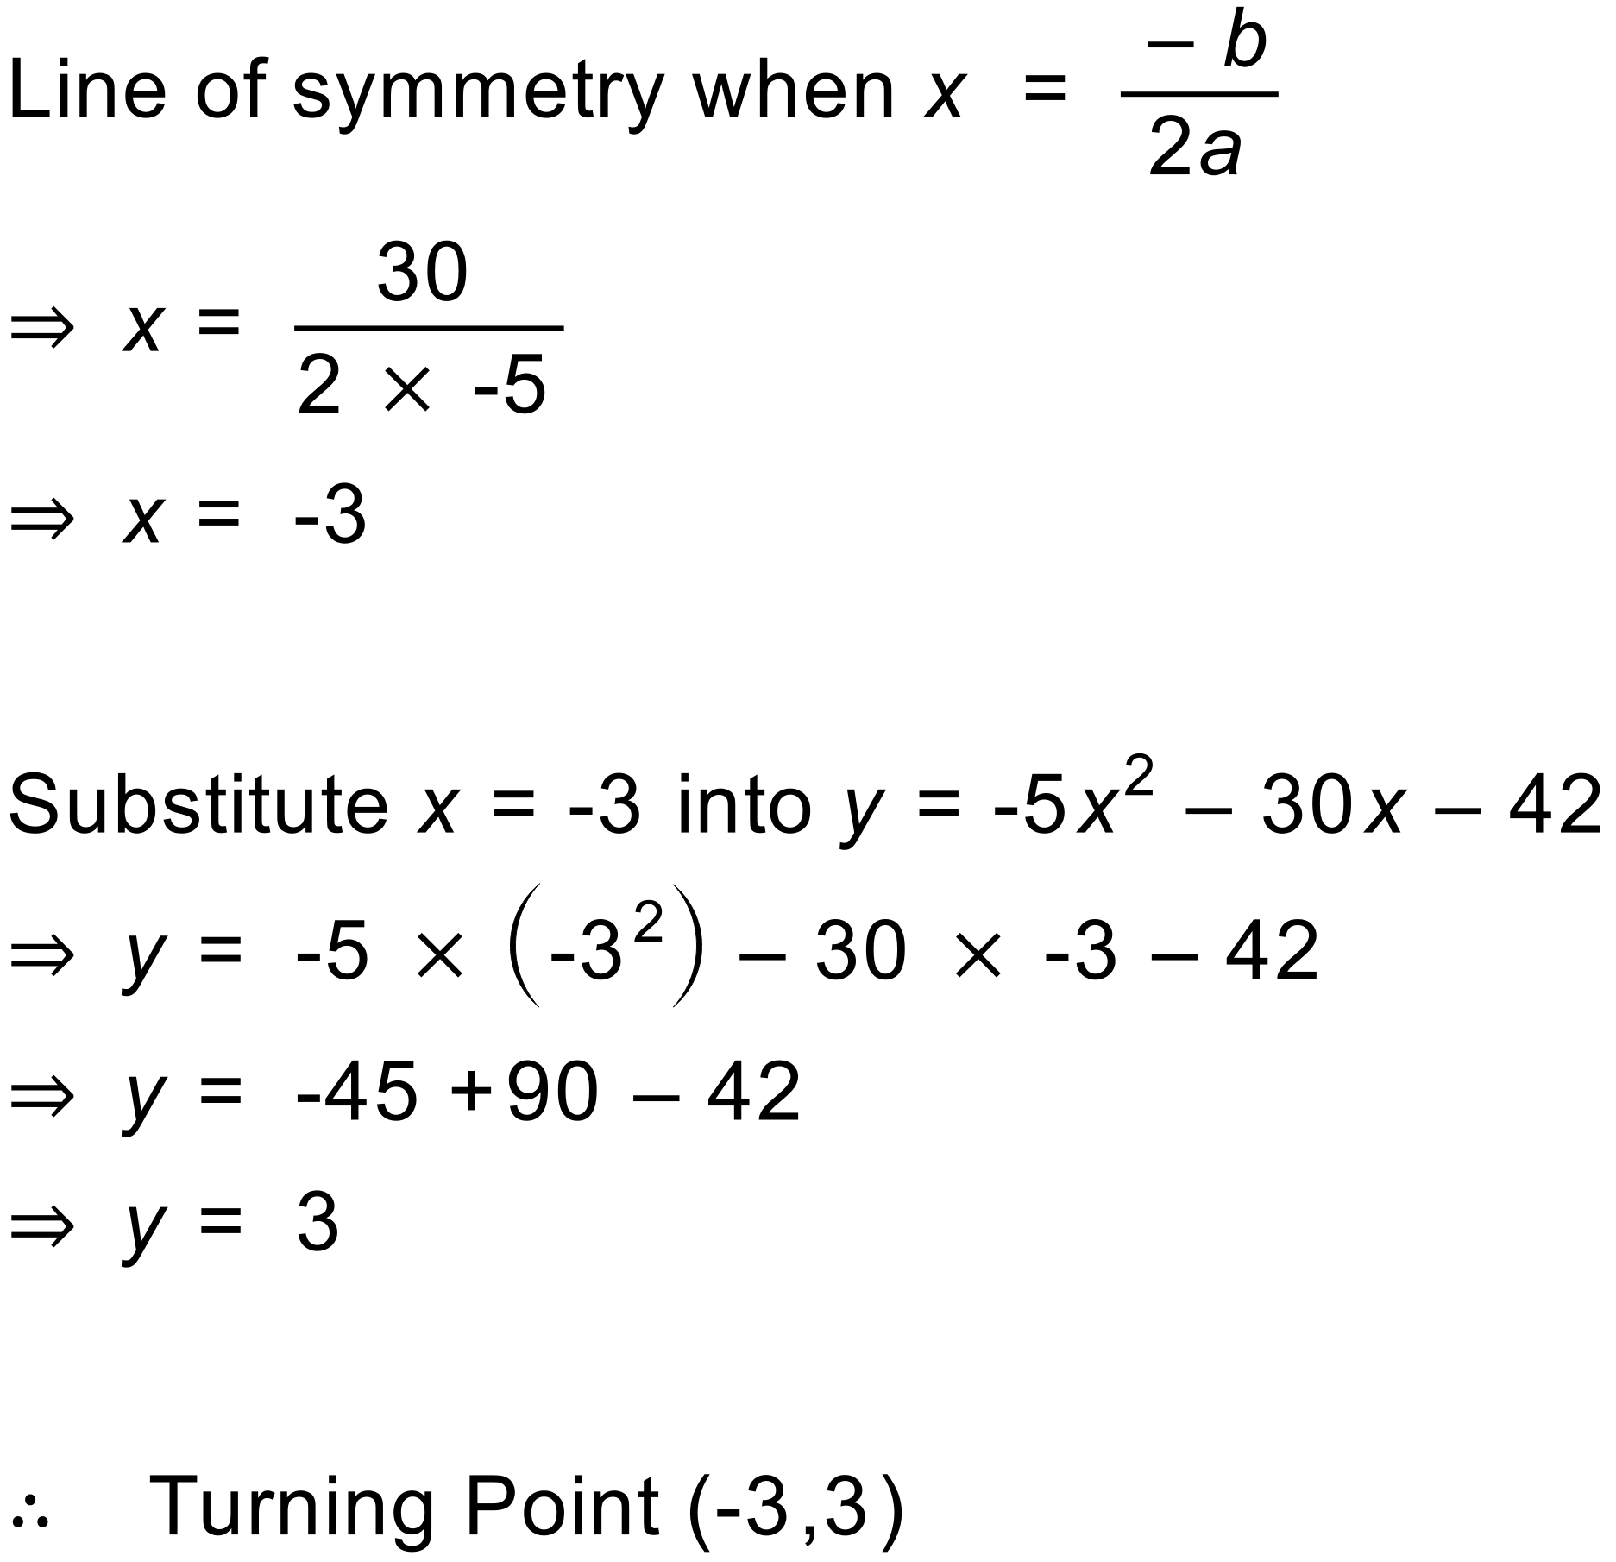
Notes
360 variations.
Question
For the quadratic function 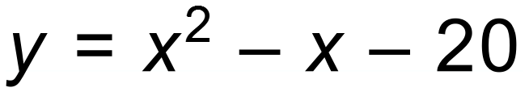, find the y-intercept roots and turning point and hence, sketch the graph.
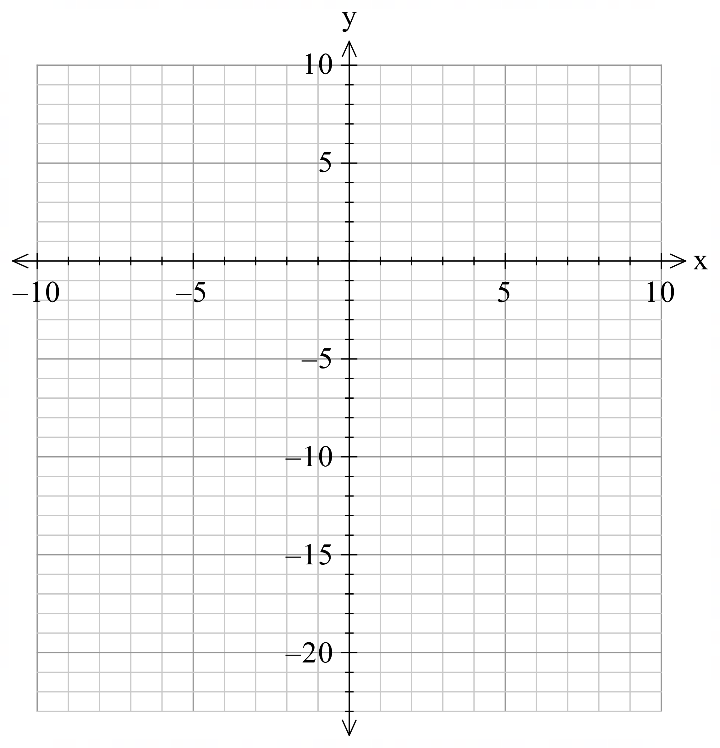
Solution
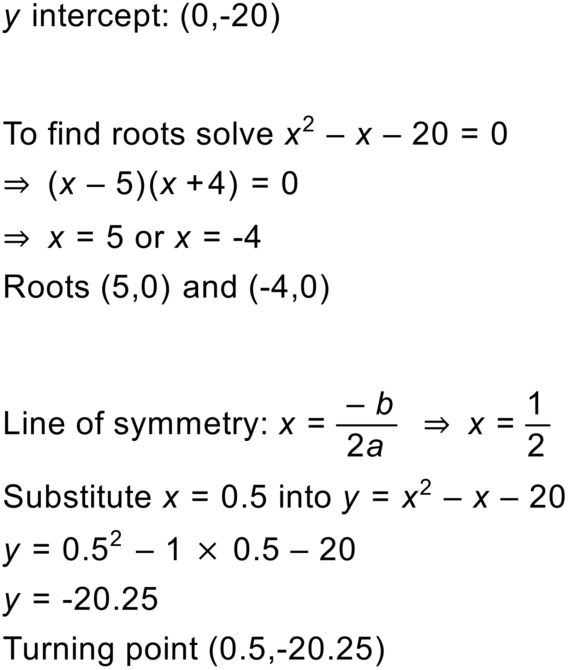
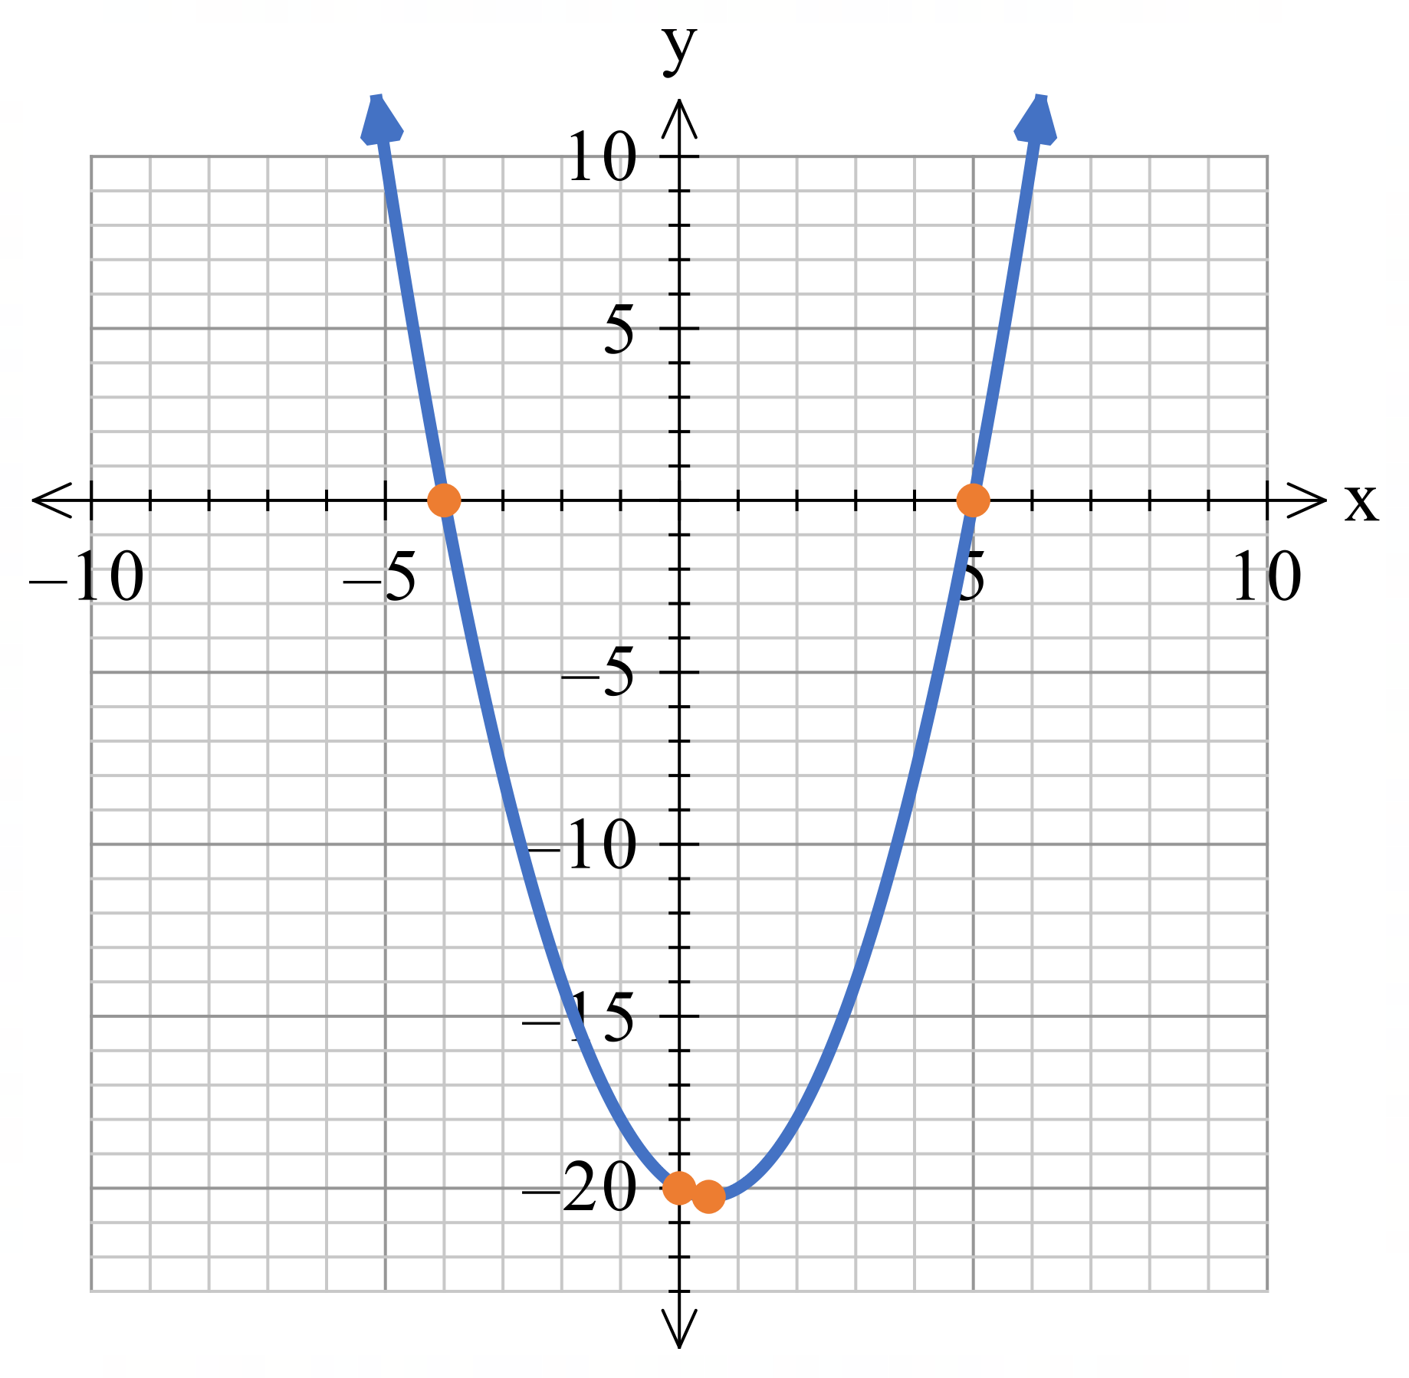

Notes
48 variations.
Question
Write the quadratic function for this graph in the form y=ax²+bx+c.
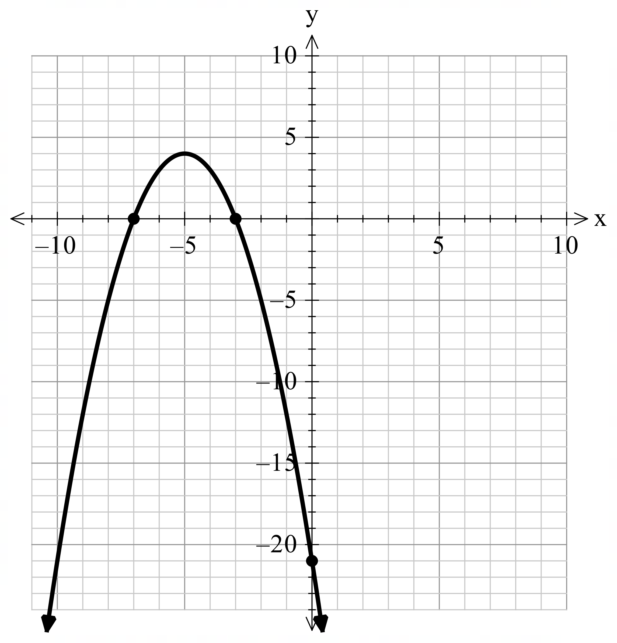
Solution
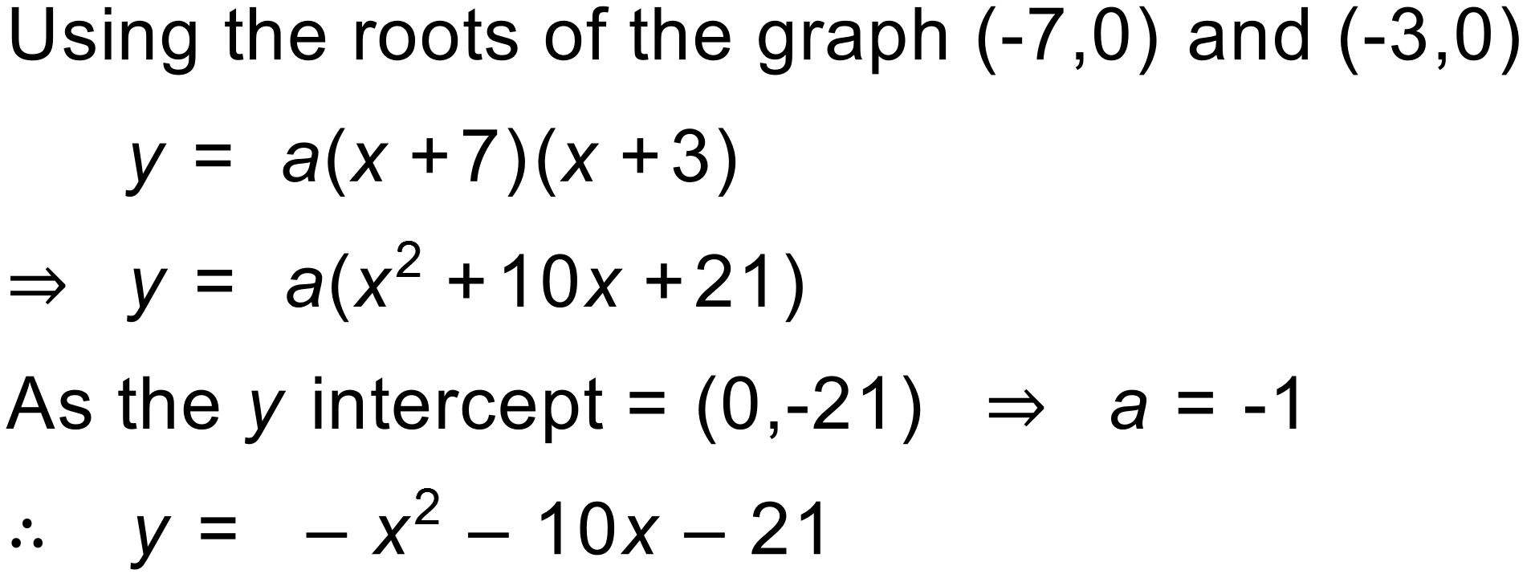
Notes
648 variations.
Question
Write the quadratic function for this graph in the form y=ax²+bx+c.
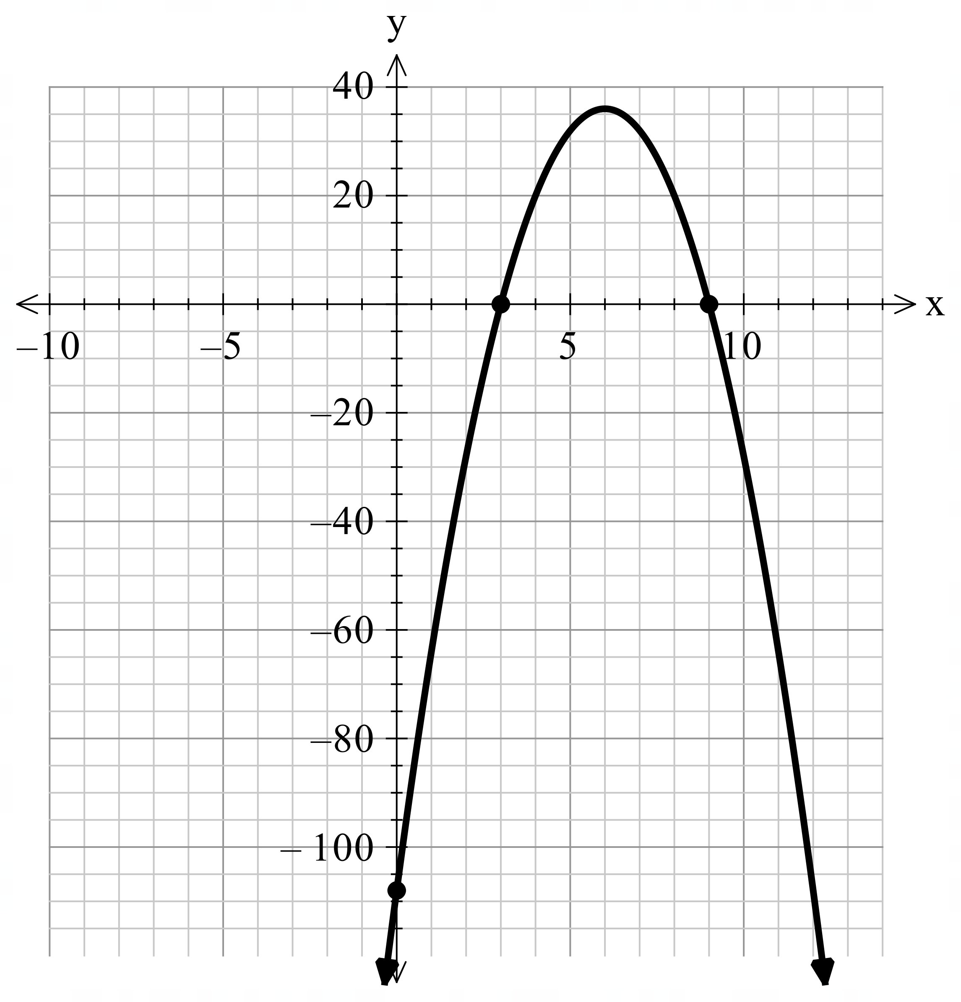
Solution
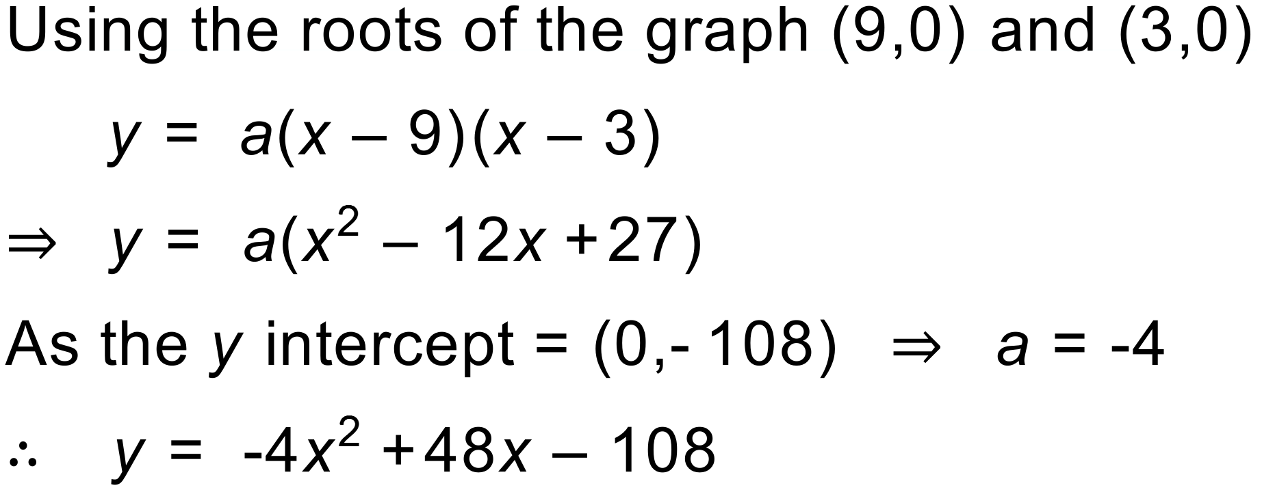
Notes
1944 variations.
Question
Find the turning point of the quadratic function 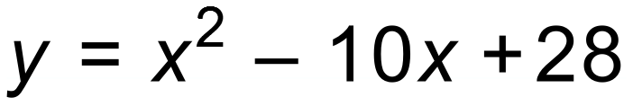 by completing the square.
Solution
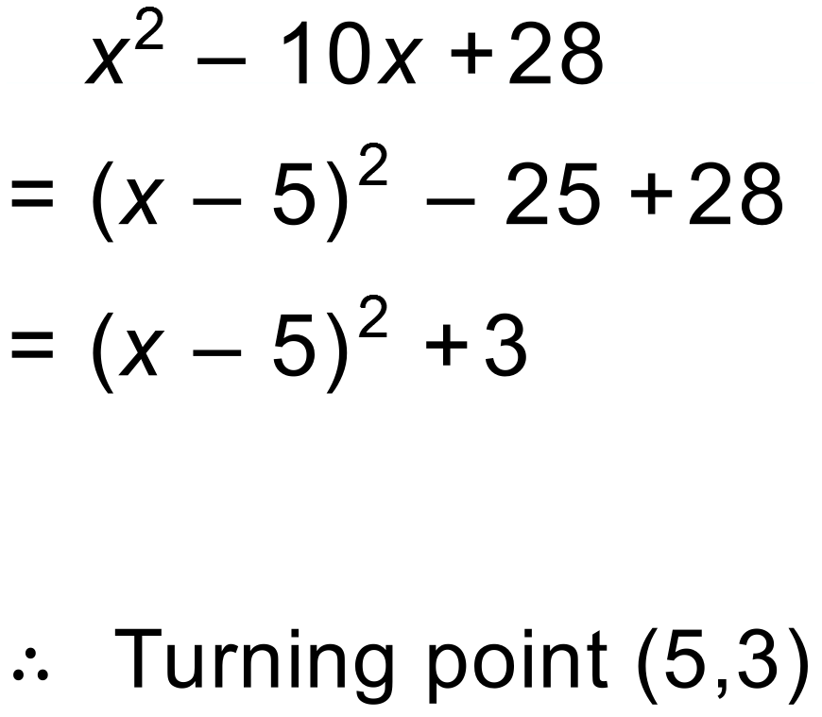
Notes
324 variations.
Question
Find the turning point of the quadratic function 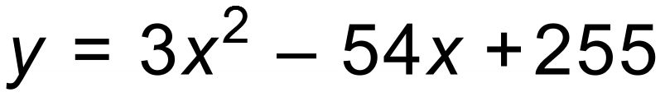 by completing the square.
Solution
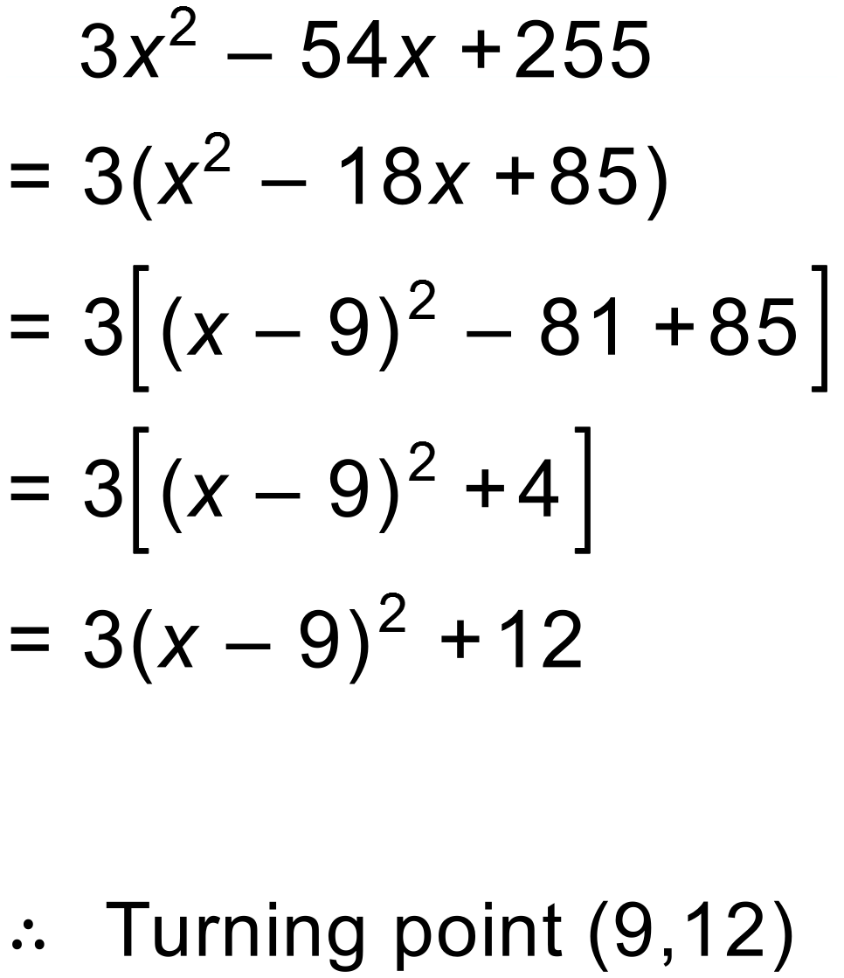
Notes
540 variations.
Question
- Complete the following table by matching each graph (A, B, C, D, E, F) with an equation below. Some graphs may not be matched.
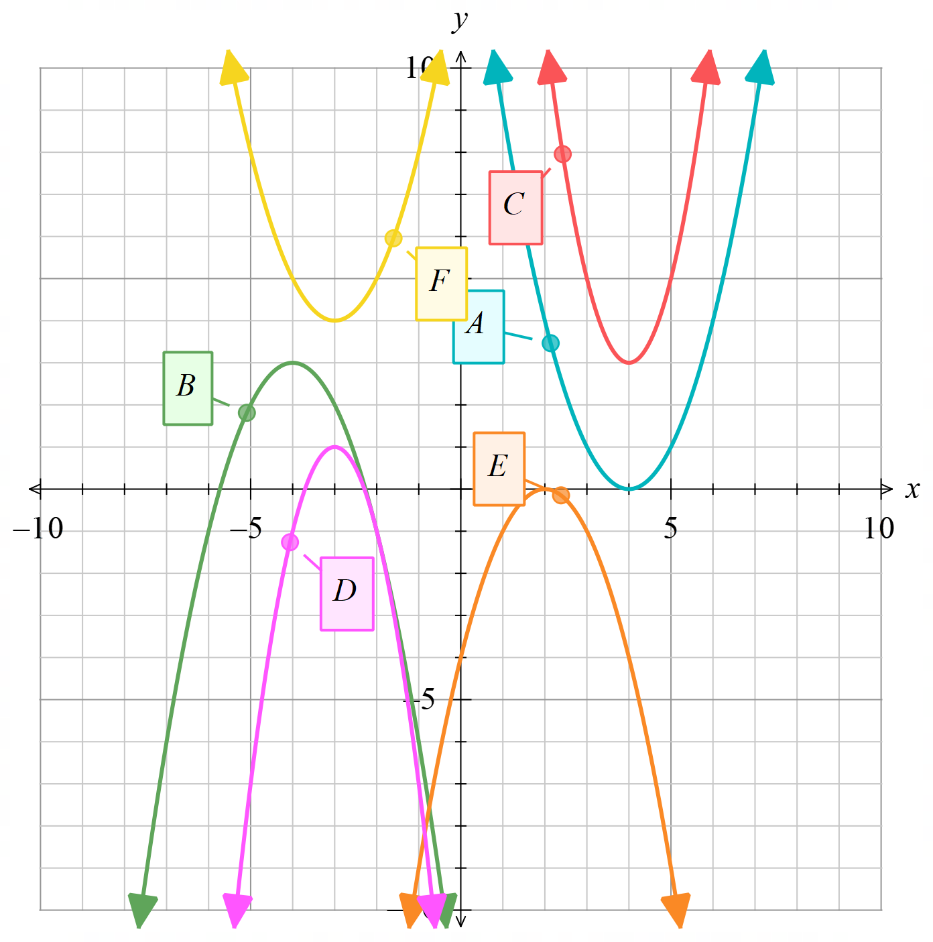

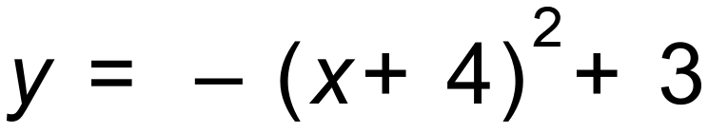 |  | 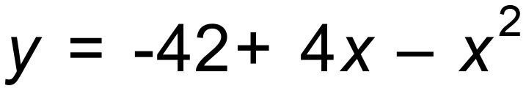 | 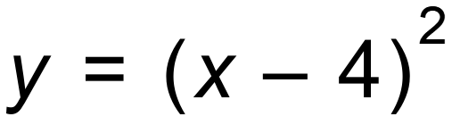

b) The graph of y = x² is translated 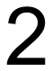 units to the right and units down. What is the equation of the new parabola?

[2]

c) (i) The graph of 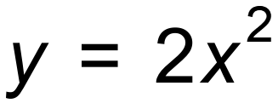is reflected about the x- axis, then translated units left and units up. What is the equation of the new parabola?

[4]
(ii) What is the turning point, y intercept and equation of line of symmetry of the new curve?

Solution
a)
B | D | E | A

b)

c) 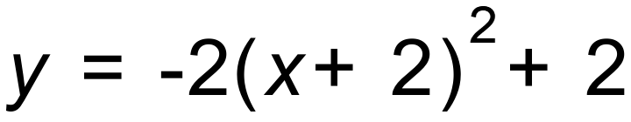

d) 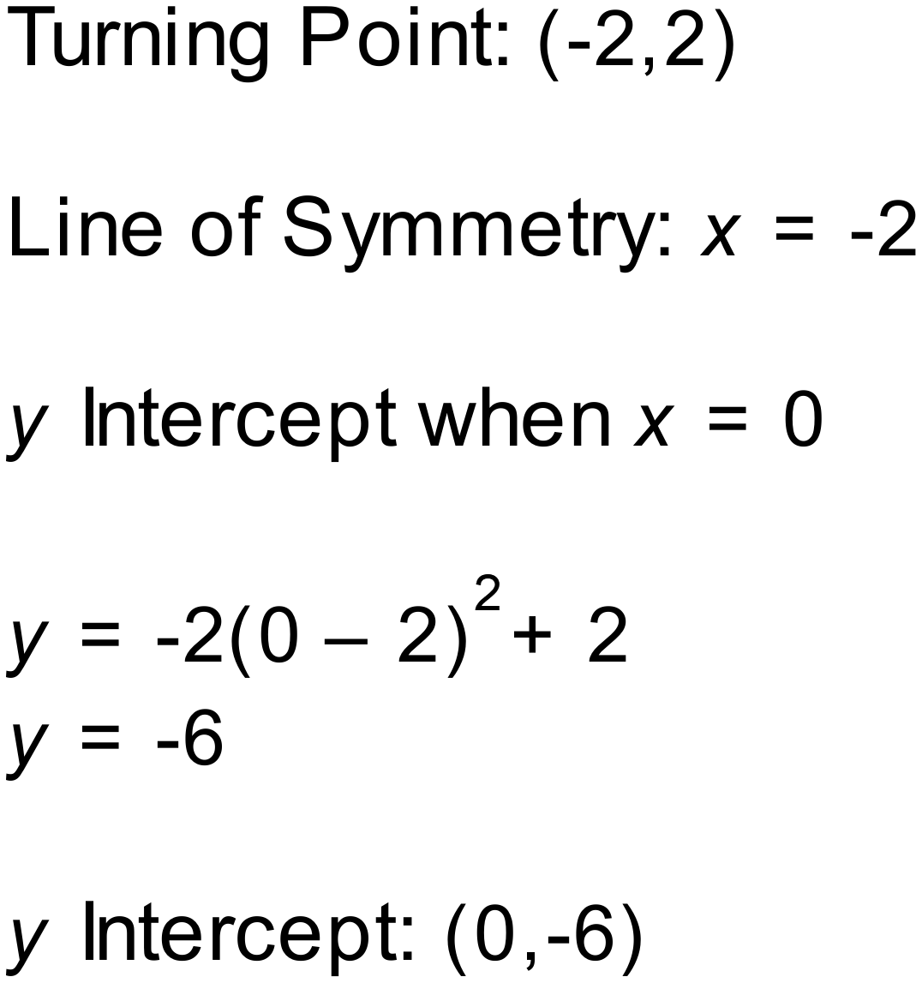
Notes
100 000+ variations.

Question
This is the graph of the quadratic function 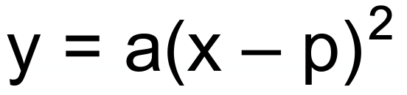. Using the graph, which of these four statements is correct.
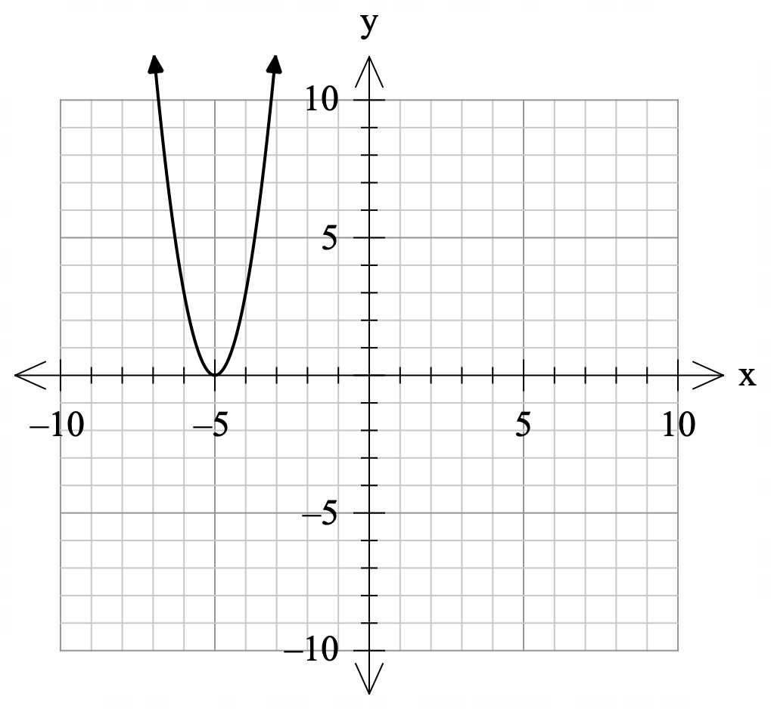
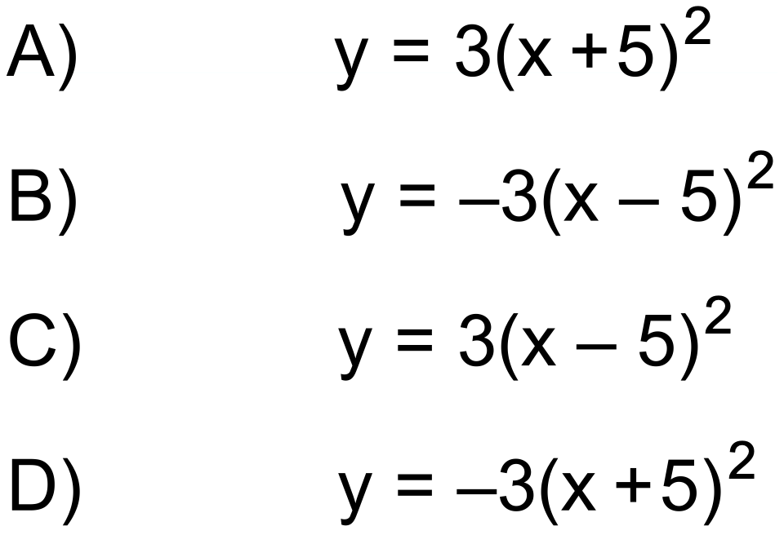

Solution
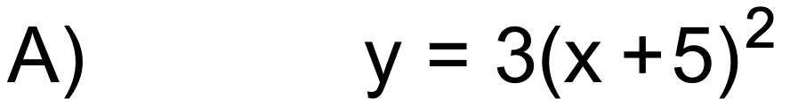
Notes
20000+ variations.
Question
A farmer has 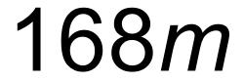 of fencing and decides to build a rectangular yard along the side of an existing shed. The farmer wants to design the yard to enclose the largest area possible for their fencing.
If the length of the side of the yard is x m long:
- Write an equation which calculates the area of the enclosed yard.

- Draw a graph showing how the area of the yard varies depending on the length of the side (x). You can use the axes below to draw your graph.

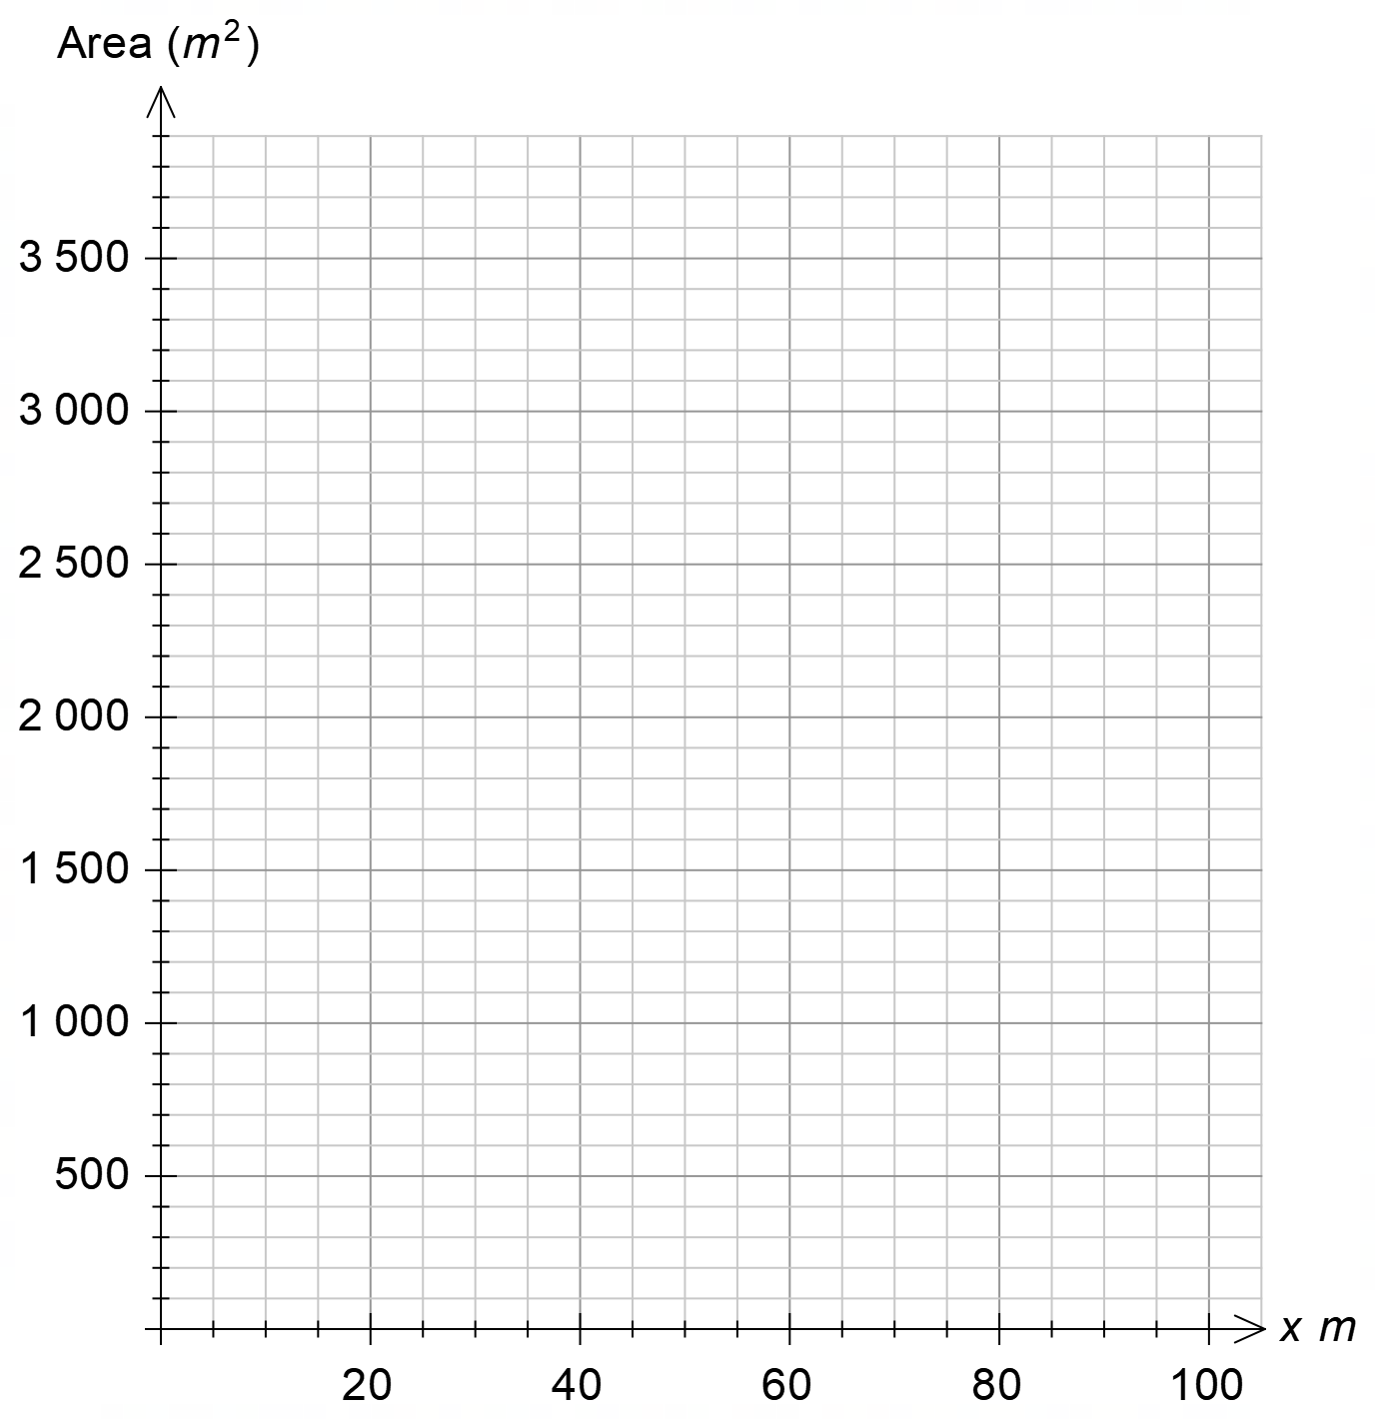
- Use your graph to estimate the dimensions of the yard which produces the largest enclosed area and the area produced.

Solution
- 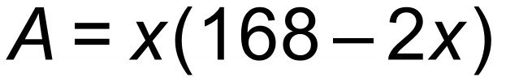

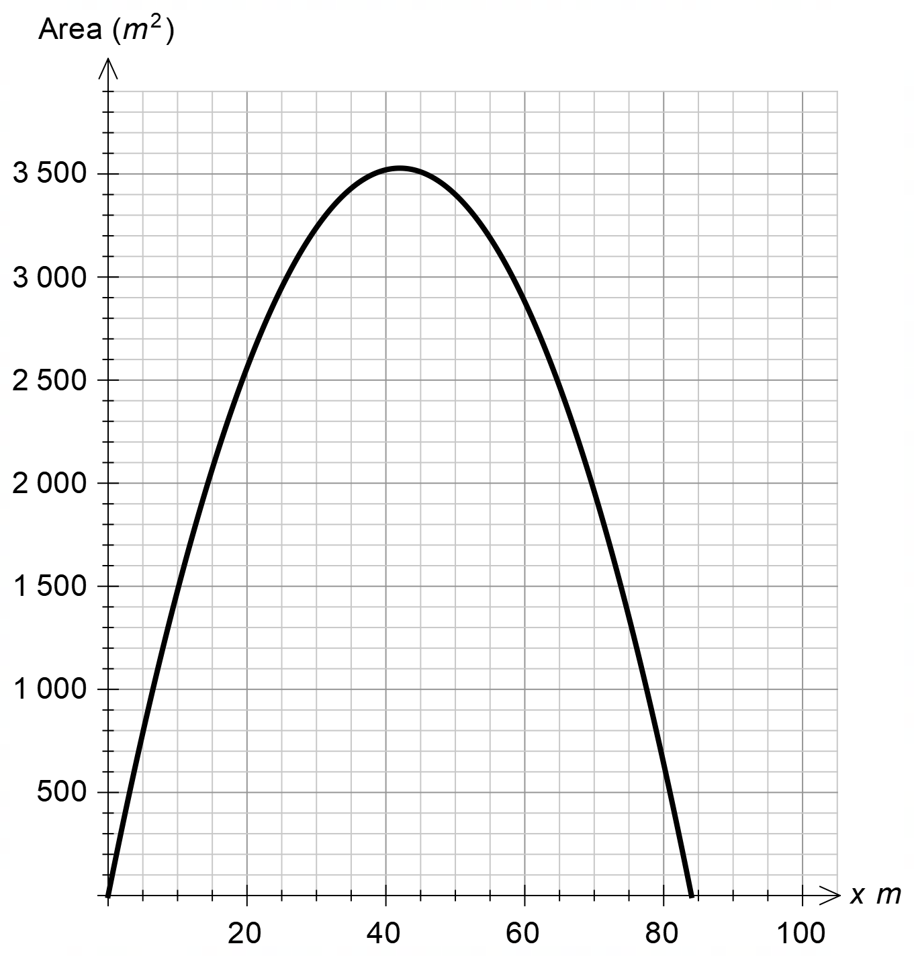

- 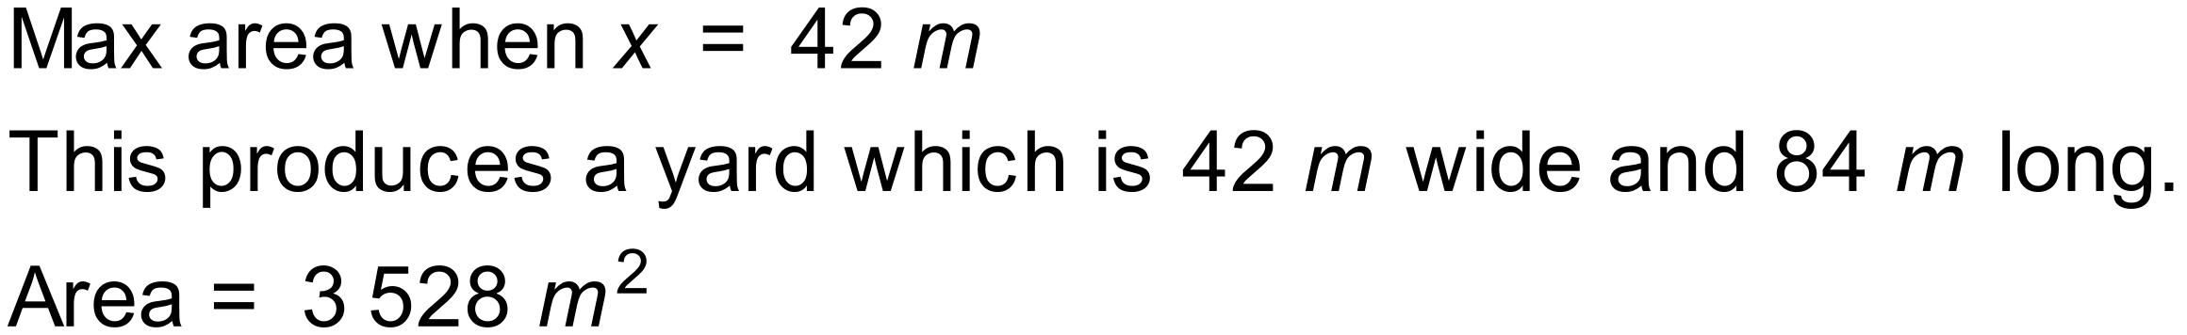
Notes
26 variations.
Question
A bridge is supported by a parabolic arch.
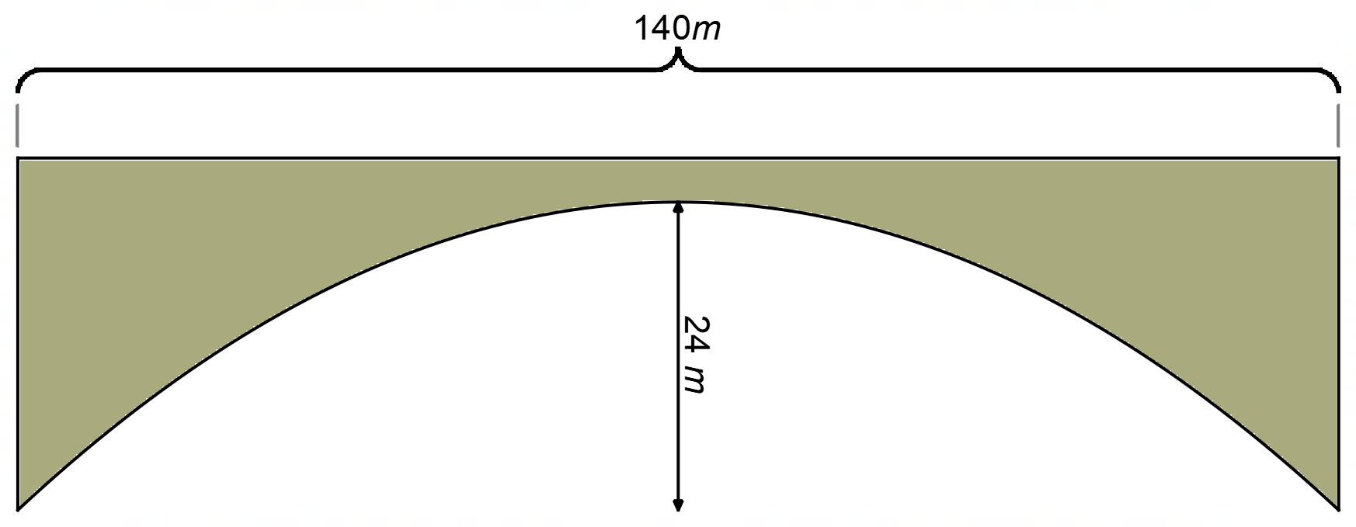
An engineer needs to determine an equation which models the curve and has drawn the graph below.
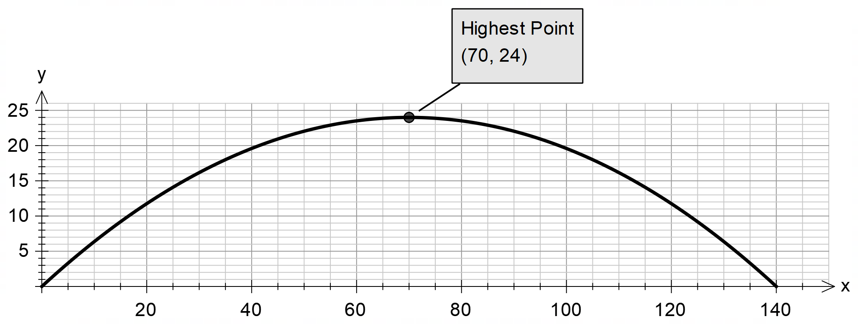
Use this information to find the equation of the parabola.

Solution
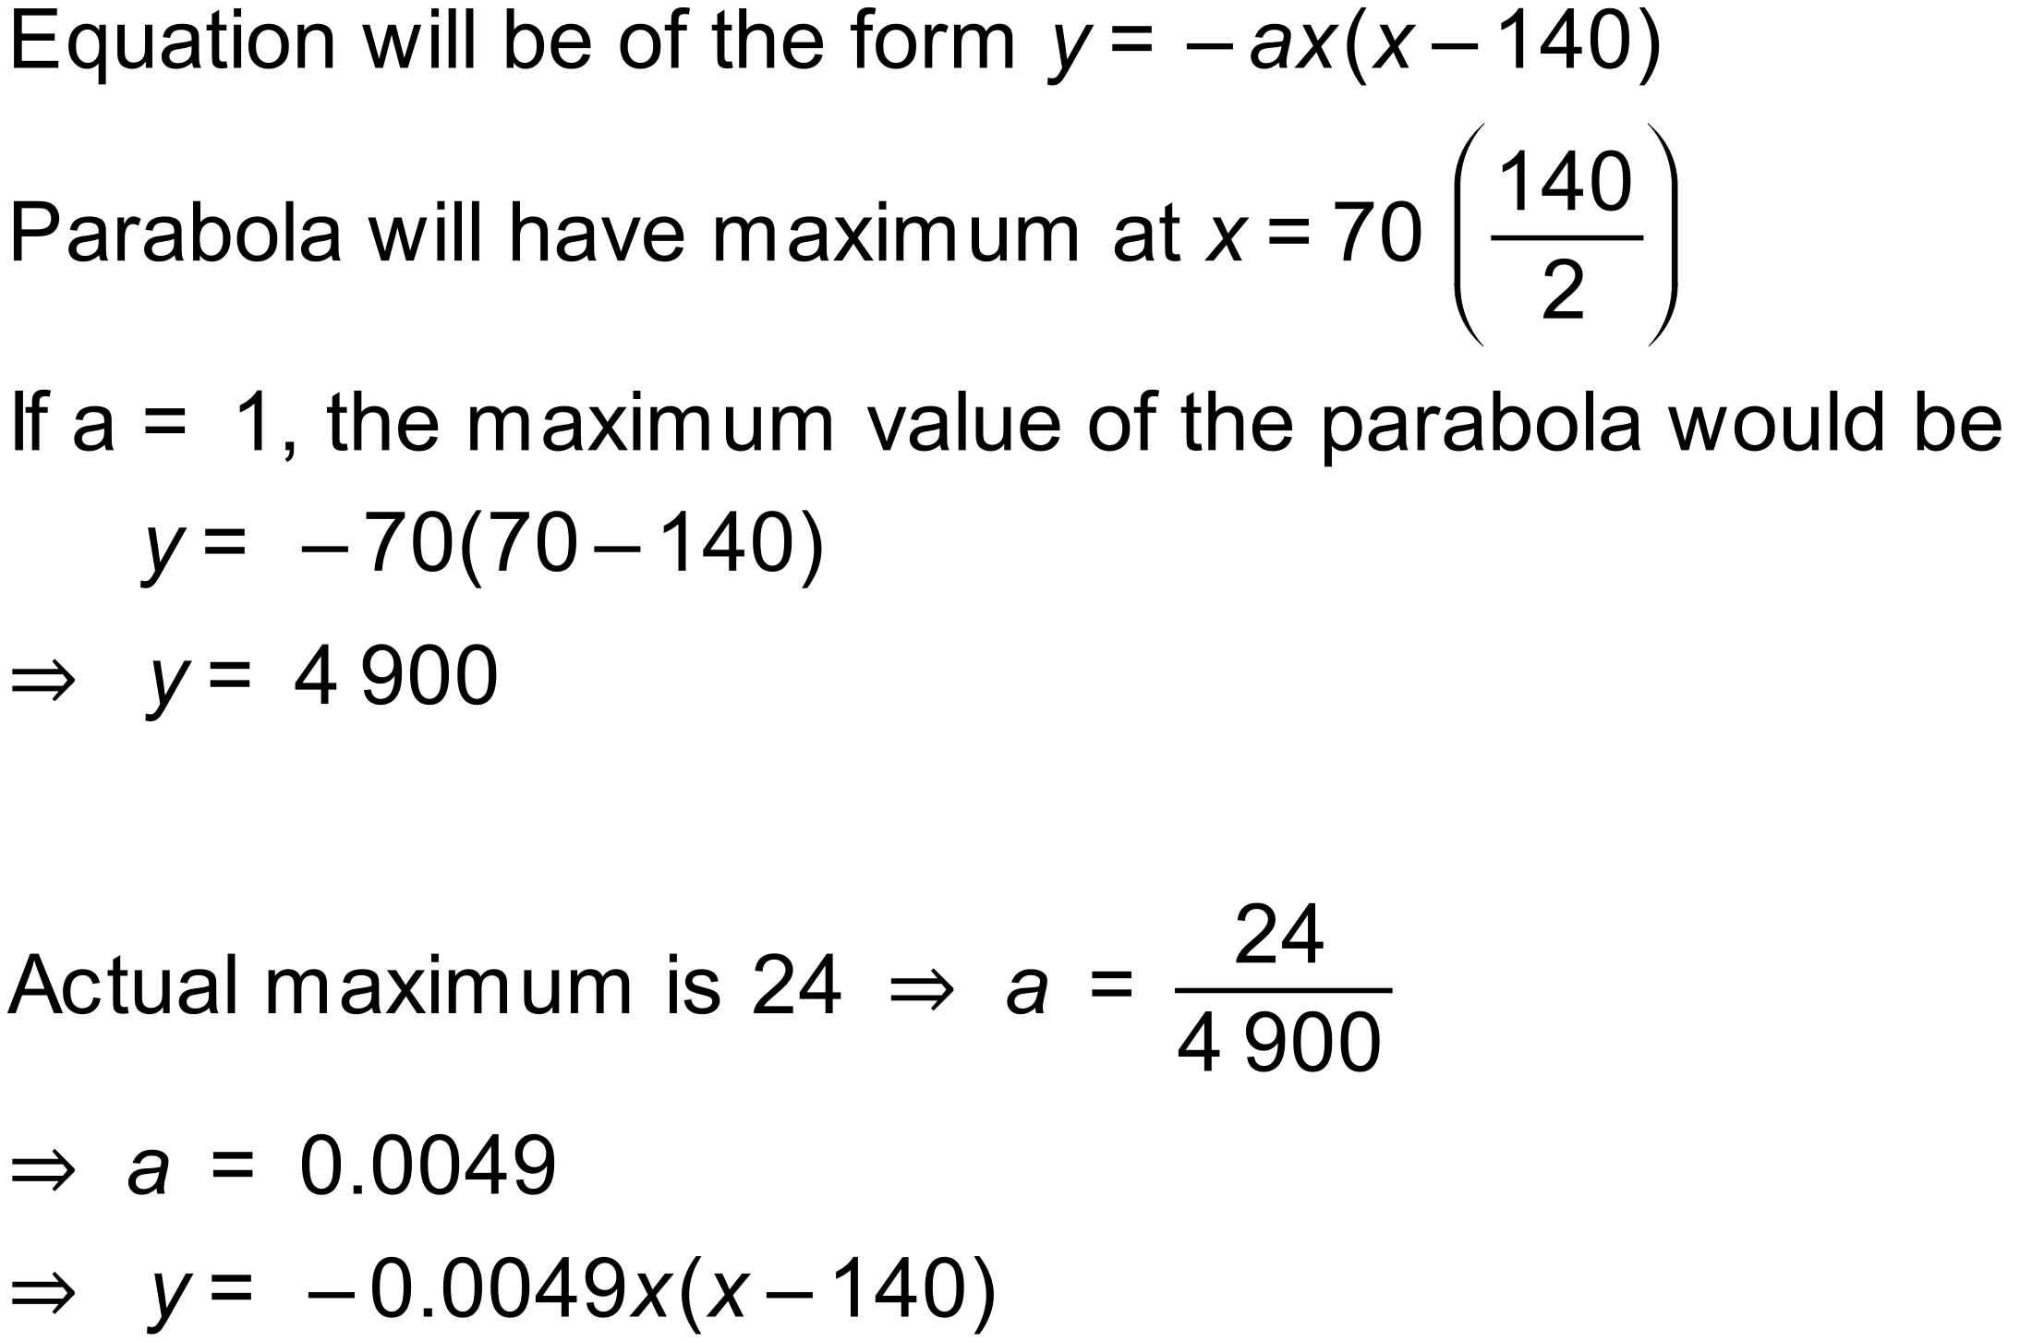

Notes
400 variations.

