FX Library Modules

Continuous Growth & Decay

Copyright Information
If you are an Efofex subscriber and work in a school, you can copy and/or modify the FX Library materials and use them with your students. We hope that this material will help you write your tests, worksheets, exams, presentations and any other educational materials. You cannot claim copyright over the FX Library materials or present them as your own work.
FAQ

Who are the questions/materials for?
We are providing the materials for teachers in schools. If you are a teacher in a school (or similar context) you are welcome to use the questions/materials freely in just about any manner. Most other usages of our questions/materials are prohibited. In particular, you are expressly prohibited from using our materials in any context where the aim is to generate a profit.
Can I photocopy the questions/materials for use by my students?
YES.
Can I copy questions/materials and paste them into my own documents?
YES.
Do I have to include the Efofex Software copyright notice on my own documents if I have included some of your questions/materials?
NO.
Can I use your questions/materials to generate a profit?
NO.
Can I use the questions/materials on my website/PowerPoint presentation/Moodle...?
It depends. If your usage is within the context of a teacher of students at an educational institution, YES. If you want to use the materials for profit, NO.
I am a home-schooling parent. Can I use your materials?
YES.
I am a student and want to use your products for revision. Can I use them?
YES (but make sure to tell your teachers how good they are!)
Can I modify your questions/materials for my own use?
YES.
If I modify your questions, can I claim copyright?
It depends. If the modifications are substantial, YES. If the modifications are trivial or superficial, NO. Using the Parameter Regeneration feature of our products is NOT a substantial modification
I am a professional tutor. Can I use your materials with my students?
NO.
Can I republish your materials?
NO.
I think that I might be able to use your materials but don't seem to fit any of your FAQs. What do I do?
Send us an email describing what you want to do (to info@efofex.com) and we will get back to you as soon as possible.

How To Use This Material
Copy a question from this document and paste (with reparametizing) into your document. This allows you to quickly build a collection of regeneratable questions into a test, worksheet, presentation, or exam.

Question
is a radioactive isotope with a short half-life (measured in hours). A scientist has a 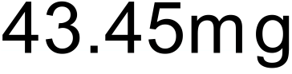 sample of the isotope and is measuring its decay.
The mass, in milligrams, of remaining after t hours can be written as
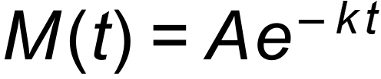
Where A and k are constants.
The scientist notes that, after 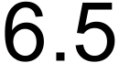 hours, there are 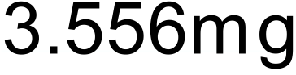 of the isotope remaining.
- Use this information to find A and k.
The scientist is interested in the half-life of the isotope.
- Use your formula to calculate the half-life of the isotope, in hours, to 3 decimal places.

Solution

a) 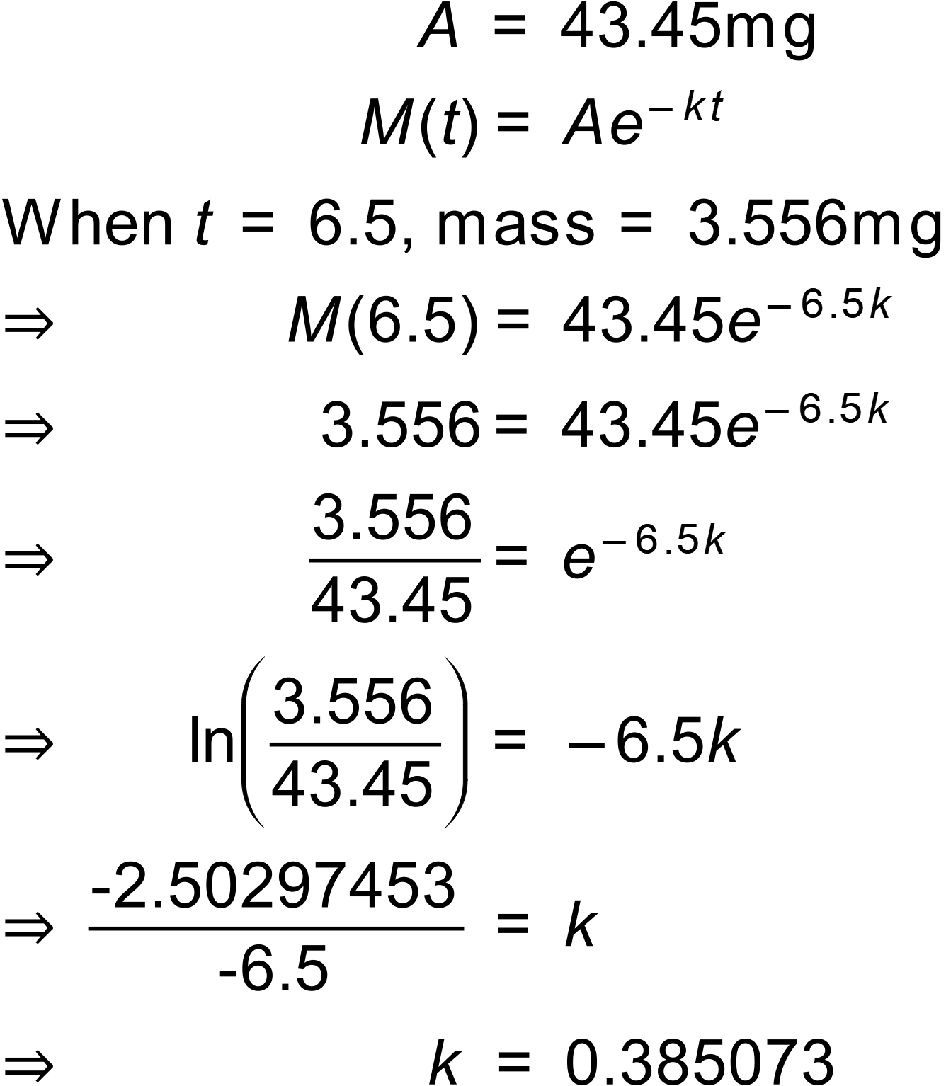
b) 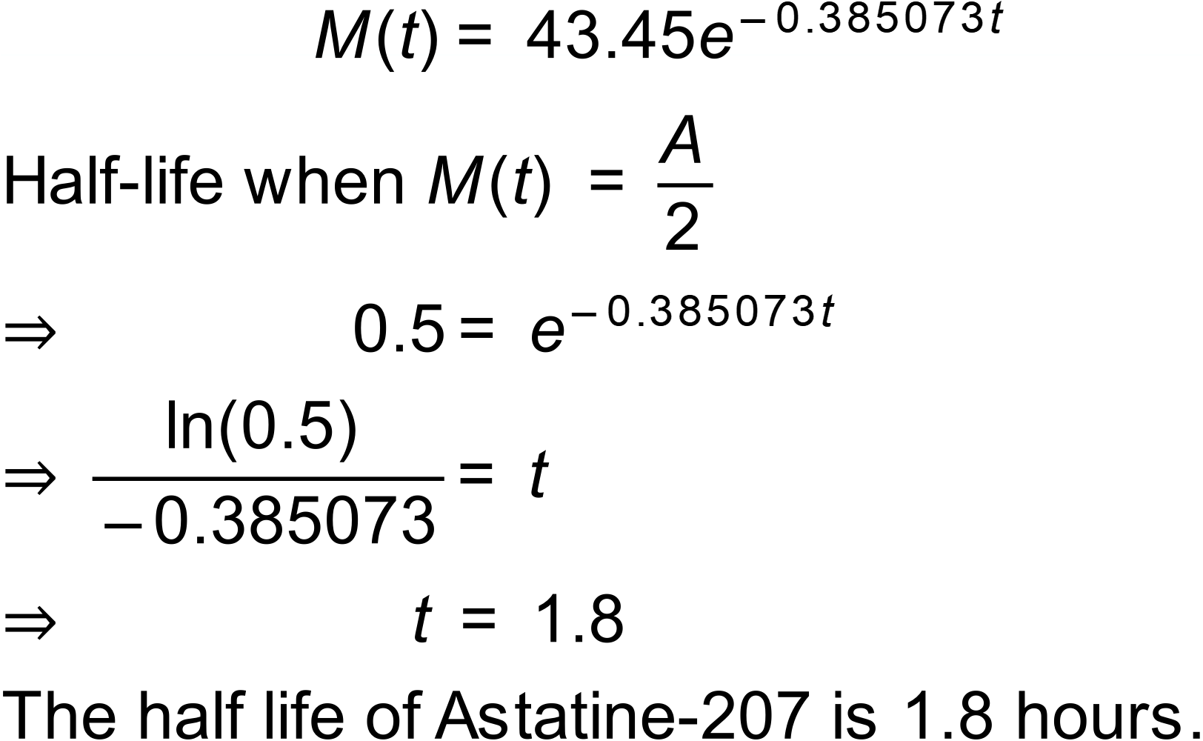
Notes
900 000+ variations.
Question
The population of a local government area during the 1996 census was but had grown to 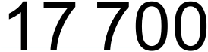 by the time of the 2021 census.
Assuming that the population P is increasing exponentially and satisfies an equation of the form where A and k are constants and t is measured in years from the beginning of 1996.
- Show that satisfies 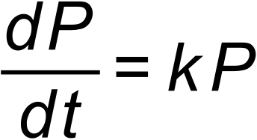

- Determine the value of A and k and complete the equation.

- Use your equation to predict the year when the population of the local area will have tripled to 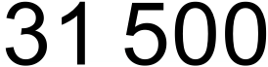.

Solution
a) 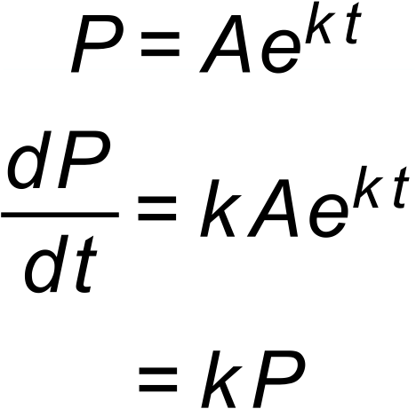
b) 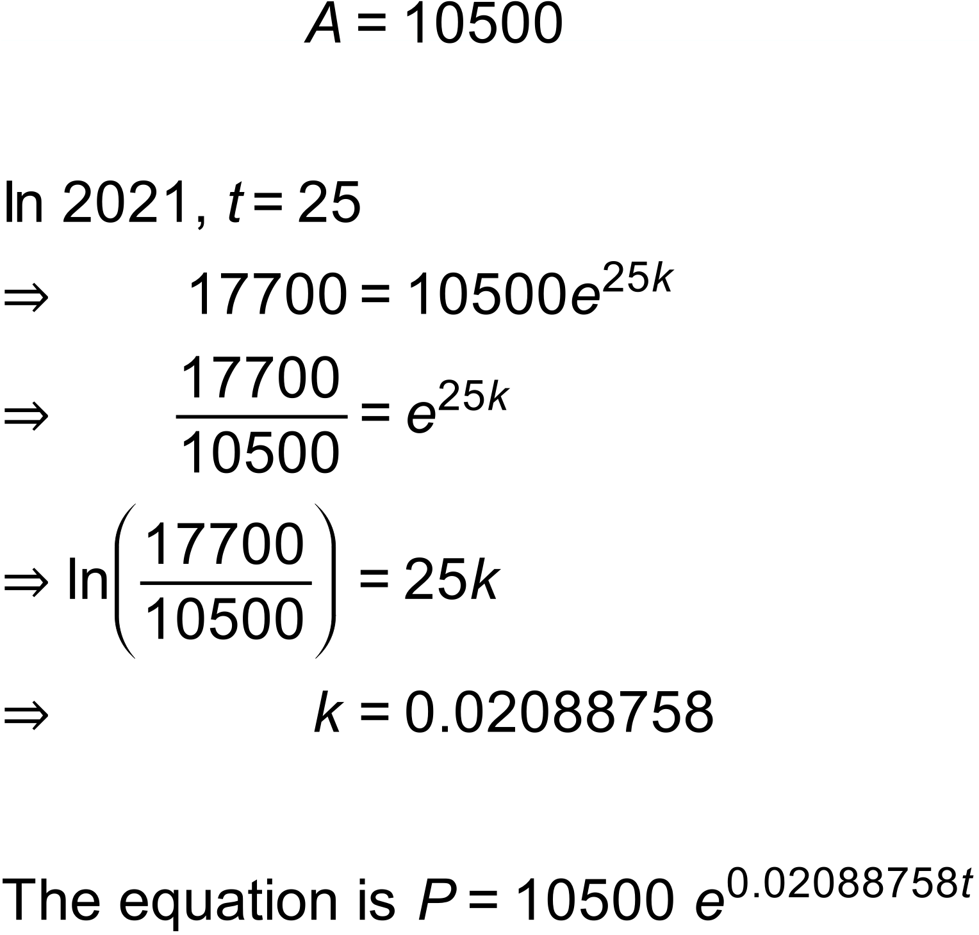

c) 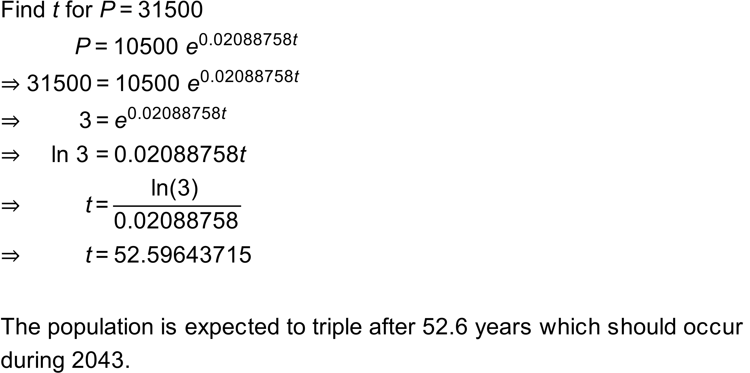

Notes
450 variations.

Question
Researchers have found that the amount of a new drug, D, that remains in a human body decreases according to the equation:
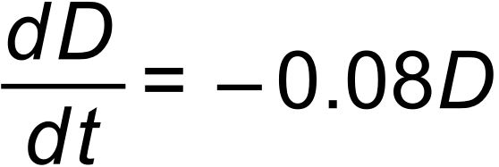
where D is measured in mg and t is the time in hours.
- Show that 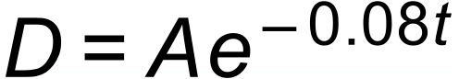 is a solution to where A is a constant.
When t = 0 there are of the drug in a patient’s body.
- Use this information to find the value of A.

- What will be the amount of the drug left in the patient’s body after hours?

- Calculate the half-life of the drug – the number of hours taken for the amount of the drug to halve in the patient’s body.

Solution
a) 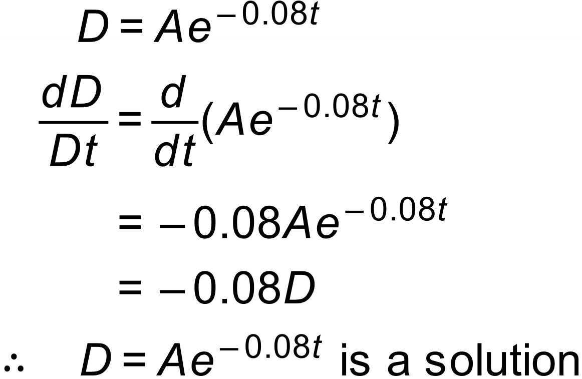

b) 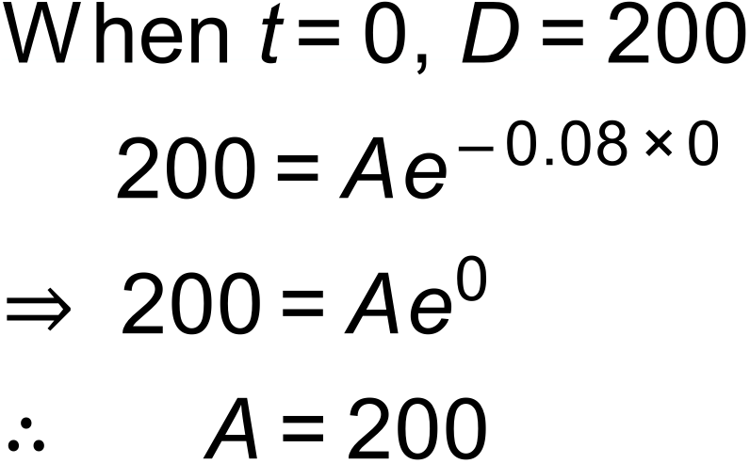

c) 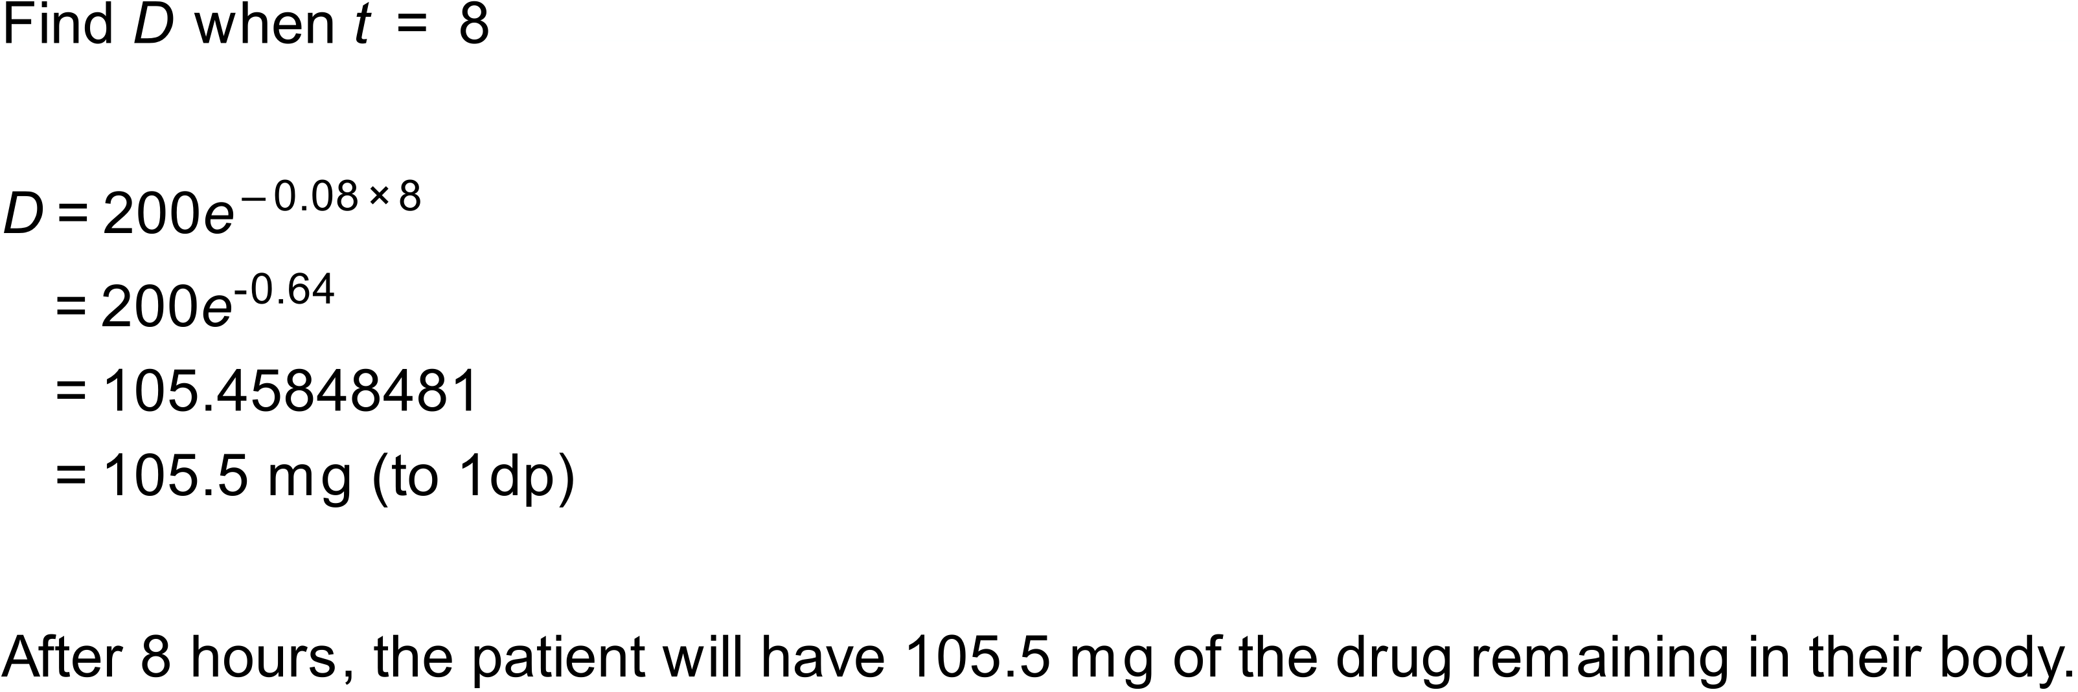

d) 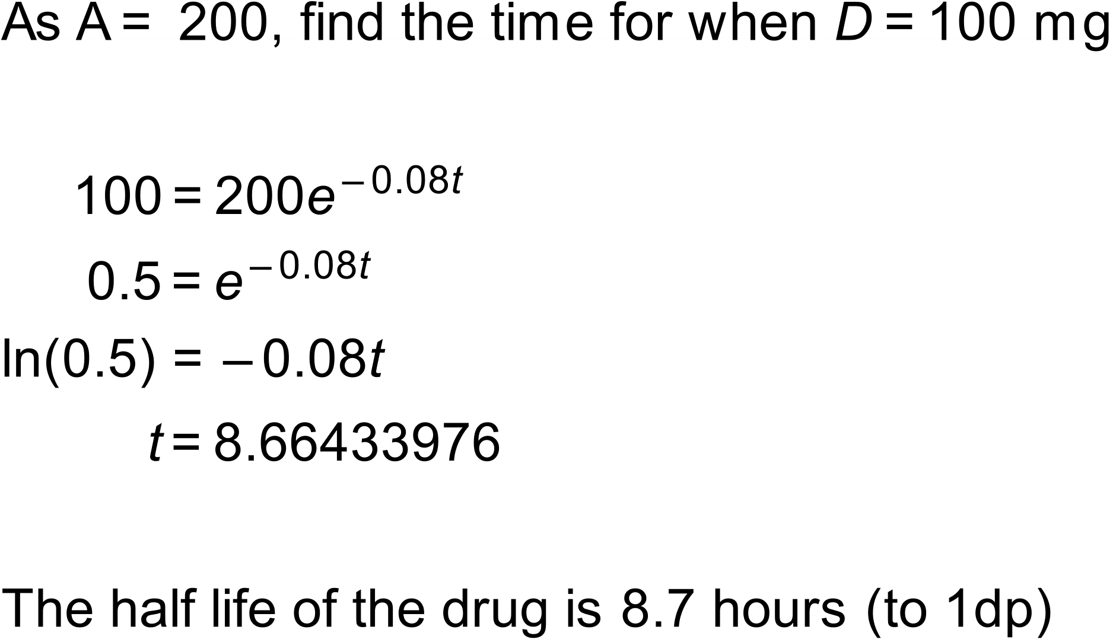

Notes
2500+ variations.

Question
A bacterial culture is used to determine the type of bacteria causing an infection. Initially, the bacterial colony contained bacteria and the number of bacteria after t minutes is given by
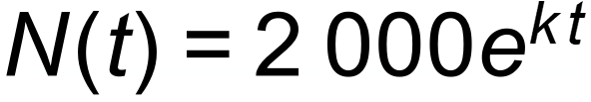
After 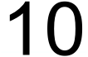 minutes the colony had bacteria.
- Show that k = 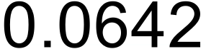 to 4 decimal places.

- How many bacteria are there when t = ?

- How long does it take for the number of bacteria to increase from to 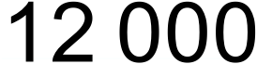?

The rate of change in a bacterial colony can be determined by the derivative.
- What is the rate of change in the colony, in number of bacteria per minute, when t = ?

Solution
a) 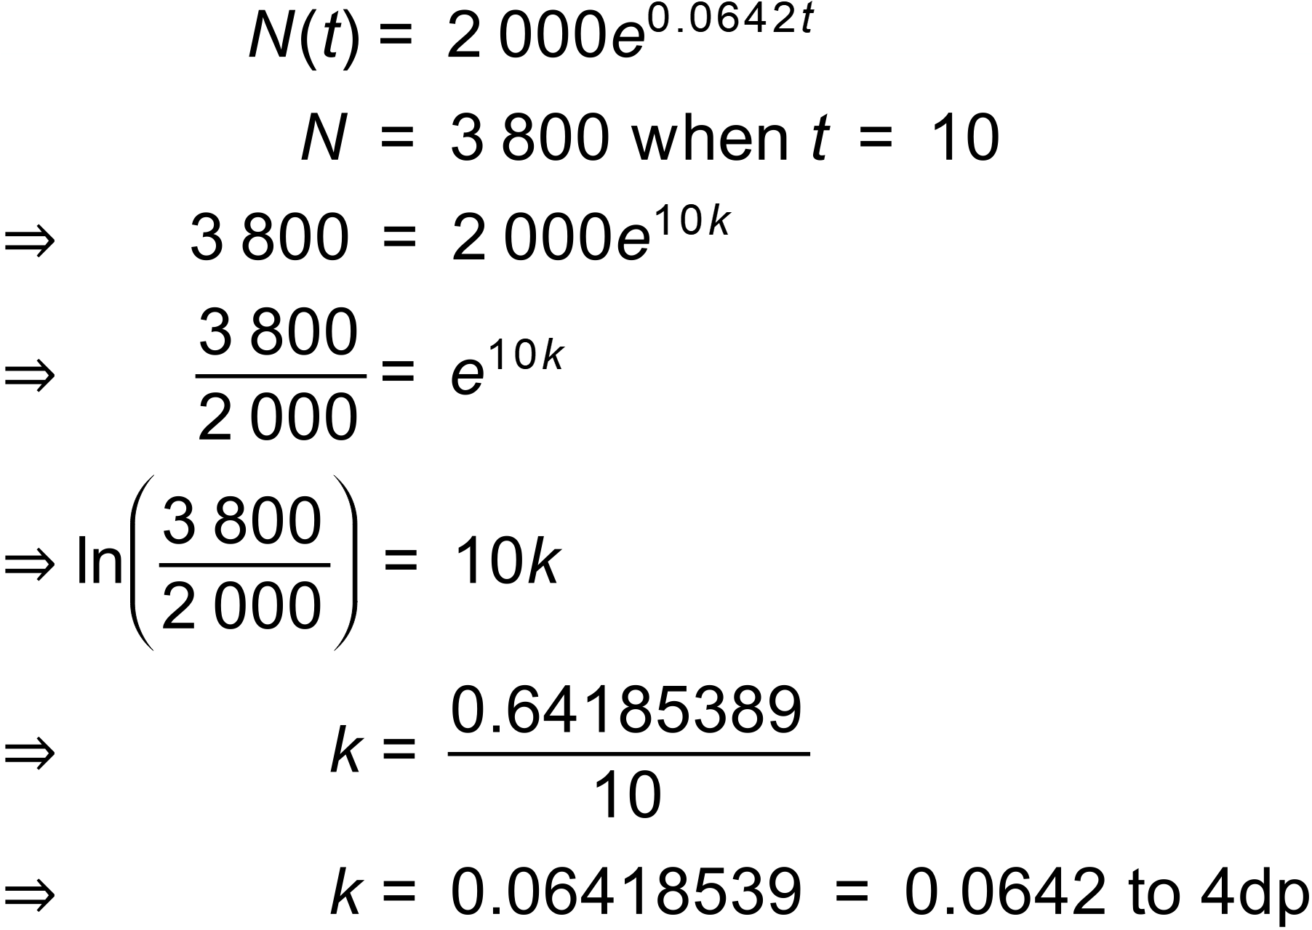

b) 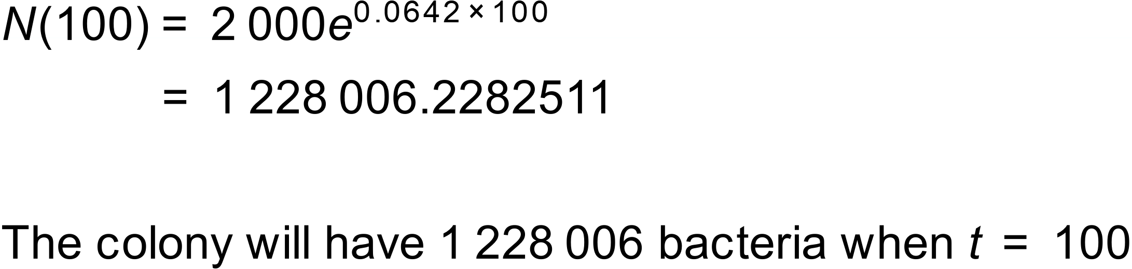

c) 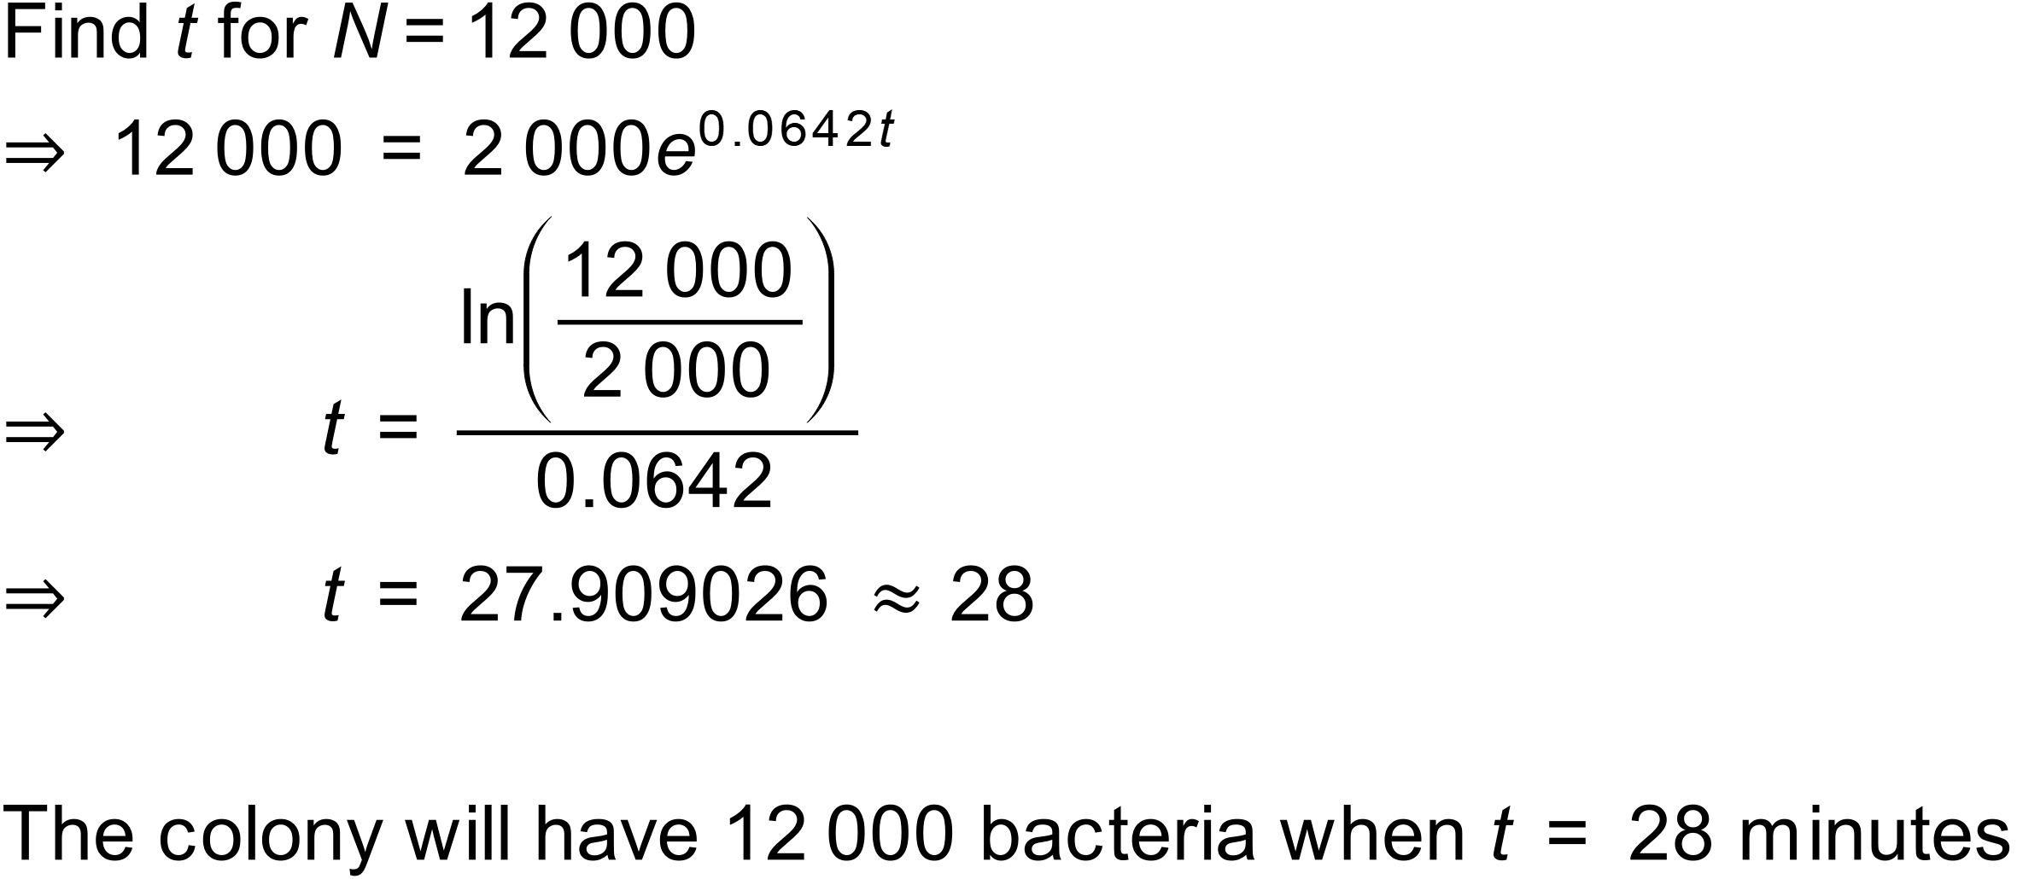

c) 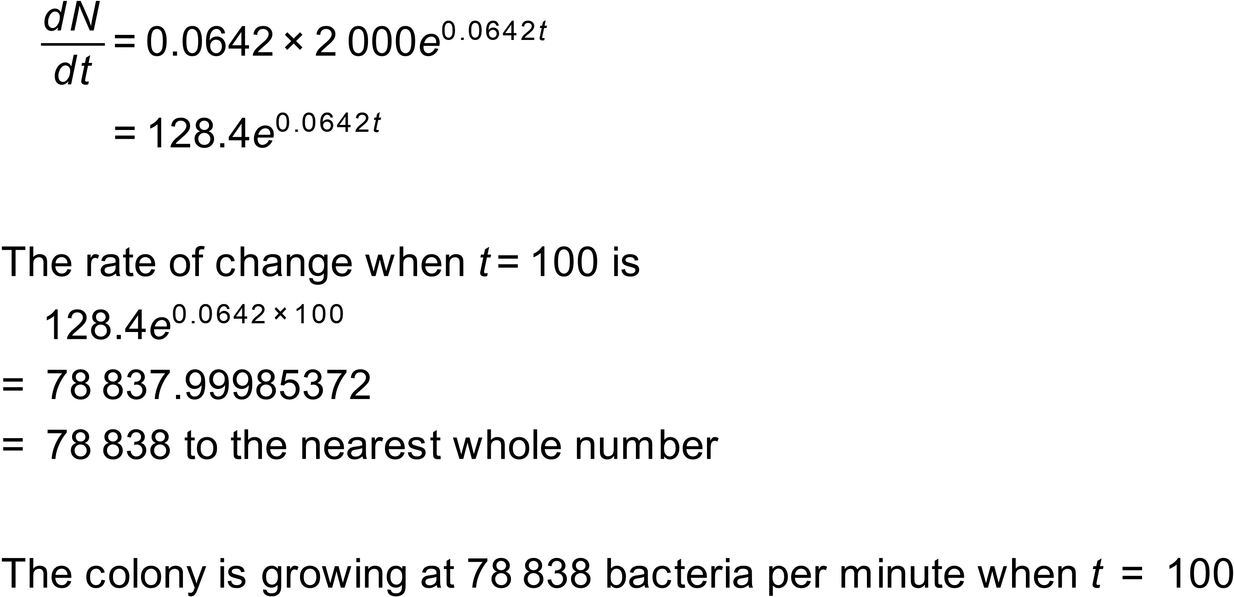
Notes
100 000+ variations.
Question
Carbon-14 is a radioactive isotope that decays with a half-life of 5730 years, and it is often used to estimate how long ago a fossil died. An archaeologist has found an old campfire and is using Carbon-14 dating on some shells found in the campfire to estimate the age of the site.
If the amount of Carbon-14 remaining in the sample is given by the equation:
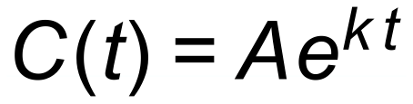
where t is the number of years,
- Find k, correct to 3 significant figures.

- The amount of Carbon-14 in the shells is 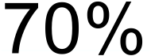 of the original amount. Find the number of years since the shells were cooked in the campfire.

Solution
- 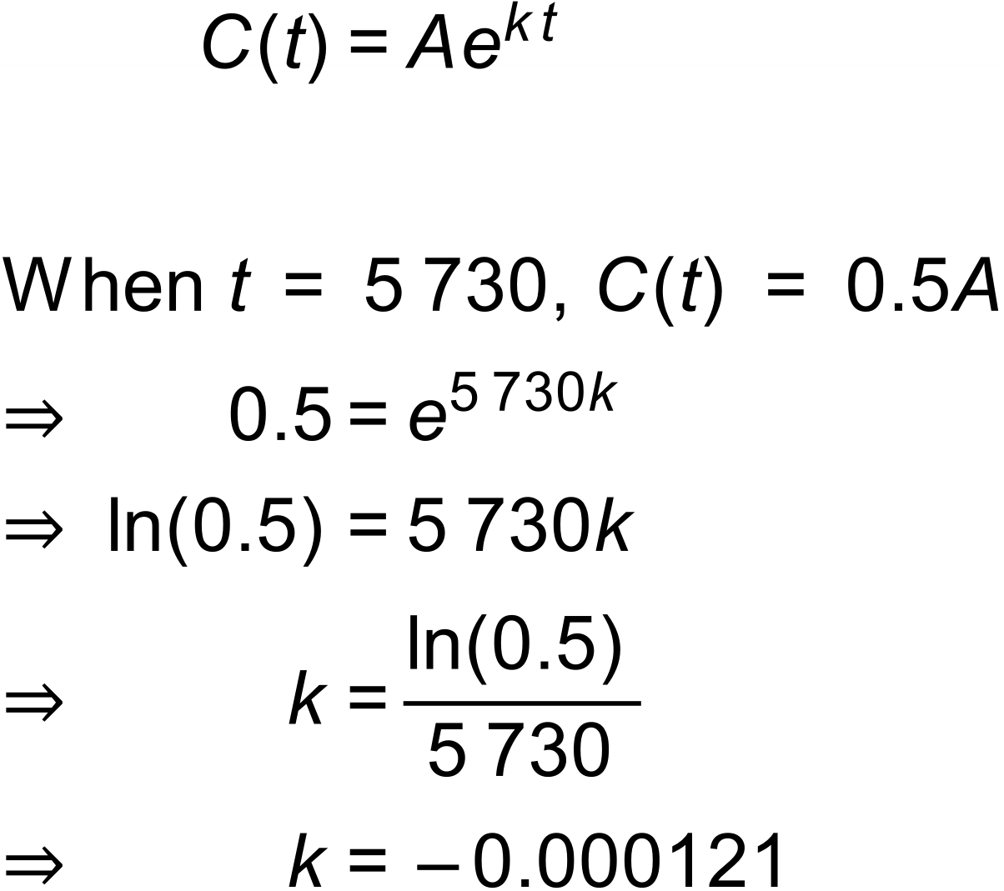

- 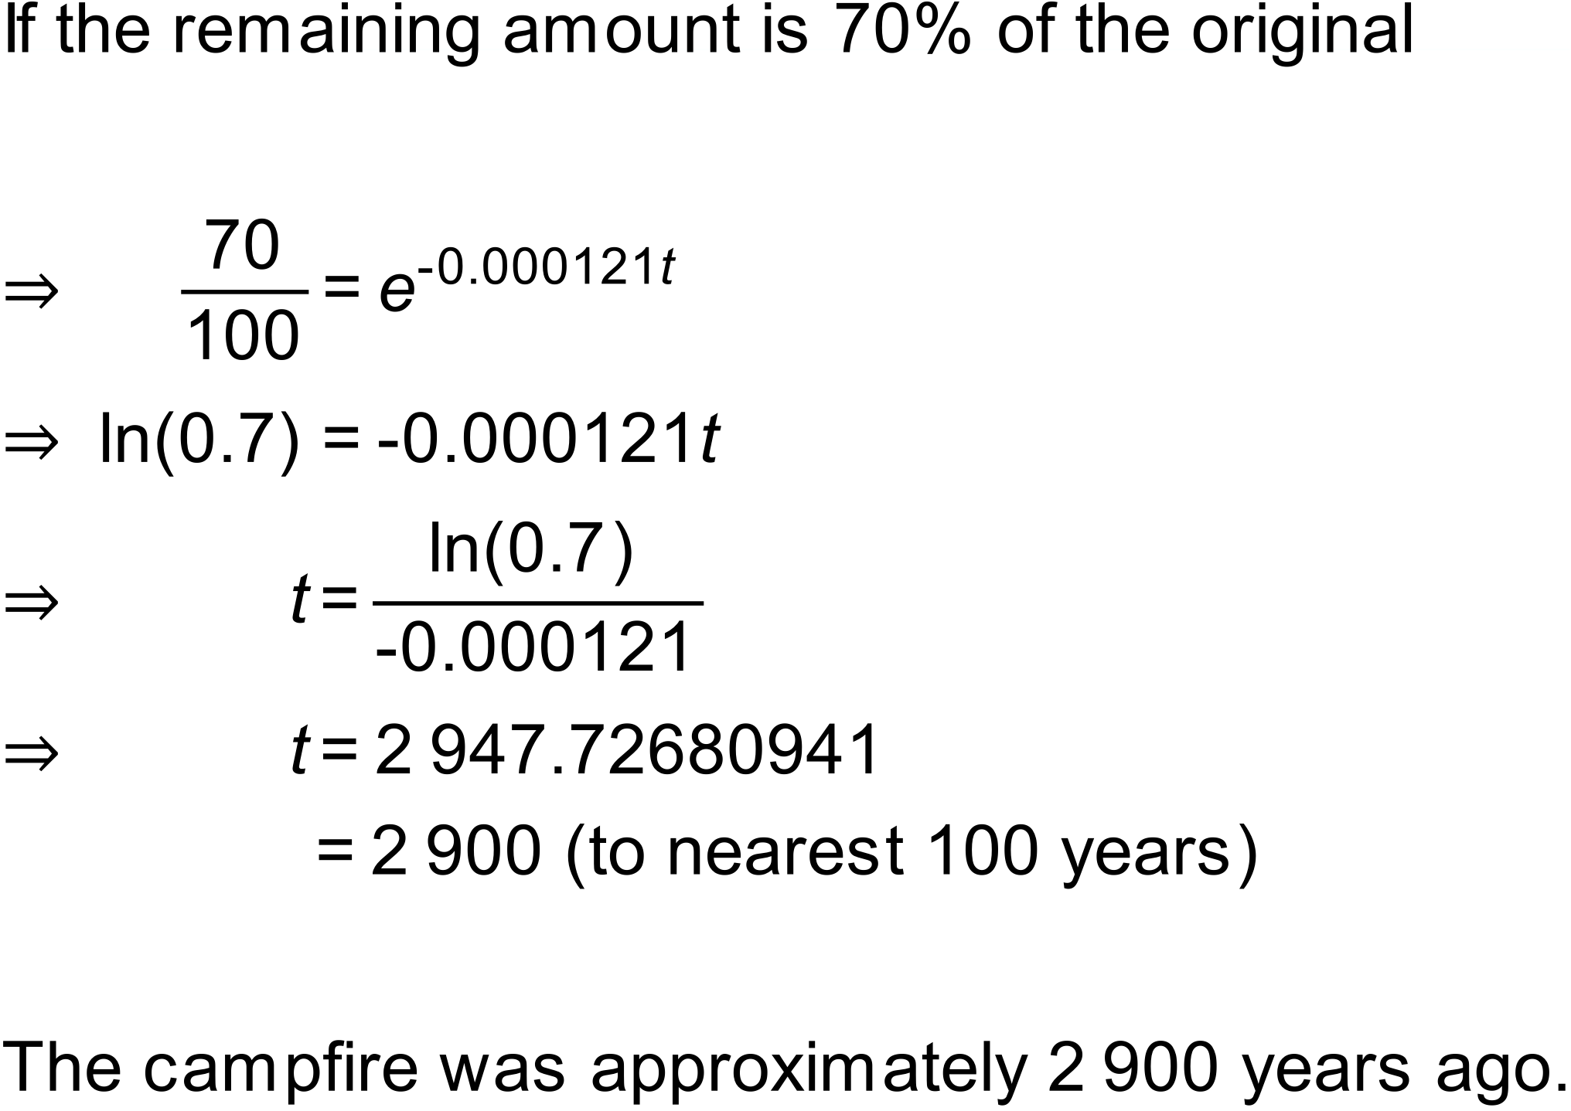

Notes
13 variations.

