FX Library Modules

Compound Areas

Copyright Information
If you are an Efofex subscriber and work in a school, you can copy and/or modify the FX Library materials and use them with your students. We hope that this material will help you write your tests, worksheets, exams, presentations and any other educational materials. You cannot claim copyright over the FX Library materials or present them as your own work.
FAQ

Who are the questions/materials for?
We are providing the materials for teachers in schools. If you are a teacher in a school (or similar context) you are welcome to use the questions/materials freely in just about any manner. Most other usages of our questions/materials are prohibited. In particular, you are expressly prohibited from using our materials in any context where the aim is to generate a profit.
Can I photocopy the questions/materials for use by my students?
YES.
Can I copy questions/materials and paste them into my own documents?
YES.
Do I have to include the Efofex Software copyright notice on my own documents if I have included some of your questions/materials?
NO.
Can I use your questions/materials to generate a profit?
NO.
Can I use the questions/materials on my website/PowerPoint presentation/Moodle...?
It depends. If your usage is within the context of a teacher of students at an educational institution, YES. If you want to use the materials for profit, NO.
I am a home-schooling parent. Can I use your materials?
YES.
I am a student and want to use your products for revision. Can I use them?
YES (but make sure to tell your teachers how good they are!)
Can I modify your questions/materials for my own use?
YES.
If I modify your questions, can I claim copyright?
It depends. If the modifications are substantial, YES. If the modifications are trivial or superficial, NO. Using the Parameter Regeneration feature of our products is NOT a substantial modification
I am a professional tutor. Can I use your materials with my students?
NO.
Can I republish your materials?
NO.
I think that I might be able to use your materials but don't seem to fit any of your FAQs. What do I do?
Send us an email describing what you want to do (to info@efofex.com) and we will get back to you as soon as possible.

How To Use This Material
Copy a question from this document and paste (with reparametizing) into your document. This allows you to quickly build a collection of regeneratable questions into a test, worksheet, presentation, or exam.

Question
Find the area of this shape. You can assume that sides that appear parallel are parallel.

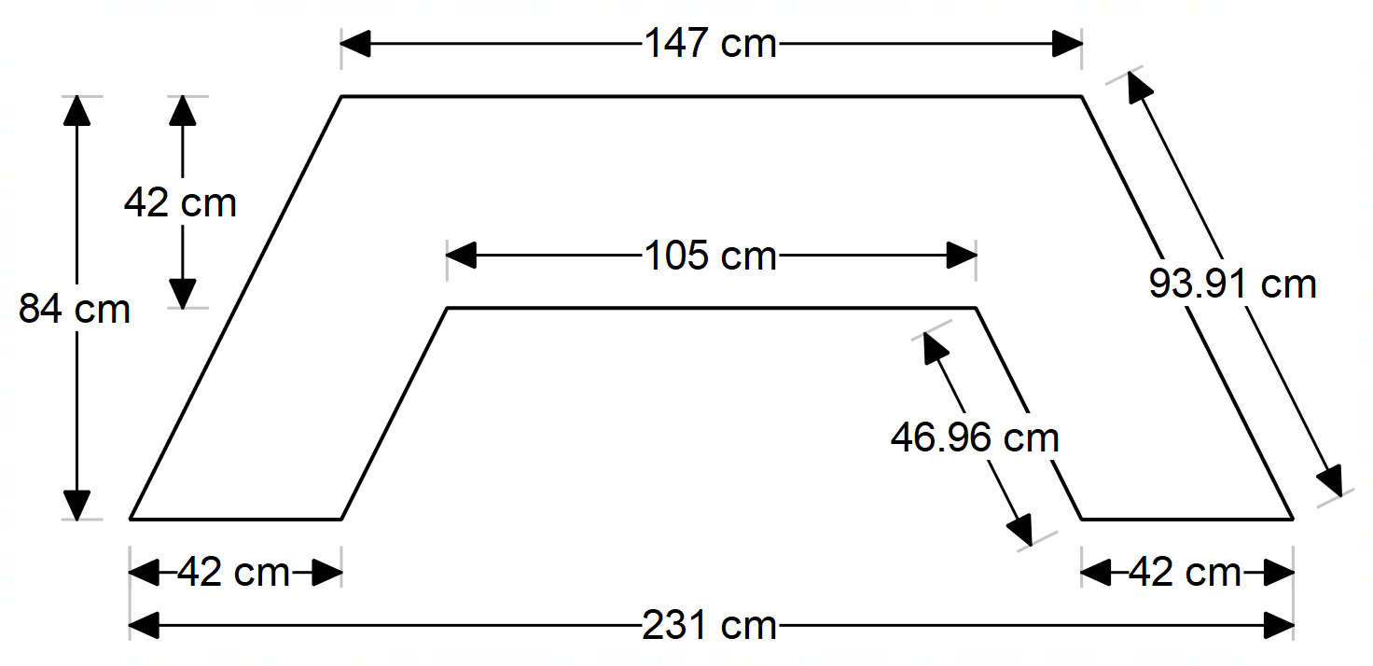

Solution
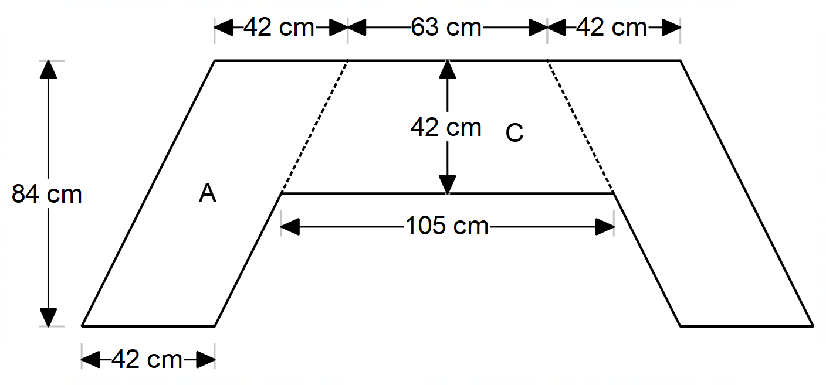

This is one way of subdividing the shape. Other divisions are acceptable.
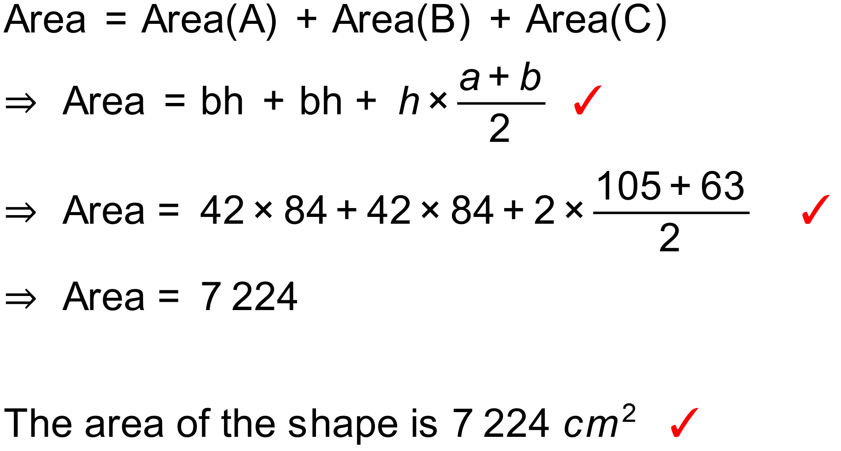
Notes
24 variations.
Question
Find the area of the shaded regions to the nearest square millimetre.
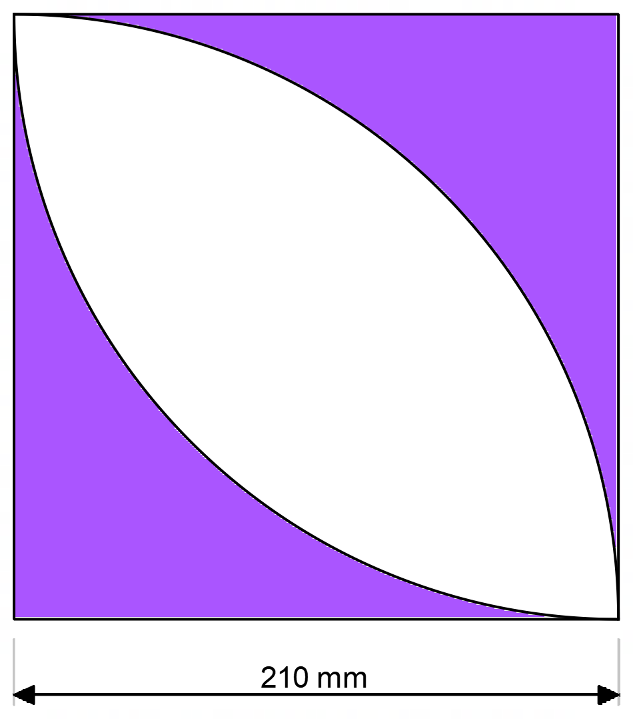

Solution
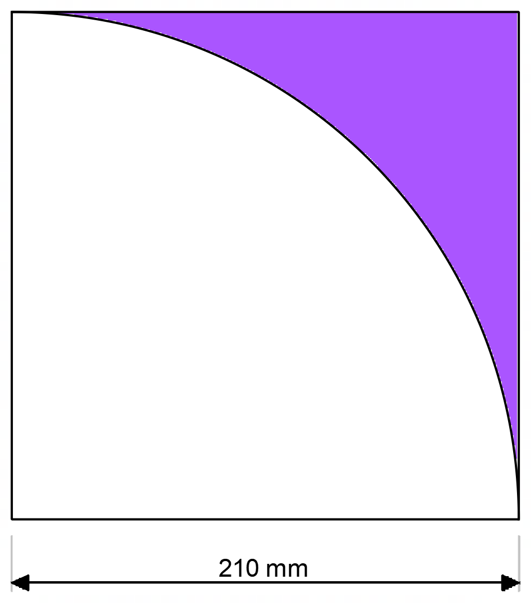

Desired area is twice the area shown above.

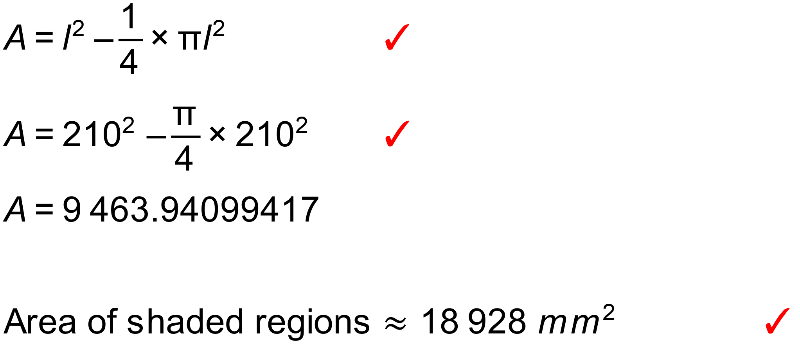
Notes
28 variations.

Question
Find the area of the shaded region bounded by these four congruent circles
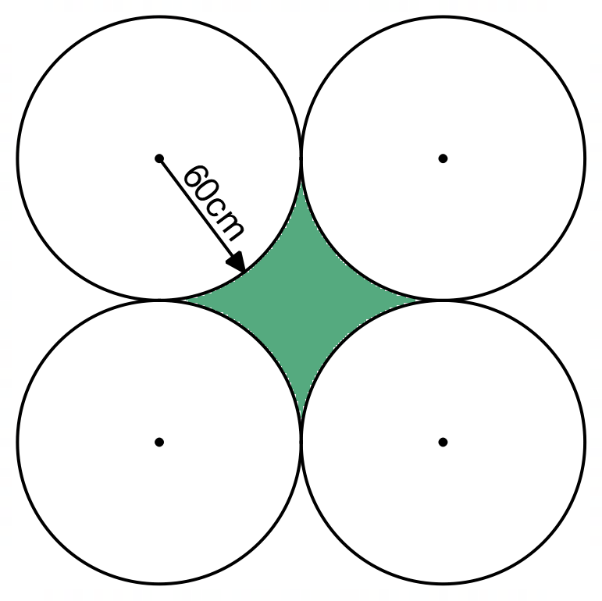

Solution
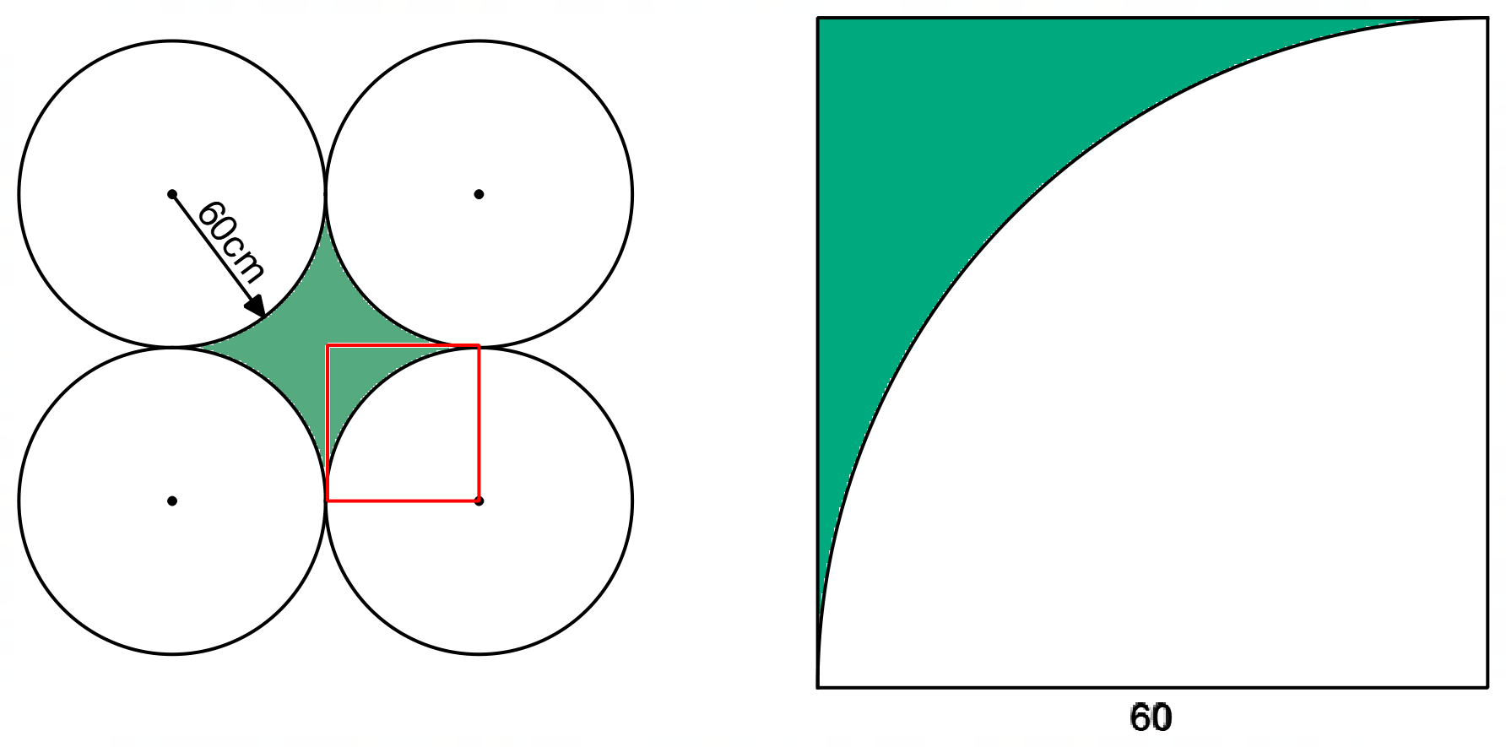
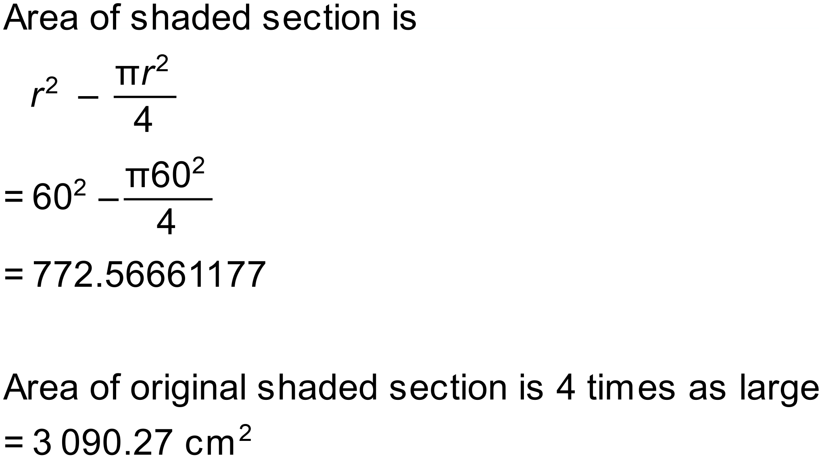
Notes
300+ variations.

Question
Calculate the area of the shaded shape where the radius of the larger circle (OQ) is 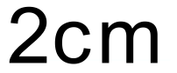.
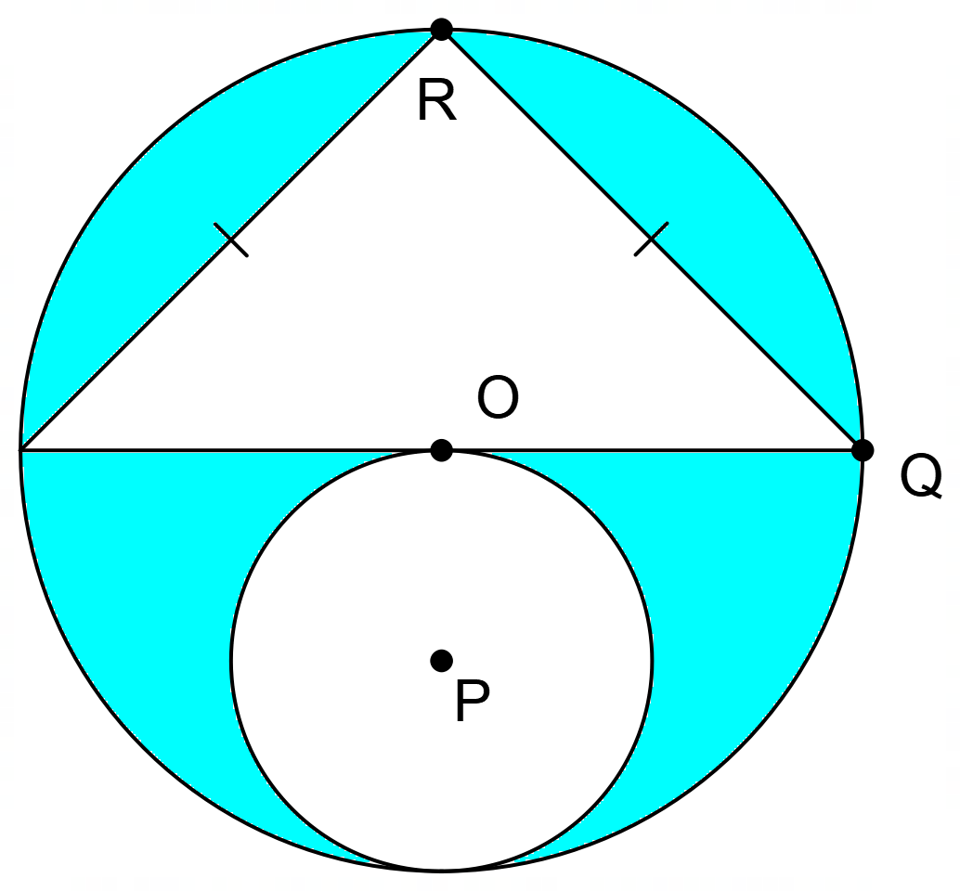

Solution
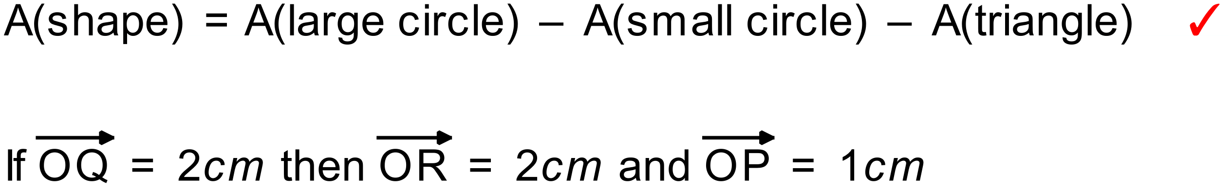

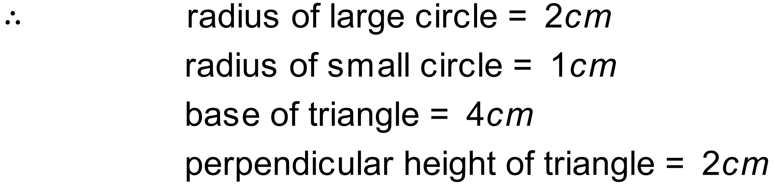

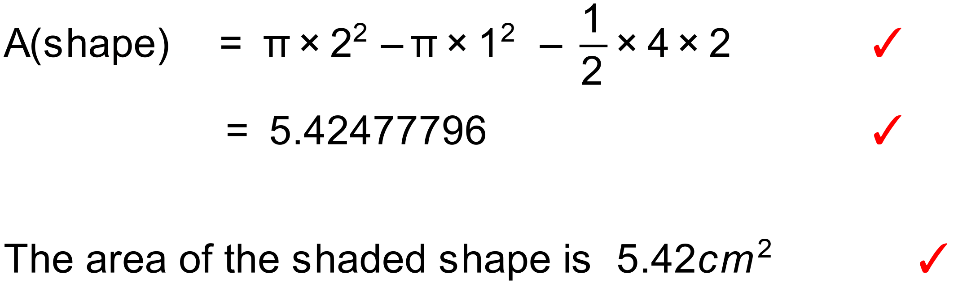

Notes
499 variations.

Question
Calculate the area of this shape.
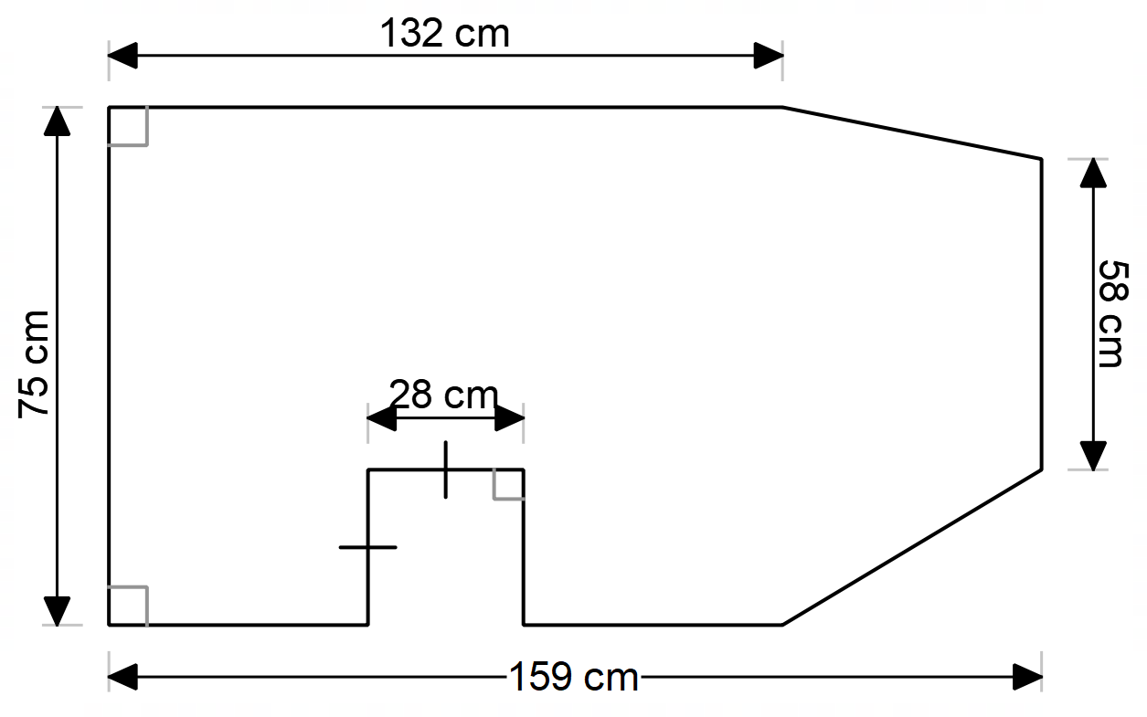

Solution
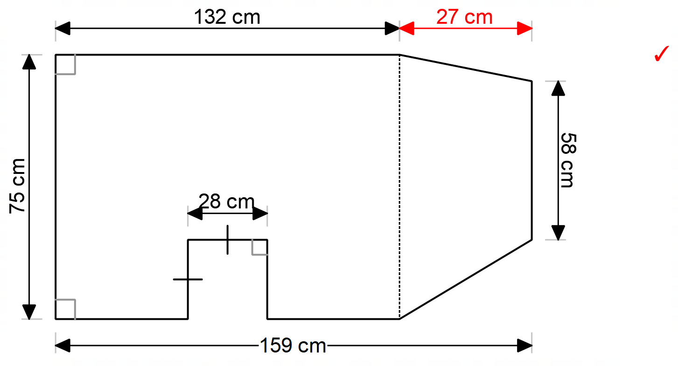

A(shape) = A(rectangle) + A(trapezium) – A(square)

Rectangle
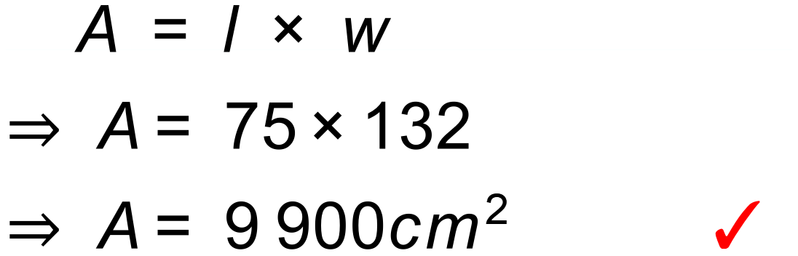
Square
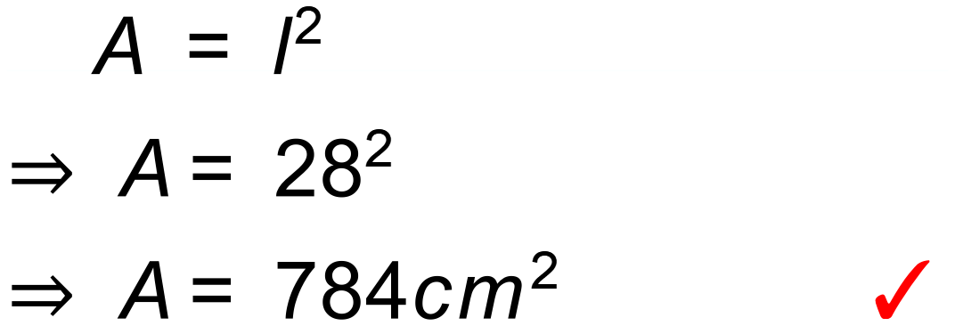
Trapezium
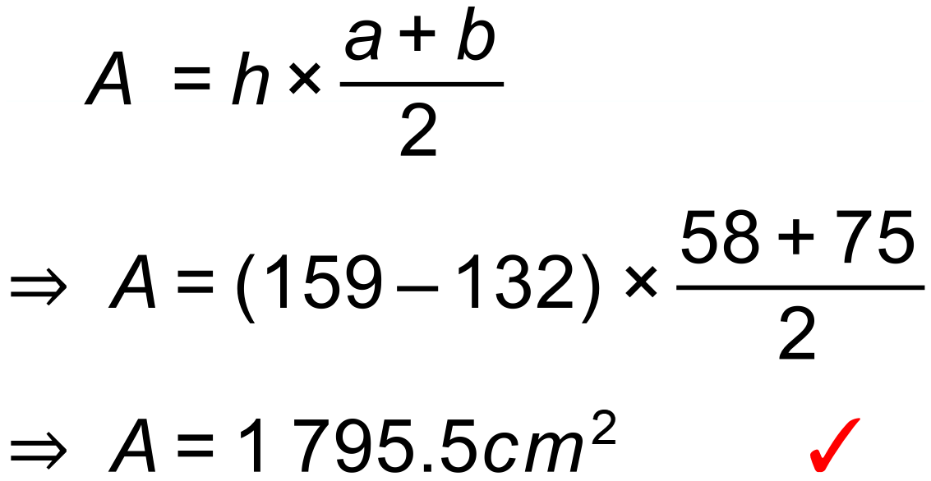

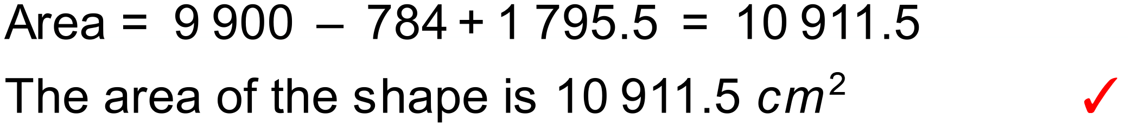

Notes
10000+ variations.
Question
Find the area of this shape that is defined by quarter circles that have centres and end points that lie on a grid.

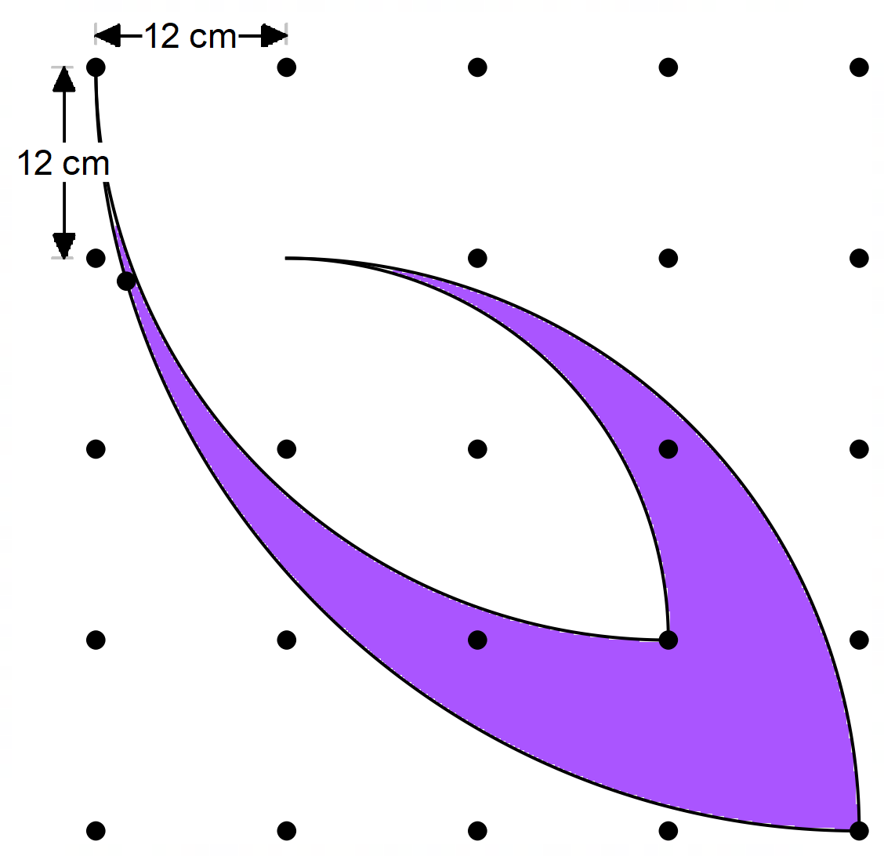

Solution
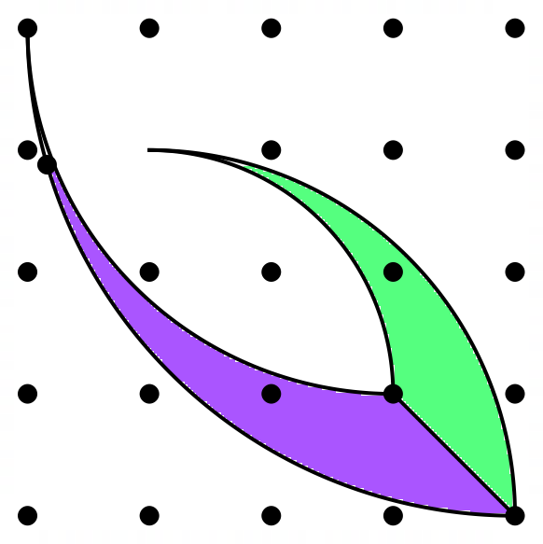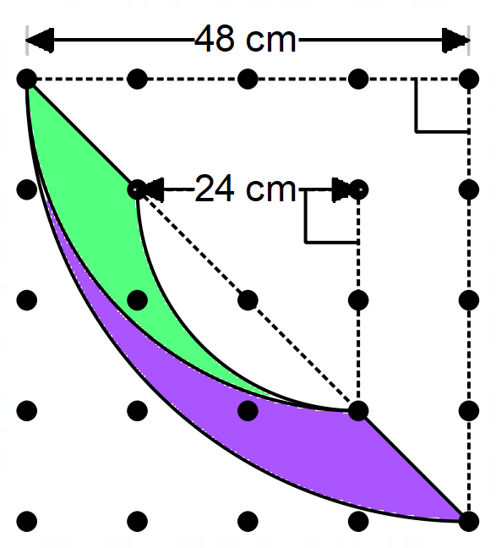
There are many ways of dissecting this area, all of which are equally valid. Any valid approach should be awarded full marks.
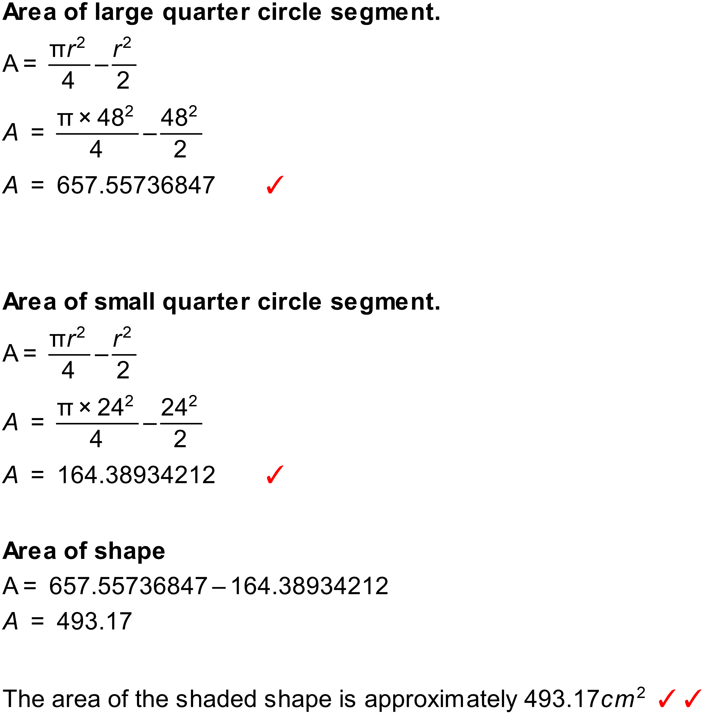
Notes
11 variations.

Question
Find the area of this teardrop shape where the 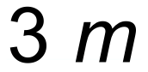 side is tangential to the circular arc.
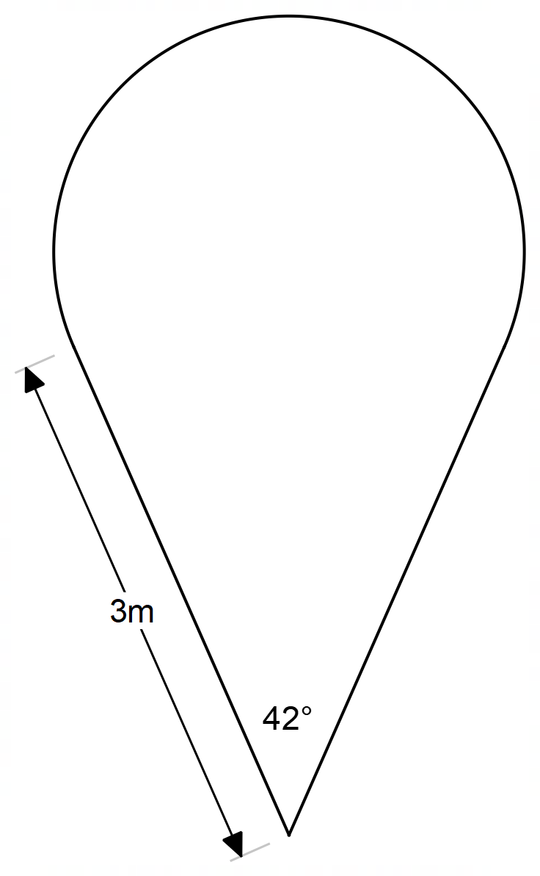

Solution
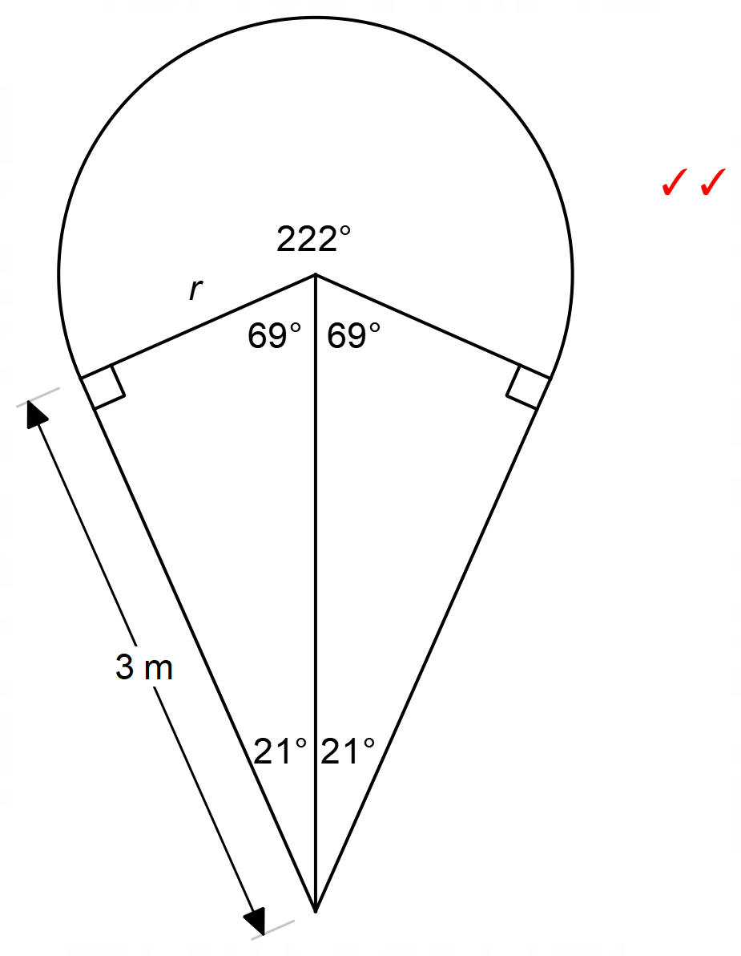
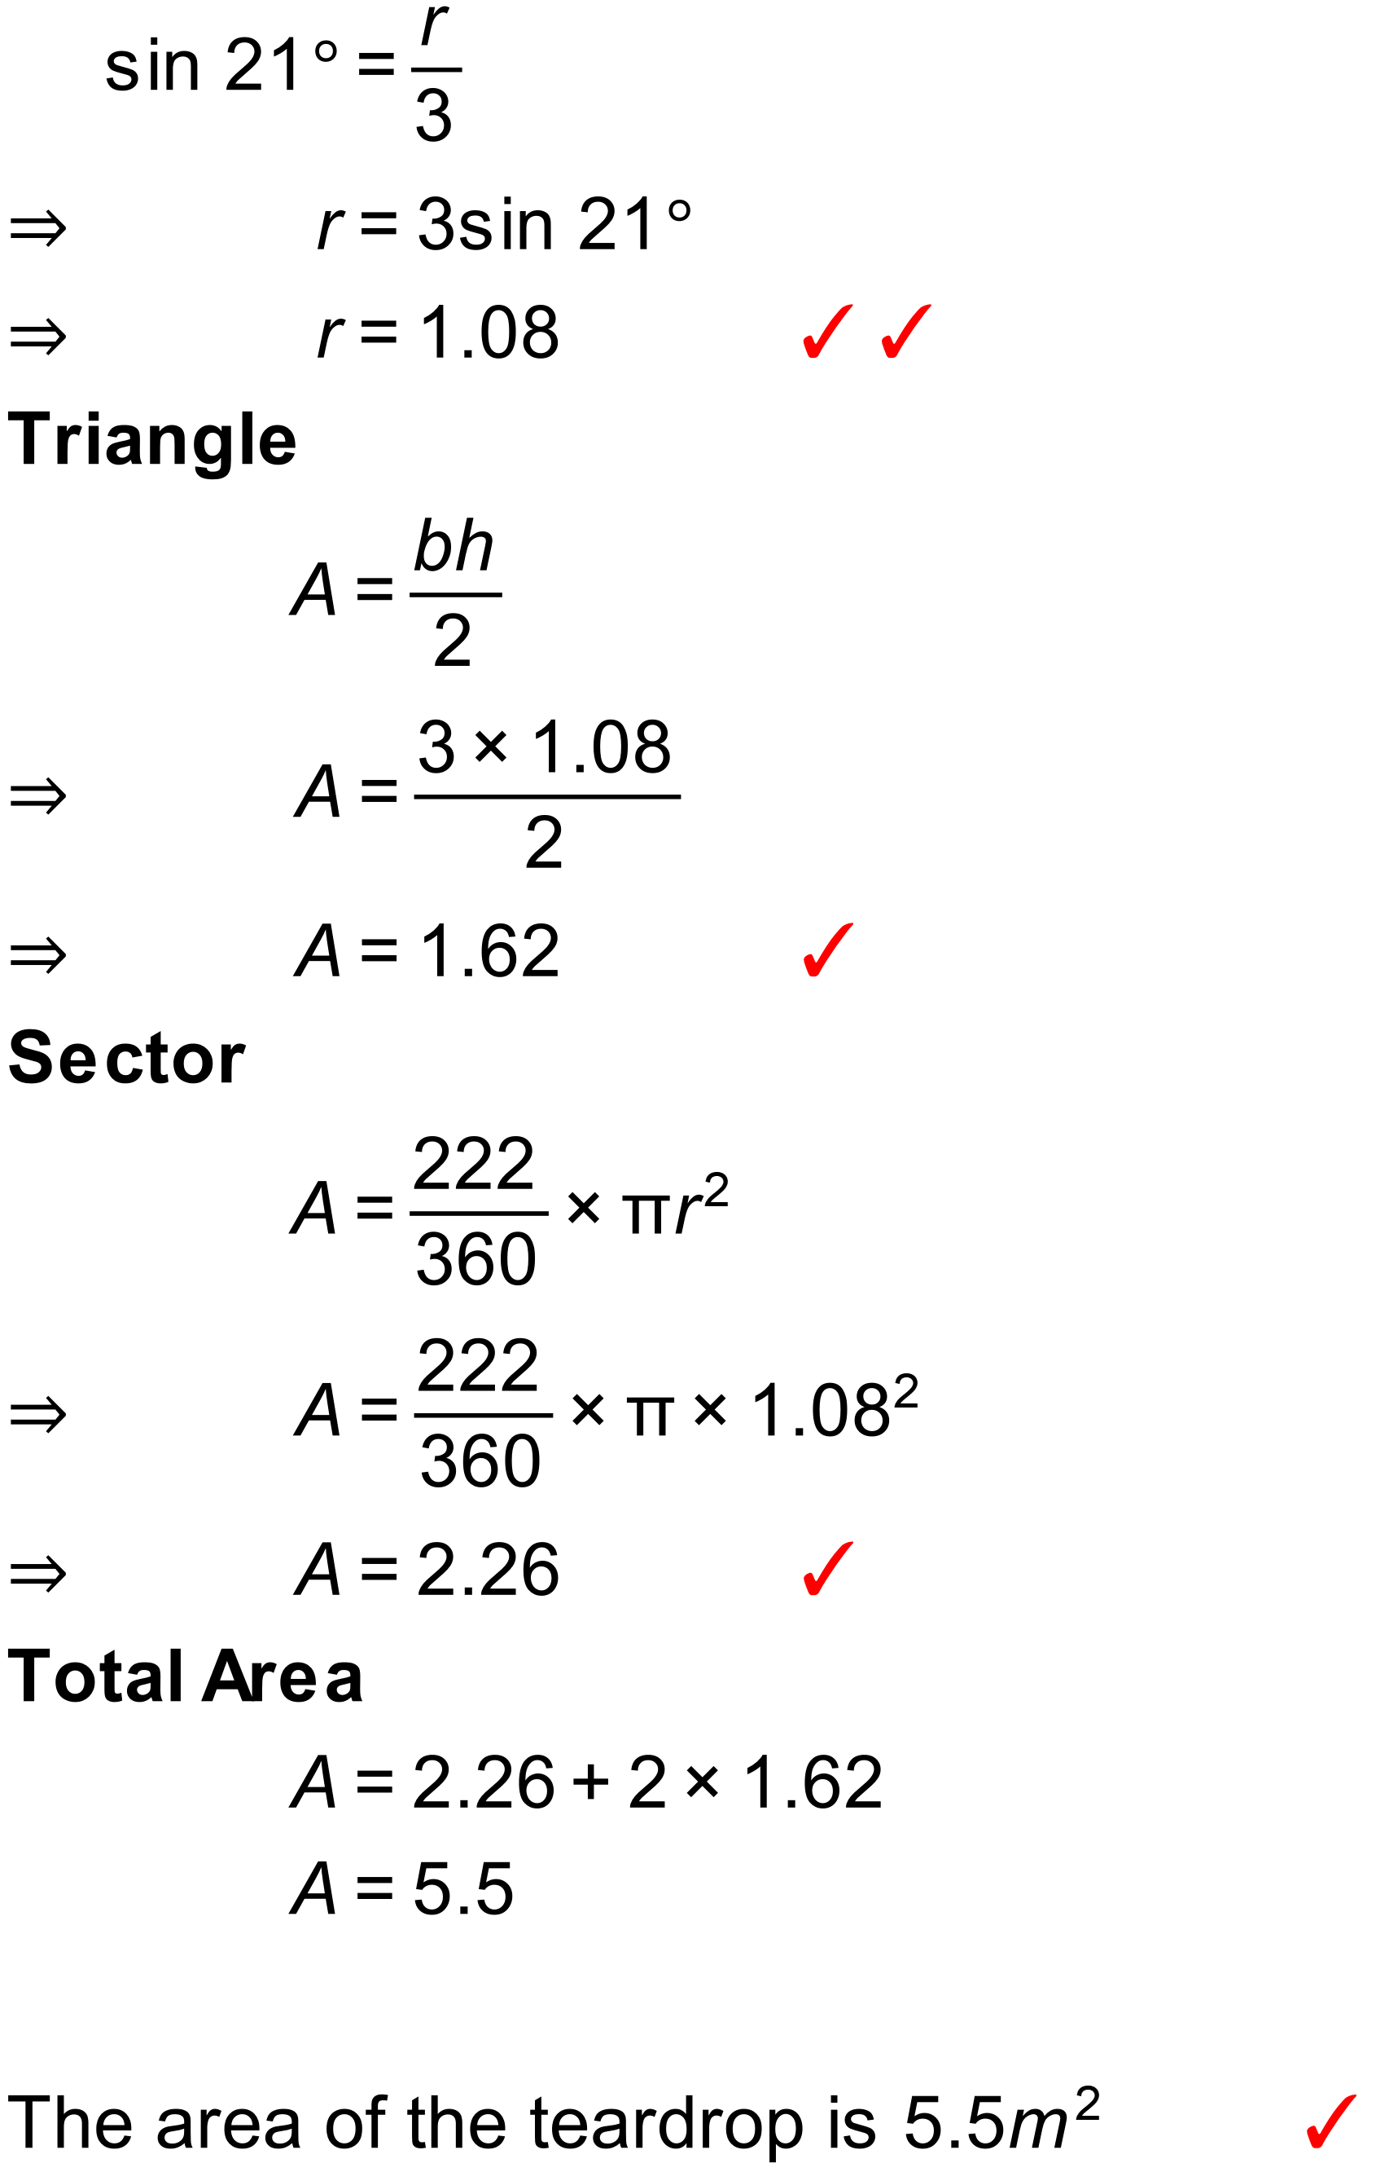

Notes
582 variations.
Question
A contractor needs to lay a large concrete slab as shown below. Calculate the area of the slab.
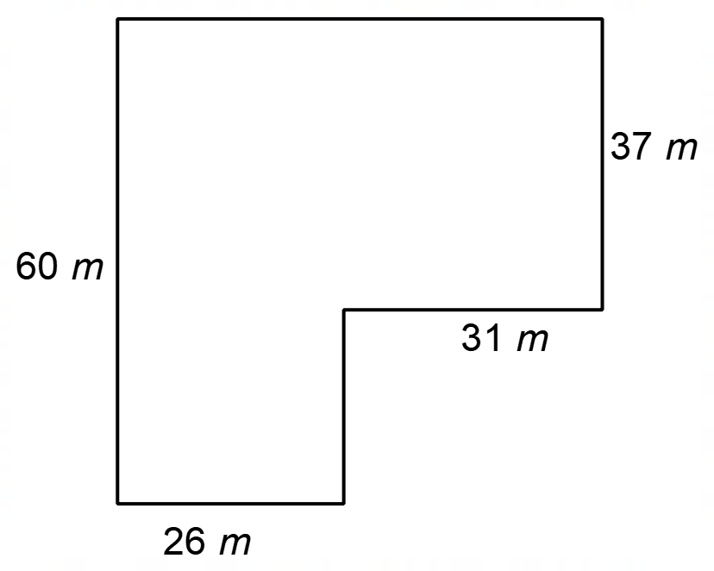

Solution
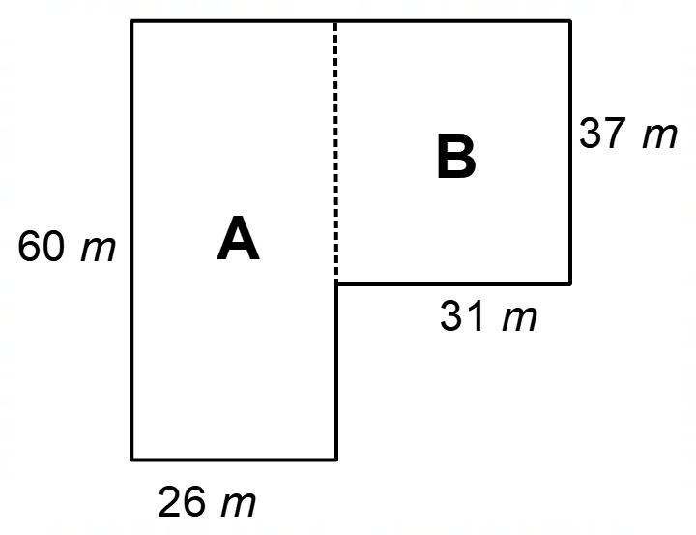
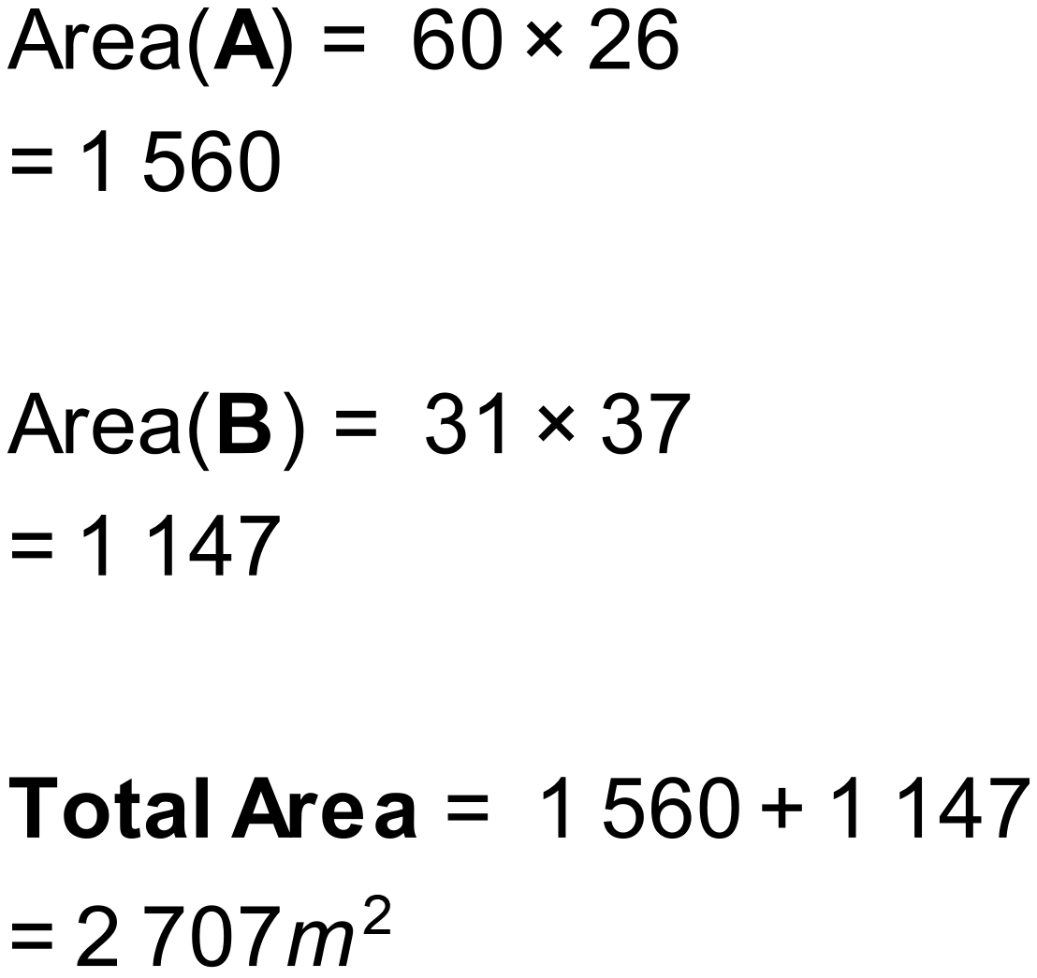
Notes
39 variations.

Question
Calculate the area of the shape shown below.
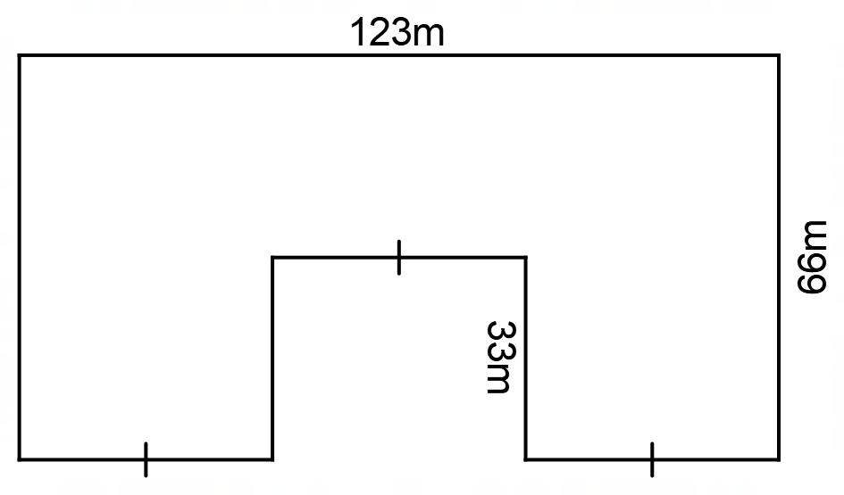

Solution
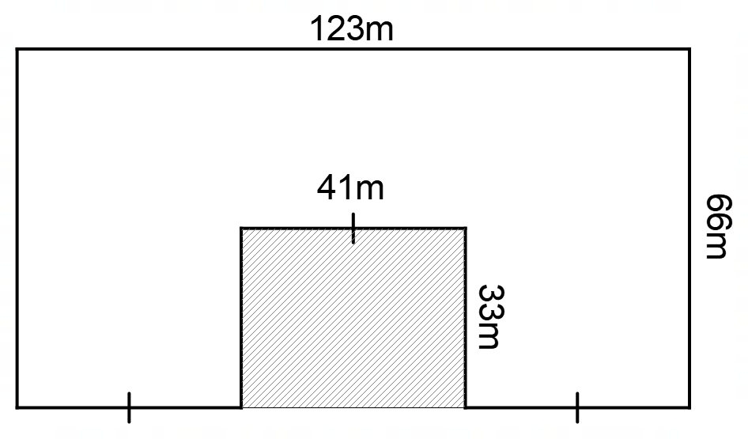
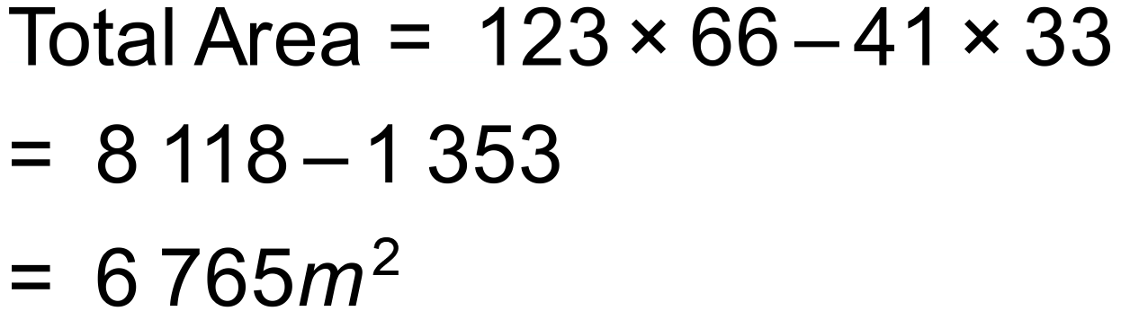
Notes
330 variations.

Question
A local community group is building bird nesting boxes and the end of the box has the shape shown below.
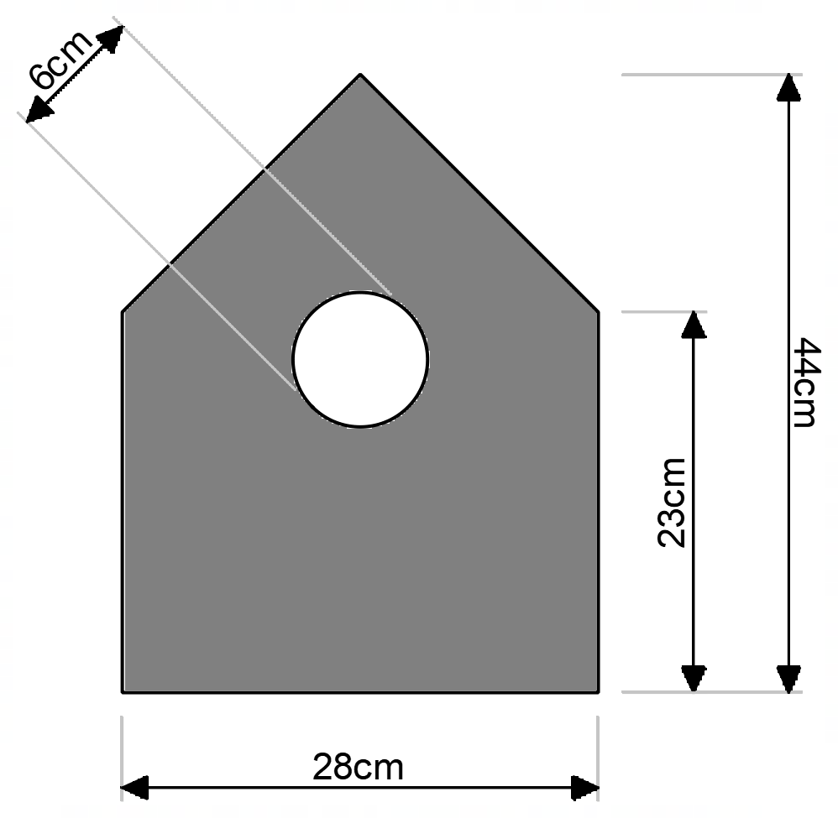
Calculate the area of the shape so that the community group can order the correct amount of paint.
Solution
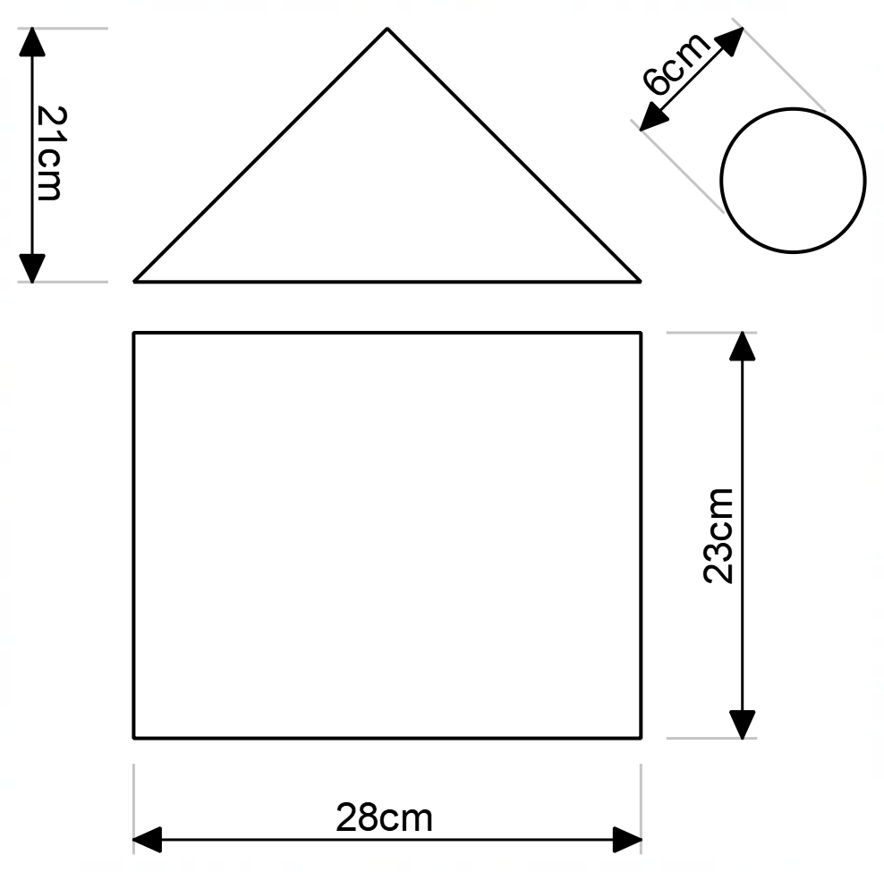
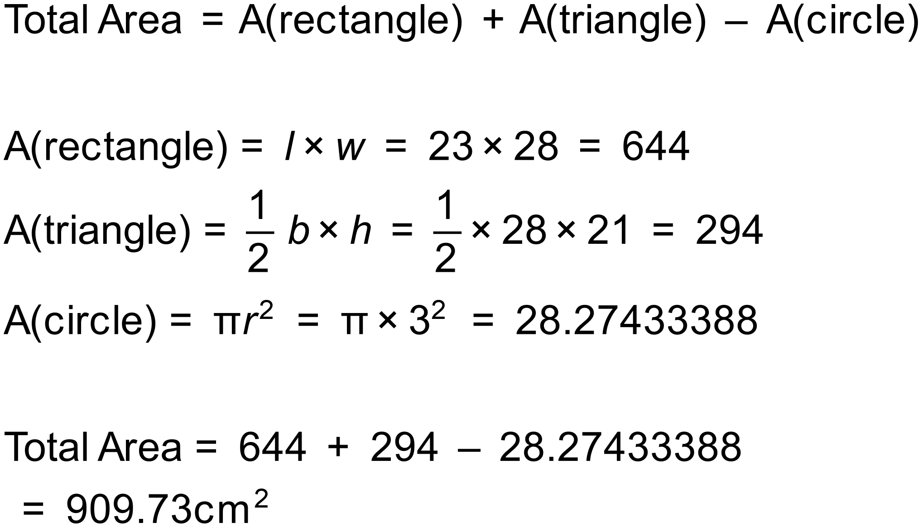
Notes
2000+ variations.

Question
Find the area of this shape.
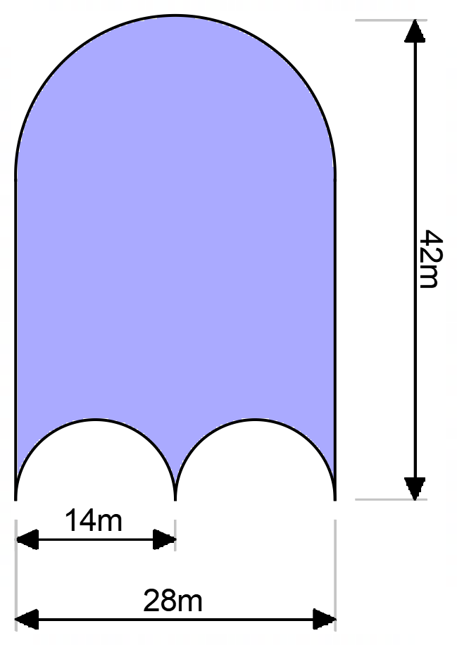
Solution
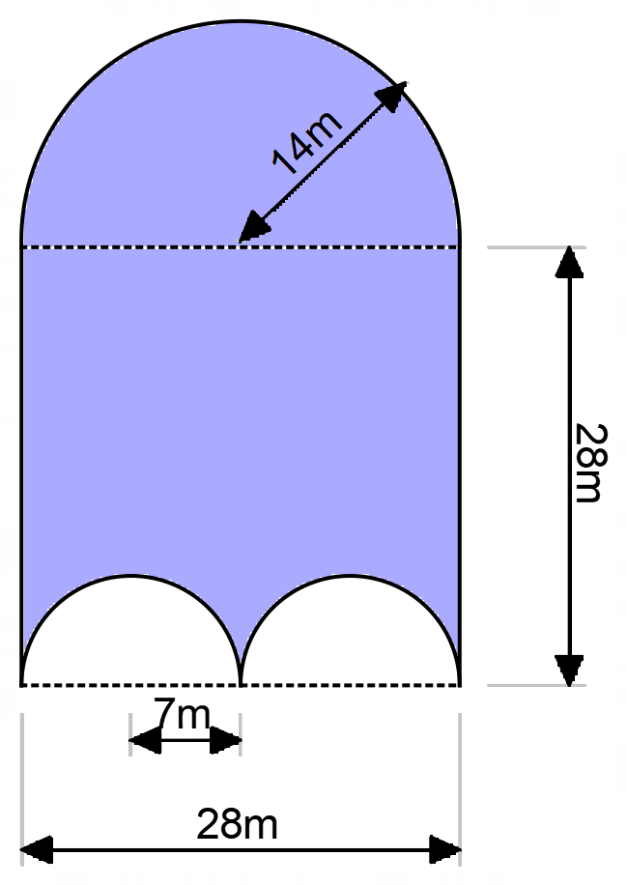
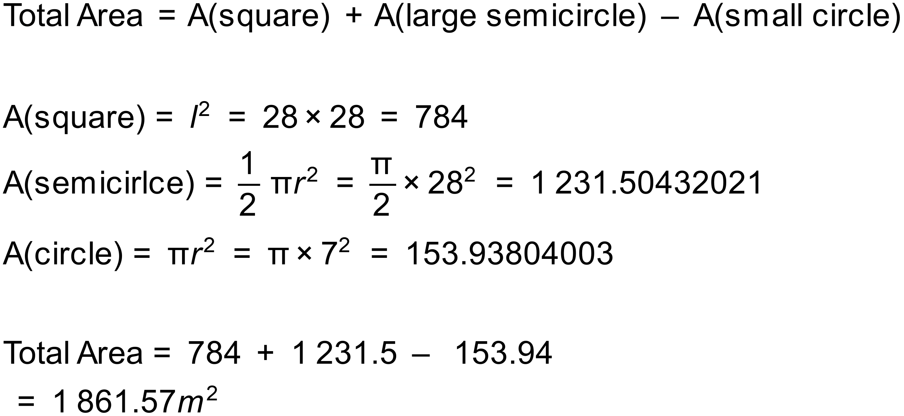
Notes
40 variations.

Question
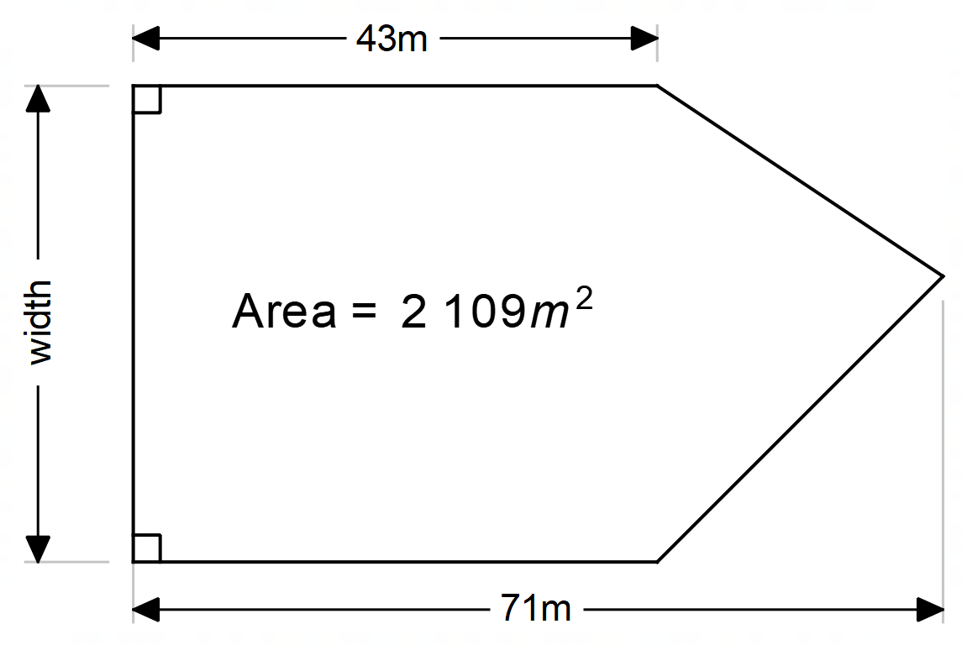

Solution
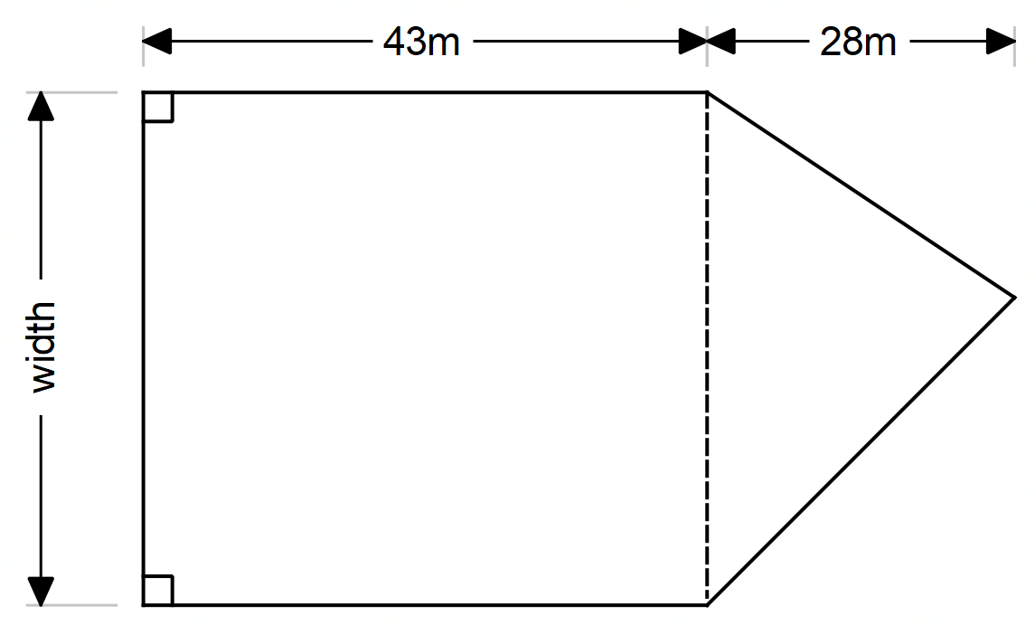
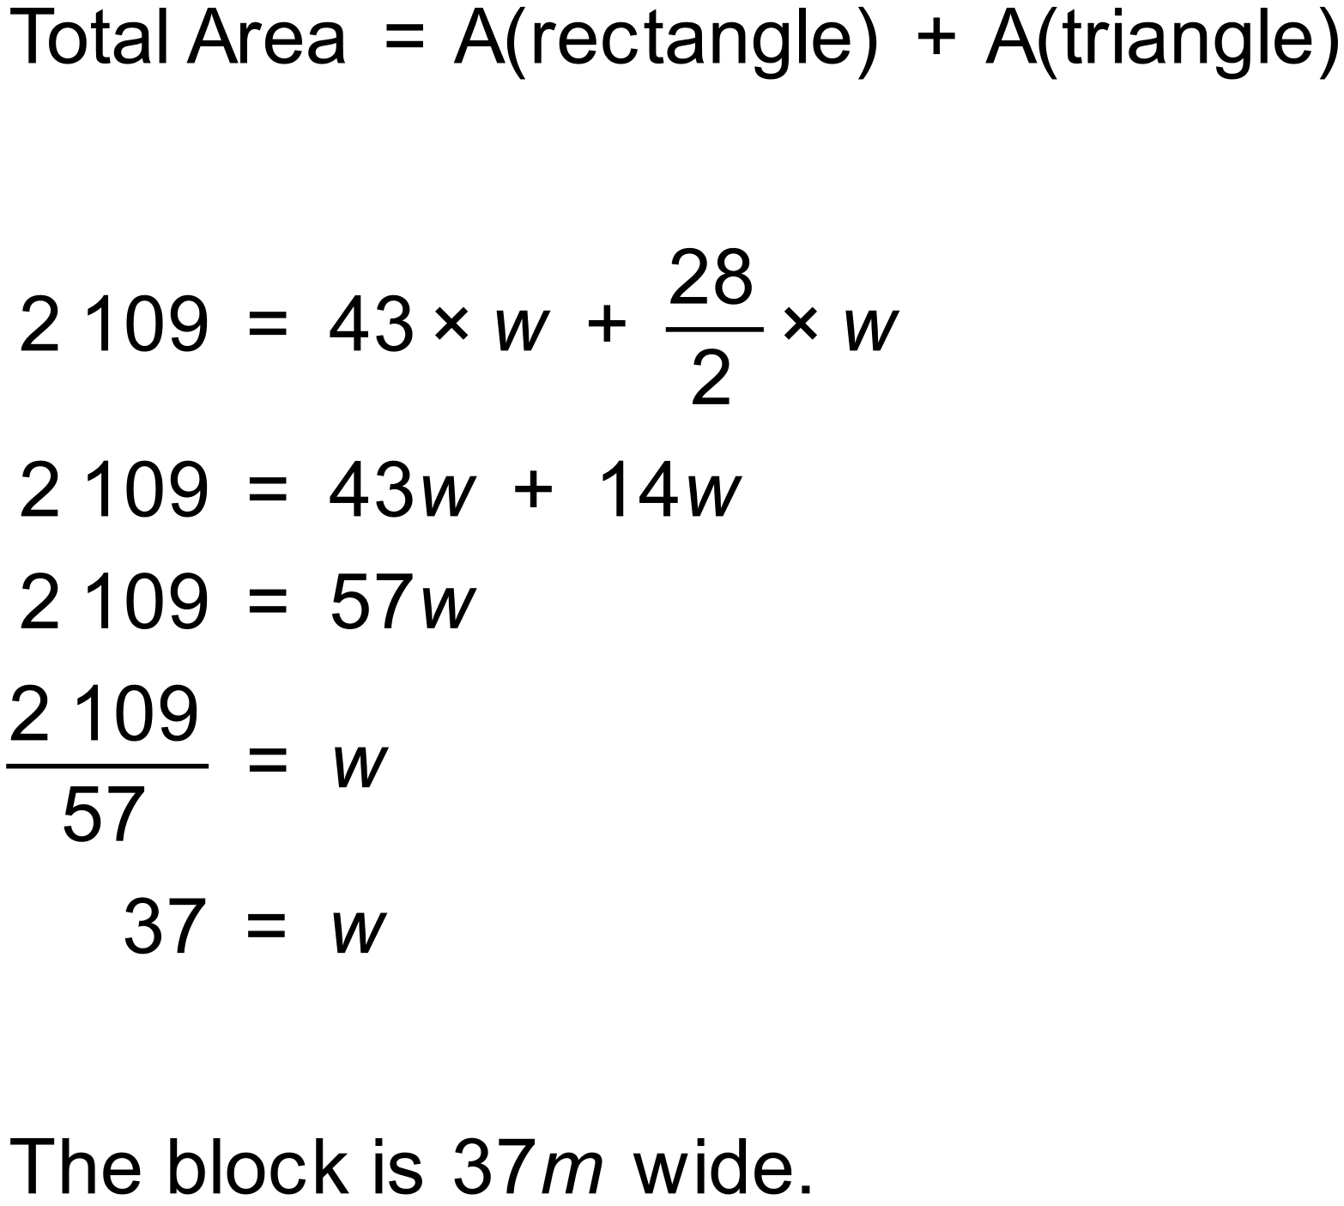
Notes
700+ variations.

Question
Calculate the area of this shape.
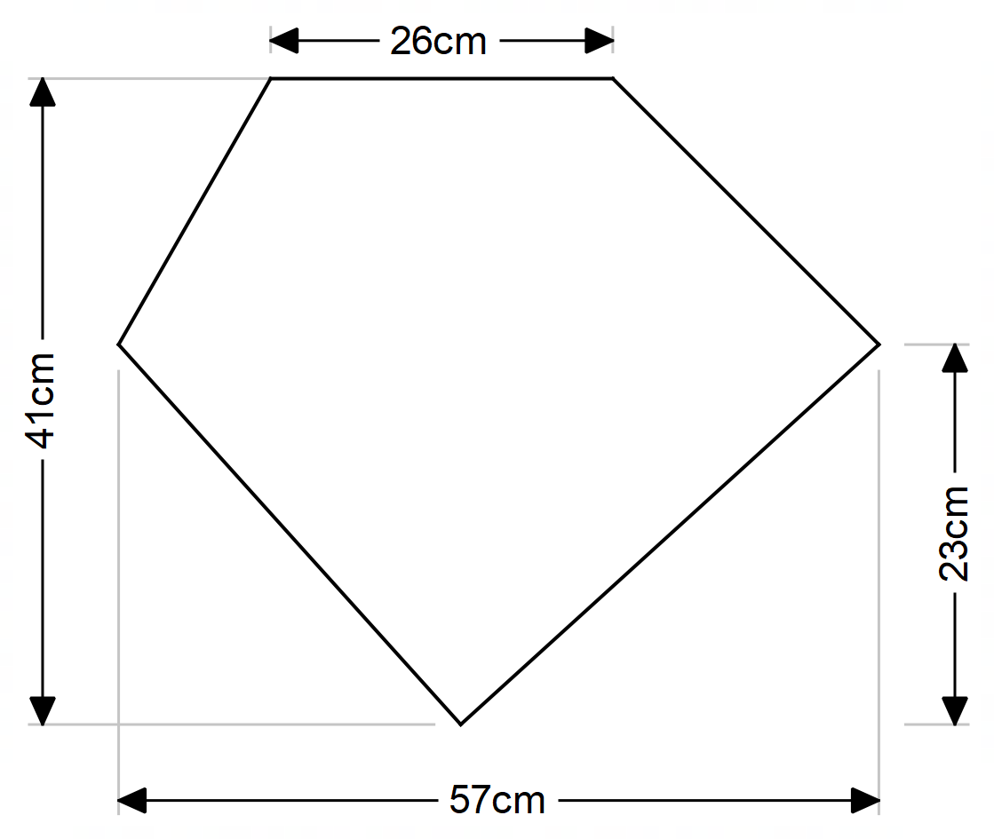

Solution
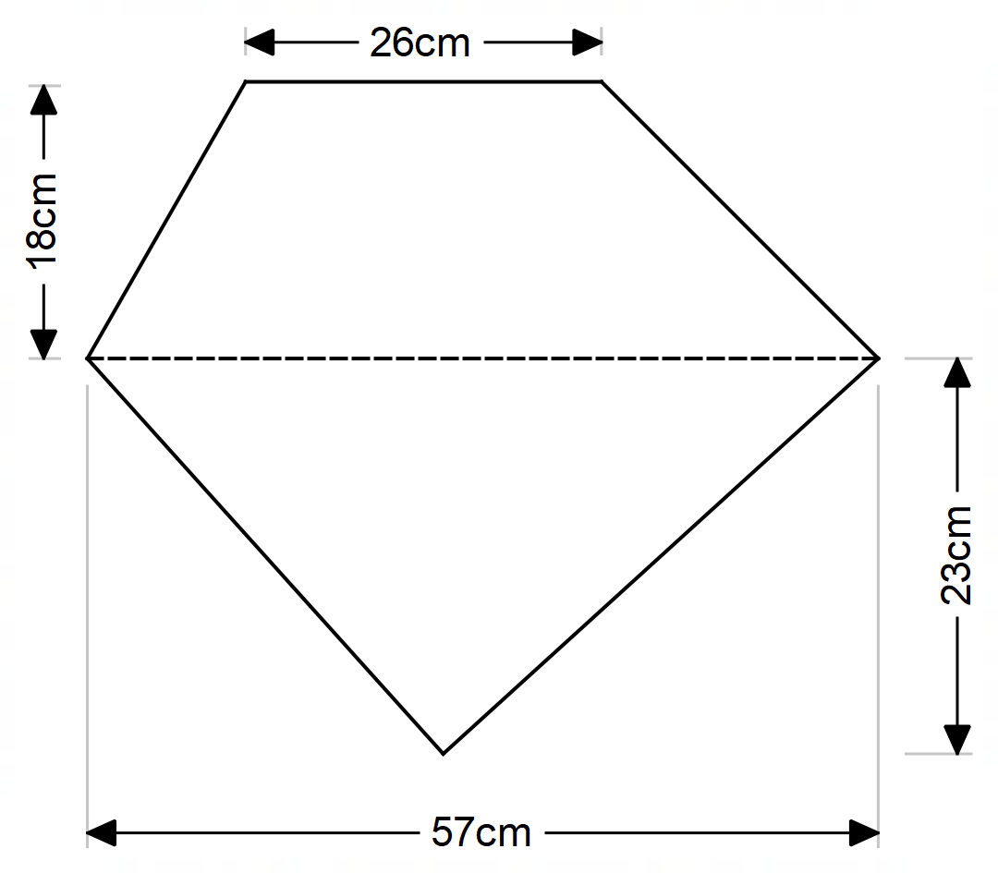
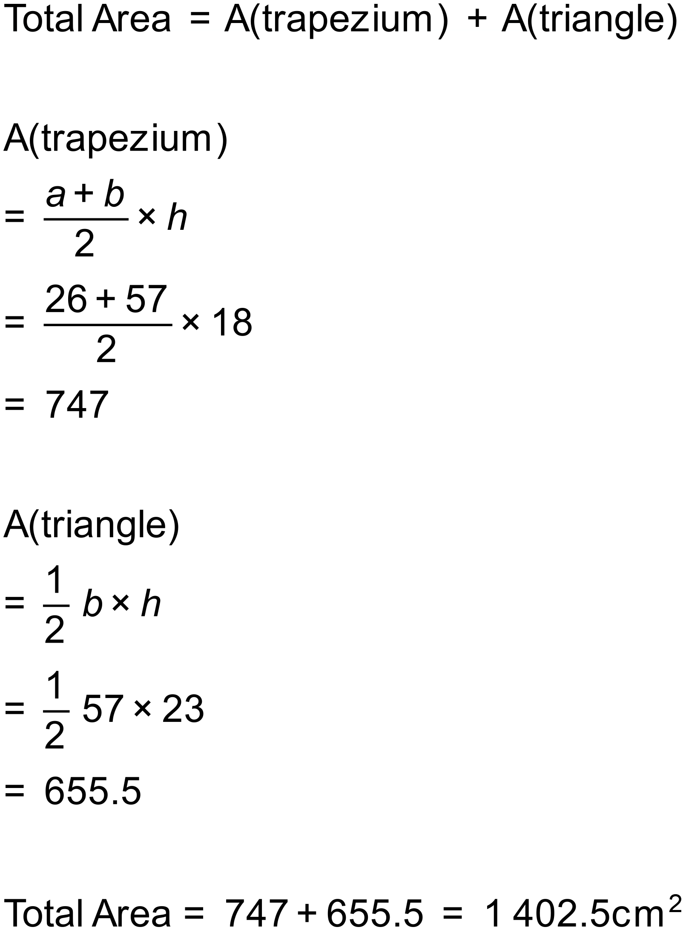
Notes
2000+ variations.

